**Peace School for Afghan Refugees and Host Communities**

**Report – Photos**

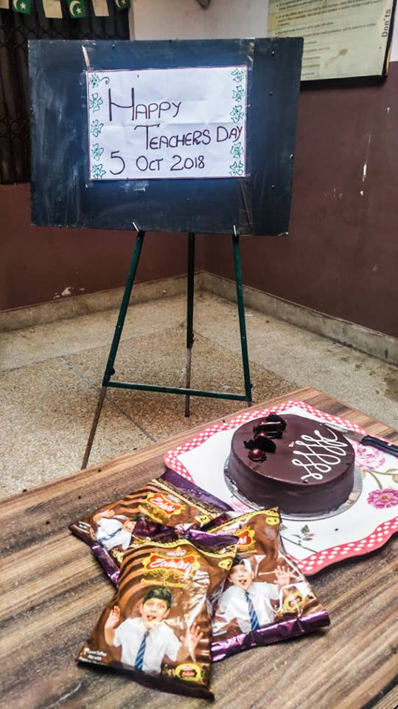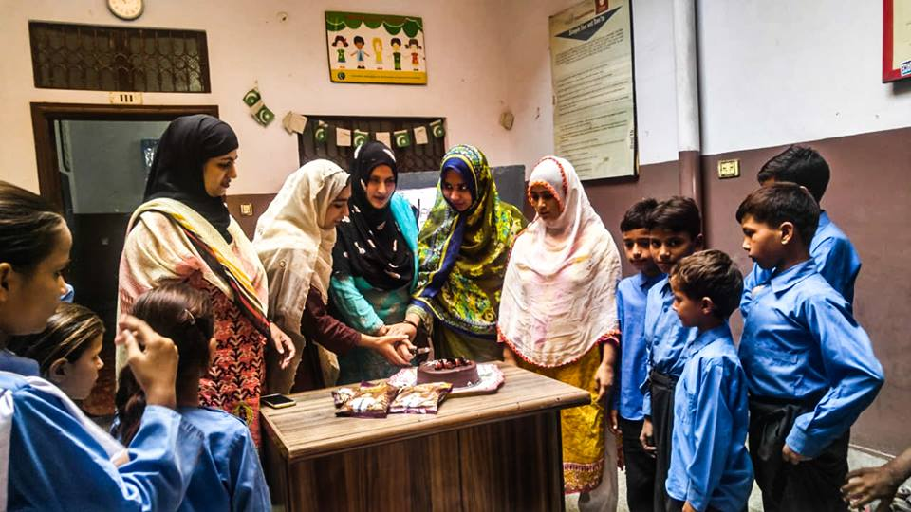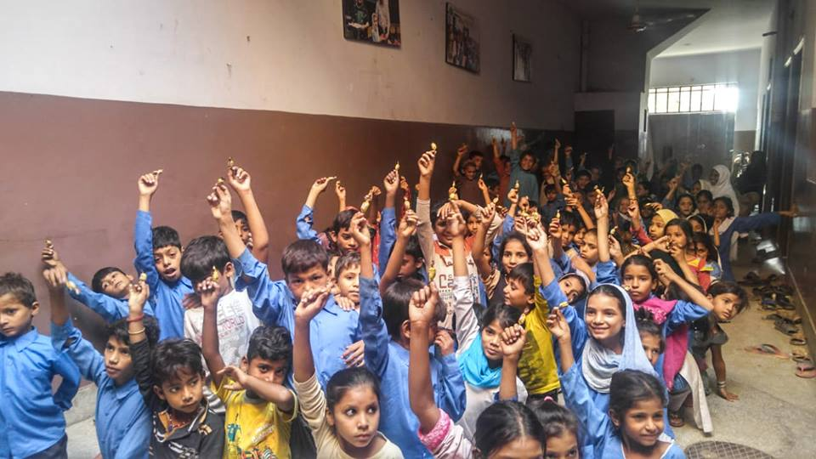 **November 2018**

Peace School celebrates "Teachers Day " There is no question that teachers play an essential part in a student’s life.

**SDG 6 calls for clean water and sanitation**

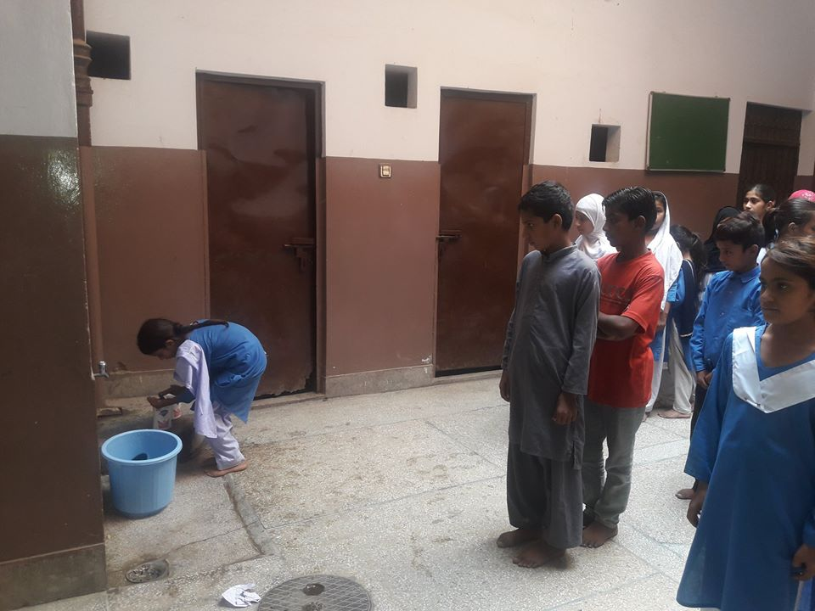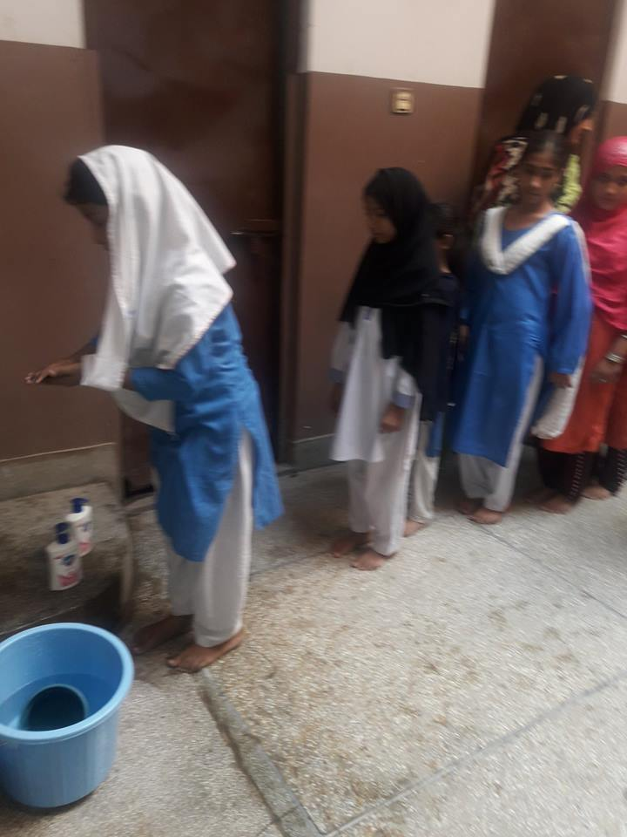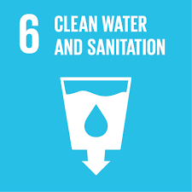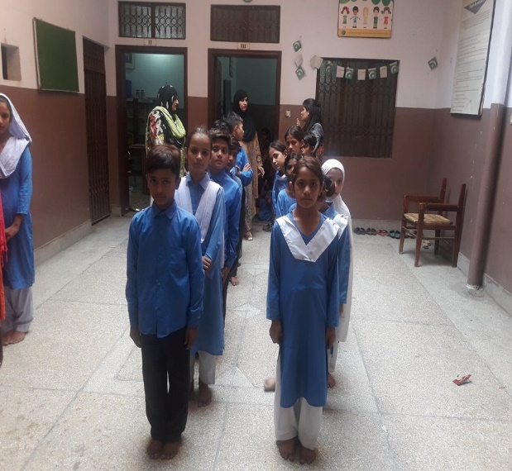

FACES Pakistan held a hand-washing day activity with the children of the Peace School who live in impoverished parts of urban Lahore.

**"SDG 3 is the health-related Goal “**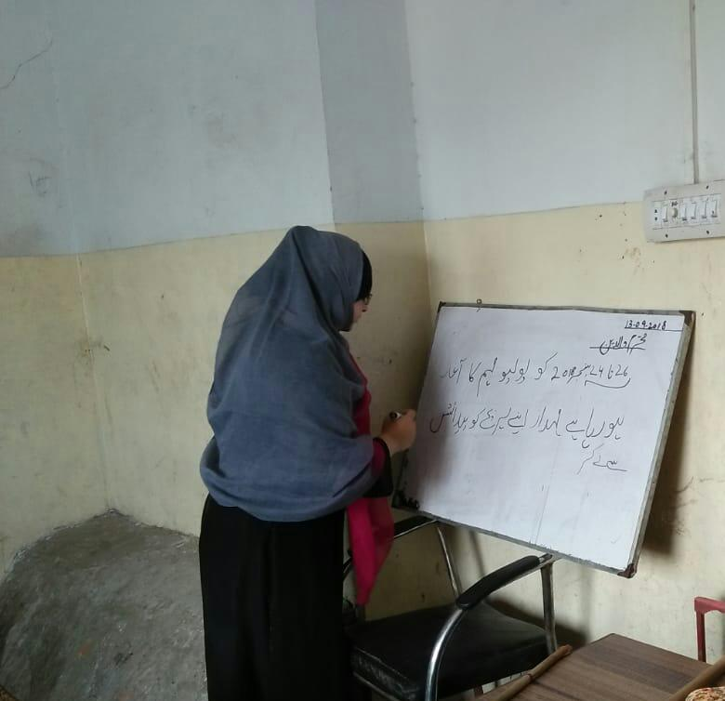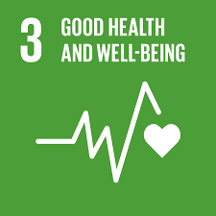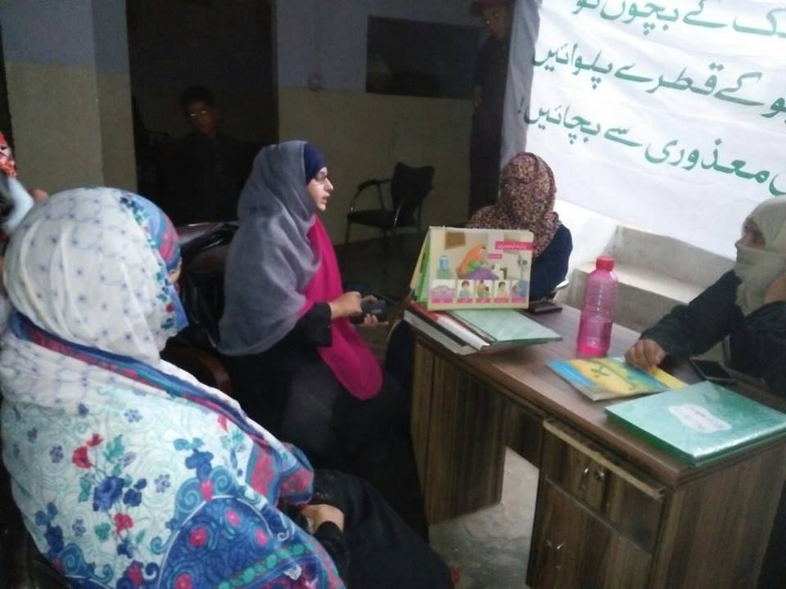

FACES Pakistan and the Ministry of Health organised a polio campaign to ensure the health and safety of the residents of the Manzoor Park area where hundreds of children and adolescents benefit from our free school and vocational training.

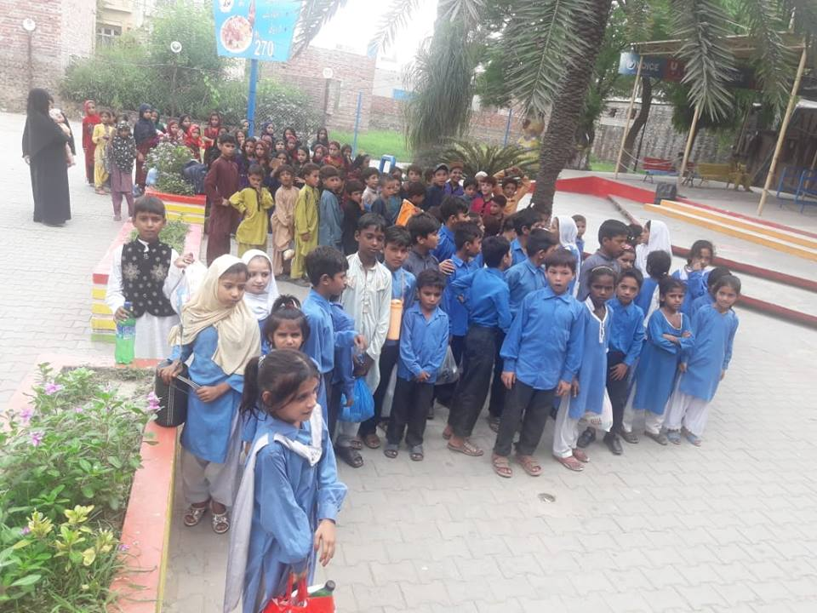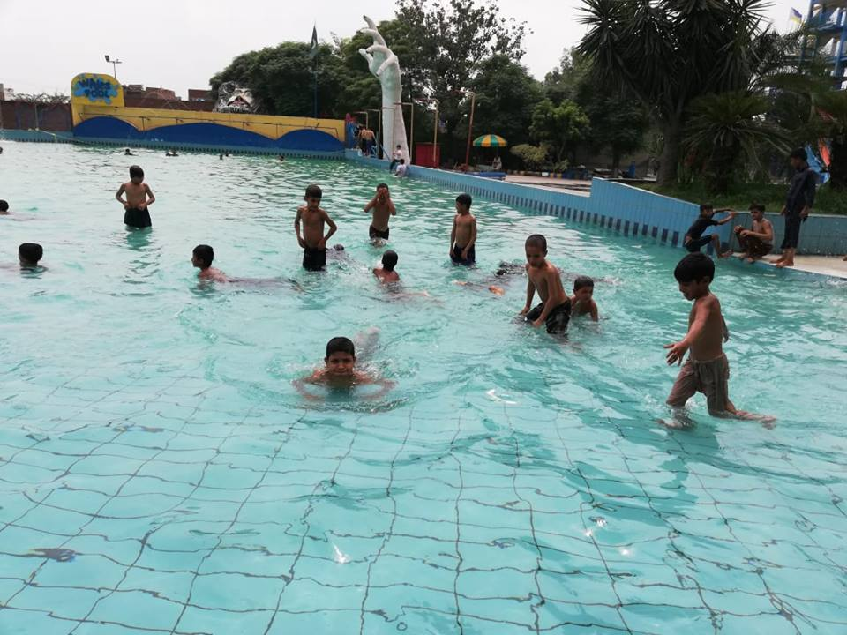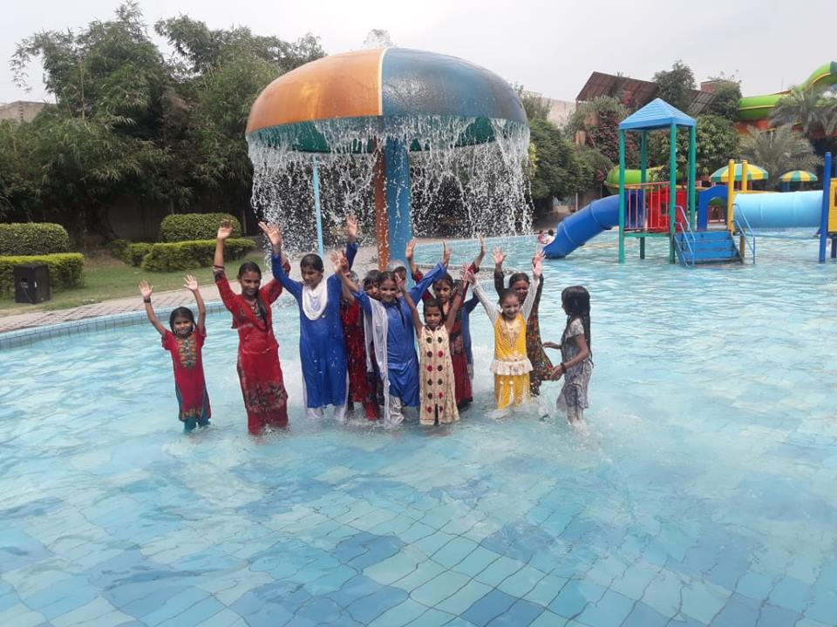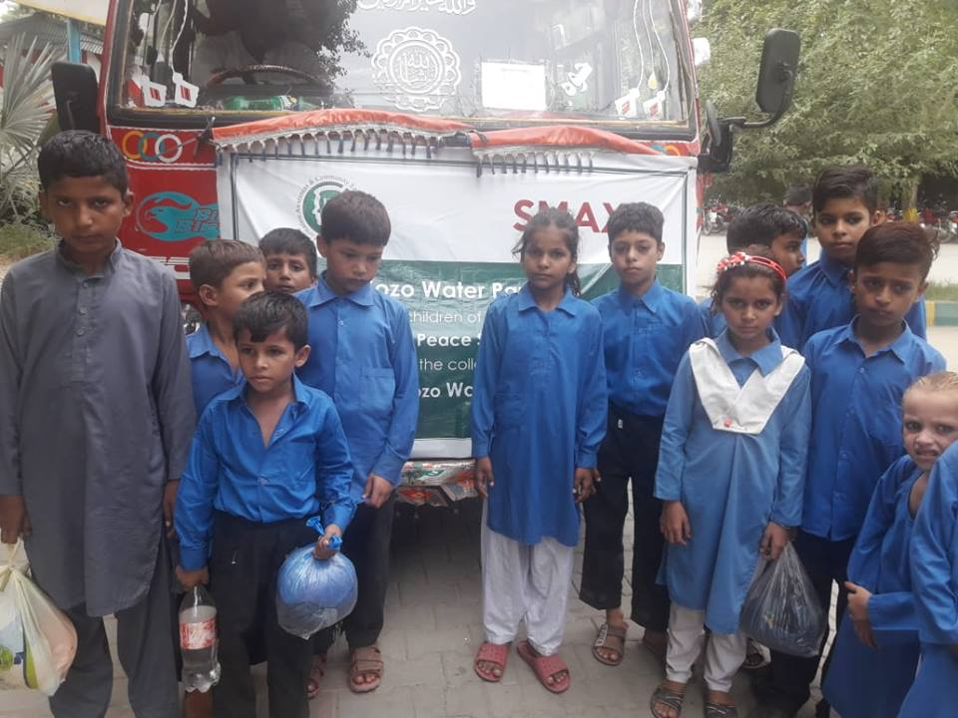

FACES Pakistan has collaborated again with the extremely kind and generous Sozo World Cinema and Sozo Water Park. This time Peace School children had a one-day trip to the Sozo Water Park for 270 children who refused to leave because they had never seen so much water, they could play in.

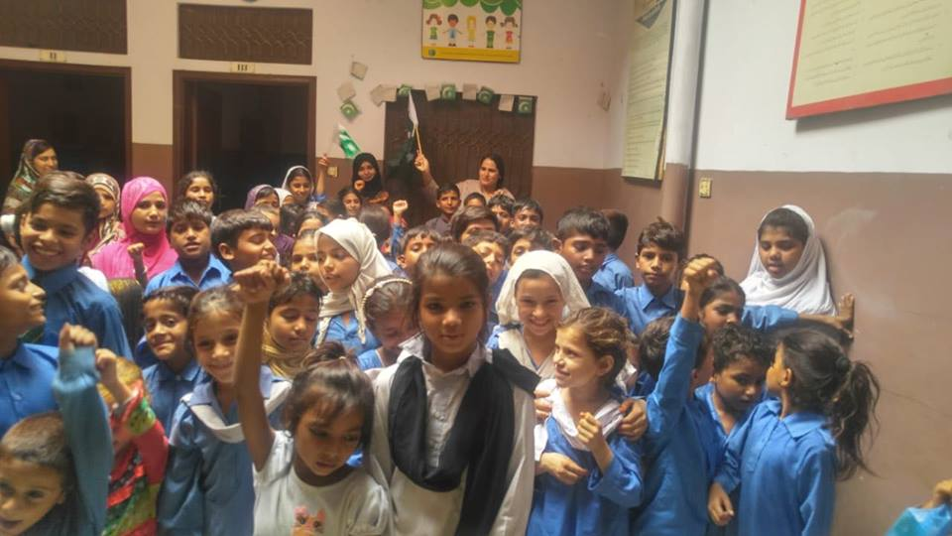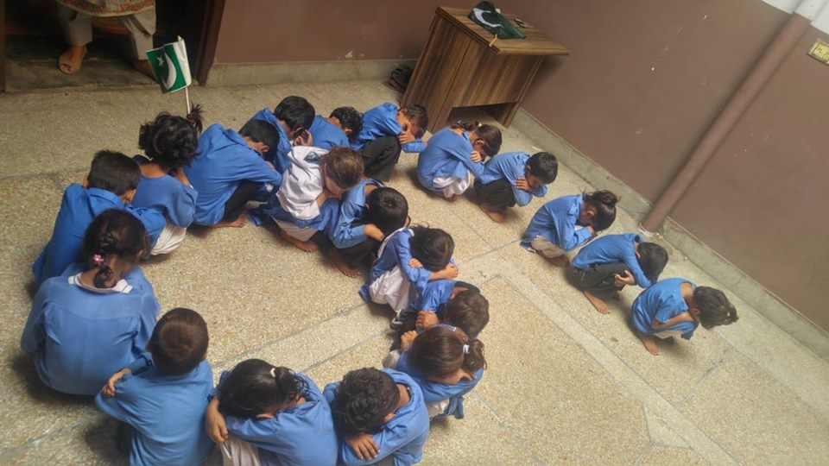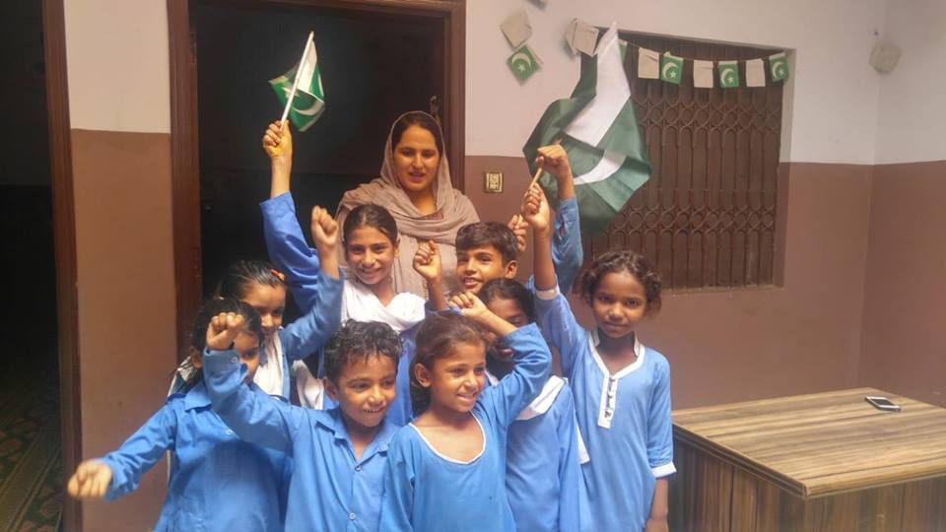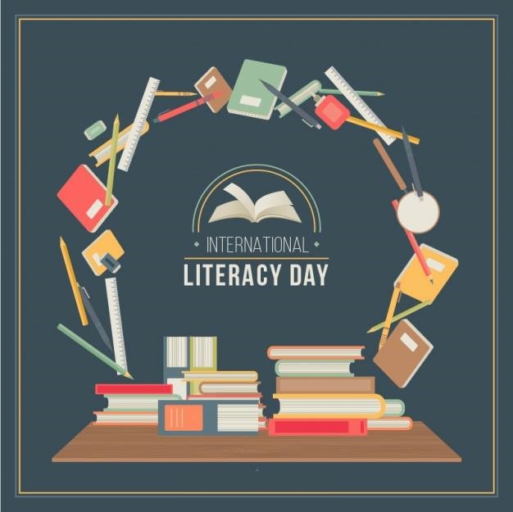

FACES Pakistan ‘s Peace School celebrated International Literacy Day Here are some pictures on by our brilliant students and teachers. May you continue to shine and be the future Pakistan earnestly needs!