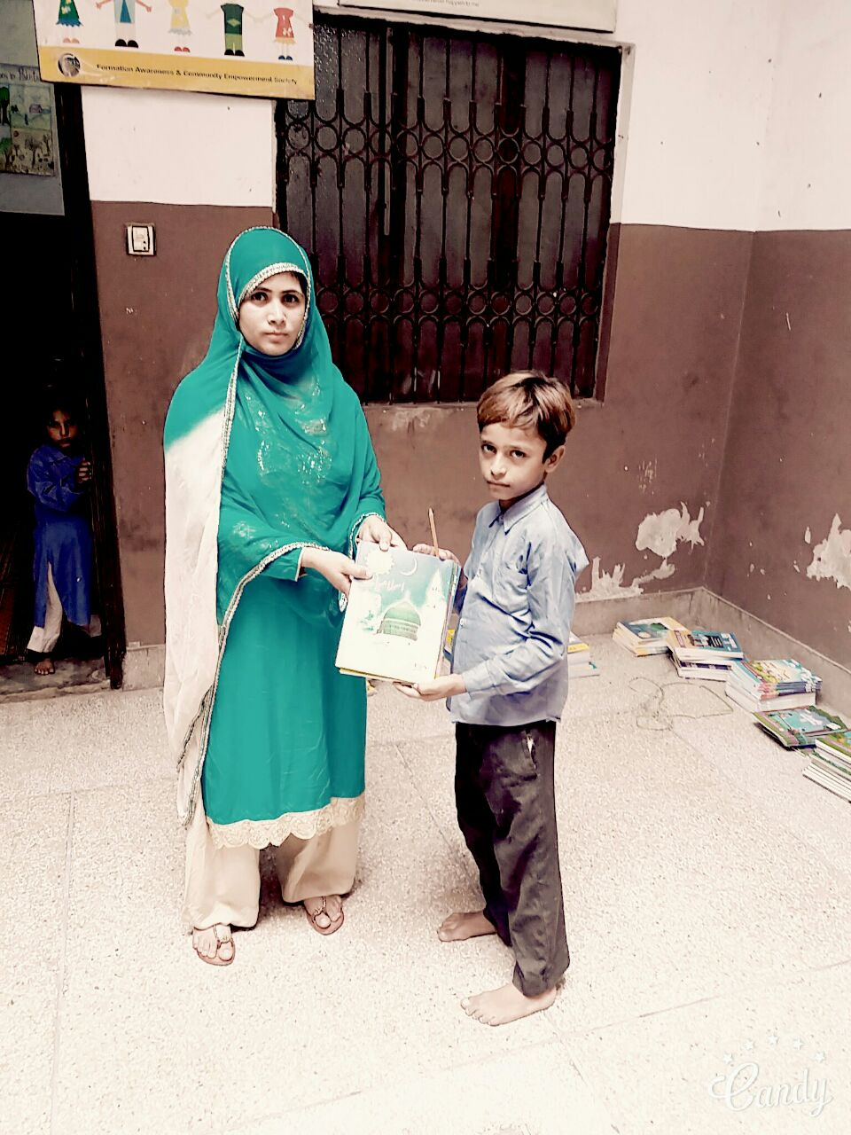
Qasim receiving books from a staff member of FACES Pakistan

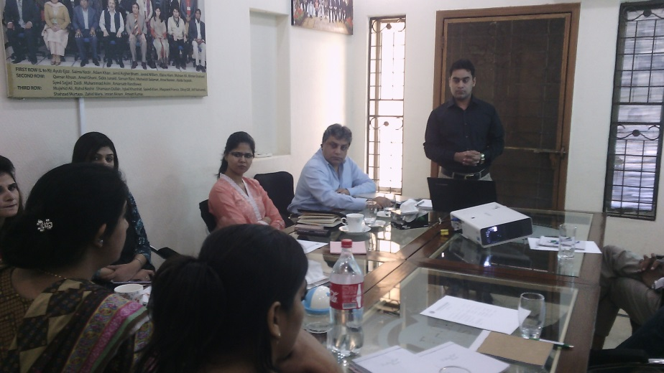
To develop an understanding about the project, FACES Pakistan organized a full day orientation session for the project team at its Head Office in Lahore

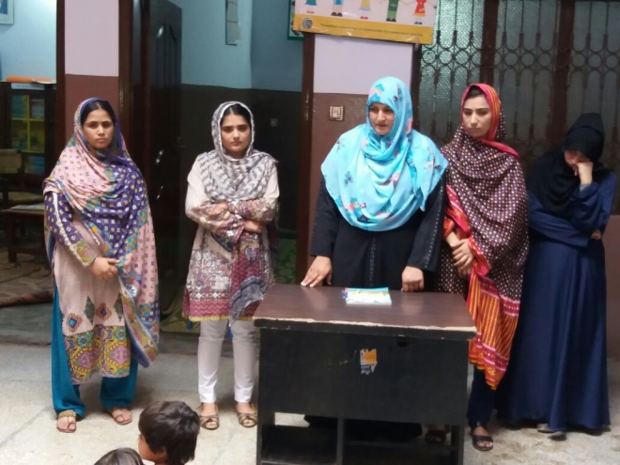
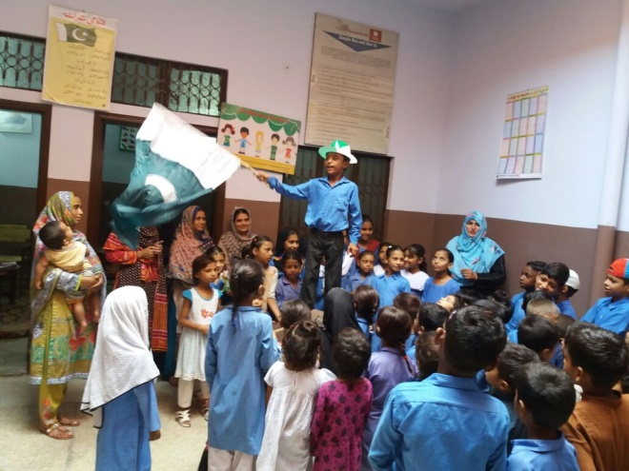
Defence Day Celebrations at Peace Schools

