Peace School for Afghan Refugees and Host Communities
Report – May 2019 (Photos)

The students from FACES Pakistan Peace School participated in National Songs competition Nazaria-i-Pakistan Trust. Our very own Iqra Kashif from FACES Pakistan Peace School received her Special Award for the speech competition.
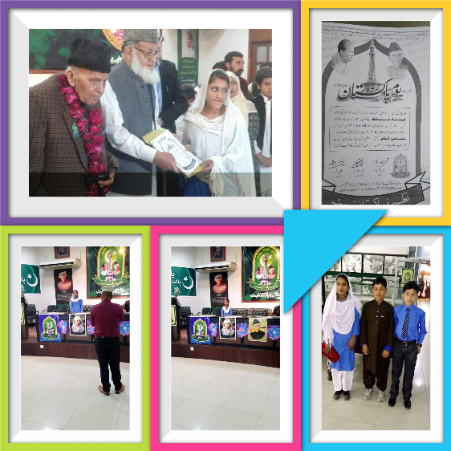

Faces Pakistan Peace school also participated in a Speech Competition at Nazaria-i-Pakistan Trust, Lahore in connection with the "Pakistan Resolution Day" 18 Mar, 2019.

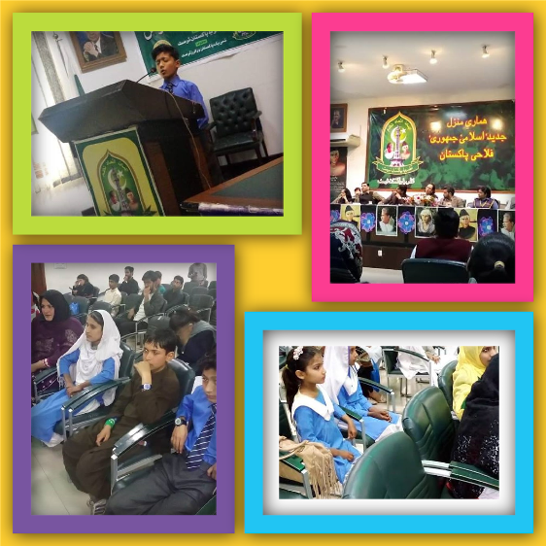

FACES Pakistan Peace School celebrates International Women’s Day.

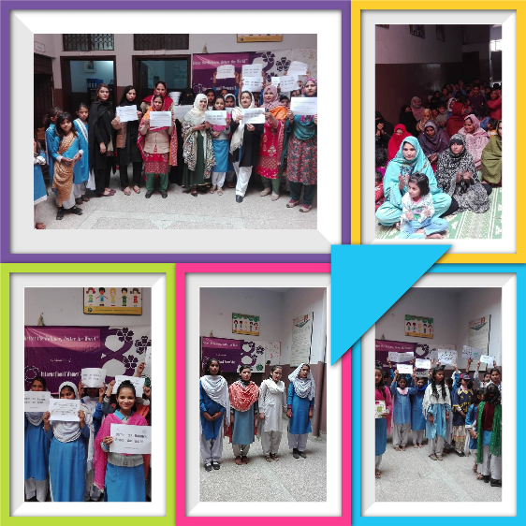

Prize distribution ceremony
The management of the FACES Pakistan gave cash prizes to the participants of the speech and national song competition. The students who took a part in the competition also performed for their fellow students in the school where the proud parents of the students were also there to share the proud moment.
