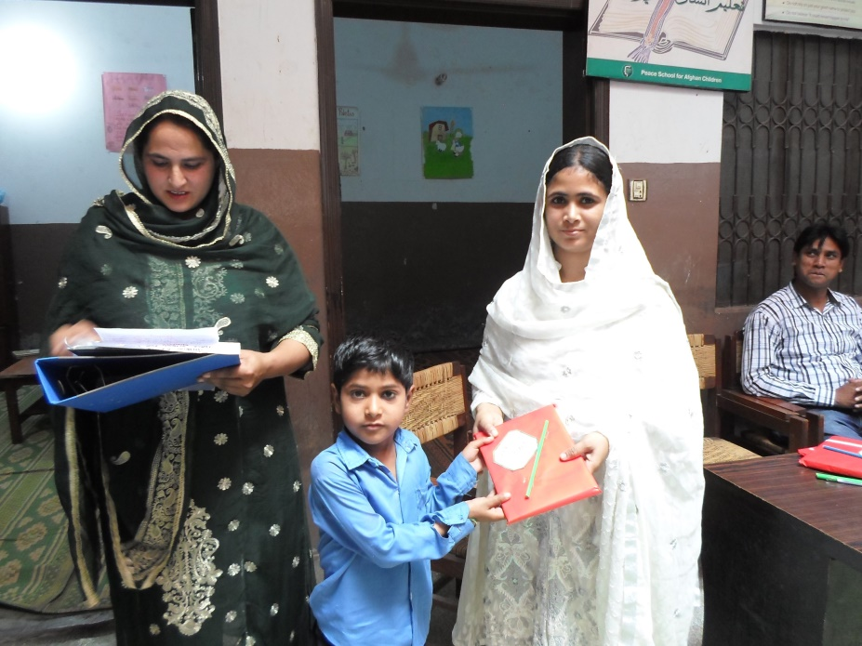
Noman receiving his prize on Result Day

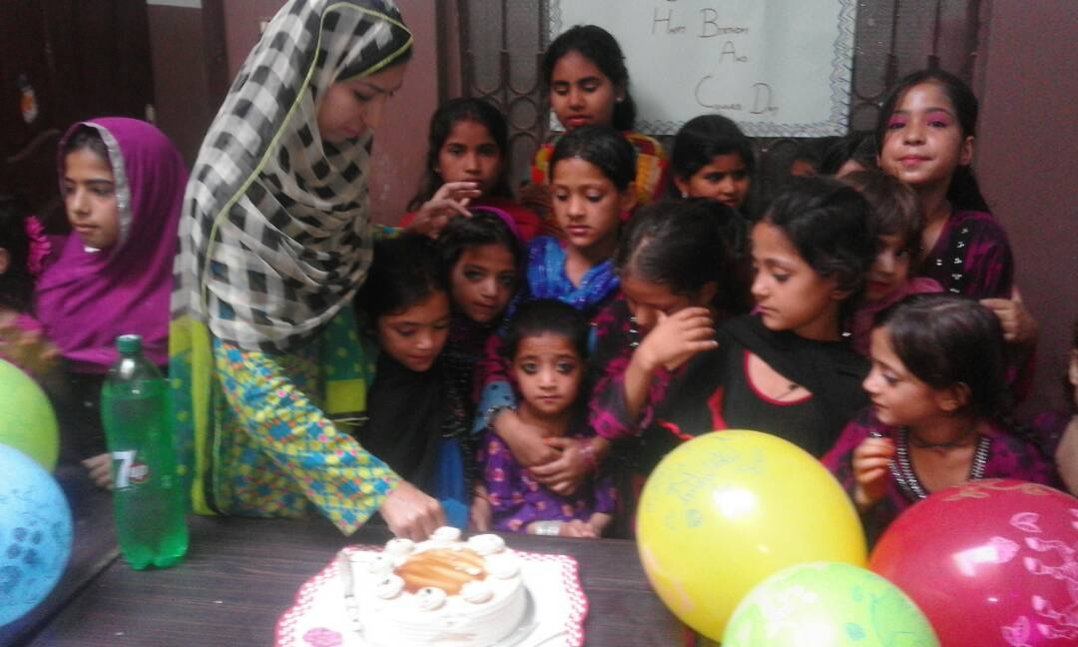
Colour Day celebration at Peace School

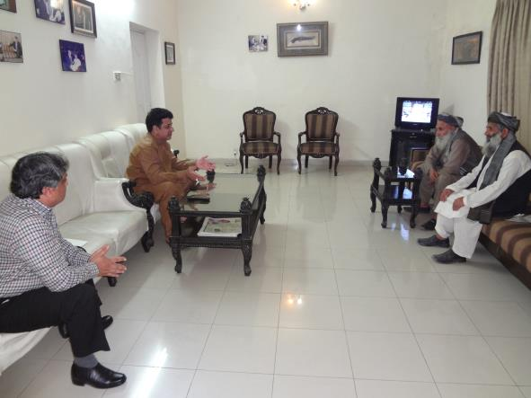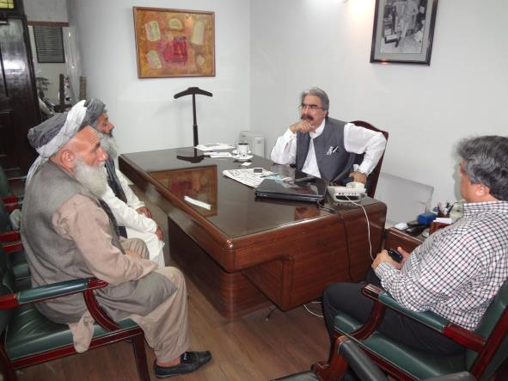
Afghan leaders meeting, Mr. Khalil Minister for Human Rights and Minorities Affairs in Punjab and Mr. Riaz, Afghan Commissionarate, Government of Pakistan

