Peace School for Afghan Refugees and Host Communities
Report – February 2018
Photos

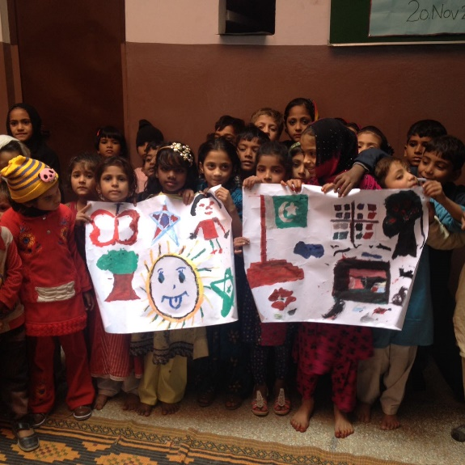
Celebrating Universal Children’s Day through Paintings

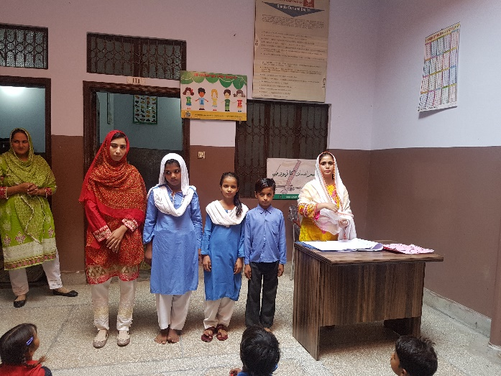
Teacher’s Day celebrations in Peace Schools

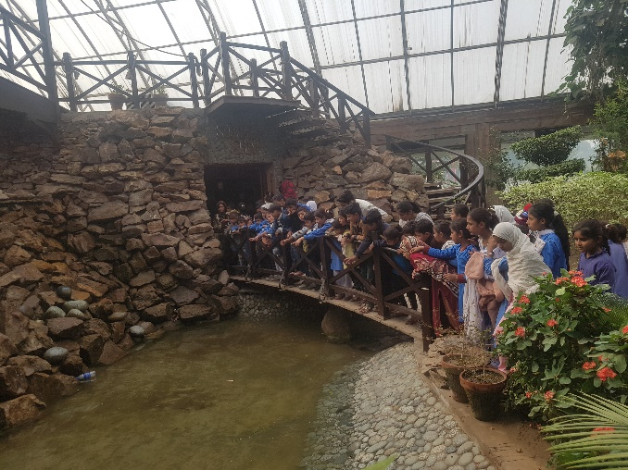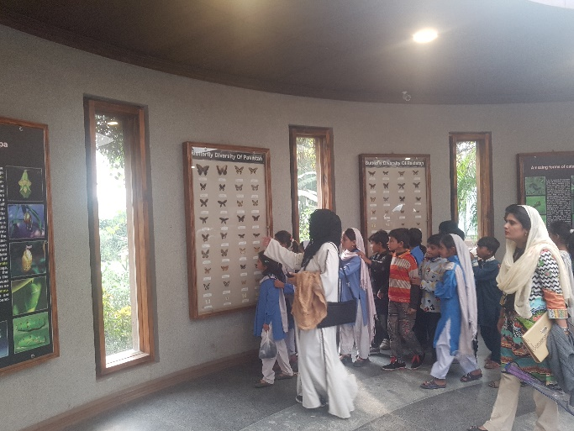
Trip to Jallo Park

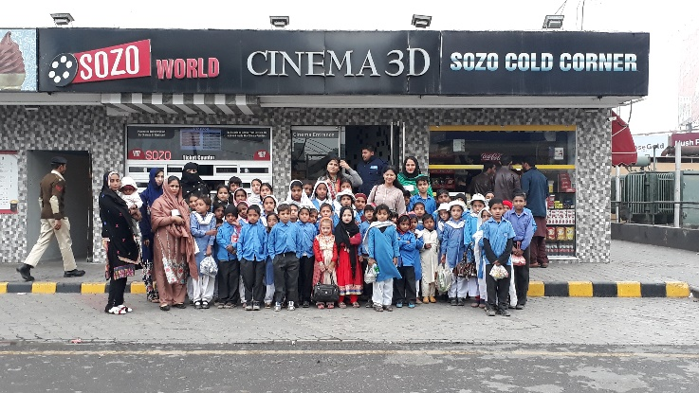
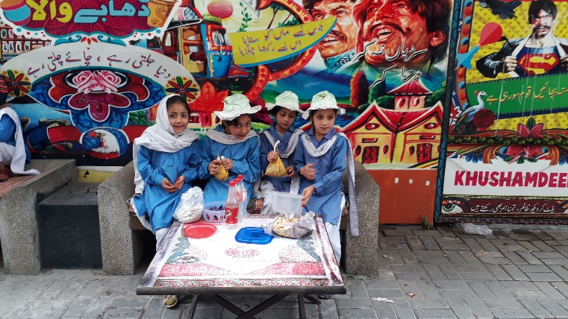
At Sozo World Cinema for Movie Allahyar & the Legend of Markhor

