Peace School for Afghan Refugees and Host Communities
Report – Photo
February 2019
Universal Children’s Day

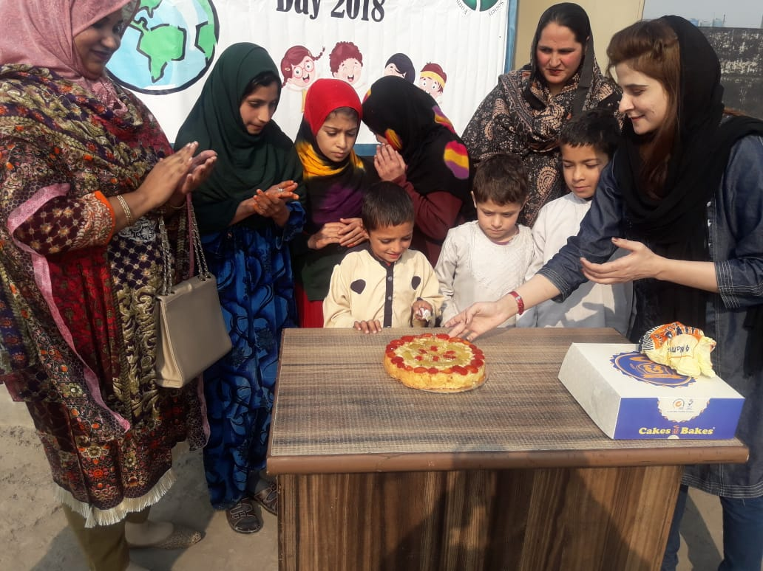
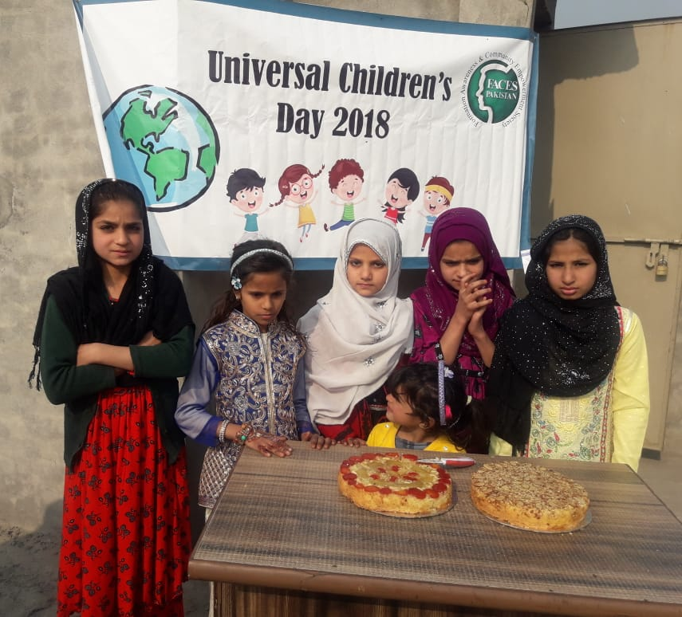

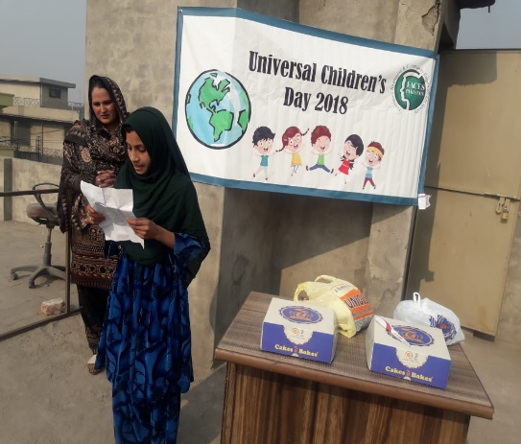
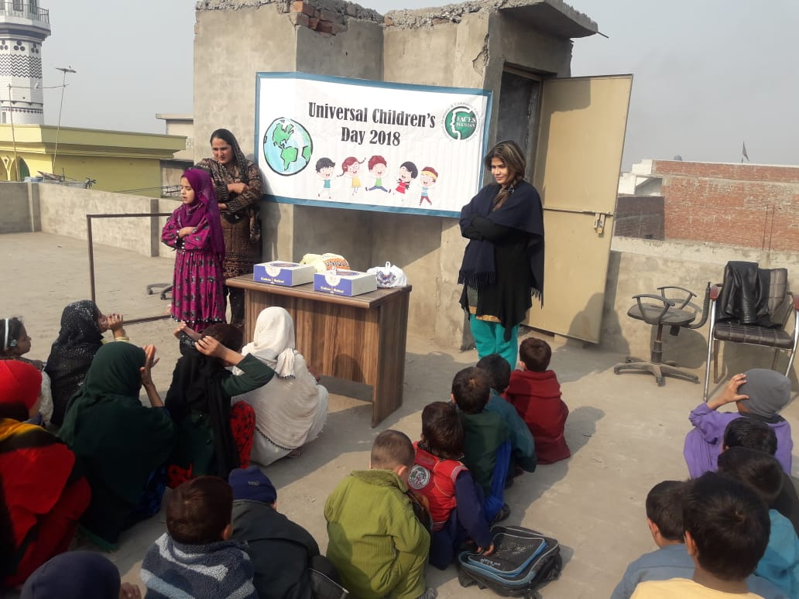

FAECS Pakistan Peace School celebrates "Universal Children’s Day" This day was devoted on honouring children as well as improving their welfare. There is no question that children play an impeccable and valuable part in our lives as they are the future of tomorrow hence, we need to protect them, give them the right to education and nurture them in a safe haven.

Art & Crafts Activities

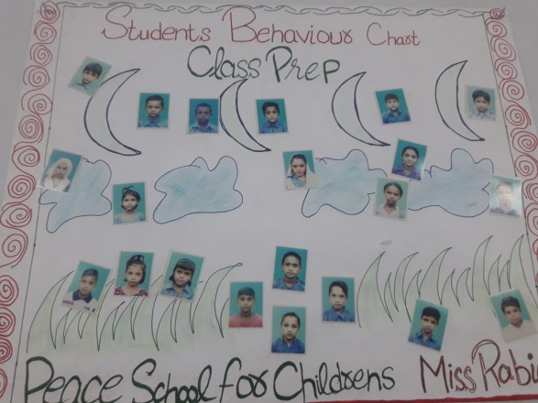
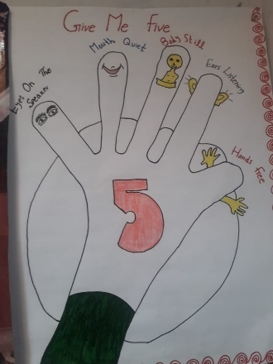
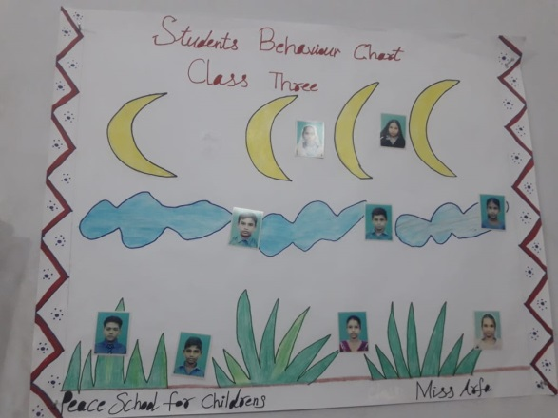
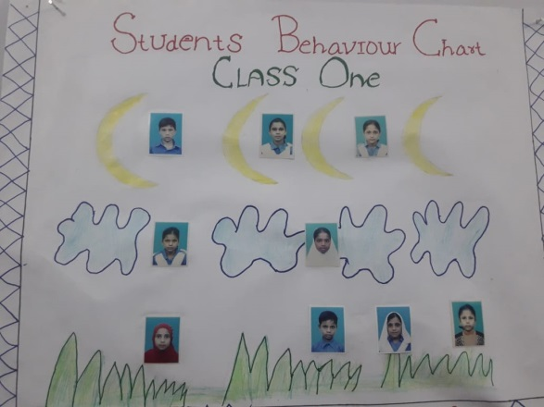
FACES Pakistan Peace School did various fun activities to rejoice Universal Children’s Day. They were asked to make creative ways to express themselves, they showed their enthusiasm by being involved with many arts and crafts activities.

Midterm Exam Week

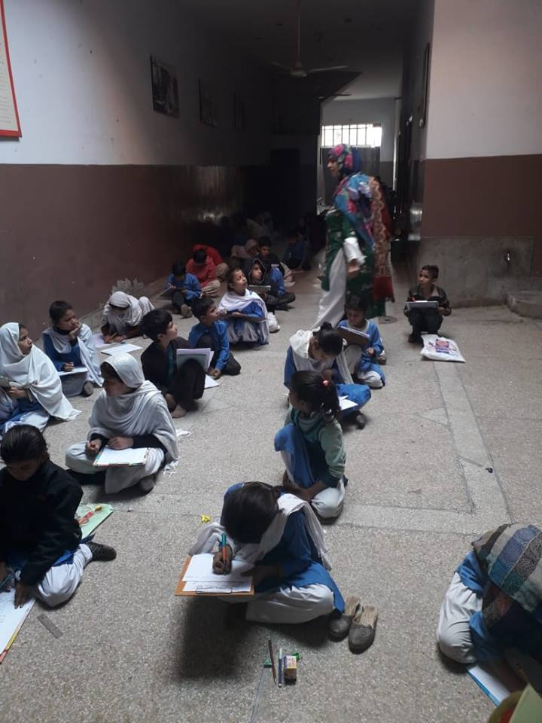

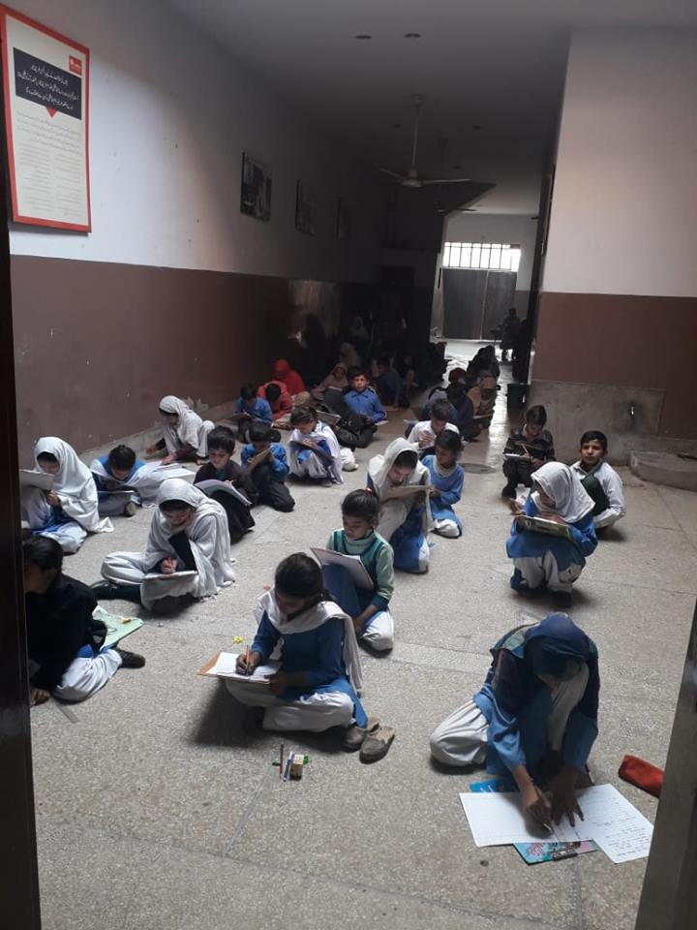

FACES Pakistan Peace School Midterm Examination Week has started and therefore it is time to open the book, study hard and fill the head with problem solving equation. Indeed, investing in your children’s education will grant your child a fighting chance to be successful in life.

International Day of the Girl Child

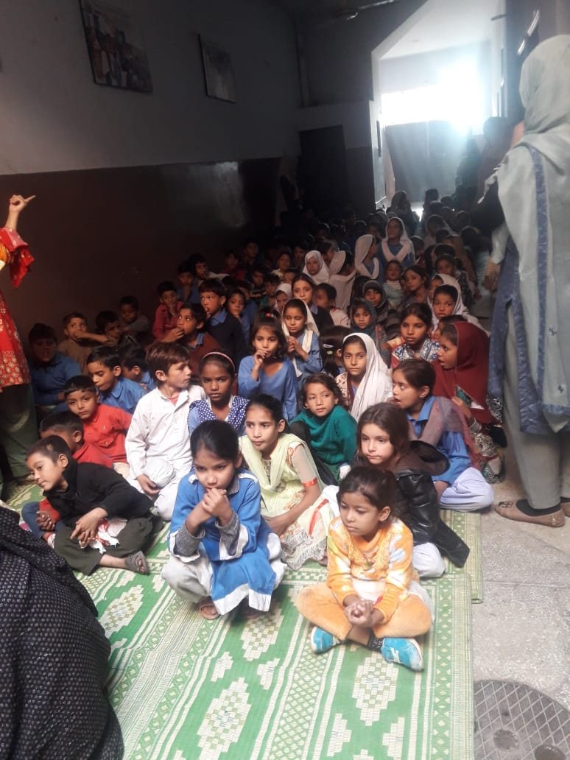
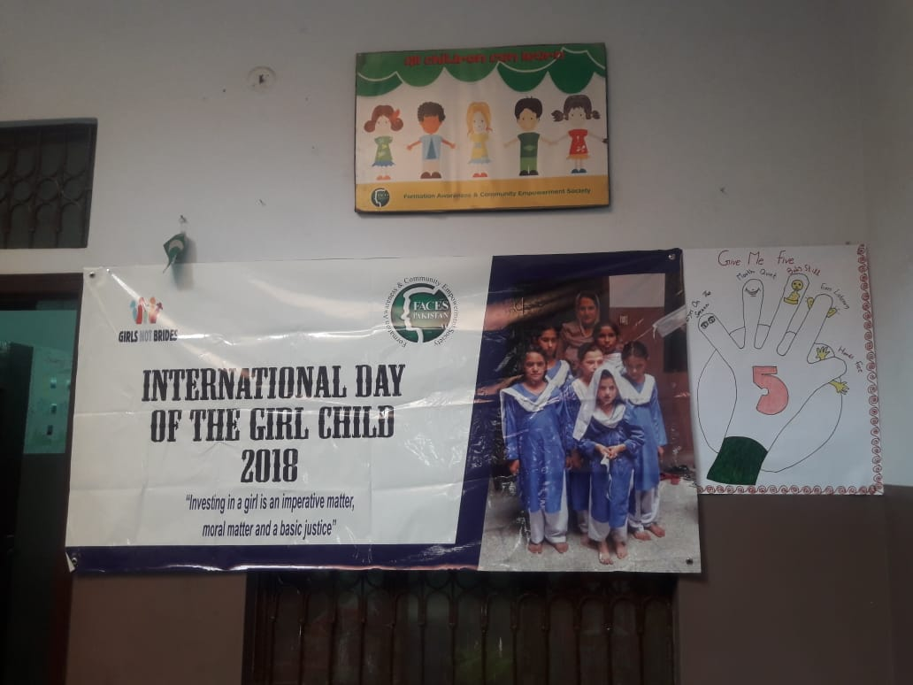

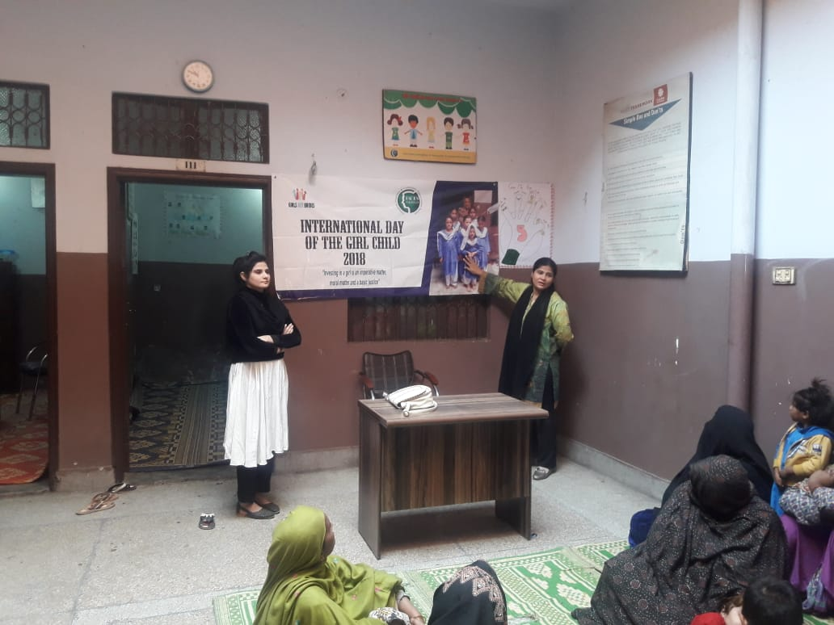

FACES Pakistan celebrates “International day of the Child Child 2018”. This day marks as the day where we all show our support to young girls. It is time for the girls to make a stand, to enhance their education, become inspired, innovate and take charge of their own future.

Mother’s Meeting
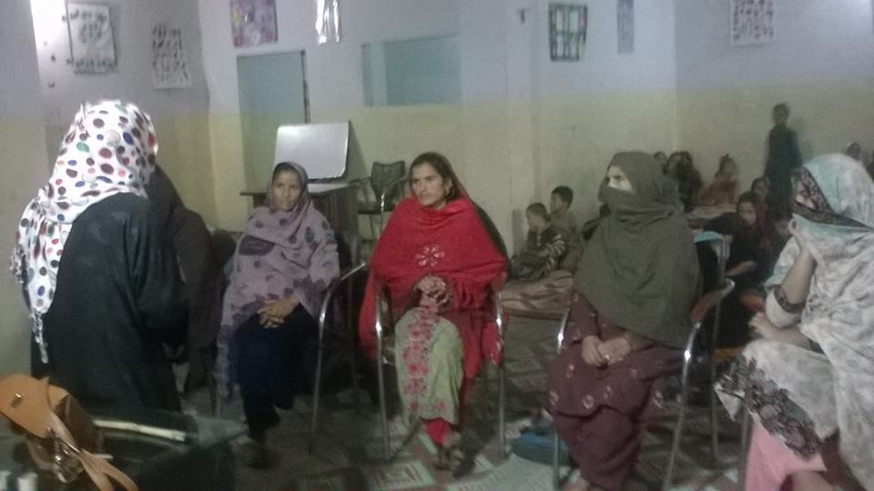
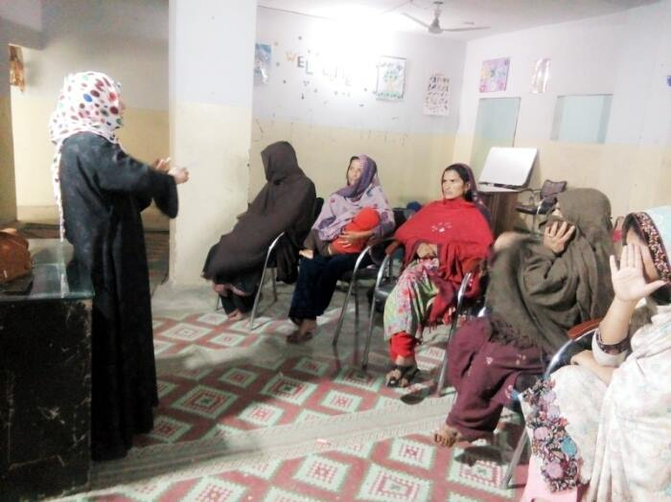
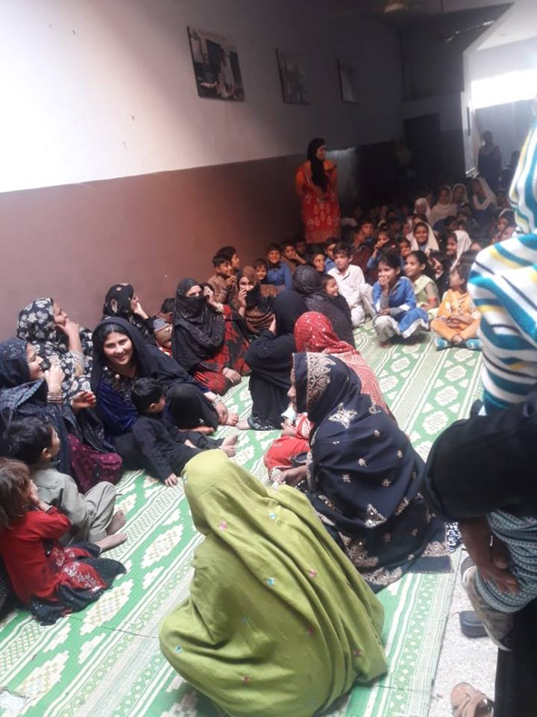

In the International Day of the Girl Child 2018. Mothers of the children were asked to attend a session, in which they had a thorough discussion on the welfare and potential futuristic goals of the girls. There is no question that girls can play a powerful asset to improve the ongoing conditions that our country faces. There should be no hindrance when it comes to their education or training. Families should be the first who should show their dedication and support to enhance their own girls learning opportunities.

"Health-related Goal “
Polio Campaign
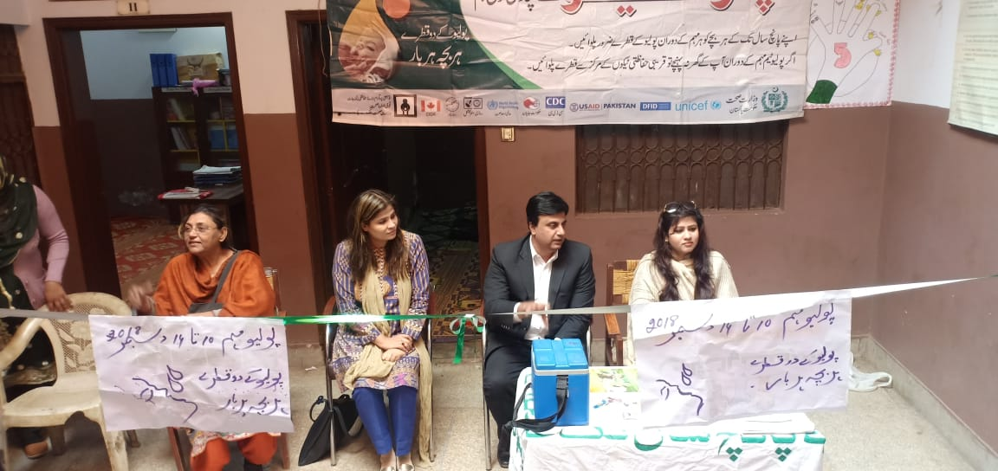

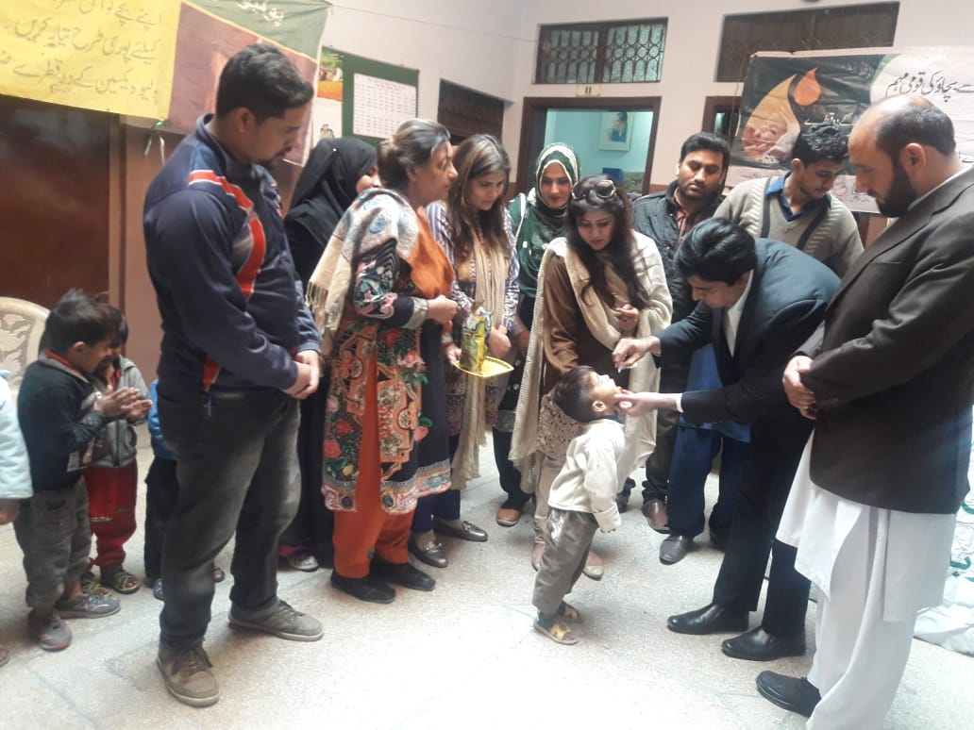
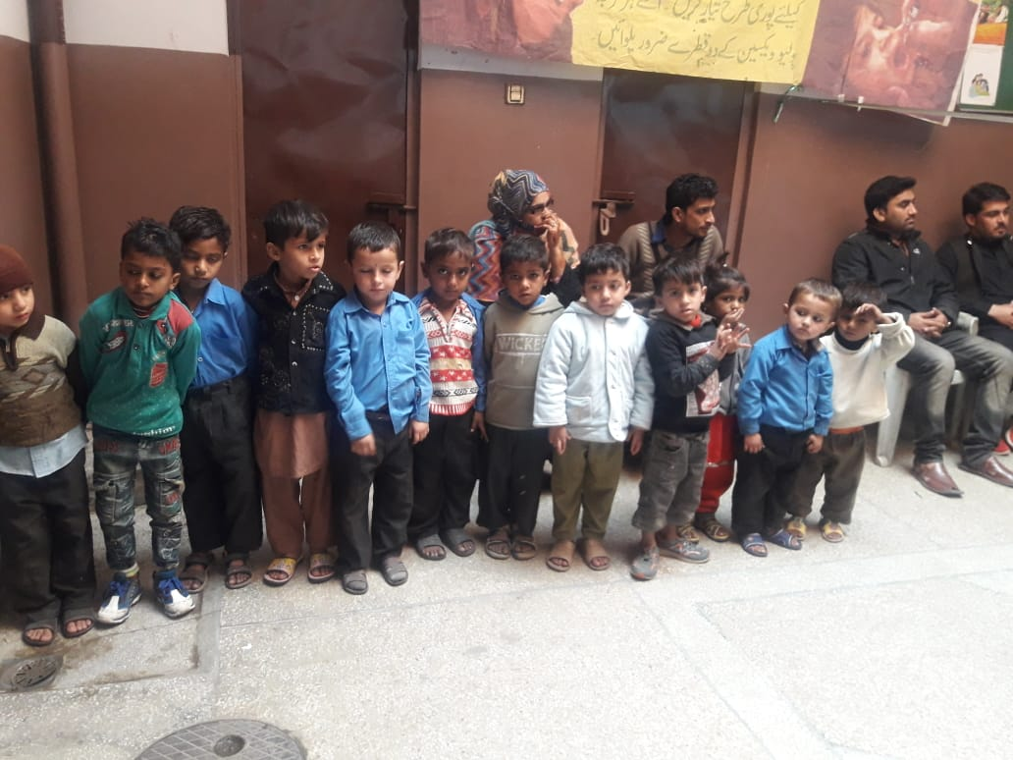

Primary and Secondary Health Care department conducted an opening ceremony in FACES Pakistan Peace School for Polio Vaccination Campaign. Doctor Zahid Muneer, the Deputy District Health Officer accompanied with FACES Pakistan team members brought attention to the vast health consequences one might suffer due to Polio and the safe precautionary steps everyone should be aware of. All children were vaccinated through polio drops that day.

Vaccination for Measles

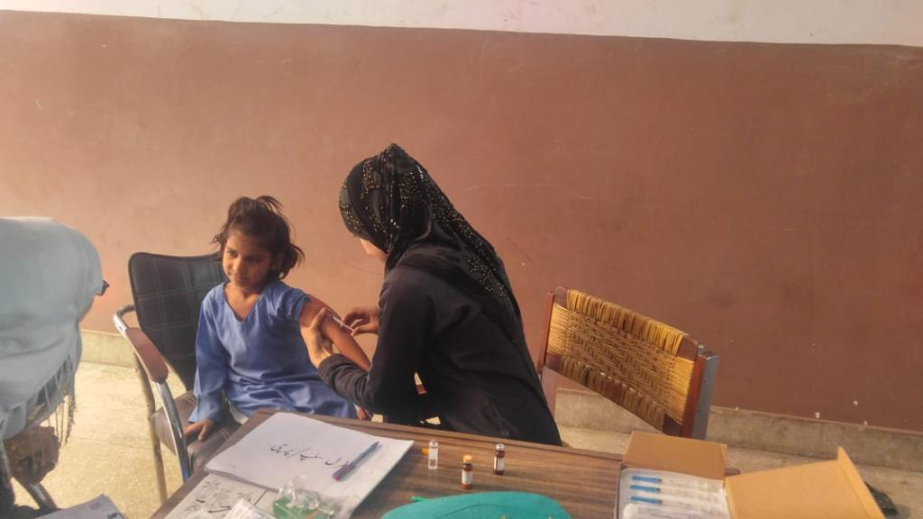
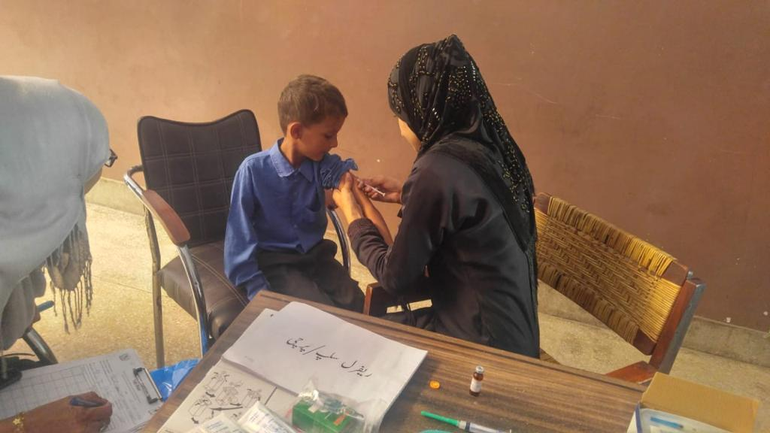

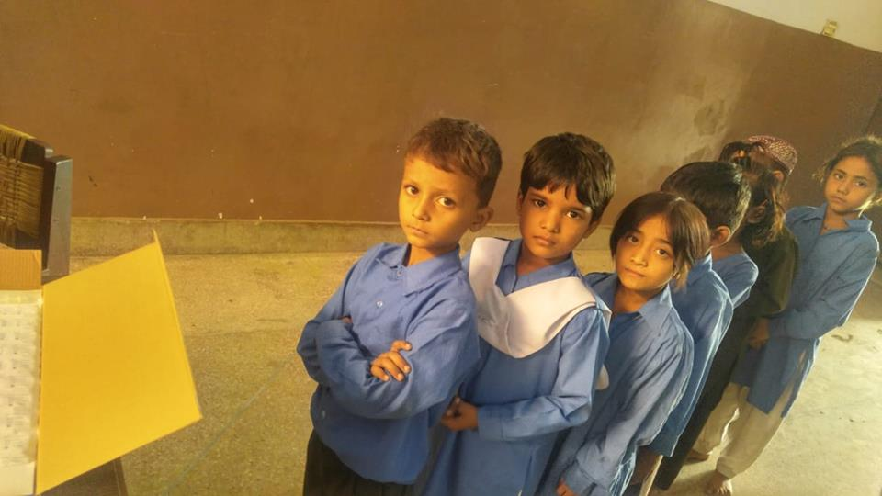
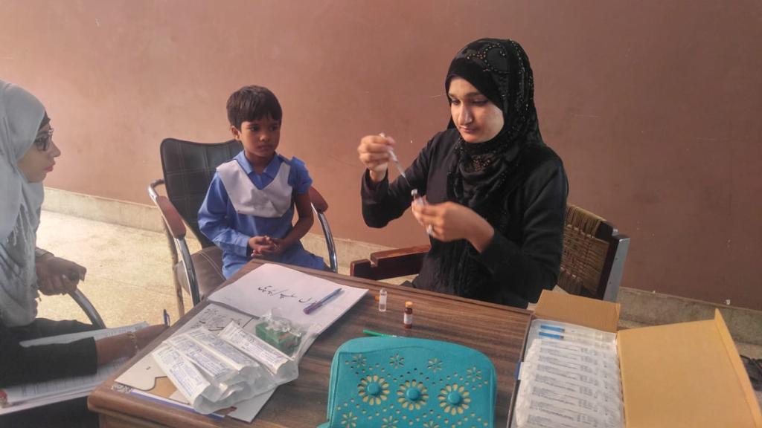

Ministry of National Health Services, Regulations and Coordination collaborated with FACES Pakistan in organizing a vaccination program in Peace School. All children had their measles shots. Indeed, improving and maintaining children’s health is our biggest concern and priority.

