Peace School for Afghan Refugees and Host Communities
Report – August 2019 (Photos)

Summer school preparation and art work at FACES Pakistan Peace School
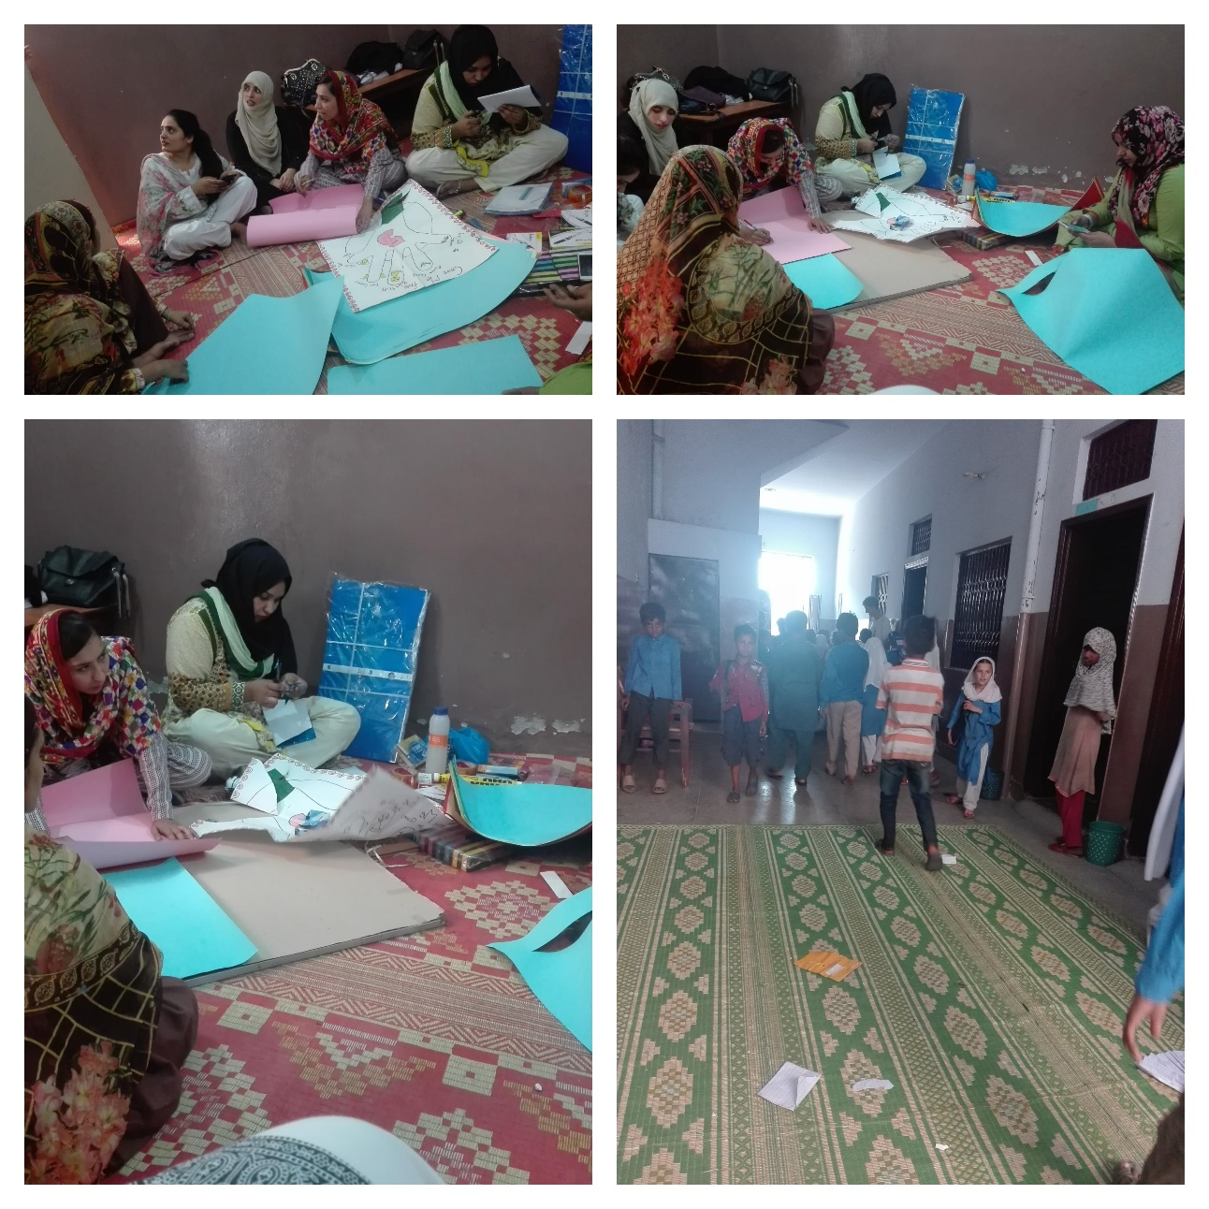

Story telling session at FACES Pakistan Peace School during summer school
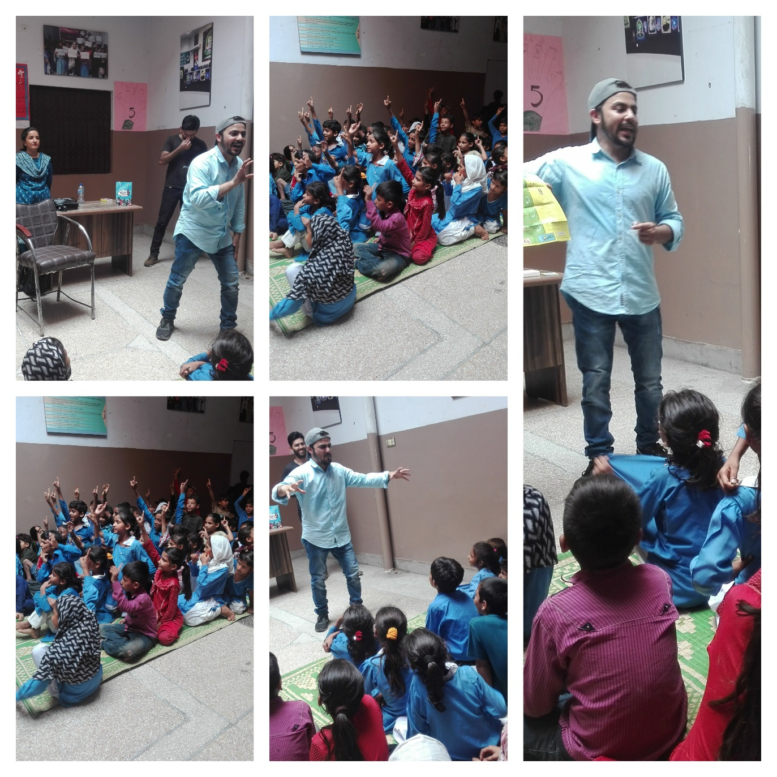

72nd Independence Day celebrations at FACES Pakistan Peace School
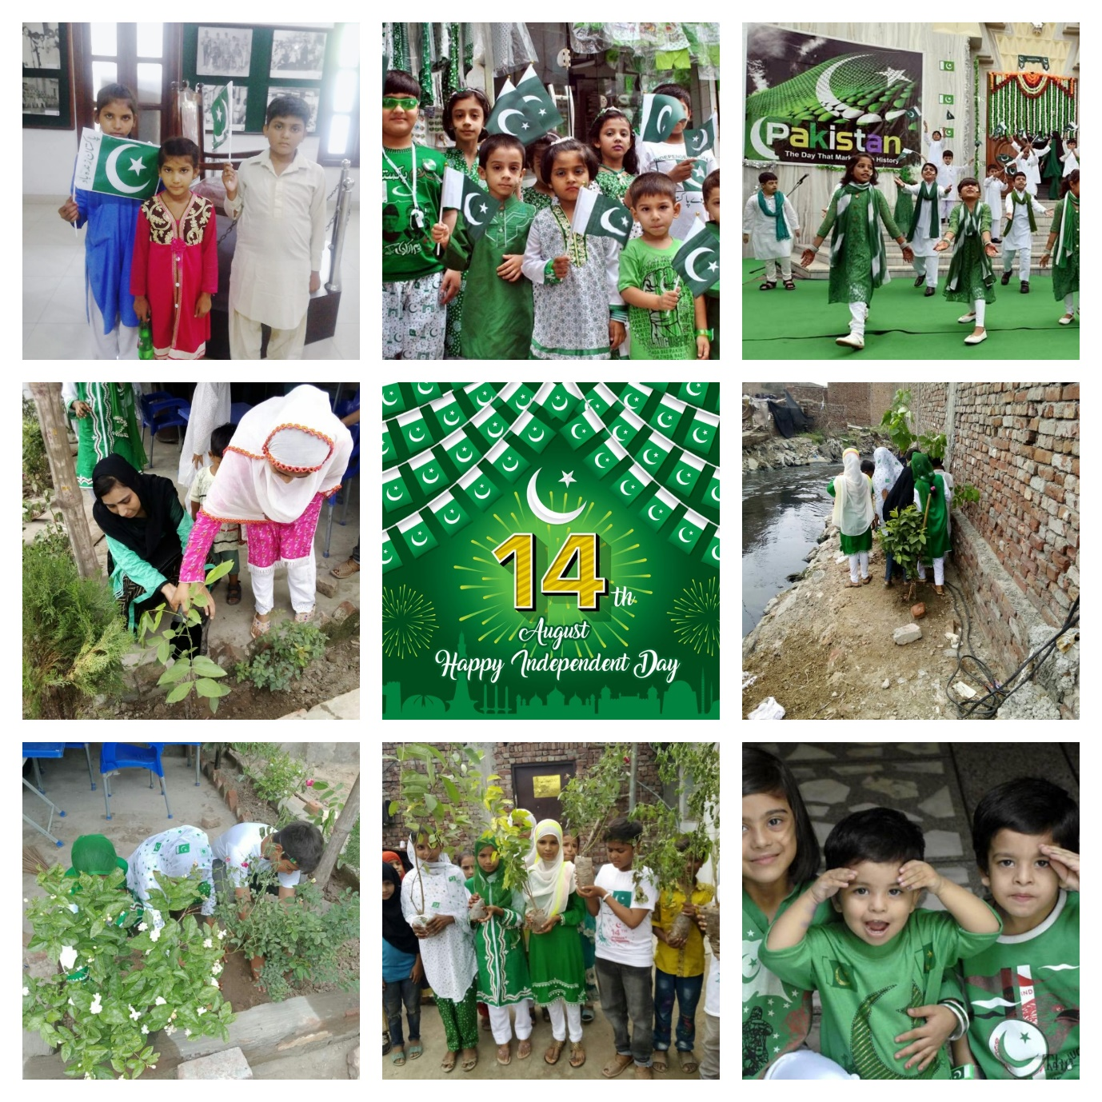

72nd Independence Day celebrations FACES Pakistan Peace School children participated in a competition organised by Nazria Pakistan Trust
