**Peace School for Afghan Refugees and Host Communities**

**Report – Photos**

**August 2018**

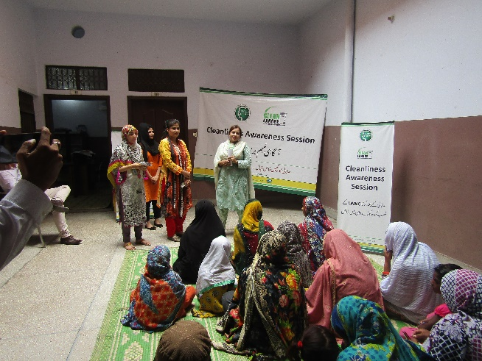 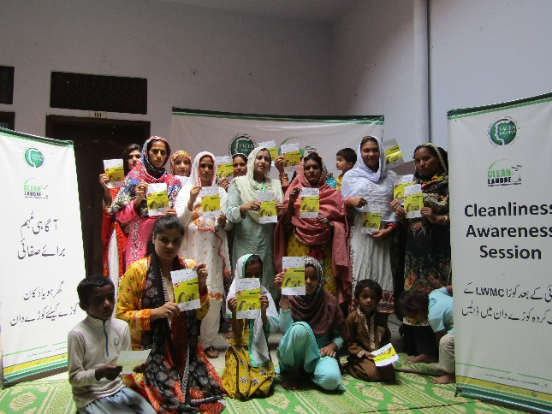

Cleanliness Awareness Session in collaboration with LWMC for Peace Schools student’s Mothers in Akram Park and Manzoor Park

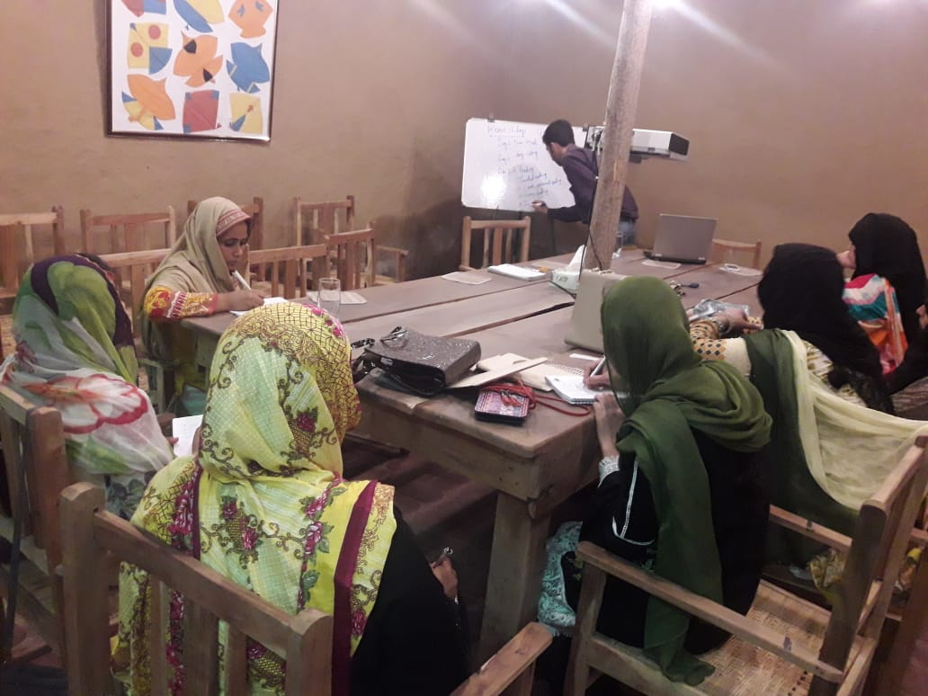 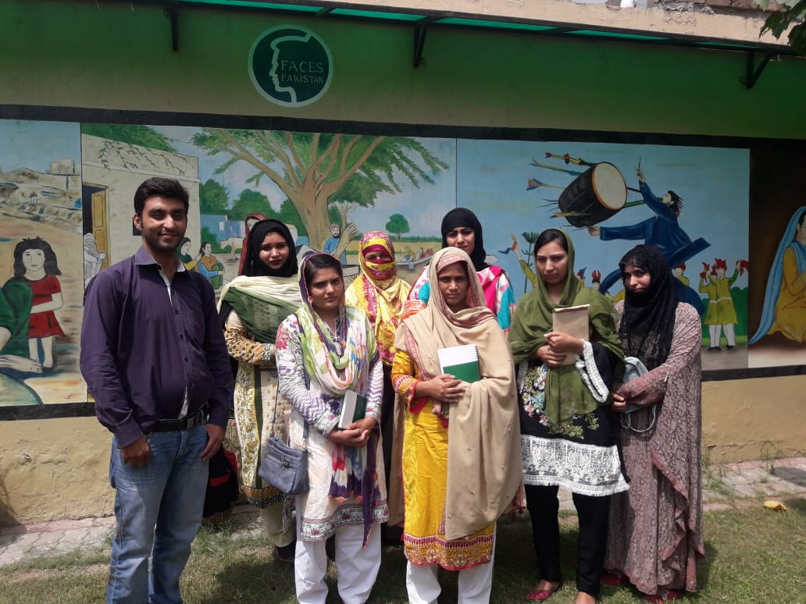

All teachers well trained with the new techniques of teaching with regular teacher training sessions to ensure quality education from expert Pakistani organisations like EAST Online.

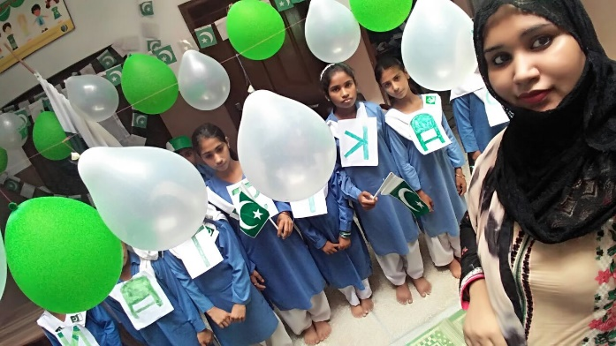

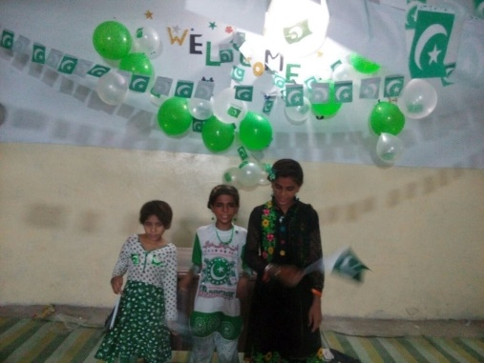 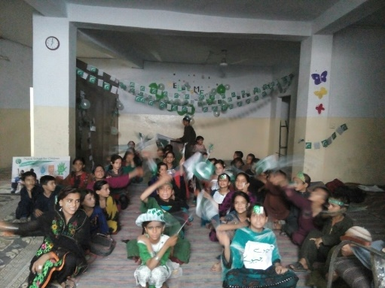

71st Pakistan Independence Day Celebrations at PEACE Schools