These are the children and youth who attended our clean up campaing after our school holiday Virtues Training
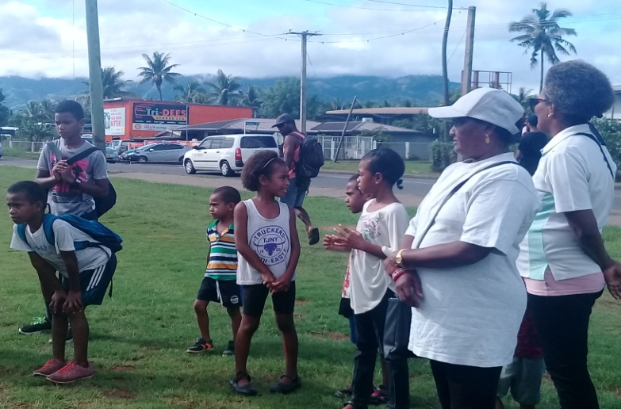
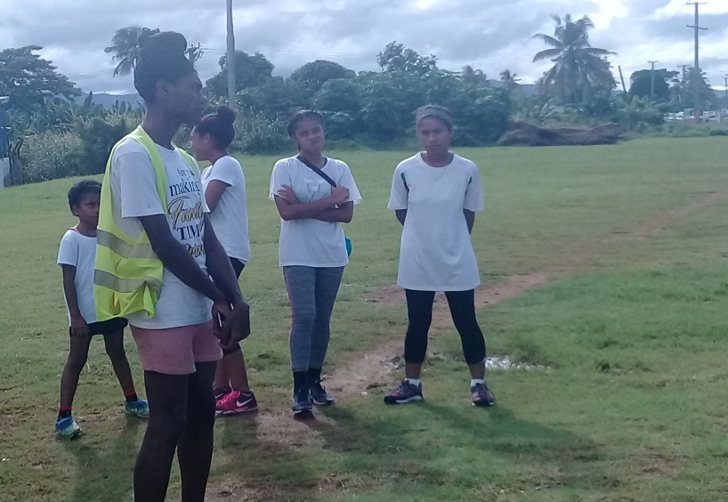

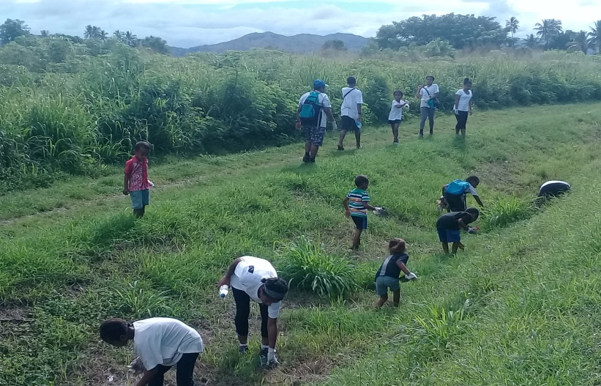

Virtues Project Fiji facilitator attended the ADB meeting held in Fiji 1st – 5th May, 2019
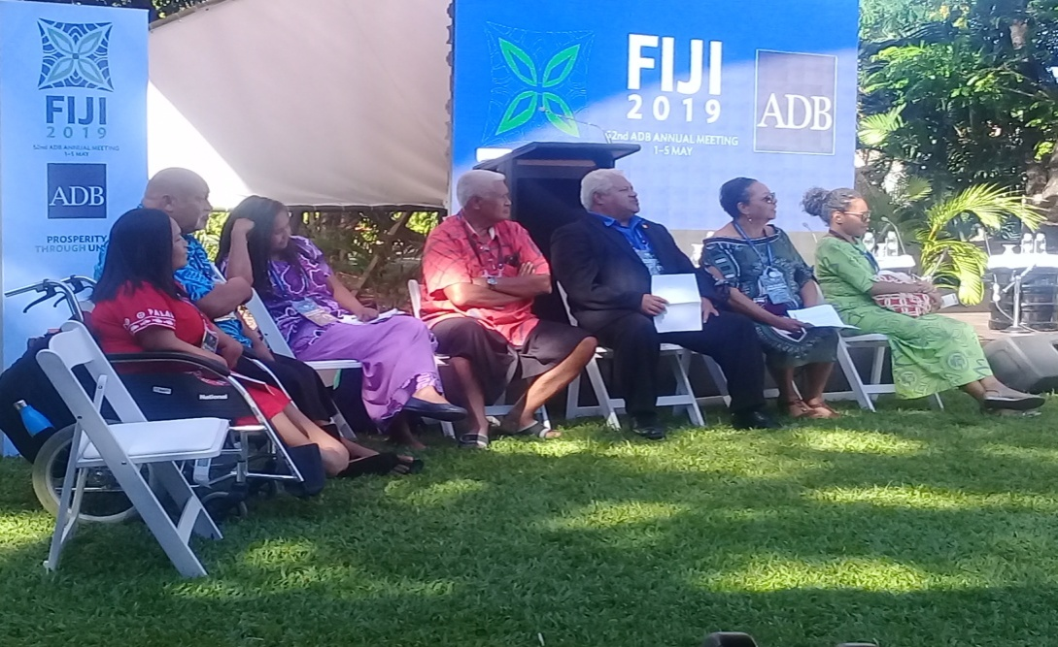
Civil Society around the region took part in a dialogue session

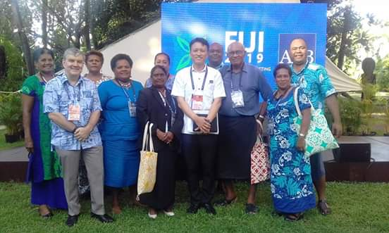
Members of the local CSO including our Virtues Master Facilitator in Fiji

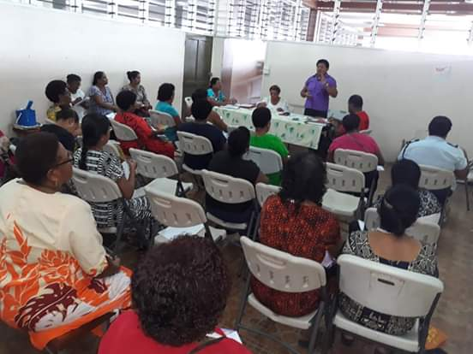
Lautoka Women during one of our Virtues consultation program

Women who attended the Virtues program that advocate on environmental issues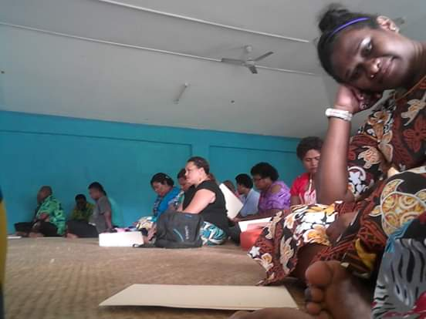
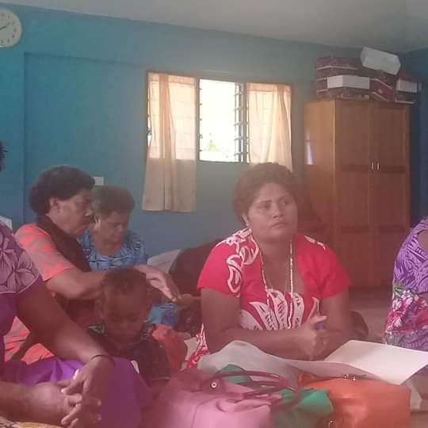
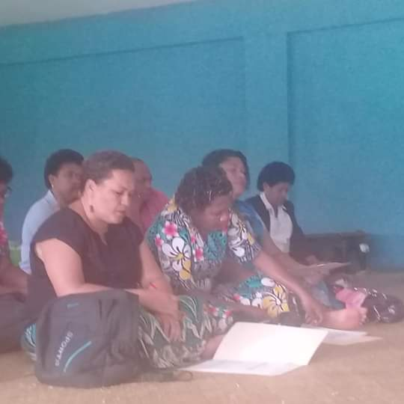
After the workshop women were taught how to make smokeless stove
