CancerLink Kwai Chung

Hong Kong Cancer Fund
15th November, 2016

Project Background

Hong Kong Cancer Fund has been offered a unique opportunity by a generous supporter of a 7,300 sq.ft space in a converted industrial building in Kwai Chung at a subsidized rent. This will allow us to complete our support network with a CancerLink centre.

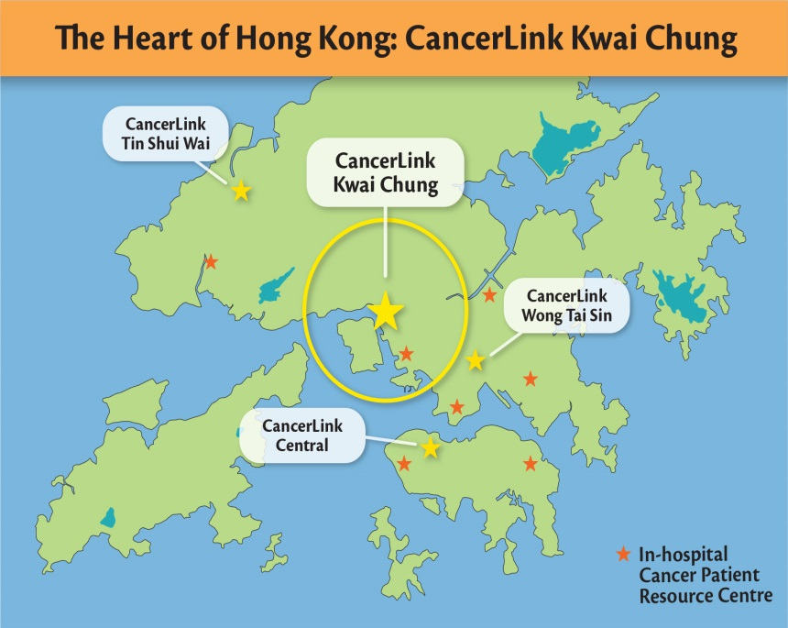
With the new CancerLink centre in Kwai Chung, we are able to expand our support network to reach a much neglected and underprivileged area in Hong Kong that has increasingly growing demand on cancer support services.

CancerLink Kwai Chung is going to be a centre with a difference. This premises will allow us to expand our range of rehabilitation programmes, provide a stable venue for our wellness classes, we will also be able to add new and upgraded services such as in-house physiotherapist, diet and nutrition workshops and an even larger range of wellness programmes. The centre will also provide our regular services, including a centralised hotline, peer support, psychosocial counselling, home care, palliative care etc.

Objectives
The objectives are to provide free services with professional carers who help clients manage the physical, emotional, psychological and social challenges brought about by a cancer diagnosis.
By offering a wide range of free support and rehabilitation programme, our goal is to empower individuals so that their cancer journey is as comforting, informed and stress-free as possible.
Hong Kong Cancer Fund's work encompasses public education, home care, peer support, complementary therapies, funding of hospital equipment and much more in filling the gaps in cancer care and making life better for people affected by cancer.

Service Target
People diagnosed with cancer and cancer survivors, and their carer and family members.

Projected number of beneficiaries:
 | Users | Family Members | General Public
Year 1 | 12,100 | 3,200 | 500
Year 2 | 16,900 | 4,500 | 700
Year 3 | 17,800 | 4,800 | 740

CancerLink Kwai Chung Set Up Progress

- Fit out works are 80% completed.

- Cancer support service operation will be soft launched in December 2016.

CancerLink Kwai Chung Service Promotion Progress

Hospital and community networking programme started in April 2016, activities conducted includes:

- Social workers meeting newly diagnosed cancer patients at Princess Margaret Hospital twice a month;

- Courtesy visits to major social service providers including family service and elderly service units in Kwai Chung, Tsing Yi and Tsuen Wan to provide service briefing on the new CancerLink centre in Kwai Chung;

- As part of the CancerLink Kwai Chung promotional activities, our registered nurse has delivered breast cancer awareness talks in five integrated family service centres and one neighborhood elderly service centre in the area;

- Soft launch of centre services at CancerLink Kwai Chung in December 2016.

Photos of CancerLink Kwai Chung

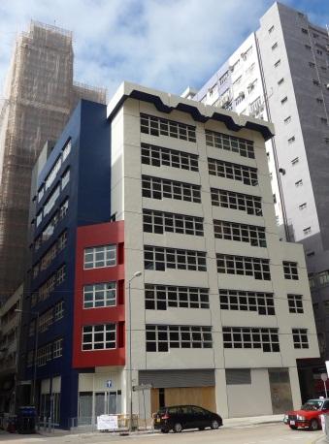 | 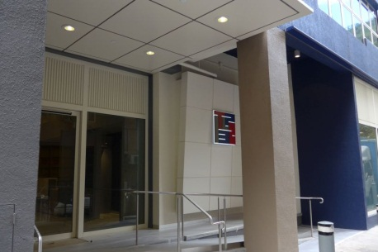
The building of the CancerLink Kwai Chung centre and its entrance.

TLP 132
Nos. 132-134 Tai Lin Pai Road, 3rd Floor
Kwai Chung, New Territories

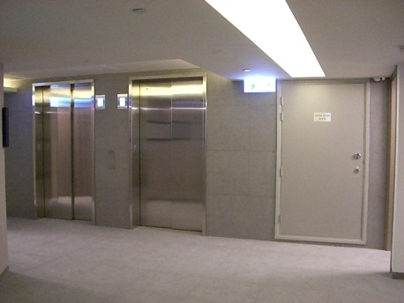 | 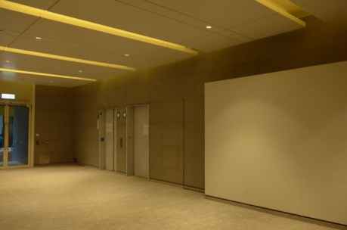
Building lift lobby and floor lift lobby.

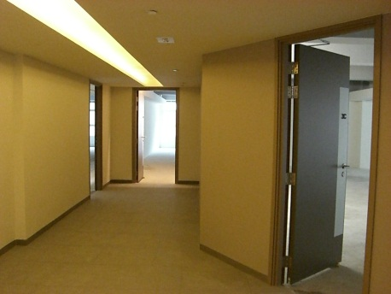 | 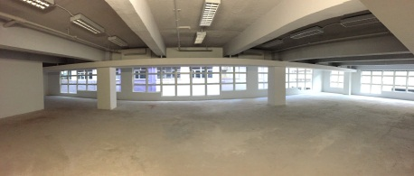
3rd floor - CancerLink Kwai Chung centre.
(Original floor layout of the premises)

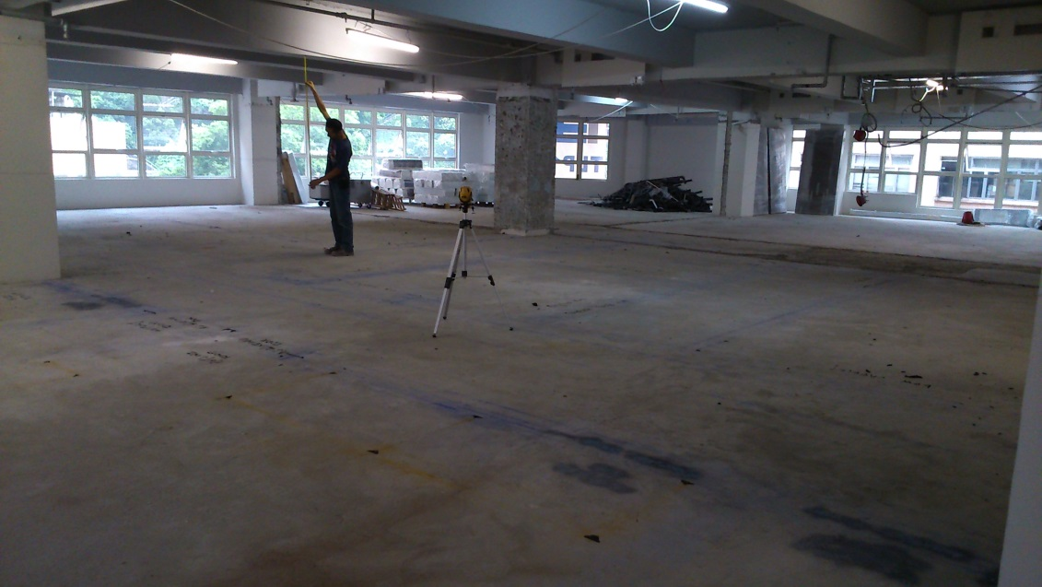
Demolition work completed and began new fit out works.

