ITIE2016 Maker Space: Report on the results of the Design and Creation Competition
Structure of the WeChat Post
- Introduction to the contest
- The achievements of adolescents
- The maker competition is a promoter of the maker education among schools

ITIE2016 Maker Space: Design and Creation Competition

The 2016 contest junior high school students faded away with the spring festival; I, the editor still resonated with those students. As an experienced commentator, I must say that the young makers were like big waves that nobody can block! Hence, a series of articles will continuously be posed to review the contest.

To introduce the Maker Education into the partner schools of Green Tree, in May 2016, Green Tree launched the space design and creation competition for the middle school students. The 12-18-year-old youth team from 10 schools in Gansu, Guizhou, Shaanxi, Yunnan, Hong Kong and the United States, went through two challenges at the contest under the guidance of the teacher. The contest lasted eight months.

Task 1: Design their Maker Space for their school

Task 2: Design and implement a hands-on project based on their interests and community needs

For teachers and students, the Maker Contest gave the first opportunity for them to have contact with the Maker Space and Maker Education. It was a process of learning and reflection. In November 2016, the ten teams competed in their finals at the International Conference "Maker Space: Creativity in the Library" held by Green Tree. During the eight months, what kind of stuff did the young people create at the end? I have seen the finals and what was only left for me to say is: "my eyes got really goggled and wide"!

First, let's look at cooling umbrella designed and made by a team from the Third Middle School in Tongwei County, Gansu Province. The fan is embedded in the top of the umbrella and is driven by two solar panels. A safety gauze is applied to prevent the hair from getting into the fan. It is pleasantly cool under such an umbrella when going out at summer.
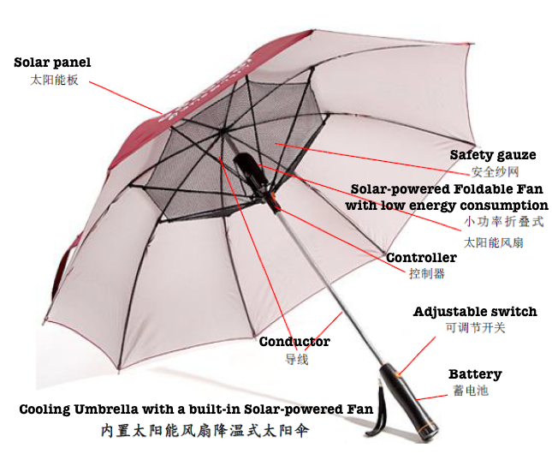
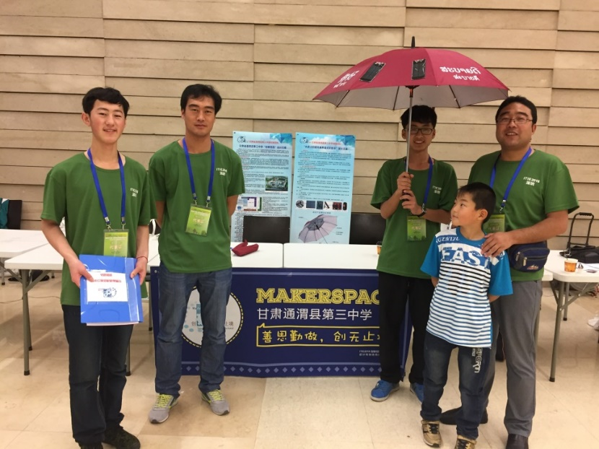
Figure 1: Cooling Umbrella with a built-in Solar-powered Fan

Then comes the low-cost electric wheelchair designated for the disabled! This wheelchair for poor people with disabilities is designed by the four senior middle school students (illustrated below) in Ralston, California. The wheelchair uses the Arduino control circuit, and a driving engine and the user can easily control the wheelchair through the joystick. If put into mass production, this kind of wheelchair will be cheaper nearly 2,000 US dollars than those in the market. It is good news for the poor.

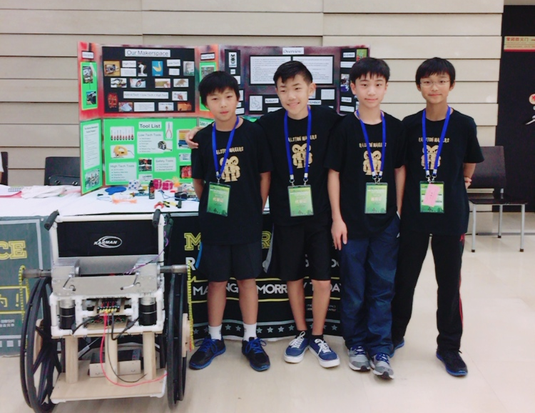
Figure 2: Electromechanical wheelchair
The following smart home model was assembled by the high school students in Danfeng County Middle School in Shaanxi Province, and it competed in their spare time.
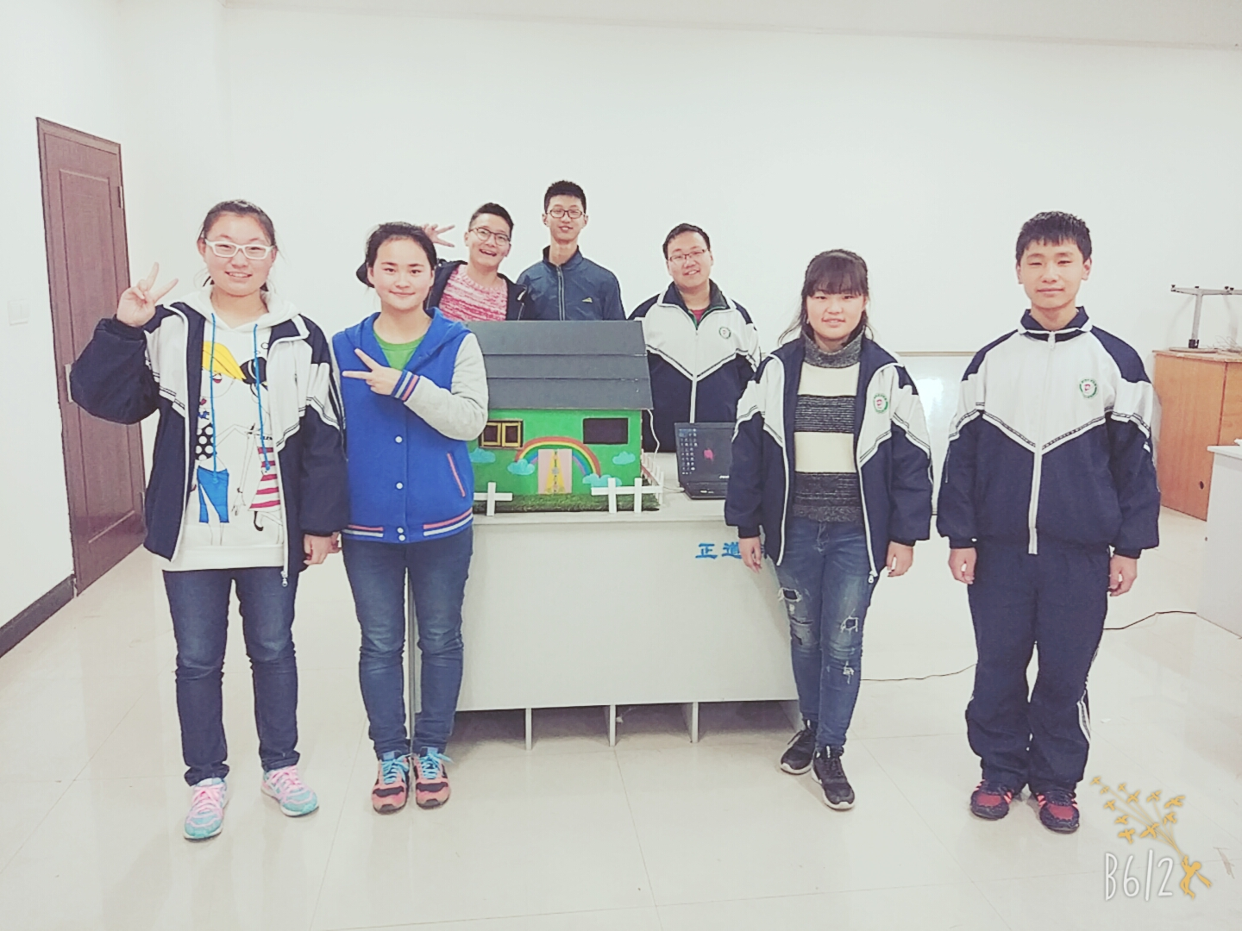
Figure 3: Smart home model

The cute housing model contains a control circuit consisting of gas smoke sensors, Arduino boards, stepper motors, and so on. When the smoke concentration exceeds the threshold, the small window of housing model will automatically open, at the same time the fan in the room will automatically turn on. When the smoke concentration return to the safety range, they will be shut off. It is said that after the competition, several students also wish to continue the setting up of the automatic air detection and intelligent ventilation unit in the smart home model.

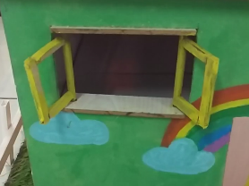

Students at No. 1 Middle School in Tianzhu Tibetan Autonomous County, Gansu solved the problem of water shortage in their hometown by making a water purifier. They began with knowing nothing about the water purifier. The water purification unit make it possible to purify water in the river into drinking water, with a total cost of 300 Yuan, approximately equaling 43.6 US Dollars!
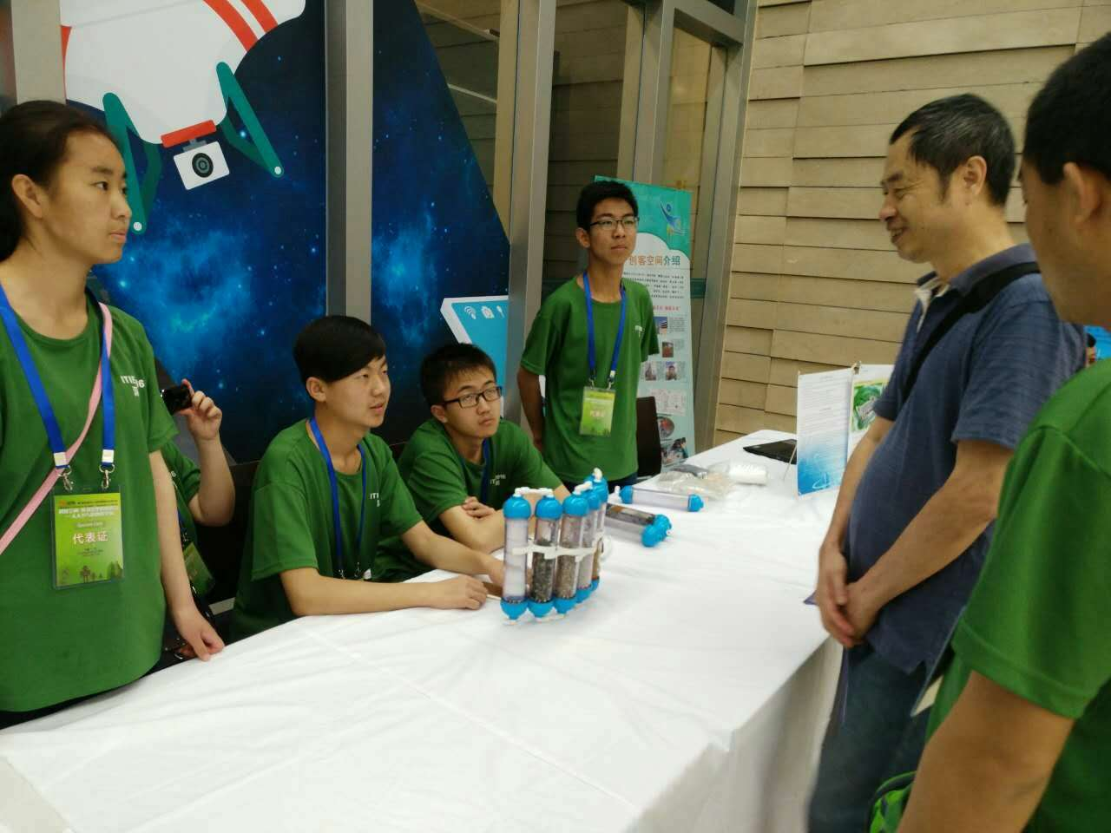
Figure 4: Simple water purification unit which can solve the problem of water quality in Gansu

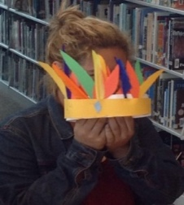
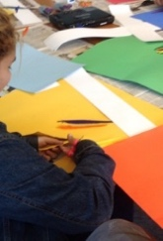
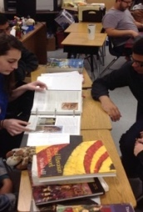
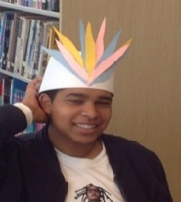
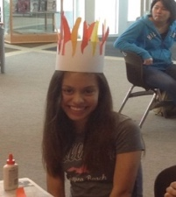
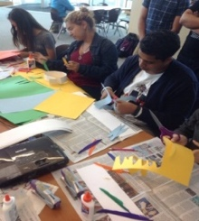
In the maker space concerning humanities in Chula Vista High School in San Diego, California, a student project operates in the name of "travel around the world." Senior students design a variety of workshops, and they lead the lower grade students to make handicrafts with characteristics from around the world so that students can understand the colorful and various arts and culture.
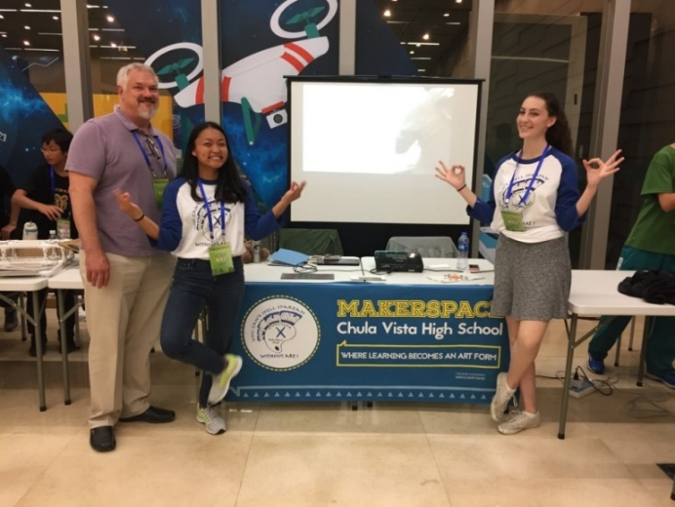
Figure 5: Chula Vista Humanities Maker Space

Students in the HKSKH Bishop Hall Secondary School were shock by the cold feeling given by the industrial area or public housing estates. Therefore, they combined handmade artworks with virtual reality technology to promote the interaction of public space to the public. They made sculptures with clays, sponges, stones, and a unique sculpture texture made by line and sprayed color on them. After coloring, they used virtual reality software, and added the sculpture images to the virtual reality of the community, raising the awareness of the public about the relationship between people and public space.
Figure 6: Handmade miniature sculpture

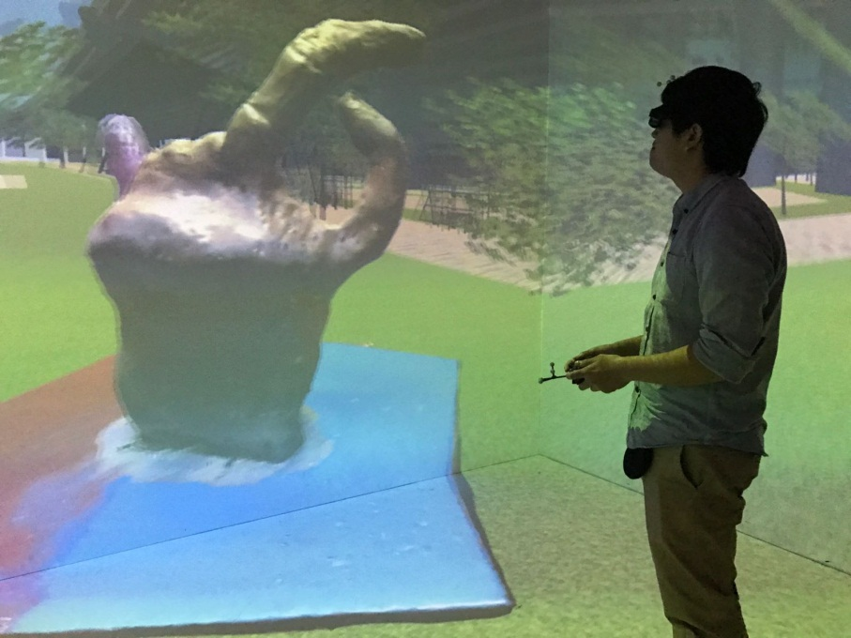
Figure 7. Virtual reality space of the community with sculpture added

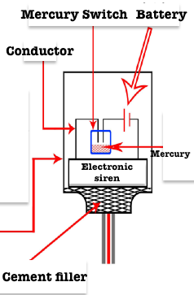
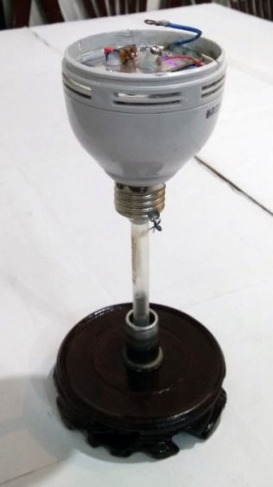
Finally, let's look at the drop-type earthquake alarm designed by middle school students in Yaoshan Middle School in Pucheng County, Shaanxi. Once the earthquake occurs, the alarm will loudly "jangle" and wake the sleeping people ... ... Students applied their knowledge in high school physics to making this devil with a high sensitivity but low cost. It is surprising that the middle column was made with an old ball pen.
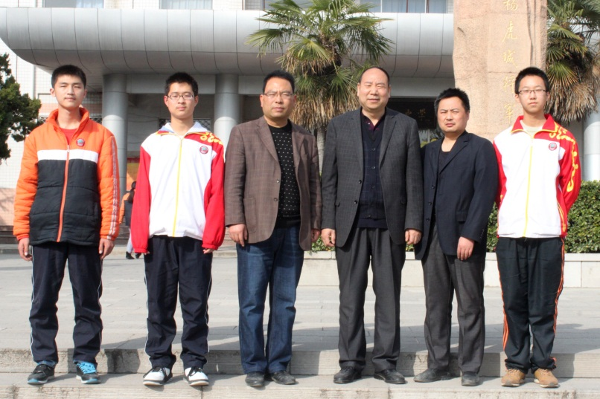
Figure 7: Drop-out Type Earthquake Alarm

How could it be so powerful?

A teacher named ZHANG Jiangjiang exclaimed in surprise: "Our students are stronger than we think, and they have great creativity. The maker space is an excellent platform to stimulate students' creativity, so we need it!" SONG Zhankun, a student from Tianzhu County, Gansu Province, said confidently: " We need to be bold to innovation and bold to practice so that we will be closer from our dreams......"

As a promoter, as a starting point, the maker space competition has made the partner schools and educators more concerned about the maker space. Hence, it brings a positive understanding of the Maker Education. At the same time, it encourages young people to explore and try the innovative projects, and it enhances their abilities to think critically, solving problems, working in teams and managing the budgets. More importantly, the competition allows the participants to further their understanding of their interests and abilities and allows them a solid foundation in becoming a positive contributor to the society. This reveals the original intention of the ITIE2016 Maker Space: Design and Creation Competition.

The future series of post, I will approach the participating teachers and students, listen to their stories, hear their voice and share them with everyone.

For more information on entries and winners, please click on "Read More" in the lower left corner of the page.

