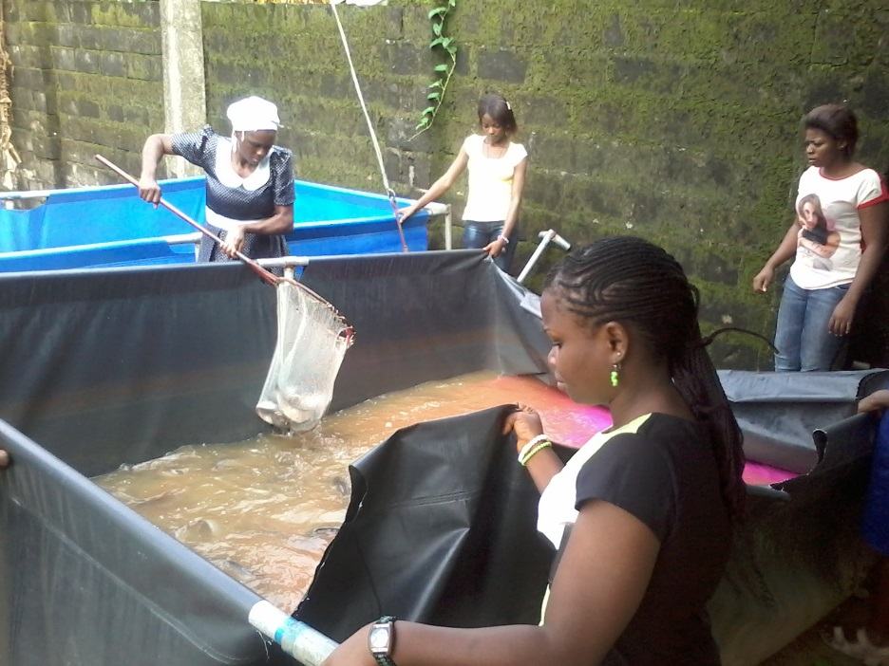

Trainees changing water in one of the fish ponds at GPI training centre

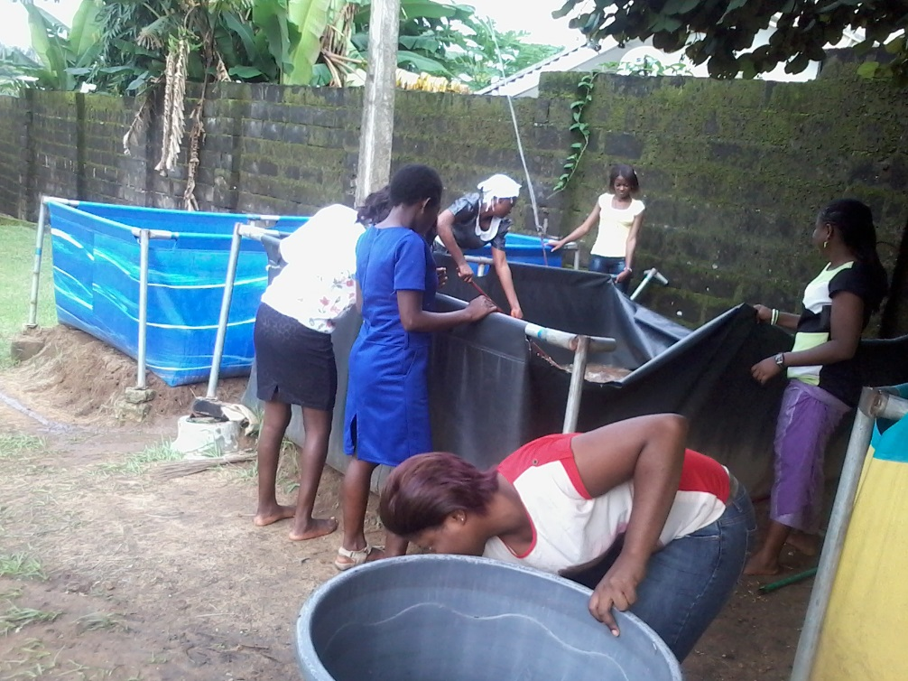

Trainees working in groups