PHOTO GALLERY

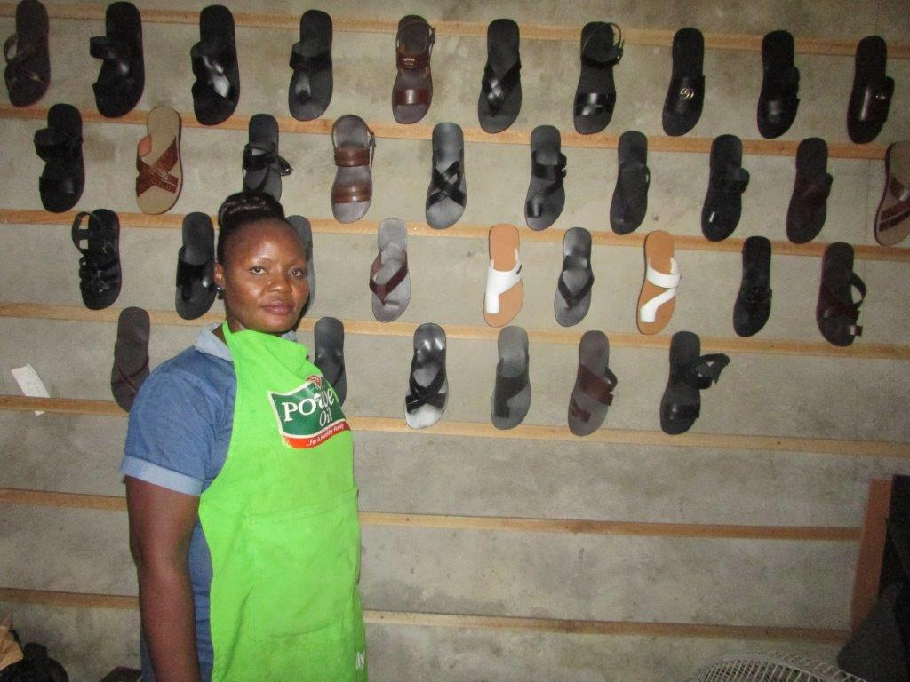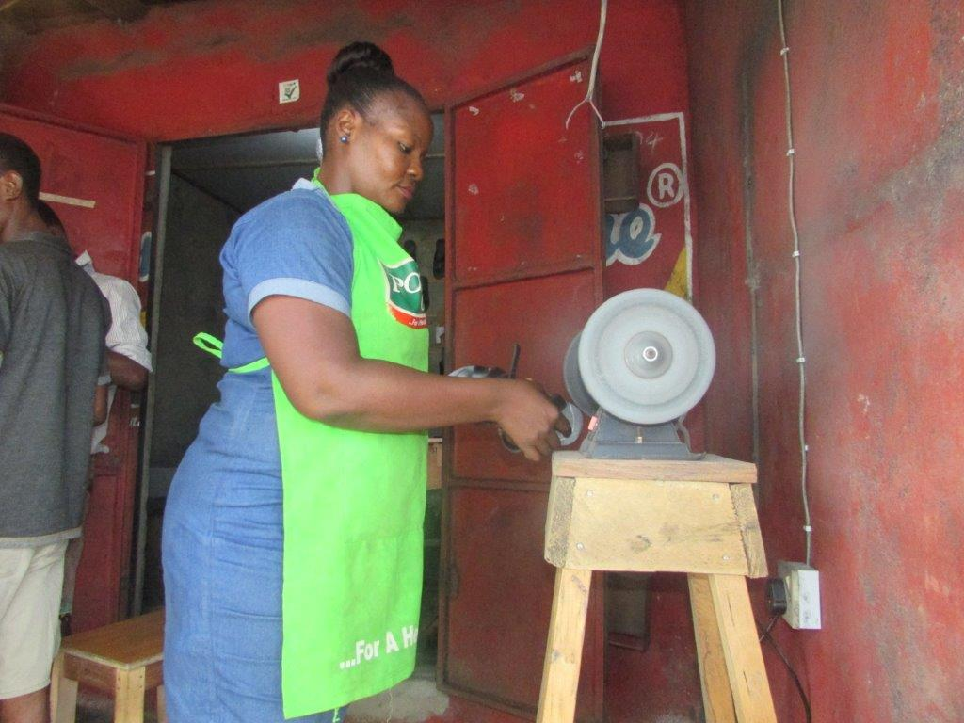
Shoemaking beneficiary displaying products Shoemaking beneficiary in her shop
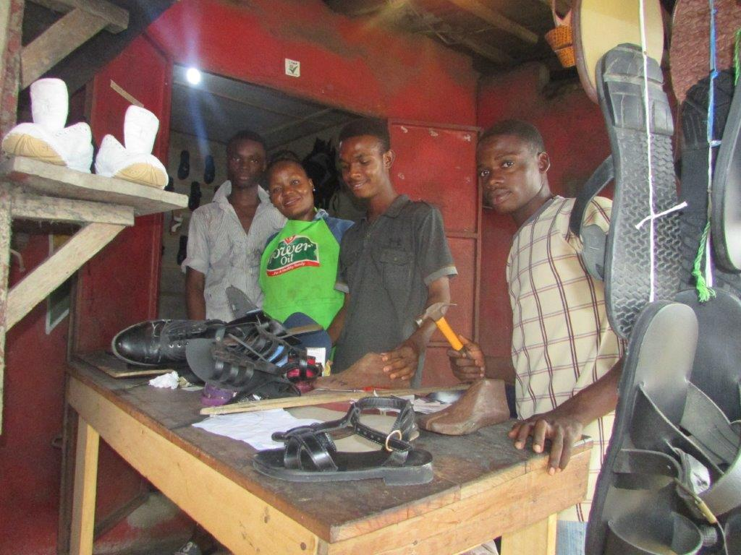
Shoemaking beneficiary and male trainees

