

***Resource person showing the trainees how to prepare fish pizza, fish shawama, and fish rolls***

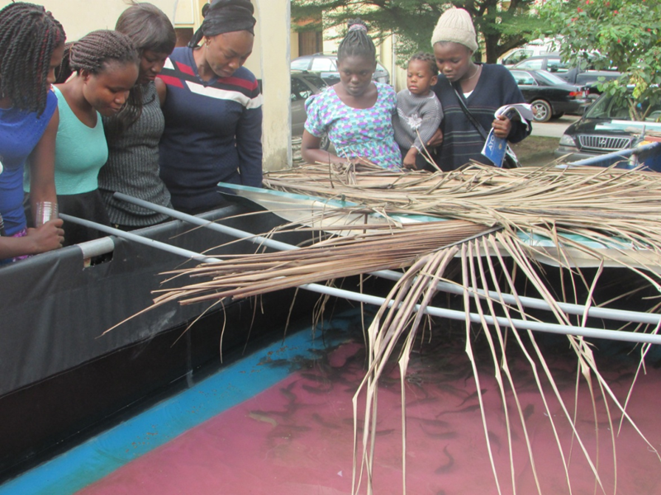

*Trainees selecting fishes to be processed*