WEST POINT WOMEN FOR HEALTH AND DEVELOPMENT ORGANIZATION (WPWHDO) PROFILE

ORGANIZATION DETAILS

Name of the Organization: West Point Women for Health and Development (WPWHDO)

Address: Township of West Point, Montserrado County, Liberia

Contact Person: Nelly S. Cooper
President
Cell #: 0777809353

Founders: Group of 10 West Point Women

BACKGROUND West Point Women for Health and Development (WPWHDO) was founded in July 2002 and is an accredited nonprofit organization based in the Township of West Point, Montserrado County, Republic of Liberia that is dedicated to addressing the humanitarian needs of the community. We are the only institution in West Point that is fully dedicated to representing the interests of women and children in our community.

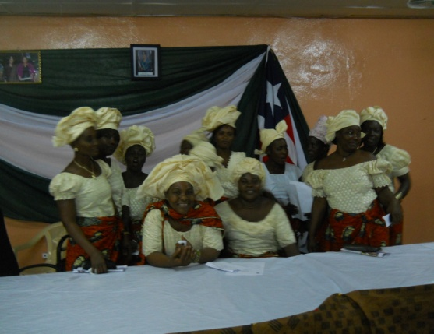

The West Point Community is the largest slum community in Monrovia, situated on 0.36 kilometers of government owned land that lies between the Mesurado River and Atlantic Ocean with a population of about 62,000. Of this percentage, 45% are children, 35% are women and 15% men. The majority of the population lives off of subsistence fishing and petty trade.

YEAR OF ESTABLISHMENT: WPWHDO was established in 2002.
MISSION: To tackle the many problems facing the West Point community, with the aim of improving the livelihood of the people in the West Point community especially women by bringing the Health and Sanitation System to international standard, reducing the cases of Gender Based Violence, providing Adult Literacy programs, reducing teenage pregnancy and prostitution, and providing temporary care for lost and abandoned children.
VISION: Is to see grassroots women and all other women empowered through livelihood sustainability, education, health and to live in a peaceful and clean environment.

GOAL: To see women empowered and their rights respected to enable them participate fully in the decision making processes at all levels.

OBJECTIVE: * Engaged into advocacy and awareness-raising within the community (ties), to reduce SGBV and improve relationships between women and men, boys and girls;

- Provide education for women and girls, with the importance of empowering them;

- Play mediatory role, in terms of Domestic Violence cases and community dispute/conflict between and among spouses, family members and youths, in an effort to avoid recurrence and as well reduce the level of Domestic Violence and disputes going to court

- Conduct community and town hall meetings and as well provide education on personal hygiene practices, in order to combat diarrhea and other water-borne diseases

- Mentor and provide counseling services to abandoned women, girls and children in order to stabilize their conditions

CORE VALUES AND PRINCIPLES:

- Promote dialogue and respect amongst community dwellers (women and men, boys and girls);
- Create level playing field for everyone, especially women and girls;
- Promoting effective communication between women and men, boys and girls;
- Build and strengthen collaboration between women and men; boys and girls, for effective growth and development within families and the community at large;
- Strengthen relationship between community dwellers and the organization;

MEMBERSHIP: The West Point Women for Health and Development Organization has a founding membership of 100 women, including the executive staff and a general membership (open to the entire community) 2,500 plus are affiliate members. All of our members work on a volunteer basis to help address the issues in our community.

Thematic Areas: WPWHDO is working in 4 Thematic areas of Advocay:-
Economic Empowerment
Gender Based Violence
Conflict Resolution and Mediation (WAHALA)
Health and Sanitation:

WHAT WE DO: The West Point Women for Health and Development Organization is dedicated to tackling the many problems faced in our community through numerous activities:

Economic Empowerment: WPWHDO benefits from strong support of its members. We utilize our membership dues to bolster our Economic Empowerment. The empowerment program is created to help women who are involve in the voluntary services of the organization and the community to benefit from skills training, adult literacy and loans. In so doing, these women will be relieved of the many constraints they encountered in the running of their homes. This program will also empower them and reduce the dependency syndrome. And with the help of our funder and donors the women are given stipends while WPWHDO implements value programs with the funding from our donors and funding partner organizations.

Gender Based Violence (and domestic violence): Since the founding of the organization, WPWHDO has engaged in advocacy for the rights of many rape victims in the community and prosecution for men or women, who are guilty of domestic violence, this includes spousal and parental abuse. We work closely with the Ministry of Gender and Development and the Association of Female Lawyers of Liberia (AFFELL) to help push these cases through the court and the judicial system. The organization is involved in the transportation of victims of rape and domestic violence to hospitals and provide care for them while they undergo treatment. We also call on the Sexual Gender Based Violence (SGBV) Crime Unit a newly established division of the Ministry of Justice on most of the cases that involve rape. Parents of rape victims are encouraged taking their cases to court with the women helping in the background. Regular awareness on rape and domestic violence are being carried out in the seven sub communities or zones of West Point.

Conflict Resolution and Mediation (WAHALA): On a daily basis the leaders of WPWHDO are called upon by community members to address domestic conflicts, community dispute among women, men, girls, boys and youths. We also work with those that have come out of jail to peacefully integrate them into our community. During the mediation, the opposing parties are given the opportunity to express their dissatisfaction so as to avoid reoccurrence. This program considerably reduces the amount of cases going to the court where unnecessary amounts of money are spent.

Health and Sanitation: West Point is the most densely populated (slum) community within Monrovia without any sanitation systems or adequate health facilities. Our community suffers from outbreaks of malaria, cholera and other water born diseases. The WPWHDO is addressing these issues through door to door advocacy & awareness and community meetings educating people on how to take care of their drinking water and good hygiene practices. We also use our resources to help women and children receive emergency health care. The health and hygiene promotions are done through awareness. Some of the areas that are focused are: the use of latrines, washing of hands, proper waste management and disposal methods, the improvement of household water, the use of water guard and the setting of the Oral Rehydration Therapy (ORT) concerns in our center and in some parts of the community in order to combat diarrhea and other water borne diseases.

Temporary Care to Abandoned Women & Children Project: Due to the stress as a result of poverty and the densely population of our community WPWHDO has noticed high cases of lost or abandoned children. Our Taking Care of Children on a Temporary Basis provides secure homes (with the consent of the police) until the child’s parents are found or given to proper authorities. There are also fathers and mothers who abandoned their families. In an effort to reduce the amount of families that suffer abandonment, the organization is making effort in the following directions:

A. Carry on awareness in the seven community zones explaining and educating the people on the effects of the act.

B. Render assistance to those who suffer such condition. The assistance can be the provision of food, clothes or shelter. Other times, the basic needs have to be provided.

c. Counseling services is also provided to victims in order to stabilize their conditions.

