Dear Compassionate Friend,
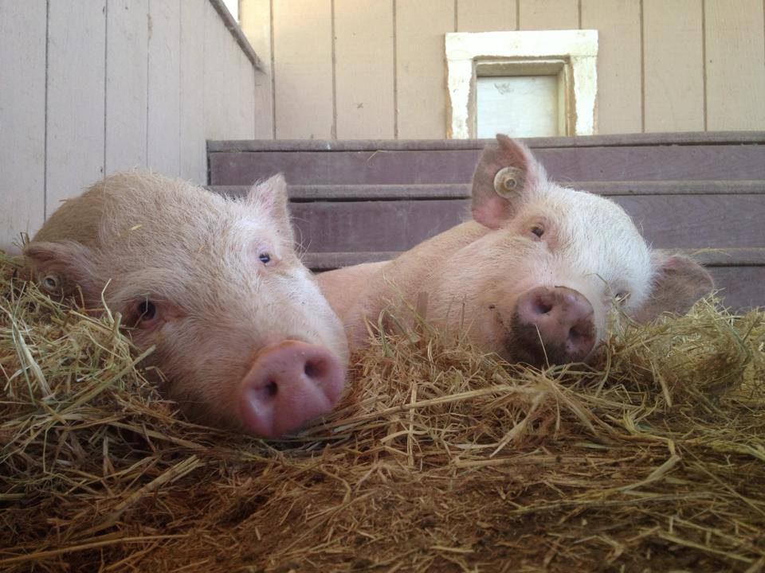
What an amazing adventure it has been for us here at the sanctuary in the last ten years.
Over the last decade, Harvest Home Animal Sanctuary has saved the lives of thousands of animals from certain death. To us, every life saved matters.
For millions of animals confined in factory farms, research labs, and other institutions of animal exploitation in California, the hope of a new life outside a tiny wire cage is merely a dream.
Nestled in fertile farmland in California’s San Joaquin Valley, our two-acre rescue and rehabilitation sanctuary is home to 11 unique animal species. At Harvest Home, second chances become a reality.
Through our work and your unwavering support, we continue to make this dream a reality for more and more animals each year. We would love nothing more than to continue to provide much-needed vet care for animals in crisis, with your help.
Together, we can save more lives in our next ten years. We are honored to partner with you to build a more compassionate world as we move forward to help more animals in need.

With gratitude,
Christine Morrissey

