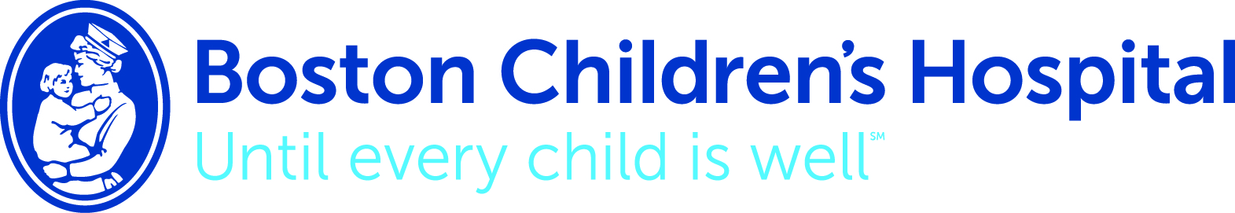
The Children’s Fund
At Boston Children’s Hospital, our goal is simple: to provide the very best care until every child is well. Founded in 1869 as a 20-bed hospital for children, Boston Children’s Hospital today is a 404-bed comprehensive center for pediatric and adolescent health care. Boston Children’s ranks first in more specialties than any other pediatric hospital. This year – we continue to be ranked as the top children’s hospital in the country by U.S. News & World Report. Boston Children’s ranks #1 in seven of the ten specialties ranked by the report, including cancer, cardiology and heart surgery, diabetes and endocrinology, gastroenterology, nephrology, neurology and neurosurgery and urology. The hospital is known for excellence in research, the education of tomorrow’s medical leaders, and its commitment to community health.
Gifts to The Children’s Fund go immediately to where support is needed most - to help sick children and move the needle for faster cures and innovative treatments for disease, illness, injury, and trauma incidents. The Children’s Fund enables Boston Children’s to continue to provide the highest quality health care, lead innovative efforts in research and discovery, educate the next generation of leaders in pediatric health care, and provide community health care for children and families in our community. Special focus is given to children from low income, high-risk families who require more resources through intervention and prevention initiatives.
Pediatric care is different than adult care. While children don’t need care as often as adults, when they do, it is more complicated and costly. On average, children are twice as sick as adults when hospitalized requiring more nurses, highly specialized equipment and more pharmacists to reformulate medication.
Boston Children’s Hospital never stops looking for ways to make patient care safer, smarter and more personal. We’ve developed a device that reduces the risk of infection, put 3-D printing to work in the operating room, and used the internet to improve care of chronic illness. These innovations come from constantly reexamining how we care for patients, interact with families, and understand disease. They also come from vital philanthropic support.
The Children’s Fund supports the many priorities and innovative programs in patient care, teaching/medical training, research and community health for children from low income families and communities.
None of our work—the revolutionary or the routine—would be possible without the generosity of so many people. Philanthropy is at the heart of everything we do, from hastening a new era of precision medicine to easing the stress on worried families.
We are deeply grateful for your commitment to our mission.

