Chennai Flood Relief Programme – 2015 - 2016
Global Giving and Child Rights & You

The Flood Relief Programme was rolled out within a few days after the Floods devastated Chennai city and affected the lives of millions of marginalised children.
The first phase constituted the distribution of relief kits to the neediest families in Vyasarpadi area. Due to the TN state assembly elections which were scheduled for May 16th 2016, the Election Commission Code of Conduct was in place till the end of May 2016. Immediately after the CoC was lifted, CRY re-started its work on the remaining phase of the Chennai Relief Programme.
Relief support of Educational and household materials to more than 1000 Families and children was possible due to fund support from Global Giving.
Household Kit:
- Utensil Set with 10 pieces
- BedSheet
- Saree & Peticoat
- T-shirts
- Salwar Kameez set for girls
Educational Kit:
- 5 Long size note books
- 5 Small size note books
- Stationery Set - 10 pencil pack / 1 erasor / 1 sharpner/ 1 pack of pens.
- 1 Geometry box
- 1 pack sketch pens
- 1 long size (30cm) Plastic Ruler
- 1 School bag
Procuring of Materials:
The procuring of all material was done by CRY after identifying vendors in Chennai city who were offering the items at competitive prices. As per CRY accounting norms, three Quotations from different vendors were taken for each item in the kits. An analysis sheet of quotations, prices, quality of goods and transport commitments was prepared for final shortlisting and approval by the Internal Quotations Approval Committee. This Committee was formed as per CRY’s Disaster Management Programme norms to ensure objectivity and transparency in the process of Vendor selection and Quotation approvals. The Committee consisted of the Regional Director – CRY South, Director Finance & Strategic Planning – CRY, Programme Head – Development Support - South and the Finance Head – South.
After comprehensive perusal of the quotations, necessary clarification seeking and applying clear principles of vendor compliance to statutory norms, cost conservativeness and quality of goods the Committee approved the vendors/quotations for each item.
Subsequently, the purchase orders were generated and the orders were placed. All payments to the vendors were done through NEFT and cheques. Cash payments for goods were not done to any vendor.
Packing and Transport of Materials:
All materials were received at the CRY office located in Chetpet in Chennai. With close follow - up from CRY, all the vendors delivered the goods as per committed timelines. All items were counted by CRY staff on its arrival in the CRY office and the delivery slips were signed only after verification against the order.
In both phases of the programme, the kits were then meticulously packed by the CRY staff in the CRY office within just a few days and prepared for transport to Vyasarpadi. After packing, the goods were transported to the hired storage space in Vyasarpadi for distribution.
Distribution of Kits:
A comprehensive analysis and identification of the children and families who would be the beneficiaries of the programme was done by CRY with the help of local volunteers in Vyasarpadi. Families and children who were residing in the interior parts of the slums and in homes most affected by the floods were chosen. Families who had lost everything and also had not received any form of relief from either government or non government groups were also identified.
The distribution was done in Vyasarpadi by CRY with the help of local volunteers. Signatures were procured from each of the beneficiaries as the distribution was completed. Kits were given only if the child, father or mother of the household were physically present to collect it. Distribution lists with signatures of all beneficiaries is available in the CRY office.
The entire distribution process was completed in a dignified and smooth manner in both phases. While the first phase was completed immediately after the Floods, the second phase was completed by June 28th 2016.
Response of the Community to the Kit:
The response from the beneficiaries was a very positive one and there was a great deal of joy at the kind of materials received.
The families felt that the Household Kits helped them to restore basic home needs and ensure cooking of safe food for the children at home. The floods had completely washed away the vessels and clothing in the hutments/buildings thus leaving the children and families without basic clothing or means to store clean water and cook safe food. In this context the families were very happy to receive the household kits.
The Educational Kits were also very well received especially since they were given at the time of School reopening for the next academic year. Here again, the children had lost all their school material in the floods and the thought of going back to school without basic material had been a very serious concern. With this Educational kit the children were happy to get a complete set which would help them get ready for school and complete uninterrupted schooling.

Household Kits:
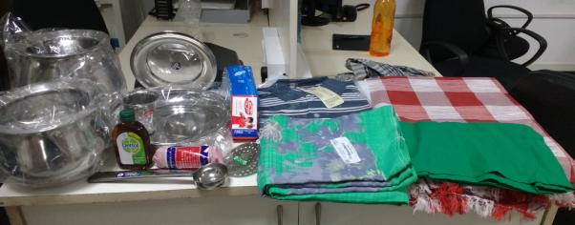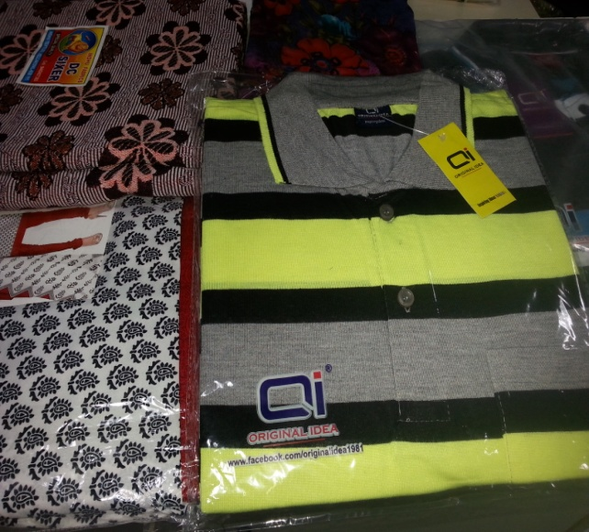

Educational Kits:
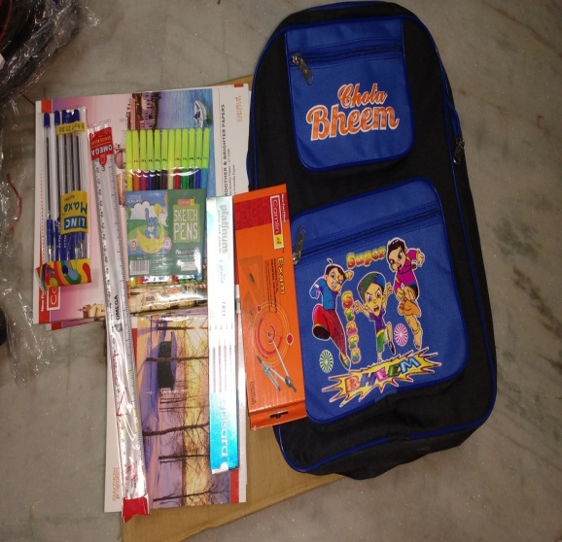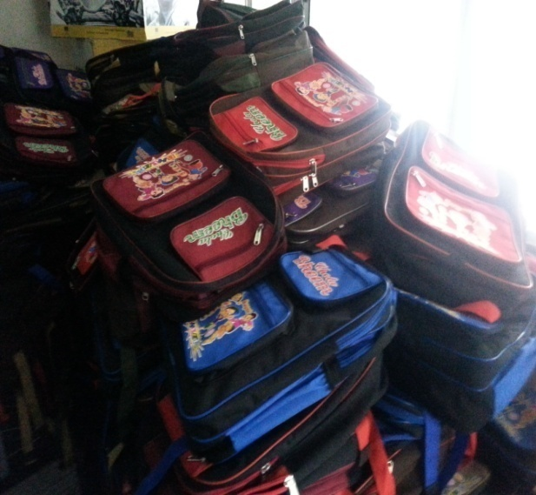

Packing & Loading:
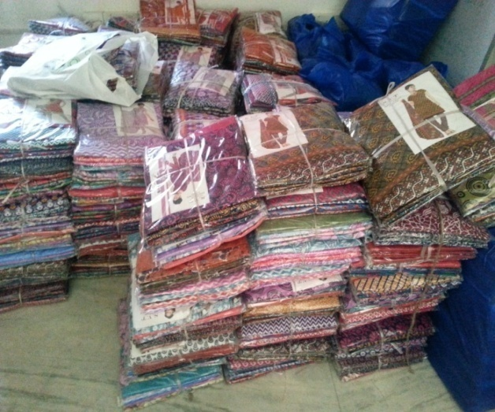
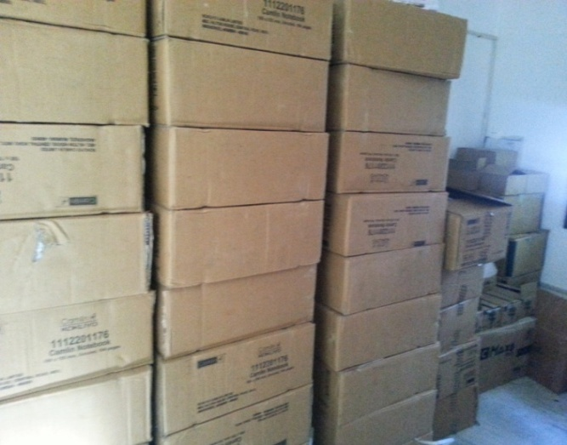
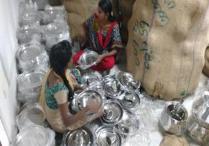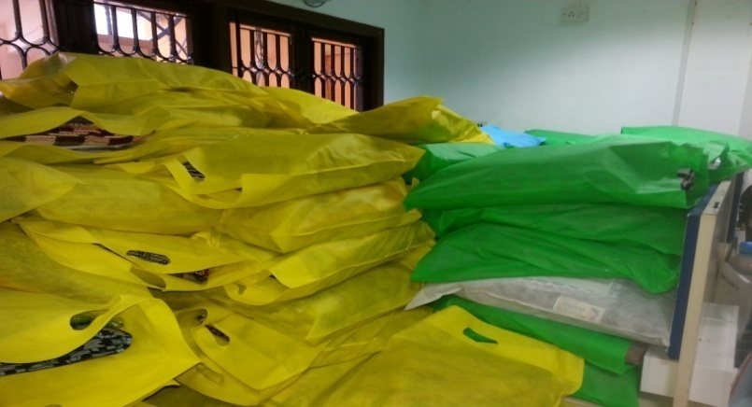

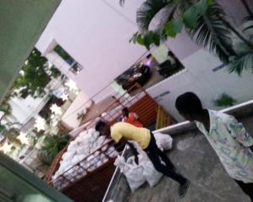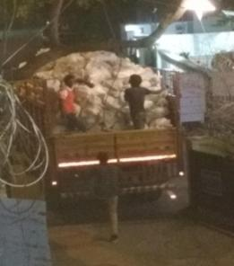

Distribution:

