CHEVALIER ROCHE SOCIETY (CRS) – THOOTHUKUDI & CUDDALORE

EMERGENCY APPEAL FOR IMMEDIATE RELIEF ASSISTANCE ON LIVELIHOOD SUPPORT TO THE VICTIMS OF STORM & FLOOD HIT PEOPLE OF CUDDALORE & THOOTHUKUDI DISTRICTS IN TAMILNADU – INDIA.
PROJECT TITLE: FLOOD DISASTER RESPONSE AT TAMILNADU , S. INDIA
PROJECT PERIOD: DEC 2015 – NOV. 2016 (1 YEAR)
The ongoing 2015 South Indian floods have resulted from heavy rainfall during the annual northeast monsoon in November –December 2015. They have affected the Coromandel Coast region of the South Indian states of Tamilnadu and Andhra. Tamil Nadu has been hit hard with torrential rains in November 2015. The seasonal rainfall has turned into torrential rainfall with several cyclonic formations in the Bay of Bengal has devastated the entire coastal district of Cuddalore. The city of Cuddalore in Tamilnadu has been particularly hard-hit, receiving its highest ever rainfall recorded in November. Nearly 300 people have died due to the floods, which have affected over 1.8 million people and have caused damages and losses in excess of ₹20000 crore (US$3 billion). The worst affected area is Cuddalore (180 kilometers from Chennai) which reported the highest number of death due to rains.

At least 1320 people have lost their lives. Also some water borne diseases are on the rise. A total of 2560 families are completely washed out and need help with food, blankets and plastic sheets for tents. Please note that the assistance requested is to provide the basic necessities in the affected areas. So far, CHEVALIER ROCHE SOCIETY (CRS), along with other volunteers of local area is coordinating the efforts on the ground. CRS a coastal based community development NGO working in Cuddalore and having head office at Tuticorin Coastal District have been working for the empowerment of Coastal Communities and a well experienced organisation in Disaster Management & Preparedness activities since 2005. CRS has a great working relationship with these Coastal Families in Cuddalore district and is very well connected with a number of them. It has already done several works at Cuddalore District on: Recapitalization of Thane Cyclone victims in Cuddalore district (Online donated thro Global Giving) by 2011 (year) For more details and background regarding the work done by Chevalier Roche Society (CRS) during the previous years, please visit @ http://www.globalgiving.Chevalier Roche Society Tuticorin

By having a rich experiences and pioneer in Disaster Management & Preparedness our Chevalier Roche Society (CRS) has immediately conducted a Rapid Assessment Survey at 39 Target sites at Cuddalore District (namely, Kurunjipadi, Keerapalayam and Parangipettai Union (5 panchayats) & Townpanchayats (3 wards) each of total 24 sites and 15 sites in Cuddalore Municipality and Union (totally 39 sites) for 15 more days (two weeks) for an instance and identifying the immediate needs of victims and therewith continue the relief work along with the local volunteers and neighbouring organisation in Cuddalore district. The detailed resulted of the Rapid Survey Assessment is available in a separate document @ CRS – Cuddalore Rapid Assessment Report, Nov 2015.

Due to the continuous heavy rainfall, pond and lakes reached thro fullest capacity water. Cuddalore District received 266mm rainfall on 8th and 9th November 2015 and huge flood occurred. Already this district had the heavy rainfall (500mm), leading a large scale flooding. The banks of the Kedilam and Paravanaru rivers got demolished, Hundreds of Agricultural villages got immersed in heavy flood. 49 persons died off, this flood. 12,000 houses, especially 50,000 hut houses been damaged. About 23,432 people in rural areas 4345 is urban areas have been arranged to stay in various relief centers. About 200 electric poles have fallen down. The paddy crops planted around 12,364 hectares were submerged, more than 5000 cattles, submerged in flood water, died and floated. About 300 villages had been cut off from Drinking water supply. More than 650 school buildings were demolished by this flood; Hundreds of Fishing boats were dashed by flood, and it gone in to the ocean. In tail end cavery river delta regions of Kurinjipadi, Keerapalayam and Parangipettai Blocks were the worst affected. Where crops of 11, 880 hectares were sub merged.
On 8 November 2015, during the annual cyclone season, a low pressure area consolidated into a depression and slowly intensified into a deep depression before crossing the coast of Tamil Nadu near Puducherry the following day. On 28–29 November, another system developed and arrived over Tamil Nadu on 30 November, bringing additional rain and flooding. By the afternoon of 1 December, power supplies had been suspended to 60 percent of the city's districts, while several city hospitals stopped functioning. The state government announced a holiday for all schools and colleges; many factories also halted operations. Hundreds of houses flooded in the slums area in Kurunjipadi, Keerampalayam, Parangipettai and Cuddalore Municipal areas the main GST road, connecting the city with the southern districts was cut off from the main city – Cuddalore. Thousands of people were forced to evacuate their homes after major lakes breached and flooded residential areas in the southern suburbs. Chennai and Cuddalore were officially declared a disaster area on the evening of 2 December 2015.

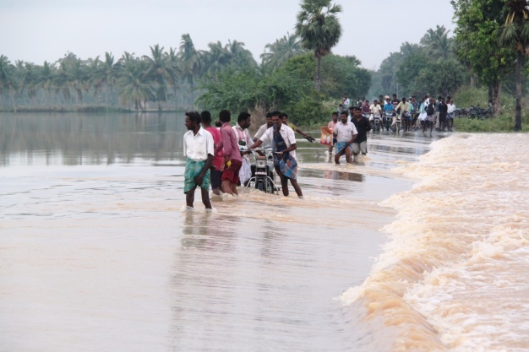
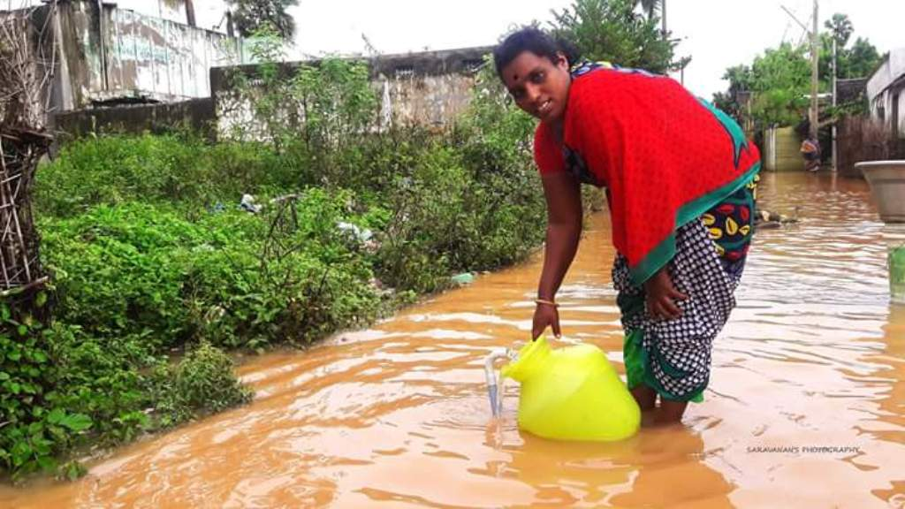
Our staff team (each team consists 3 persons) headed by Mr. Dhamodharan (Manager, CRS) and Mr. Armstrong (Manager, CRS) began the rapid assessment in Cuddalore District. They provided the coastal Disaster preparedness to the local Panchayat Level Federation (PLF) in the below said villages and made them deeply to involve in the problem identification. The spot assessment visit by the CRS revealed that the damage caused by flood and storm on 9th to 16th and 28th November and at Cuddalore was devastating. Following pictures taken during our situational assessment visit speak much more than words could express:
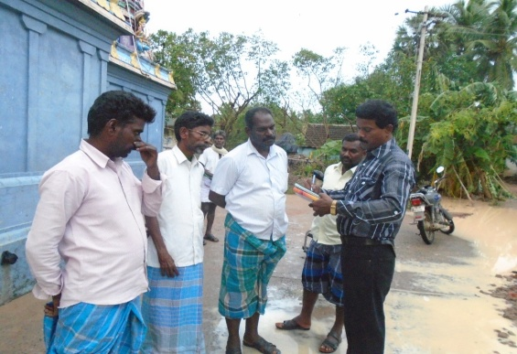

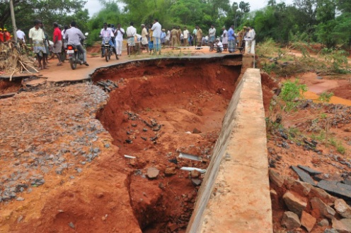
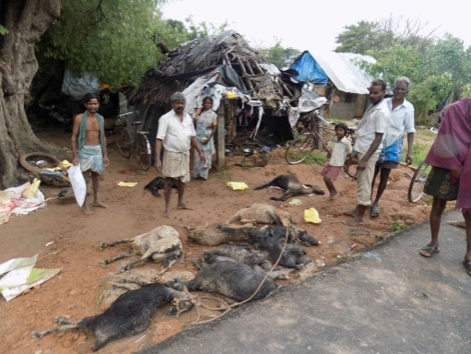
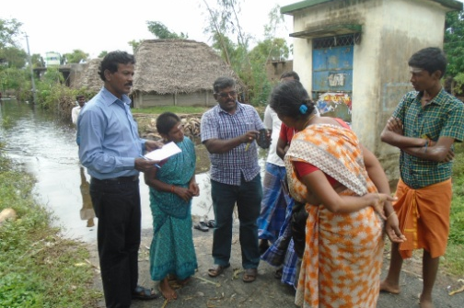

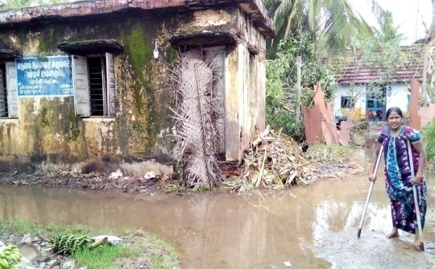
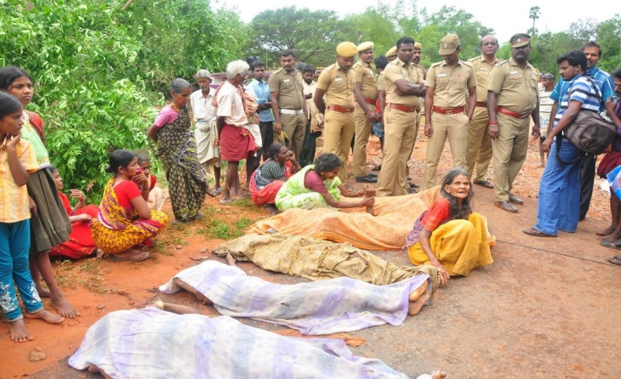

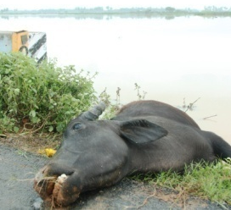

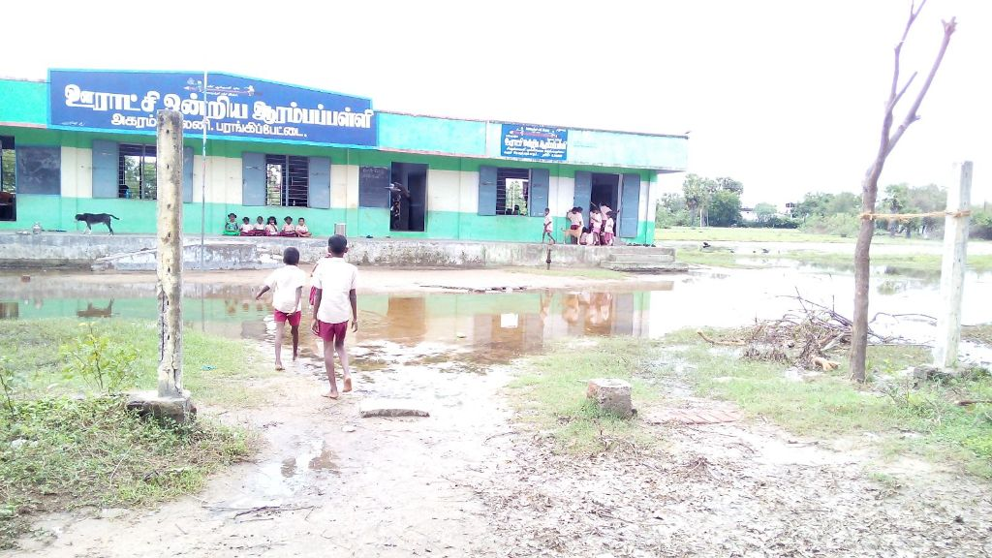

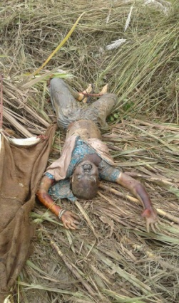

RELIFE WORKS Carried by CHEVALIER ROCHE SOCIETY @ Cuddalore District

- CRS along with the local volunteers and neighbouring NGOs had visited the flood hit area by 16th November 2015 to 28th November 2015 and engaged in relief programmes to express their solidarity with the victims of flood.

- CRS provided the coastal Disaster preparedness to the local Panchayat Level Federation (PLF) in Kurunjipadi, Keerapalayam and Parangipettai areas in Cuddalore district.

- Our CRS Staff team with volunteers involving relief assistance work along with the existing team in Cuddalore for 3 more days.

- Mr. Dhamodaran & Mr. Armstrong (Sr. Staffs of CRS) involved in Water Quality Assessment works along with Govt officials and Technicians in Kurunjipadi and Prangipettai villages.

- CRS staffs provided Trauma Counselling especially focused Children during the Relife measures undertaken at Paragipettai Union and the slums of Kurunjipadi.

- Protective Cloths were distributed to the children and aged to handle the existing cool climate in Kurunjipadi and Keerapalayam villages.

- The CRS relief team with staffs had a solidarity meeting with the small and marginal farmers at Kurunjipadi village who lost their crops and were so emotional and frustrated.

- Our CRS volunteers in Cuddalore involved in making and distributing Foods, Ration and assisting the existing Disaster Relief Work team at District level in several villages.

- CRS volunteers helped to shift and transport the victims including several children and elders from the damaged houses in to safe zone.

- The team members and through volunteer support our CRS helped to remove the damaged parts of the houses and transporting the affected victims to relief centres located in Prangipettai and Kurunjipadi villages.

Till on 3rd December 2015, our CRS staff team are engaging the relief works, collecting data on physically disabled and involving relief works carried out different parts in Cuddalore district.
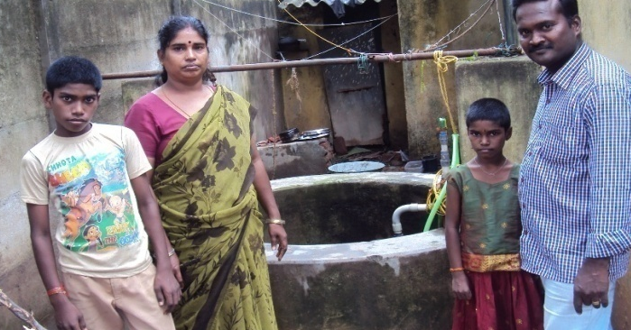
Our staffs assisting food preparation works for flood victims @ Parangipettai

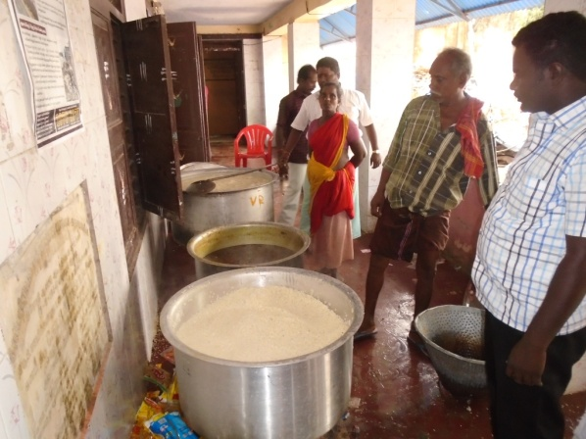

Our staff team with family rescue
and
Distributing Food to affected victims

Our Volunteer Rescue a Child from a Damaged hut

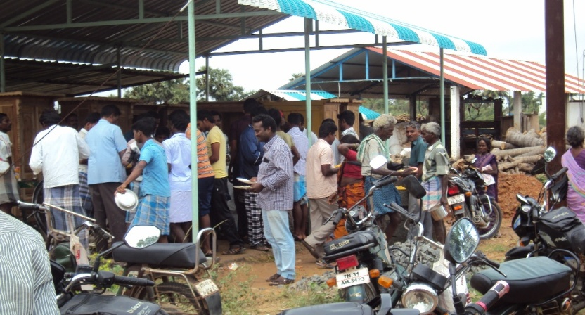
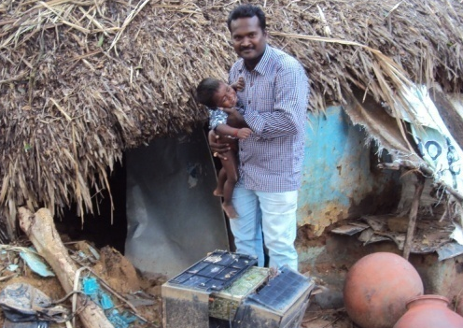

Condition of lifestyle – LOSS OF LIVELIHOOD @ Parangipettai & Kurunjipadi villages
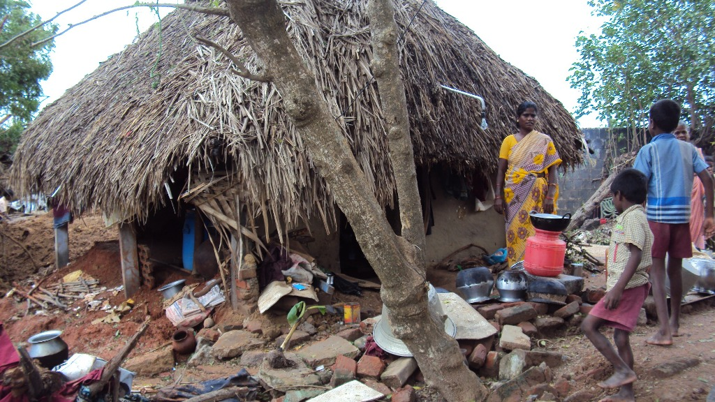

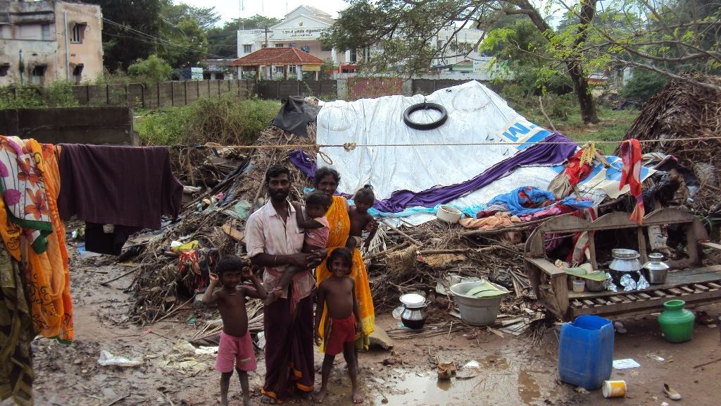

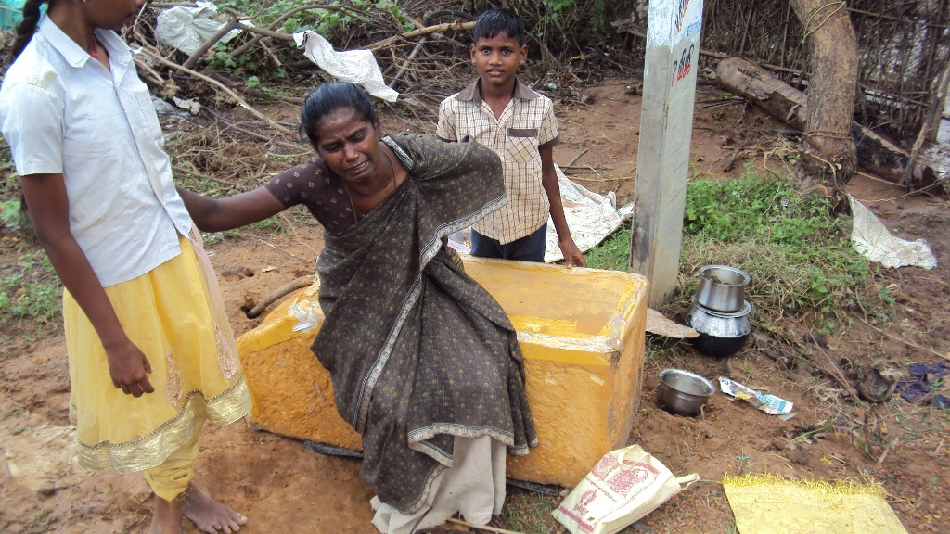

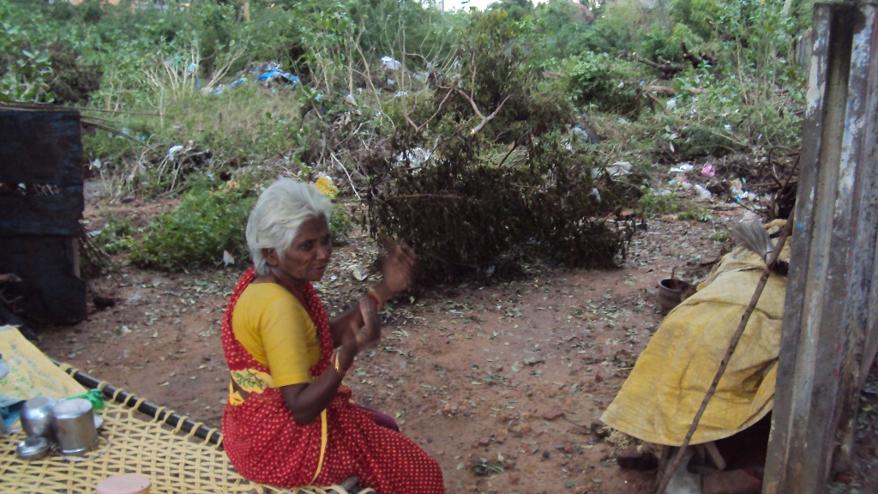
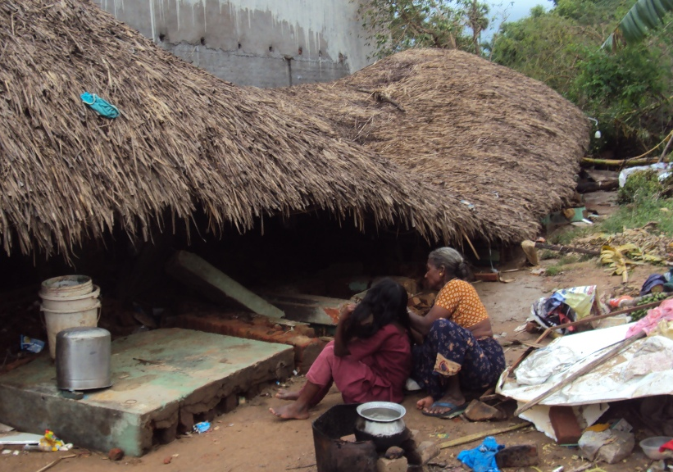
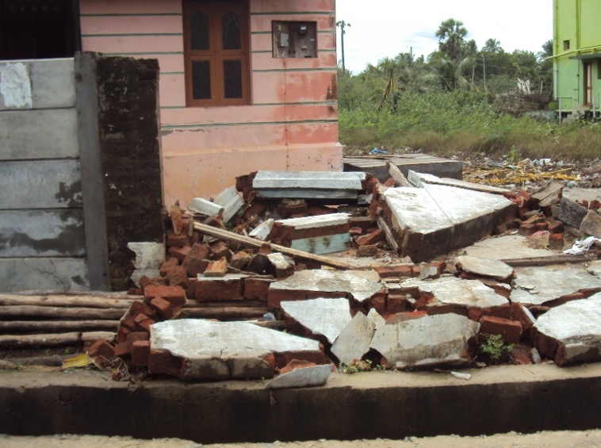
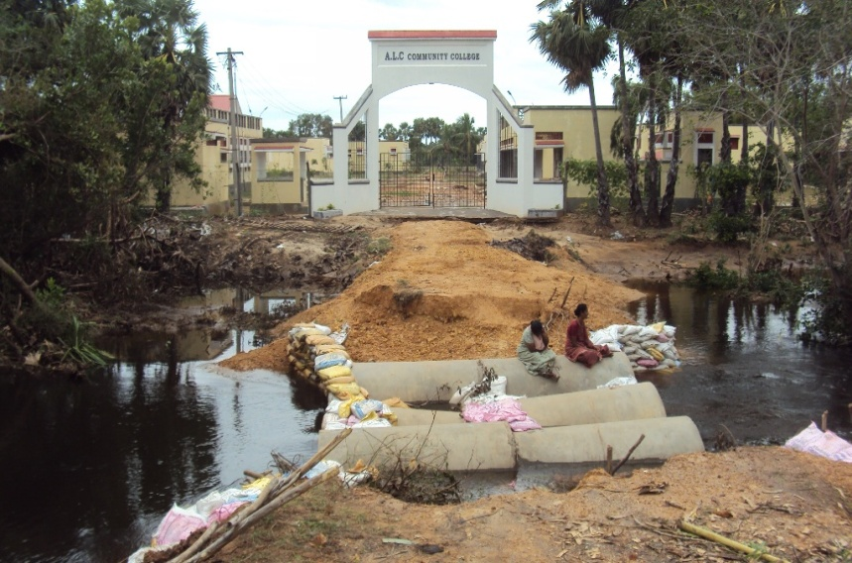
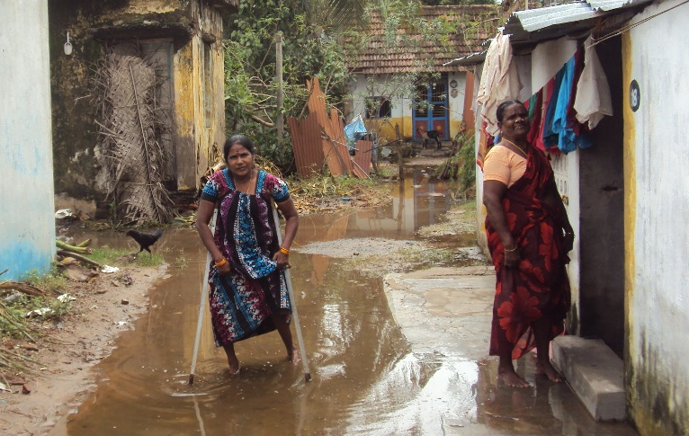

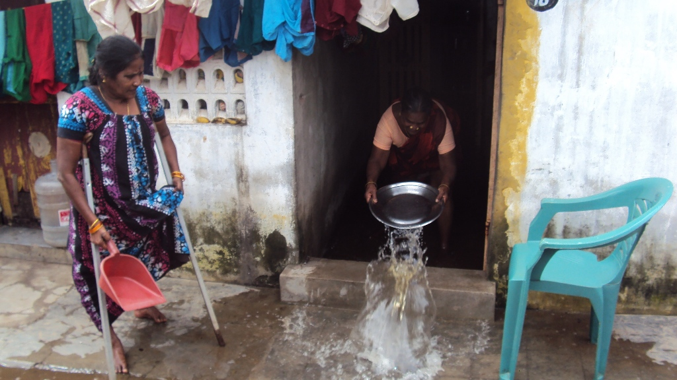

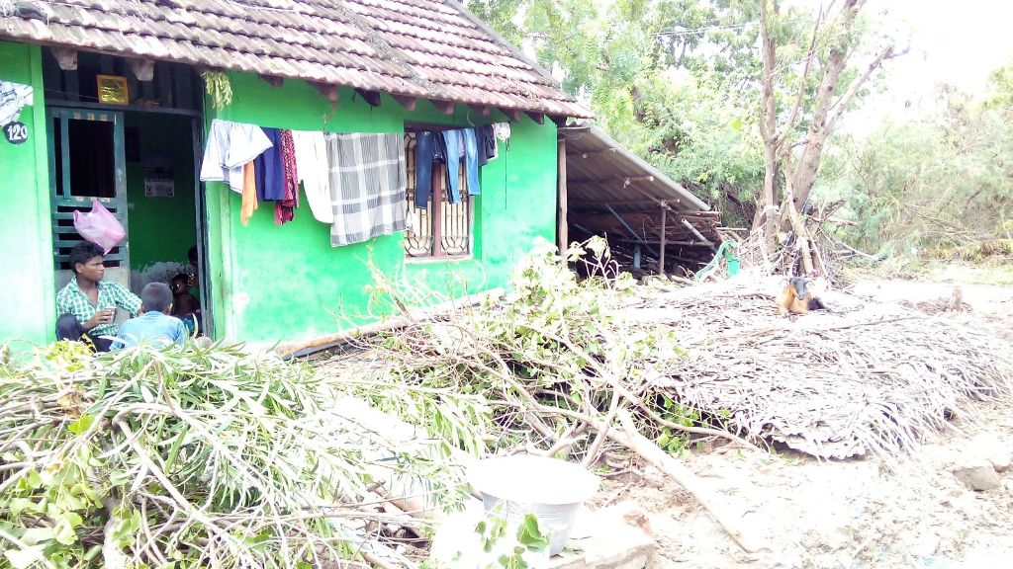
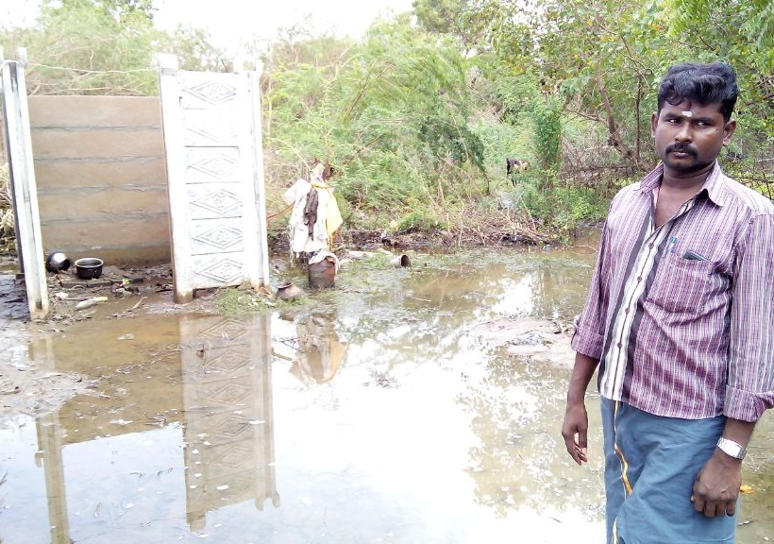

Assessment of Flood Situation & the Need of Relief Measures and RATIONALE OF APPEAL

In Parangipettai and Kurunjipadi villages, about 650 families were serious affected, they lost their houses and basic livelihood. They lost their household things such as utensils, clothes, bed sheets, money, televisions, mixie, grinder, shoes etc., Their houses are filled by rainwater and contaminated drainage sewages they are living roofless roadsides.

People affected by flood are demanding for provision of basic amenities as their houses have been completely washed away and some of them are still marooned by flood water. Most of the Huts in Slums at Kurunjipadi, Parangipettai are completed vanished by flood and continual flow of water inside the houses, the loss of human lives and serious damage to infrastructure in Cuddalore is so saddened. However the Government mechanisms trying to coordinate with various agencies on relief operations but the continual rain fall and the roads and runways are filled with water it is so difficult to carry the relief operation effectively and unable send the food and other amenities to reach them in time. The flood had brought huge destruction to the shelters, properties, livelihood sources such as cultivable lands etc,

The district collectorate and government have made appeals to NGOs to engage in relief works. There is a dire need for provision of cooked food, utensils, provisions required for at least one month. Their entire livelihood opportunities have come to stand still. The lands have become completely eroded and it will take months to reclaim the soil and resume their agricultural operations which are the main stay of the people of Cuddalore. As an emergency relief work we are expected to support the worst affected community with basic provisions for at least 10 days.

The Donations you give us will get fully Tax Exempted u/s 80 G of Income Tax Act 1961
OUR EFFORTS & STRATEGY AND OUR APPEAL
Our CHEVALIER ROCHE SOCIETY (CRS) had visited the area and distributed relief materials to our might. The expenses shared through local contribution, volunteer support, assisting the relief works etc, As a theme based, experienced, coastal community focused working NGO, our CRS have decided to engage in the relief assistance jointly and if needed in the rehabilitation phase in the coming days. We met the district administration and who has requested as to support families. We have agreed to mobilize resources to support for basic living. Once if your esteemed organization commits, we shall do the needful to distribute the relief packages to the more needy victims in Cuddlore. Visibility of the donor and proper accountability will be ensured by CRS. Hence our CHEVALIER ROCHE SOCIEY made a humble request to your esteemed organisation for making generous contribution and donations and kindly come forward to support the cause!

Let us Join our Forces !

CHEVALIER ROCHE SOCIETY
CHEVALIER J.L.P. ROCHE VICTORIA K.S.G. MEMORIAL TRUST SOCIETY
(H.O. Tuticorin Coastal Town)
Pappankudi Street, Opp. To Govt. Girls High School
Parangipettai – 608 502
Cuddalore Dist. Tamilnadu, India.
Phone: 0461 2346220, 2346227, Mobile : 9842146227
E-mail: chevalier_society@yahoo.in, chevaliar_society@yahoo.co.in,
Website: www. chevalierindia.org,
*******************

PROJECT TITLE: FLOOD DISASTER RESPONSE AT TAMILNADU, S.INDIA
PROJECT PERIOD: DEC. 2015 – NOV. 2016

ACTIVITIES: | REMARKS:
Preparation on Disaster Management in all affected panchayats. | We plan prepare Disaster management plans as follows. It will contains the following provision, social mapping ven diagram seasonal diagram. With the various types of sociological tools and modern technologies the plan will be prepared. If thro UNDP some Disaster Management plans already prepared, it will strengthened.
Formation / Strengthen of Disaster management committee / team. | We will form the Disaster Management committee / team and strengthen the same.
First aid trainings | Particularly in village areas we will offer the first aid trainings.
Short term Certificate course on Health cum disaster assistant | In Cuddalore and Thoothukudi districts 25 adolescent girls will be train on Health Cum Disaster Assistant. For the past 21 years (from 1994) our NGO convene Nurse Assist / Health Assist, paramedical trainings with the financial assistance of Govt. of India SSCP – CCDP. As we are familiar into Nursing subjects, we will add in our syllabus at Community Based Disaster Risk Management (CBDRM). By this trainings provided to them, they can easily find jobs for them in any clinic at the same time, if they find any Disaster they can serve as the full time trained volunteer.
Evacuation Route / Early warning and mock drill | Special attention will be given to the provision of evacuation route and early warning system. In addition to the mock drill trainings will be provided with the Govt. fire & rescue dept.

LIVELIHOOD ACTIVITIES:
Palm / Coconut craft | In both districts palm and coconut trees are prevalently found. From these community set the raw material perennially, training for the manufacture of following by products will be provided them properly.
Palm | Palm leave craft, (Baskets, Broom) Palm jaggery, Palm near / sap water.
Coconut | Tender coconut, Coir craft, Coir mat, coconut leave craft, Sweets.
Ornamental Shells making | In our effective inter tidal coastal area shells are easily found. Because of this heavy flood, shells died. With the Easily available of raw materials many craft products will be manufacture.
Ornamental Fish culture | In our area victims can easily rear fishes either of sea water or fresh water thro trainings.
Mushroom production | Paddy Hay easily can be collected in the sites. Here is the suitable temperature for mushroom culture.
Ground nut cakes | The ground nuts grown everywhere we will provide the training on preparation of ground nut cake.
Drinking water conservation | Due to this torrent major water bodies have been nearly affected. That is why we have decided to offer them usage of pure drinking water.
Field water tool kid | We will provide the trainings to volunteer about analyze the drinking water. Thro this analytical experiments we can analyze 18 characteristic of water thro adolescent volunteer.

BUDGET:
S.N | DESCRIPTION | UNIT COST  ( IN INDIAN MONEY) | (RUPEES) INDIAN MONEY | DOLLAR
1 | Preparation on Disaster Management in all affected panchayats. | Rs. 6,500 | Rs. 6,500 x 36 sites =  Rs. 2,34,000 | 3,600
2 | Formation / Strengthen of Disaster management committee / team. | Rs. 2,000 | Rs. 2,000 x 36 sites =  Rs. 72,000 | 1108
3 | First aid, identification of Evacuation route training and display and Mock drill trainings | Rs. 5,000 | Rs. 5,000x 18 sites = Rs. 90,000 | 1385
4 | Short term Certificate course on Health cum disaster assistant | Rs. 10,000 per trainee | Rs. 10,000 x 18 trainees =  Rs. 1,80,000 | 2770
6 | LIVELIHOOD ACTIVITIES:  Palm craft, jaggary etc.  Coconut craft, sweet etc.  Ornamental Shells making  Ornamental Fish culture  Ground nut cakes  Mush room culture | Rs. 5,000 per person x 20 numbers x 1 unit  Rs. 5,000 per person x 20 numbers x 1 unit  Rs. 5,000 per person x 20 numbers x 1 unit  Rs. 10,000 per person x 10 number x 1unit  Rs. 4,000 per person x 10 numbers x 1 unit  Rs. 5,000 per person x 20 numbers x 1 unit | Rs. 1,00,000  Rs. 1,00,000  Rs. 1,00,000  Rs. 1,00,000  Rs. 40,000  Rs. 1,00,000 | 1538  1538  1538  1538  615  1538
7 | Drinking water conservation training and analyze of water using Field water tool kid | Rs. 5,000 x 36 units | Rs. 1,80,000 | 2770
8 | Stationeries |  | Rs. 4,000 | 62
9 | GRAND TOTAL |  | Rs. 13,00,000 | $ 20,000

(NOTE: 1 Dollar = Rs. 65 Indian money - Rupees)

RAPID ASSESSMENT FOR FLOOD DISASTER
AT CUDDALORE & THOOTHUKUDI DISTRICTS

Submitted to
GLOBAL GIVING

Submitted by
DR. J. TAGORE DEROSE
CHEVALIER ROCHE SOCIETY
42, POLPETTAI, OPP. TO NEW BUS STAND
THOOTHUKUDI – 628 002
TAMILNADU, INDIA

CHEVALIER J.L.P. ROCHE VICTORIA
_{K.S.G MEMORIAL TRUST SOCIETY}
DR.J.TAGORE DEROSE, M.Sc., Ph.D.,
DIRECTOR

DEROSE CENTRE, 42, POLPETTAI,
OPP, NEW BUS STAND,
THOOTHUKUDI – 628 002.
TAMIL NADU. INDIA.

Date : 12.12.15
To
M/S Global Giving
Respected Madam,
Sub: Request to sanction CBDRM project in Tamil Nadu – Reg.
Greetings from CRS
Our NGO has been serving for the community in the coastal districts of TamilNadu for the past 27 years. Particularly we are sourcing on “Community Based Disaster Risk Management” (CBDRM) and Climate Change Adaption (CCA) in coastal Districts. We have enough experience of being served with UNDP, World Bank, Govt. Dept and also foreign donors. One or our main targeted district - Cuddalore, following the rain flood. We have made a “Rapid Assessment” survey at midst of November 2015. We have service experience at Cuddalore district during Thane cyclone on 2011. Being consider the deadly need of the community, I hope you would give the opportunity to serve at Cuddalore & Thoothukudi Districts in this project with the constant guidance and co-operation of your esteemed organization. I am awaiting your favorable reply at your earliest convenience.
Thanking you,
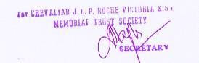
Yours Sincerely,

(DR.J.TAGORE DEROSE)

E-mail: chevalier_society@yahoo.in, chevaliar_society@yahoo.co.in,
Website: www. chevalierindia.org, Phone: 0461 2346220, 2346227, Mobile : 9842146227
RAPID ASSESSMENT
FLOOD DISASTER:
Cuddalore District, has already met many cyclones and receding flood water again here by natures disaster due to the depletion over the Bay of Bengal. During 8th and 9th November 2015, in Cuddalore District there was heavy rainfall (500m on both days of rainfall) against the usual one and it measured 697mm during the North east monsoon.
THE IMPACT:
Due to the continuous heavy rainfall, . Pond and lakes reached thro fullest capacity water. Cuddalore District received 266mm rainfall on 8th and 9th November 2015 and huge flood occurred. Already this district had the heavy rainfall (500mm), leading a large scale flooding. The banks of the Kedilam and Paravanaru rivers got demolished, Hundreds of Agricultural villages got immersed in heavy flood. 49 persons died off , this flood. 12,000 houses, especially 50,000 hut houses been damaged.
About 23,432 people in rural areas 4345 is urban areas have been arranged to stay in various relief centers. About 2000 electric poles have fallen down. And the electricity failure power to most of the villages during Deepavali Holidays TNEB (electricity workers) more than 1000 workers from other districts arrived at Cuddalore District worked fast, got right the condition. Transformers have been reformed,
The paddy crops planted around 20,164 hectares were submerged, more than 5000 cattles, submerged in flood water, died and floated. About 300 villages, had been cut off from Drinking water supply. More than 1000 school buildings were demolished by this flood, Hundreds of Fishing boats were dashed by flood, and it gone in to the ocean. In tail end cavery river delta regions of Kurinjipadi, Keerapalayam and Parangipettai Blocks were the worst affected. Where crops of 11, 880 hectares were sub merged.
Our staff team (each team consists 3 persons) headed by Mr. Dhamodharan (Manager, CRS) and Mr. Armstrong (Manager, CRS) began the rapid assessment in Cuddalore District. They provided the coastal Disaster preparedness to the local Panchayat Level Federation (PLF) in the below said villages and made them to deeply involve in the problem identification.

VULNERABILITY IN SCHOOLS:
In many following places primary school buildings have been heavily damaged at Bhuvanagiri, Keerapalayam, Kurinjipadi, panchayats and parangipettai areas and more than 100 roads lead to many schools immersed into water. Due to the inflow of flood many snakes invaded in to school premises.
TRAGIC DEATH DATA
Some tragic deaths in our target sites in Kurinjipadi as follows:
No | Targeted village | Human death | Reasons for death
1 | Kalkunam Panchayat | Mr. Ramalingam  Mr. Loga Nayagi - 42 | The couple lead the ducks for feeding and they died in the flood.
2 | Boothapandi Panchayat | Mr. Dhanasekar – 32 | Demolished house fell upon them
3 | Kurinjipadi  Ambedhar colony | Mr. Manimaran - 32 | House demolished fell upon them
4 | Ayan Kurinjipadi | Mr. Arun (Age - 5)  s/o Mr. Veera Muthukumar | House demolished fell upon them

GOVT. RELIEF:
Flood relief works have been announced, to redeem the locally affected, who lost the livelihood basis. The State Ministers released Rs. 4 lakh for the families of dead in the flood. More than 30,000 peoples were accommodated for 4 days in various schools, Govt. Buildings and relief centers.
COMMUNITY AGITATION:
This tragedy leads to many protected road strikes. In Kurinjipadi block, Anadi kuppam village schools, commenced strike regarding the non availability of Drinking water and electricity. This strike also occurred in Kullamchavadi – Karumachipalayam also and also in sorakuppam village near vadalur.

HEALTH BENEFITS:
From the districts, vetenary medical officers team provided the treatment for cattles and also provided the treatment for human Health from Primary Health Centres, Medical Officers also treated patients in the affected villages. Wandering swines in the stagnant water, leads to health hazards spreading and many communicable diseases in surrounding areas at Chidambaram Periyar Street, North Street, Azhalagan lane etc. Now swine are removed from the vulnerable areas and clearing works are slowly done by Municipal Officials.
NORTH EAST MONSOON 2015
WORST AFFECTED TARGETED DETAILS

Sl. No | Name of the Block | No. of worst affected panchayat / Municipal / Town Panchayat wards
1 | Kurinjipadi Union | 5 Panchayats
2 | Kurinjipadi Town Panchayat | 3 Wards
3 | Keerapalayam Town Panchayat | 3 Wards
4 | Keerapalayam Union | 5 Panchayats
5 | Parangipettai Town Panchayat | 5 Wards
6 | Parangipettai Union | 5 Panchayats
7 | Cuddalore Municipality | 5 Wards
8 | Cuddalore union | 8 Wards
 | Total Targeted sites | 39

KURINJIPADI UNION
ARANGAMANGALAM PANCHAYAT
Hamlet Name | Oonankuppam
Houses damaged | 64
Agricultural damaged | 78 Acre paddy field
Cattle | 13
Sheep | 17
Poultry | 7
Hamlet Name | Samathuvapuram
Houses damaged | 59
Agricultural damaged | 63 Acre paddy field
Cattle | 11
Sheep | 23
Poultry | 17
Hamlet Name | Aandikuppam
Houses damaged | 76
Agricultural damaged | 115 Acre paddy field
Cattle | 10
Sheep | 9
Poultry | 4
Hamlet Name | Pazhaya Road
Houses damaged | 89
Agricultural damaged | 83 Acre paddy field
Cattle | 3
Sheep | 8
Poultry | -

KURINJIPADI UNION
KALKUNAM PANCHAYAT
Hamlet Name | Kalkunam
Human Death | 2
Houses damaged | 121
Agricultural damaged | 75 Acre paddy field (sugarcane, flower gardens)
Cattle | 3
Sheep | 4
Poultry | 65
Swine | 25
Duck | 242
Hamlet Name | Kalkunam Colony
Human Death | -
Houses damaged | 65
Agricultural damaged | 123 Acre paddy field
Cattle | 3
Sheep | 2
Poultry | 42
Swine | 41
Duck | 25
Hamlet Name | Thiruvaranai Nallur
Human Death | -
Houses damaged | 23
Agricultural damaged | 33 Acre paddy field (sugarcane, flower gardens)
Cattle | 3
Sheep | 7
Poultry | 21
Swine | 22
Duck | 25
Hamlet Name | Pathirimedu
Human Death | -
Houses damaged | 56
Agricultural damaged | 77 Acre paddy field (sugarcane, flower gardens)
Cattle | 1
Sheep | 2
Poultry | 8

KURINJIPADI UNION
BOOTHAMPADI PANCHAYAT

Hamlet Name | Boothampadi
Human Death | 2
Houses damaged | 31
Agricultural damaged | 513 Acre paddy field  (Manila, Flower Gardens)
Cattle | 2
Sheep | 4
Poultry | 5
Hamlet Name | Boothampadi Colony
Human Death | -
Houses damaged | 19
Agricultural damaged | 412 Acre paddy field  (Manila, Flower Gardens)
Cattle | 1
Sheep | 2
Poultry | 4

KURINJIPADI UNION
AADOOR AGARAM PANCHAYAT
Hamlet Name | Aadoor Agaram
Human Death | -
Houses damaged | 15
Agricultural damaged | 169 Acre paddy field
Cattle | 2
Sheep | 8
Poultry | 7
Hamlet Name | Mela Colony
Human Death | -
Houses damaged | 13
Agricultural damaged | 178 Acre paddy field (Manila)
Cattle | 484
Sheep | 3
Poultry | 4
Hamlet Name | Paranthampattu
Human Death | -
Houses damaged | 17
Agricultural damaged | 219 Acre paddy field (Manila)
Cattle | 712
Sheep | 8
Poultry | 6
Hamlet Name | Keela Colony
Human Death | -
Houses damaged | 14
Agricultural damaged | 112 Acre paddy field
Cattle | 1003
Sheep | 3
Poultry | 12

DETAILS OF BURRIED CATTLES
S.No | Block | Name of the Panchayat | Owners of Cattles | Details of Died Cattles | No of Died Cattles | Either burried or not | Either Chlorinated or not
1 | Kurinjipadi | Thiyakavalli | Mohanasundaram  s/o Jeyaraman, East Street, Thiyakavalli | Cow | 1 | Burried | Chlorinated
2 |  | Aadoor Agaram | Sekar, s/o Perumal, Aadoor Agaram | Cattle | 1 | Burried | Chlorinated
3 |  | Aadoor Agaram | Seenivasan, s/o Arumugam, Aadoor Agaram | Cattle | 1 | Burried | Chlorinated
4 |  | Aadoor Agaram | Sambasivam, s/o, Kaliaperumal, Mettustreet, Aadoor Agaram | Sheep | 2 | Burried | Chlorinated
5 |  | Aadoor Agaram | Manikandan, s/o Thangarasu, Aadoor Agaram | Sheep | 2 | Burried | Chlorinated
6 |  | Aadoor Agaram | Kasiammal D/o Thangarasu, Aadoor Agaram | Sheep | 4 | Burried | Chlorinated
7 |  | Boothambadi | Ramalingam, s/o Ramamoorthy, Boothambadi | Cattle | 2 | Burried | Chlorinated
8 |  | Koranapattu | Arumugam, s/o Manikam, Sivananthipuram, Peikanatham | Poultry | 1232 | Burried | Chlorinated
9 |  | Ayikuppam | Karthikeyan, s/o Krishnamoorhi, Ayikuppam | Poultry | 4500 | Burried | Chlorinated
10 |  | Valuthalampattu | Sivakumar, s/o Sambantham, Valuthalampattu | Poultry | 354 | Burried | Chlorinated
11 |  | Agaram | Thanapathi, s/o Shanmugam, Ramanathakuppam, Agaram | Poultry | 1317 | Burried | Chlorinated
12 |  | Agaram | Thirumalmoorhy, s/o Amirthalingam, Ramanathakuppamm, Agaram | Poultry | 642 | Burried | Chlorinated
13 |  | Agaram | Lakshmi, w/o Govindharasu, Ramanathakuppam, Arivolipannai, Agaram | Poultry | 917 | Burried | Chlorinated
(source:BDO, Kurinjipadi )

KURINJIPADI UNION
KALLAIYANKUPPAM PANCHAYAT

Hamlet Name | Thittaveli
Human Death | -
Houses damaged | 15
Agricultural damaged | -
Poultry | 15
Duck | 1232
Hamlet Name | AnnaNagar
Human Death | -
Houses damaged | 13
Agricultural damaged | -
Poultry | 10
Duck | -
Hamlet Name | Arunthathiyar Street
Human Death | -
Houses damaged | 21
Agricultural damaged | -
Poultry | -
Duck | -
Hamlet Name | Kallaiyankuppam Street
Human Death | 1
Houses damaged | 15
Agricultural damaged | -
Poultry | 5
Duck | 5145

KURINJIPADI TOWN PANCHAYAT

Hamlet Name –ward | Railadi
Human Death | -
Houses damaged | 13
Trees damaged | 18
Sheep | 4
Poultry | 7
Hamlet Name –ward | Patchiram palayam
Human Death | -
Houses damaged | 62
Agricultural damaged | 125 Acre
Road damaged | 2
Electricity post damaged | 14
Trees damaged | 86
Cattle | 8
Sheep | 16
Poultry | 18
Hamlet Name –ward | Kottara Street
Human Death | -
Houses damaged | 17
Agricultural damaged | 76 Acre
Trees damaged | 13
Electricity post damaged | 6

KEERAPALAYAM UNION
SATHAMANGALAM PANCHAYAT

Hamlet Name | Sathamangalam
Human Death | -
Houses damaged | 27
Agricultural damaged | 13 Acre paddy field (vegetables)
Cattle | 1
Poultry | 17
Hamlet Name | Sakthivilagam
Human Death | -
Houses damaged | 38
Agricultural damaged | 22 Acre paddy field (vegetables)
Cattle | 2
Poultry | 11
Hamlet Name | Nagaramalai
Human Death | -
Houses damaged | -
Agricultural damaged | -
Cattle | -
Poultry | -

KEERAPALAYAM UNION
PUDAIYOOR PANCHAYAT

Hamlet Name | Pudaiyoor
Human Death | 1
Houses damaged | 27
Agricultural damaged | 212 Acre paddy field (sugarcane)
Cattle | 5
Poultry | 15
Hamlet Name | Kudikadu
Human Death | 1
Houses damaged | 83
Agricultural damaged | 67 Acre paddy field (sugarcane)
Cattle | 6
Poultry | 5

KEERAPALAYAM UNION
SENGALMEDU PANCHAYAT

Hamlet Name | Sengalmedu
Human Death | -
Houses damaged | 45
Agricultural damaged | 159 Acre paddy field (sugarcane)
Cattle | 2
Sheep | 1
Poultry | 12
Hamlet Name | Mela Sengalmedu
Human Death | -
Houses damaged | 14
Agricultural damaged | 145 Acre paddy field
Cattle | 3
Poultry | 4
Hamlet Name | Sengalmedu colony
Human Death | -
Houses damaged | 65
Agricultural damaged | 17 Acre paddy field
Swine | 42
Poultry | 25

KEERAPALAYAM UNION
MUHAIYOOR PANCHAYAT

Hamlet Name | Muhaiyoor
Human Death | -
Houses damaged | 17
Agricultural damaged | 13 Acre paddy field
Cattle | 1
Sheep | 2
Poultry | 7
Hamlet Name | Kodiyalam
Human Death | -
Houses damaged | 65
Agricultural damaged | 12 Acre paddy field
Cattle | 3
Sheep | 2
Poultry | 15

KEERAPALAYAM UNION
THUNICIRAMEDU PANCHAYAT
Hamlet Name | Thuniciramedu
Human Death | -
Houses damaged | 19
Agricultural damaged | 145 Acre
Cattle | 4
Sheep | 6
Poultry | 22
Hamlet Name | Periyatheru colony
Human Death | 5
Houses damaged | 129
Agricultural damaged | 315 Acre paddy field
Cattle | 1
Sheep | 4
Poultry | 45
Hamlet Name | Ponnerikarai
Human Death | 4
Houses damaged | 189
Agricultural damaged | 215 Acre
Cattle | 5
Sheep | 42
Poultry | 19
Hamlet Name | Mandapam
Human Death | 6
Houses damaged | 212
Agricultural damaged | 113 Acre paddy field
Cattle | 2
Sheep | 10
Poultry | 46

PARANGIPETTAI TOWN PANCHAYAT

Hamlet Name – Town Panchayat Ward | Thesanathaikkal Street
Human Death | -
Houses damaged | Vathiyarpalli – 141  Colony – 72  Vadakkuthurai Vannarapalayam - 77
Agricultural damaged | -
Cattle | 1 + 1
Sheep | 2
Poultry | 15
Swine | 11
Hamlet Name Town Panchayat Ward | Mathakovil Street
Human Death | -
Houses damaged | 30 – Mathakovil Street  12 – Metukudi Street
Poultry | 5
Hamlet Name Town Panchayat 15th Ward | Agaram Sivanpadavar Street
Human Death | -
Houses damaged | Periyamathagu street – 30  Meenavar Street – 23  Sunnambu Shulai – 33  Otter Street – 44  Scavanger Street – 25  Irular Street – 45  Mariamman Kovil Street – 40  Main Road – 15  Car Road – North Street - 15
Hamlet Name Town Panchayat 17th Ward | Ramapadiachi Street
Human Death | -
Houses damaged | Agaram Kollumedu – 28  Uppukara Street – 15  Manampadi – 17
Agricultural damaged | -
Cattle | 2
Sheep | 4
Poultry | 12
Hamlet Name Town Panchayat 18th Ward | Agaram Colony
Human Death | 1 child
Houses damaged | Agaram Colony – 237  Koyya Thoppu – 29  Palamain – 50  Kathavarayan Thoppu - 20
Agricultural damaged | -
Cattle | -

PARANGIPETTAI TOWN PANCHAYAT

Hamlet Name – Town Panchayat Ward | Perumal Kovil Street
Human Death | -
Houses damaged | 37
Agricultural damaged | -
Cattle | 2
Sheep | 7
Road damaged | 4
Hamlet Name Town Panchayat Ward | Agaram Colony
Human Death | 1 child
Houses damaged | 48
Agricultural damaged | 35 Acre
Sheep | 13
Poultry | 16
Trees damaged | 28

PARANGIPETTAI UNION
VILLIANALLUR PANCHAYAT

Hamlet Name | Villiyanallur Aathithiravidar Colony
Human Death | -
Houses damaged | 225
Agricultural damaged | 325 Acre paddy field
Cattle | 2 + 1
Sheep | 2
Poultry | 5
Hamlet Name | Puthusathiram
Human Death | 1
Houses damaged | 340
Agricultural damaged | 294 Acre paddy field
Cattle | 1
Sheep | 2
Poultry | 2
Hamlet Name | V. PachanKuppam
Human Death | 1
Houses damaged | 123
Agricultural damaged | 229 Acre
Cattle | -
Sheep | 4
Poultry | -
Hamlet Name | Velankiramam patti
Human Death | -
Houses damaged | 13
Agricultural damaged | 220 Acre paddy field
Cattle | -
Sheep | -
Poultry | -

PARANGIPETTAI UNION
PERIYAKUMATI PANCHAYAT

Hamlet Name | Periyakumati Aathithiravidar Colony
Human Death | -
Houses damaged | 153
Agricultural damaged | 225 Acre paddy field
Cattle | -
Sheep | -
Poultry | -
Hamlet Name | Anaiayalankuppam
Human Death | -
Houses damaged | 155
Agricultural damaged | 210 Acre paddy field
Cattle | -
Sheep | -
Poultry | -
Hamlet Name | Periyakumati
Human Death | -
Houses damaged | 363
Agricultural damaged | 462 Acre paddy field (Manila)
Cattle | -
Sheep | 2
Poultry | 13

PARANGIPETTAI UNION
SILAMBIMANGALAM PANCHAYAT
Hamlet Name | Silambimangalam
Human Death | -
Houses damaged | 205
Agricultural damaged | 315 Acre paddy field
Cattle | 1
Sheep | 3
Poultry | -
Hamlet Name | ChinnandiKuli
Human Death | -
Houses damaged | 315
Agricultural damaged | 323 Acre paddy field
Cattle | 1
Sheep | 2
Poultry | 5012 (5 Poultry farms)
Hamlet Name | Samiyarpettai
Human Death | 1
Houses damaged | 115
Agricultural damaged | 112 Acre paddy field
Cattle | 1 + 1
Sheep | 15
Hamlet Name | Nochikadu
Human Death | -
Houses damaged | 13
Agricultural damaged | 21 Acre paddy field
Poultry | 1 Poultry Farm
Hamlet Name | Railadi
Human Death | -
Houses damaged | 72
Agricultural damaged | 10 Acre
Cattle | 1
Sheep | 7
Poultry | 21

PARANGIPETTAI UNION
POOVALAI PANCHAYAT

Hamlet Name | Poovalai Aathi Thiravidar colony
Human Death | -
Houses damaged | 285
Agricultural damaged | 657 Acre paddy field
Cattle | -
Sheep | -
Poultry | -
Hamlet Name | Poovalai Village
Human Death | -
Houses damaged | 163
Agricultural damaged | 1175 Acre paddy field
Cattle | -
Sheep | -
Poultry | -

PARANGIPETTAI UNION
MANIKOLLAI PANCHAYAT

Hamlet Name | Manikollai
Human Death | -
Houses damaged | 23
Agricultural damaged | 257 Acre paddy field
Cattle | 2
Sheep | -
Poultry | 650 (1 Poultry farm)
Hamlet Name | Palavannathannan
Human Death | -
Houses damaged | 15
Agricultural damaged | 115 Acre paddy field
Cattle | -
Sheep | -
Poultry | 200 (1 Poultry Farm)
Hamlet Name | Navapettai
Human Death | -
Houses damaged | 21
Agricultural damaged | 59 Acre paddy field
Hamlet Name | Ramanathakuppam
Human Death | -
Houses damaged | 7
Agricultural damaged | 112 Acre paddy field
Cattle | 1
Sheep | 1

CUDDALORE MUNICIPAL

Hamlet Name – Municipal Ward | Vandipallayam
Human Death | -
Houses damaged | 24
Shops damaged | 16 (including Thina Thanthi office)
Vehicles | 62
Sheep | 4
Poultry | 12
Road Damaged | 3
Hamlet Name Municipal Ward | Maharaja Nagar
Human Death | -
Houses damaged | 27
Shops damaged | 26
Vehicles | 27
Cattle | 2
Sheep | 4
Poultry | 8
Road Damaged | 7
Hamlet Name Municipal Ward | PSM Nagar
Human Death | -
Houses damaged | 14
Shops damaged | 16
Cattle | 3
Sheep | 8
Poultry | 12
Road Damaged | 4
Hamlet Name Municipal Ward | Manaveli Mariamman Kovil Street
Human Death | -
Houses damaged | 18
Shops damaged | 29
Cattle | 4
Road Damaged | 3
Hamlet Name Municipal Ward | Kambiampettai
Human Death | -
Houses damaged | 12
Shops damaged | 19
Vehicles | 17
Road Damaged | 4
Hamlet Name Municipal Ward | Town Hall Road
Human Death | -
Houses damaged | 21
Offices damaged | Collector Guest House
Vehicles | 32
Road Damaged | 6
Hamlet Name Municipal Ward | Devanampettai
Human Death | -
Houses damaged | 28
Shops damaged | 17
Road Damaged | 4
Sheep | 4
Poultry | 12

CUDDALORE UNION

Hamlet Name - Panchayat | Semarankottai
Human Death | -
Houses damaged | 32
Agricultural damaged | 325 Acre
Cattle | 5
Sheep | 7
Poultry | 16
Hamlet Name - Panchayat | Subramaniapuram
Human Death | -
Houses damaged | 17
Agricultural damaged | 170 Acre
Canals damaged | 2
Cattle | 4
Sheep | 7
Poultry | 11

CUDALORE DISTRICT - RAIN FLOOD DEFECTS
CUDALORE MUNICIAPALITY
- VANDIPPALAYAM, Maharaja Nagar and PSM Nagar are located at Kedilam river bank area. That is why all streets of these areas have been surrounded by water. Water has entered into the houses completely. Drainage canals have been damaged and that is why rain water is mixed with drainage water. Thus the whole area has been surrounded with water so.
Vandippalayam area. Thina Thanthi News Paper office has been located in the ground floor. As the flood water is flowing over the top level of the bridge, all shops and sales centre have been drowned into water. All articles covered with the flood water have been damaged completely. In this shopping complex Hero Honda.Motor cycle show Room is also available. So more than 50 Motor cycles have been damaged.
- As P.S.M Nagar, Manaveli Mariammn Kovil Street, Double road areas are located very low. Rain water entered into all areas and flood water has no space to drain in these areas. That is why they have entered into the streets and all houses and it is seemed like pond.
- COLLECTOR GUEST HOUSE like which is near town hall has been entirely surrounded by rain water. Here is the situation for vehicles of every Govt. staff is really very hard. They have no way to come in and to go away
- ANNA FLY OVER has been situated at the height more than 50 feet. As the flood water is flowing up to the top level of the fly over vehicles are unable to travel for even to the next road. All nearby road routes have been cut off
- DEVANAAMBETTAI delta area: Flood water completely entered and so here rain and sea water has been mixed up. This area is completely blocked by rain flood water and here is no way to travel to other areas. As the main areas of the town named Kambiampettai and Sooppananchavadi areas have been completely drowned in flood water. Transportation is completely cut off.
CUDDALORE UNION:-
- At semarankottai panchayat area all trees broke and the surrounding area of agricultural lands have been occupied by rain flood water and farmers are in very sad condition, because they were expecting the day of their harvest season. Now their crops have been completely damaged.
SUBRAMANIA PURAM:-
- This village is located in Caddalore Chidabaram Main Road. A canal was situated across this road. As this canal was broken by the heavy rain fall and overflowing flood. This village is completely cut off from other areas.
- On the both the sides of Cuddalore, Kurinjippadi Main Road a number of trees fell down. In many places these trees have fallen upon the agricultural lands, electric wires and slum areas.
POOVANIKUPPAM:-
- This village road has been cut off from Cuddalore – Chidambaram Main Road. Hence the agricultural lands have been affected much. Also the people of this village have no any communication facilities from their village because of the rain flood.
KURINJIPADI UNION:-
VAYALANPATTI PANCHAYAT:-
Many trees have leaned and found fallen upon the houses. In Goplalapuram Village M/s.Murugan, Sargunam, Karkuvel and Paramasivam area living at a same surrounding area. Upon the roofs of their houses coconut trees have fallen and caused much damages. The family members of these house have been protected. At present they have no residence for their habitation, they sit along the road sides and spend their time.
- RAILWAY STATION AREA:-
In this location 13 thatched houses have completely fallen on the ground. Low height thatched clay walled houses have melted in water and just only roofs are found. Therefore the people of this village stay upon the sides of the roads.
- PANCHARAMPALAYAM:
Pancharampalayam village people have to go to this village by crossing the railway line. Near this railway line canal is situated. East and west to the rails road has been cut off. Therefore now the people are unable to travel into this village. As the canal over flows with rain flood water has entered much into the village. Hence walls of 62 houses damaged and fell down. As the village people went to the temple in the village loss of lives were avoided 14 nos of electric posts leaned on the roofs of the house and they fell down. 85 no of small and big trees have fallen down in the midst of the village. At the backside of the village road on the higher area also has been cut off by the heavy flow of flood. That is why the people of this village feel very hard without having any food and electricity facilities. Hence the people are unable to go away for any purpose and they are in hard situation without any electricity facilities and transportation.
- KOTTAKARA STREET:-
In the midst of the village a temple is found. Beside the temple a tank is situated. This tank over flowed with water of the village. Due to rain problem 17 houses have been completely demolished. People of the village cook their food on sides of the road. Children’s study their lessons by sitting on both sides of the road.
- Kurinjippadi – Perumal lake over flowed and puthuchathram road completely immerse
- Cuddaore – Chidambaram Road entirely occupation by flood and transpiration is totally cut off.
- KURINJIPPADI BYE-PASS ROAD:-
In the 20 thatched houses of this road side Arunthathiyar Caste people lived. Rain flood surrounded their houses and they fell down to the ground upon the remaining houses also trees fell down and they entirely damaged. People of this area how stay at fire service centre of them a woman named Jothi severely injured and she has no way to get treatment for her.
- KURINJIPPADI –OLD ROAD:-
People belong to schedule caste stay at 40 thatched houses. These were fully surrounded by water from sengal odai. Therefore 38 houses in this area completely damaged. Families lived in these houses suffer much and now stay on the sides of the road.
- SUBBARAYA NAGAR:-
Vetenary hospital compound wall demolished and flood entered into it and surrounding streets also.
KULLANCHAVADI UNION:-
In this area canal has been completely damaged and water entered into the village crops planted in the location of about 200 area has been completely destroyed. A Mother and her daughter of this village were pulled into the flood water and gone away when they tried to travel from one location to another. They were found dead in the area of a paddy field.

THAMBI PETTAI UNION:-
Agricultural lands have been completely drowned into rain flood water in this village no body is unable to trace his/her land in this village. In such a manner ground land of the village has been completely covered with rain flood.
PARANKI PETTAI UNION:-
AGARAM – PERUMAL KOVIL STREET In this area all houses were surrounded by the flood water and the filthy water entered into the houses and the people have lost many things of them a differently abled woman named Rajeswari has been affected much.
- AGARAM COLONY:-
This is a Residential area of schedule caste community. The whole colony has immersed into flood water. In this area a 8 months old male child named Santhanu of couple Moorthy – Packialakshmi immersed into water and died.
- MUTTLUR PANCHAYAT:-
At sivan kovil area the flood water fully occupation. Here the Sivan kovil is found only half size. The lower portion of the image has been fully covered with water
We also happened to see boys named Ramu & Vignesh went by boat to their houses.
KEERAPPALAYAM UNION:
In this Panchayat Thulisiramedu, Santhamangalam, Kudaiyur, Villakkadu villages have been surrounded with water completely and agricultural lands have been entirely damaged.
THOOTHUKUDI DISTRICT RAPID ASSESSMENT
Rivers have every town, and entered cover the bridges and lakes of the city. About 10 lakhs of people left their homes, and found starving. Two lakhs of perom have been accommodated in various Relief arties in the entire coastal state.
Indian National Army, Navy, Air Force and the National Disaster Management Authority (NDMA) joined with State Govt. Fire and Rescue services Dept and the State Police in relieving efforts. The destruction was of such serviour, that their combined action was not enough to redim the number of distress calls received during the months.
Various Religions, Political and Non Governmental voluntary organization distributed food and essential items at various Relief centre State Govt. supplied the food pockets regularly to the flood victories.
THOOTHUKUDI DISTRICT:
It is a coastal district. It is also a harbor district. Even though many business centers have developed here, Infrastructures are not so far developed to much extend. During the whole month of November, it was heavily raining almost in all coastal districts of Tamil Nadu, India. In Tamil Nadu State here are 13 coastal districts. Because of the recent rain flood, half of the coastal districts have been heavily affected by which some worst entered districts are: Cuddalore, Chennai, Kanchipuram and Thoothukudi. According to the Indian Coastal Govt. Home Minister announced at parliament 269 persons had dead in Rain flood.

THOOTHUKUDI DISTRICT FLOOD WORST AFFECTED SITES:

1  2  3  4  5  6  7  8  9  10  11  12  13  14  15 | Thoothukudi city  Muthammal colony  Athi parasakthi nagar  Iyappan nagar  Nethaji nagar  Kurinji nagar  Rahamath nagar  CMS nagar  State bank colony  Rajiv nagar  Rajagopal nagar  Kadirvel nagar  Rajapandi nagar  Meelesan nagar  Jothi nagar | 16  17  18  19  20  21  22  23  24  25  26  27 | Palpandi nagar  Meelavitan  Pandaram patti  Meduthur  Mullakadu  Kamaraj nagar  Santhi nagar  Thangammal puram  Saveriyar puram  J. S nagar  Sundar nagar  Athimarapatti

For a period of two weeks, water is stagnant everywhere are burned into dark blackish green in color. Because of this, many places, green manger, algae and also shrub, began to grow. Upon the flood water, solid wastes, poultry wastes, poultry dead sheep, pigs, even rats are floating. In addition to this septic tanks (drainage tanks) wastages are also emitted and too caused much problems. The major industries of Thoothukudi district are salt pan Industries and capture fisheries industries. As the flood into saltpans all salt pans pits have been destroyed completely. In Thoothukudi thro stream named “Uppar odai” (Near SPIC) entered into the block the stream, Uppar River being desisted had been widening the odai and strengthening the bunds.
THOOTHUKUDI FLOOD REMEDIAL MEASURES:
Reason for this huge flood usually torrant goes thro Ottapidaram and Kayathar blocks thro Pudukottai Bridge and ends with Thoothukudi. Gulf of Mannar Sea now a days – Industrialists and sand miners Drop the sand mineral works under the bridge. That is why, By the 12 channels from pudukottai bridge then have been blocked therefore Govt. took action to remove the blocked sand with the help of heavy vehicles.
If this bridge route is get right, this flood water will go regularly thro the channels and will reach the ocean. It is a great sorrow, this water is neither used for Agricultural purposes, nor so directly into the sea it is blocked by man made barriers.
RELIEF CENTRES:
Flood affected people; have been arranged at stay at 25 Relief centers. Almost 10,000 flood victims have been accommodated. In some centers victims stay a more than a forth night Natural streams had been identified and a comprehensive scheme must be prepared.

THOOTHUKUDI UNION
AYYANADAIPPU PANCHAYAT

Village Name | Sorespuram
Human death | Nil
Houses fully damaged | 86
Houses damaged average | 31
Agricultural damaged | Nil
Sheep | 14
Village Name | Mathavan Nagar
Human death | Nil
Houses fully damaged | 72
Houses damaged average | 28
Agricultural damaged | Nil
Poultry | 15
Village Name | Indira Nagar
Human death | Nil
Houses fully damaged | 12
Houses damaged average | 19
Agricultural damaged | Nil
Sheep | 2
Village Name | Ayyanadaippu
Human death | Nil
Houses fully damaged | 4
Houses damaged average | 7
Agricultural damaged | Nil
Cattle | Nil
Village Name | Shanmugapuram
Human death | Nil
Houses fully damaged | 3
Houses damaged average | Nil
Agricultural damaged | Nil
Cattle | Nil

KORAMBALLAM PANCHAYAT

Village Name | Anthonyarpuram
Human death | Nil
Houses fully damaged | 13
Houses damaged average | 7
Agricultural damaged | Nil
Sheep | Nil
Village Name | K. Supramaniyapuram
Human death | Nil
Houses fully damaged | 3
Huts damaged | 7
Houses damaged average | 6
Agricultural damaged | Nil
Sheep | 7
Village Name | Periyanayagapuram
Human death | Nil
Houses fully damaged | 2
Houses damaged average | Nil
Agricultural damaged | Nil

MARAVANMADAM PANCHAYAT

Hamlet Name | Maravanmadam
Human death | Nil
Houses fully damaged | 13
Houses damaged average | 2
Agricultural damaged | Nil
Cattle | 2
Sheep | 9
Poultry | 11
Hamlet Name | Anthonyarpuram
Human death | Nil
Houses fully damaged | 49
Houses damaged average | 27
Agricultural damaged | Nil
Poultry | 17
Hamlet Name | Thiraviapuram
Human death | Nil
Houses fully damaged | 13
Houses damaged average | 5
Agricultural damaged | Nil
Hamlet Name | ThambikaiMeendan Nagar
Human death | Nil
Houses fully damaged | 5
Poultry | 3
Hamlet Name | Indira Nagar
Human death | Nil
Houses fully damaged | 2
Houses damaged average | 4

S.V. HR. SEC. SCHOOL
RAIN DISASTER RELIEF CAMP

Hamlet Name | Balavinayakar Street
Human Death | Nil
Houses damaged | 22
Shops damaged | 15
Vehicles | 2
Sheep | Nil
Poultry | Nil
Road Damaged | Nil
Hamlet Name | Mela Shanmugapuram
Human Death | Nil
Houses damaged | 17
 | 85
Shops damaged | 24
Vehicles | Nil
Poultry | 2
Hamlet Name | V.E Road West Thamodara Nagar
Human Death | Nil
Houses damaged | 3
 | 10
Shops damaged | 2
Cattle | Nil
Vehicles | 1

THANGAMMAL HR. SEC. SCHOOL
RAIN DISASTER RELIEF CAMP

Hamlet Name | Kurinji Nagar
Human Death | Nil
Houses damaged | 85
Houses fully damaged | 143
Vehicles | 2
Sheep | 2
Poultry | 5
Road are fully Damaged
Hamlet Name | Nethaji Nagar
Human Death | Nil
Houses damaged | 38
Houses fully damaged | 124
Vehicles | Nil
Sheep | 1
Poultry | 7
Road are fully Damaged
Hamlet Name | Iyappan Nagar
Human Death | Nil
Houses damaged | 27
Houses fully damaged | 98
Shops damaged | Nil
Cattle | Nil
Vehicles | 1

CRUZPURAM COMMUNITY HALL
RAIN DISASTER RELIEF CAMP
Hamlet Name | Athiparasakthi Nagar
Human Death | Nil
Houses damaged | 6
Houses fully damaged | 54
Sheep | 4
Poultry | 3
Road are fully Damaged

GOVT. POLYTECHNIC
RAIN DISASTER RELIEF CAMP
Hamlet Name | Kattapomman Nagar
Human Death | Nil
Houses damaged | 12
Houses fully damaged | 45
Sheep | 1
Poultry | 5
Hamlet Name | Teachers colony
Human Death | Nil
Houses damaged | 15
Houses fully damaged | 114
Sheep | Nil
Vehicle | 2

ST. MARY’S SCHOOL
RAIN DISASTER RELIEF CAMP
Hamlet Name | Millerpuram
Human Death | Nil
Houses damaged | 14
Houses fully damaged | 36
Sheep | Nil
Poultry | Nil
Hamlet Name | West AnnaNagar
Human Death | Nil
Houses damaged | 15
Houses fully damaged | 42
Sheep | 3
Poultry | 7
Hamlet Name | Rajapandi Nagar
Human Death | Nil
Houses damaged | 12
Houses fully damaged | 25
Sheep | 1
Poultry | 3

OLD STATE BANK COLONY TO AMERICAN HOSPITAL
Hamlet Name | West AnnaNagar
Human Death | Nil
Houses damaged | 98
Houses fully damaged | 218
Sheep | 7
Poultry | 5

MUTHAIYAPURAM – THANGAMARI MARRAGE HALL
RAIN DISASTER RELIEF CAMP
ATHIMARAPATTI PANCHAYAT
Hamlet Name | J.S. Nagar
Human Death | Nil
Houses damaged | 89
Huts damaged | 24
Road damaged | 3
Shops damaged | 16
Vehicle damaged | 22
Sheep | 2
Dog | 2
Hamlet Name | Bharathi Nagar – 55th ward
Human Death | Nil
Houses damaged | 96
Road damaged | 4
Vehicle damaged | 24
Shops damaged | 19
Sheep | 4
Hamlet Name | Bharathi Nagar – 57th ward
Human Death | Nil
Houses damaged | 77
Huts damaged | 19
Shops damaged | 12
Vehicle damaged | 13
Road damaged | 3
Sheep | 1
Poultry | 2

MULLAKADU – A.V.S MIDDLE SCHOOL
RAIN DISASTER RELIEF CAMP
Hamlet Name | Kakkanji Nagar – Mullakadu Panchayat
Human Death | Nil
Houses damaged | 17
Road damaged | 1
Shops damaged | 2
Vehicle damaged | 3
Poultry | 6
Hamlet Name | Rajiv Nagar – Athimarapatti Panchayat
Human Death | Nil
Houses damaged | 15
Road damaged | 2
Vehicle damaged | 1 Tractor
Shops damaged | 2
Poultry | 4
Hamlet Name | South Athimarapatti – Athimarapatti Panchayat
Human Death | Nil
Houses damaged | 14
Huts damaged | Nil
Shops damaged | 4
Vehicle damaged | Nil
Road damaged | 2
Sheep | 1
Poultry | 3

M.SAVERIARPURAM – R.C. MIDDLE SCHOOL
RAIN DISASTER RELIEF CAMP

Hamlet Name | East Mullakadu – Mullakadu Panchayat
Human Death | Nil
Houses damaged | 14
Salt pan | 10 Acre
Shops damaged | 3
Road damaged | 2
Sheep | 2

POTTALKADU- UNION MIDDLE SCHOOL
RAIN DISASTER RELIEF CAMP

Hamlet Name | Pottalkadu- Keela Street, West Street
Human Death | Nil
Houses damaged | 13
Salt pan | Nil
Shops damaged | Nil
Road damaged | Chandi college to Pottalkadu
Poultry | 4
Dog | 2

THOOTHUKUDI MUNICIPAL

Hamlet Name | Pandukarai
Human Death | Nil
Houses damaged | 17
Road damaged | 1
Shops damaged | 2
Vehicle damaged | 2 Auto
Hamlet Name | Muthunagar Colony
Human Death | Nil
Houses damaged | 12
Road damaged | 1
Vehicle damaged | 2 Bike
Shops damaged | 2
Poultry | 3
Hamlet Name | Oorani Otha Veedu
Human Death | Nil
Houses damaged | 19
Road damaged | 3
Shops damaged | 2
Vehicle damaged | 2 Bike
Sheep | 1
Hamlet Name | Kovil Pillai Street
Human Death | Nil
Houses damaged | 15
Road damaged | 1
Vehicle damaged | 2 Bike
Shops damaged | 3
Dog | 1

RECOMMENDATION:
Since 2004 (Tsunami) 2008 (Nisha) 2011 (Thane) and also in Nov. 2015 at cuddalore it has been seriously affected by various disasters. Hence cuddalore district must be anounced as “Disaster prone district”. Being anounced this, Relay, Rehabilitation, and Reconstruction continuous activities must be done. Even though “Weather Forecast Anouncements” were declared earlier by Govt. at Panrutti more who died by this flood (10 Nos in same family) did not move from the low lying area. That is why we need to take following recommendations.
- Preparation of District / Taluk / Block / Panchayat level disaster management plans shall be done. In some panchayats, 2004 – 06 Disaster management plans have been prepared. But it was not updated. It must be in ready condition. It must be a community based. It should not happen again likewise in panrutti incident.
- Disaster management various committee/ teams must be strengthened periodically. Disaster plans must be prepared with the participation of various teams / committees.
- To this community and mainly through the teams / committees members continuous disaster management training must be provided continually and properly (mainly first aid)
- Evacuation route should have been known to everybody. In the centre of the panchayat evacuation route diagram must be displayed
- Continuous training about the “Early Warning System” (EWS), first aid training, and Evacuation route shall be convened thro “Mock drill” with “Fire & Rescue Dept officials”.
- In the point of view regarding this flood disaster, livelihood is too much (mainly agricultural) damaged. Due to this flood paddy and plantain cultivations have been heavily affected. Special attention must be given for the alternative / additional livelihood programmes.
- It must be done thro convening various types of “alternative livelihood trainings”.
- “ALTERNATIVE LIVELIHOOD TRAININGS” (identified programs)

Vocational training Alternative livelihood trainings
- Garment Production 1. Organic / Vermi fertilizer / (Azola)
- Computer 2. Seed Bank
- Paramedical 3. Green House – saplings
4. Palm /coconut craft
5. Fish, poultry, cattle culture
6. Ornamental Fish culture
7. Value added Food processing
It shall be held with the involvement of local CBO (community based organization) an PLF, (panchayat level federation) as follows:
- Another important point to be considered is a Drinking water problem. This problem was not solved even though many days passed after this flood.
- We must train the community regarding usage of clean water, boiling etc,
- If the water is contaminated,Explanations must be given on how it can be checked through “Field water tool kid’and trainings will be provided.

In cuddalore district has enough number of lakes as follows:
lakes | Water level | Water flow | Release
Veeranam | (47.5) 43.60 feet | 365 sq. feet | 1.127 sq. feet
valaja | (5.5) 3.6 feet | - | -
Perumal | 6.5 (5.5 feet) | 1400 sq. feet | 2700 sq. feet
Wellington | (27.4) (12.50 feet) | - | -

The whole agriculture of Cuddalore fully depend upon above lakes for irrigated water. Being utilized this lake irrigated water farmers cultivated their crops. Between the lakes many dams have been constructed. The lake water does not reach the end point of the farmers. The reason for the problem is reeds / and weeds in the channel area blocked. It must be dragged out on community based before the monsoon period every year.
This whole year 2015, cuddalore farmers met so many problems. During July – August there was serious drought, because monsoonal failure also irrigation water not released from lower dam by PWD Dept. During the month of August District has some rainfall. So paddy germinates. Due to the scarcity of water in Mettur Dam, they released water in “turn”. Even though the midst of all water scarcity ¼ crops survived. They also fully devastated thro this present flood. Because of this reason in our targeted sites (Kurinjipadi, Keerapalayam and Parangipettai blocks) alone more than 20,164 hectare paddy / plantain crops have been destroyed. Hence it is foremost to introduce various additional livelihood projects.

CUDDALORE DISTRICT PROFILE
PREAMBLE: In TamilNadu we have 32 districts by which 13 are coastal districts. Cuddalore, coastal District is located in between 78 48 and 80 12 of East longitude and 11 45 and 12 27 of latitude covering an area of 3,698.68 sq. K.Ms. covered by the Bay of Bengal. It lies in the very high damage risk zone of wind and cyclone with a speed of 50.M/s.
AREA AND POPULATION:
1 | Area (sq.km) | : 3,678
2 | Population (2011)  - Male Population  - Female Population  - Rural Population  - Urban Population | : 26,00,880  : 13,11,151  : 12,89,729  : 17,18,249  : 8,82,631
3 | Density | : 702
4 | Literates | : 18,49,805
5 | Male workers | : 6,36,911
6 | Female workers | : 3,36,155
7 | Rural workers | : 7,29,764
8 | Urban workers | : 2,43,325
9 | Cultivators | : 1,85,875
10 | Agri. Laborers | : 4,49,204
11 | House hold Indus. Workers | : 30,457
12 | Other workers | : 3,07,530
13 | Marginal workers | : 2,43,302
14 | Non workers | : 13,12,329
LIST OF DIVISIONS / TALUKS / PANCHAYATS:
Division | Taluk | Panchayat union | Spl. Panchayats
Cuddalore | Cuddalore | Cuddalore | Vadalur
 | Kurinjippadi | Kurinjippadi | Kurinjippadi
 | Panruti | Panruti | Thorappadi
 |  | Annagramam | Melpattampakkam
Chidambaram | Chidambaram | Keerapalayam | Annamalainagar
 |  | Parangipettai | Parangipettai
 |  | Bhuvanagiri | Bhuvanagiri
 |  |  | Killai
 |  |  | Sethiyathope
 | Kattumannarkoil | Kattumannarkoil | K.M. koil
 |  | Kumaratchi | Lalpettai
 |  |  | Srimushnam
Virudhachalam | Virudhachalam | Virudhachalam | Gangaikondan
 |  | kammapuram | Mangalampettai
 | Tittagudi | Nallur | Tittagudi
 |  | Mangalore | Pennadam

LAKES / TANKS / RESERVOIRS / ANAICUT MAINTAINED BY P.W.D.
- Perumal Eri – Cuddalore Taluk
- Sethiyathope Anicut – Chidambaram Taluk
- Wallajah Tank – Chidambaram Taluk
- Veeranam Tank - K.M. Koil Taluk
- Wellington Reservoir – Tittagudi Taluk

CUDDALORE – VARIOUS DISASTERS - PAST EXPERIENCE:
Tsunami disaster 26 Dec. 2004
Population affected | 99,704
Human /life Damaged | 15,200
No. of Human lives lost | 617
No. of Injured | 198
No. of villages afftected | 51
In 2008 the cyclone occurred during the period from 19.11.2008 to 30.11.2008 specifically framed as “NISHA”.
Northeast Monsoon 2008 (NIZHA)
Sl.No |  | Loss of life |  |  | Nos |  |  | Amount disbursed (in lakhs)
1 |  | Human loss |  |  | 29 |  |  | 58.00
2 |  | Cattle loss |  |  | 222 |  |  | 10.90
Northeast Monsoon 2008 (NIZHA)
Sl.No | Huts damaged |  |  | Nos |  |  | Amount disbursed (in lakhs)
1 | Fully affected |  |  | 42616 |  |  | 852.32
2 | Partly affected |  |  | 27090 |  |  | 541.80
3 | Special packages of Rs. 1000- each per house in water marooned area |  |  | 321489 |  |  | 3214.89
Northeast Monsoon 2008 (NIZHA)
Sl.No | Crop loss |  | Hectare |  |  | Amount disbursed (in lakhs)
1 | Rain fed |  | 55535 |  |  | 4033.00
2 | Assured irrigation |  | 10069 |  |  | 201.38
3 | Total |  | 65604 |  |  | 4234.38

In 2011 the cyclone occurred on 30.12.2011 specially framed as “THANE”
Northeast Monsoon 2011 (THANE)
Sl.No |  | Loss of life |  |  | Nos |  |  | Amount disbursed (in lakhs)
1 |  | Human loss |  |  | 40 |  |  | 80,00,000
2 |  | Cattle loss |  |  | 271 |  |  | 21,71,000
Northeast Monsoon 2011 (THANE)
Sl.No | Huts damaged |  |  | Nos |  |  | Amount disbursed (in lakhs)
1 | Fully affected |  |  | 57436 |  |  | 28,71,80,000
2 | Partly affected |  |  | 371825 |  |  | 92,95,62,500
3 | Special packages of Rs. 2000- each per house in water marooned area |  |  | 157377 |  |  | 31,47,54,000
Northeast Monsoon 2011 (THANE)
Sl.No | Crop loss |  | Hectare |  |  | Amount disbursed (in lakhs)
1 | Rain fed |  | 33214.17 |  |  | 122.91 Crore
2 | Assured irrigation |  | 96136.07

PREVIOUS EXPERIENCE ON DISASTER MANAGEMENT PROGRAMMES THROUGH OUR NGO
YEAR | Financial assistance by / through | Target Group | Programme | Achievements
2008-2009 | UNDP thro Kanyakumari District Collectorate | Entire kanyakumari District | Preparation of Disaster Management plans | District plans 30 Town panchayat preparation
2008-2009 | UNDP thro Thoothukudi District Collectorate | Entire Thoothukudi District | Preparation of Disaster Management plans | District plans
2008-2009 | UNDP thro Tirunelveli District Collectorate | Entire Tirunelveli District | Preparation of Disaster Management plans | District plans
2008-2009 | UNDP thro Ramnad District Collectorate | Entire Ramnad District | Preparation of Disaster Management plans | District plans
2008-2009 | UNDP throThiruvarur District Collectorate | EntireThiruvarur District | Preparation of Disaster Management plans | District plans
2008-2009 | UNDP thro Tanjavur District Collectorate | Entire Tanjavur District | Preparation of Disaster Management plans | District plans
2009 - 2013 | Habitat for Humanity | Tsunami Victims | Loan for New House Construction | 200 New Houses
2009 - 2013 | Habitat for Humanity | Tsunami Victims | Loan for Repair and Renovation of Tsunami construction of houses | 400 R&R houses
2010-2013 | World Bank thro Ramanathapurm District Collectorate - Emergency Tsunami reconstruction Project (ETRP) | Tsunami Victims in Ramanathapuram District | Third Party Facilitator for New Houses construction for Tsunami victims at Ramnad Districts | 5000 New houses monitored
2011 | Global Giving, USA (Online Donation Agency) | Cuddalore District, Thane cyclone victims | Rehabitilation of Thane Cyclone victims, Cuddalore South India | Disaster Management plan and trainings conducted at Cuddalore
2013 | Malteser International, Germany thro Provision | Coastal community | Feasibility study of CCA / DRR at Thoothukudi District | Study of report preparation vulnerable hot spots identified
2013 | Habitat through Mahasemam trust | Coastal community | Provision of solar Light | Energy saved

