Gawad Kalinga (GK) is a Philippine-based nation-building movement whose main strategy is to mobilize and engage all sectors of society to work together in ending poverty. It offers a concrete solution to the overwhelming problem of poverty through a community development template that has values-formation at its core and employs an integrated and holistic approach to empowerment with special focus on restoring the dignity and productivity of the poor. GK is also in the forefront of peace-building work in conflict areas in Mindanao and reconstruction work in post-disaster communities. Gawad Kalinga recently gained international recognition after being awarded the 2012 Skoll Awards for Social Entrepreneurship in Oxford by The Skoll Foundation, the world's largest foundation for social entrepreneurship. GK’s founding father, Tony Meloto, was awarded the Social Entrepreneur Award at the 2012 World Entrepreneurship Forum in France.
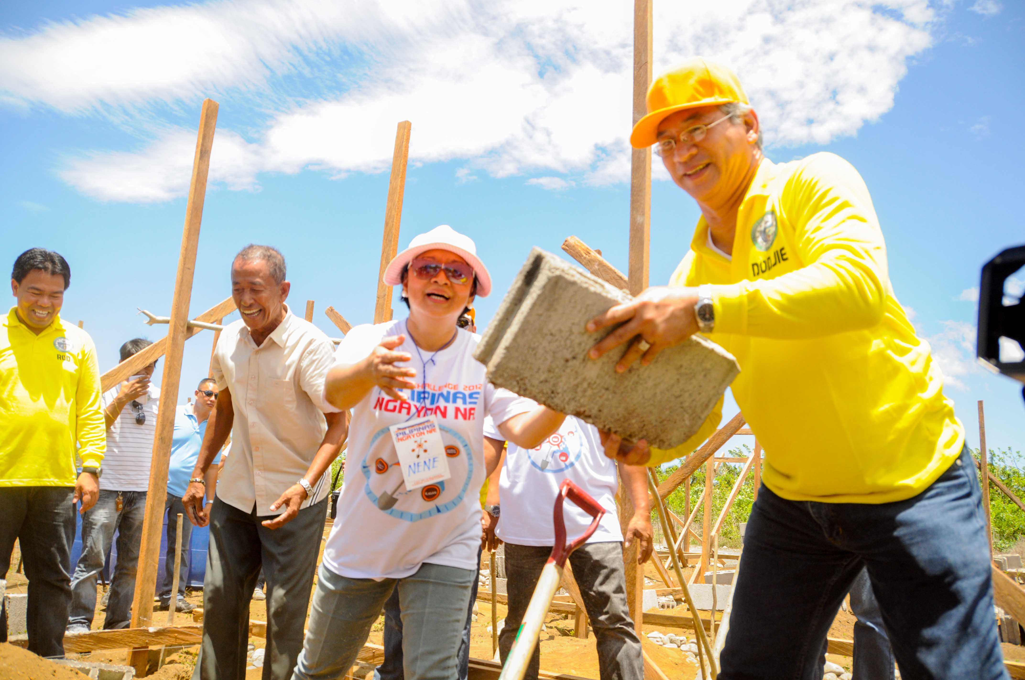
In the United States, GK is officially represented by GK USA, registered as a 501(c)(3) non-profit organization in 2009 based in San Diego, CA.
VISION: GK USA envisions a Philippines free of poverty; and a caring and sharing Filipino-American community that takes pride in its culture and identity.
MISSION: Our mission is to build strong communities in the US that foster pride in the Filipino-American identity, inspire civic action, cultivate the spirit of “Bayanihan”, and act together to end poverty in the Philippines.
Bayanihan is the spirit of communality that binds people together. It is this same spirit of caring, sharing, and helping that fuels the work of Gawad Kalinga: the belief that it is the collective acts of people which makes great and even heroic visions possible.
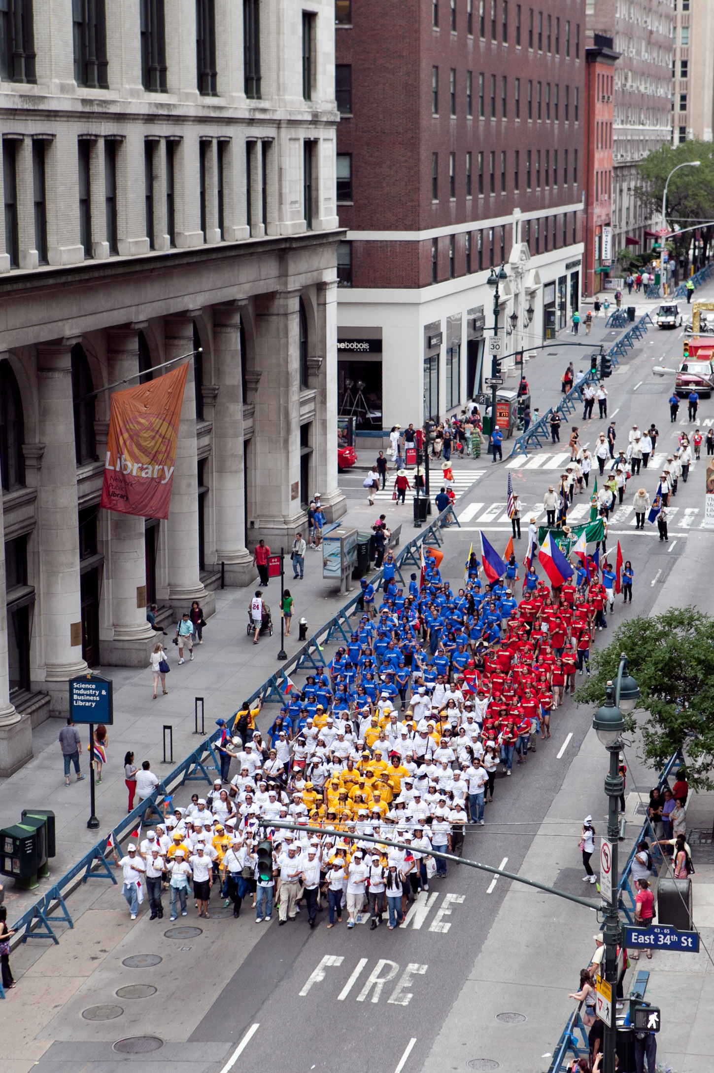

We promote partnerships, organize awareness and undertake fundraising events with organizations and individuals to support the movement in the United States and fund programs in community organizing and development in the Philippines specifically for the poor.
In the United States, we support programs for volunteerism, community organizing, scholarship/internship, disaster relief, civic leadership, and Fil-Am youth empowerment and education in order to bring people together to support the Gawad Kalinga movement in building communities for the poorest of the poor and bring five million families out of poverty by 2024.
For more information on GK, please contact us at
info@gk-usa.org or visit our website at www.gk-usa.org.
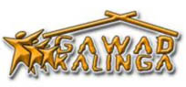
Project title: Bring a Philippine community out of poverty through Gawad Kalinga (To Give Care)
Summary:
Gawad Kalinga (GK) is a Philippine-based non-profit with the mission to end poverty in the Philippines by 2024 by engaging all sectors of society to contribute to a lasting and sustainable solution. To date, over 3,300 communities have been built for tens of thousands homeless families, restoring the dignity of the poor and getting them started on the path to recovery. We are represented in the United States by Gawad Kalinga USA, a 501(c)3 nonprofit organization.
Earlier this year, the TripAdvisor Charitable funded the construction of one village for twenty families in Bocaue, Bulacan, Philippines, with GK USA’s Boston chapter funding a second village at the same site. We would like your help in completing the funding for this second village, benefitting another 20 families. We have raised $42,000 so far and have $28,000 to go!
Funding goal: $28,000
Donation amounts:
$25
$50
$100
$125
$250
Gawad Kalinga USA-Boston, Ark of Noah and you
GK USA-Boston has adopted the residents of the Ark of Noah Community. The 98 families of the community came from temporary shelters along the railroad tracks of Bocaue, Bulacan, a city about 50 kilometers from Manila, the capital of the Philippines. The community subsequently organized itself with the help of Gawad Kalinga, and has been patiently waiting for permanent homes for the last nine years.
With the TripAdvisor grant for 20 homes and GK USA-Boston’s ongoing fundraising effort for another 20 homes, almost half of the community will be slated to receive homes by mid 2016. Ground has been broken for the villages and we look forward to sending a contingent of volunteers to help build homes at the site on April 17, 2016 once funding is complete. With your help, this will soon be a reality.
Long-term Impact
The Gawad Kalinga vision does not stop with providing homes. Consistent with our ‘hand-up, not a hand-out’ philosophy, GK USA-Boston is also in the process of incubating community health and social entrepreneurship initiatives at the Ark of Noah GK site to provide a well-rounded and sustainable solution to poverty, one family at a time. Funds raised in excess of our $28,000 target will be used to support these initiatives.
In the long-term, we would like to see the members of the Ark of Noah community with, not just a permanent roof over their heads, but the ability to create wealth sustainably, without having to fear for their health or productivity. Our immediate success metrics and milestones for 2015-2016 are as follows:
- Break ground on the two villages for 40 families: achieved on November 15, 2015!
- Complete funding for the second village, with a target of $28,000: by April 2016
- Send a team of volunteers from TripAdvisor and GK USA-Boston to meet the community and help them build their homes: April 17, 2016
- Completion of 40 homes (barring typhoons or natural disasters): July, 2016
- Recruit at least two Boston-based pre-med / medical students to train as community health interns to help develop community health infrastructure for the Ark of Noah community: July 2016
- Recruit at least two Boston-based university students to help develop a social enterprise incubation infrastructure within the community: December 2016

