Disaster Relief for the Remote Villages in Kanchipuram District
The torrential rains and the ensuing flooding of various lakes and reservoirs wreaked havoc in Chennai, Kanchipuram, Thiruvallur, and Cuddalore districts of Tamil Nadu. There has been a loss of life and property coupled with mass displacement of hundreds of rural families.
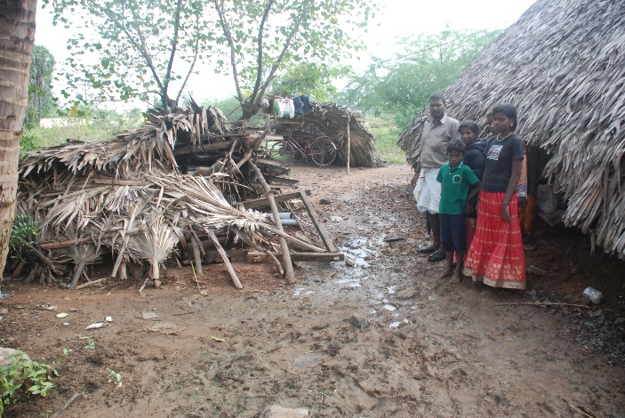
Kalanjiyam has begun and assessment of the situation in our coverage areas in Maduranthakam and Lattur blocks. We have so far identified over 100 families who have completely or partially lost their homes and are now displaced. These families resided in thatched roof /mud houses and the torrential rains have washed away all the mud walls; in some homes the roof is partially left behind, whereas in other case this has also fallen apart. The livestock and poultry have also been affected, many have become diseased and died owing to the rains. In some of the areas the crops are rotting so no yields can be expected.
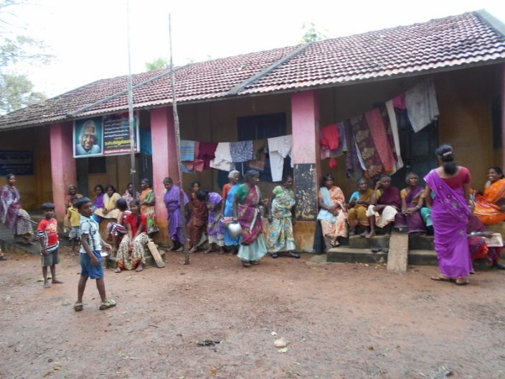
The displaced families are now being housed at schools and houses of their neighbours or those willing and able to accommodate. Some of the displaced families have shifted to their relatives’ homes or moved to cities away from the village. Kalanjiyam team has been providing food supplies/ rations in all the villages in the vicinity of our field office premises. Over the last week are also reaching to more distant areas so we can identify the needs to support. We have also been collecting and distributing clothes, blankets, toiletries, mosquito repellents, etc. Our medical van is visiting villages on a daily basis in order to attend to the immediate illnesses and health concerns that are arising. .
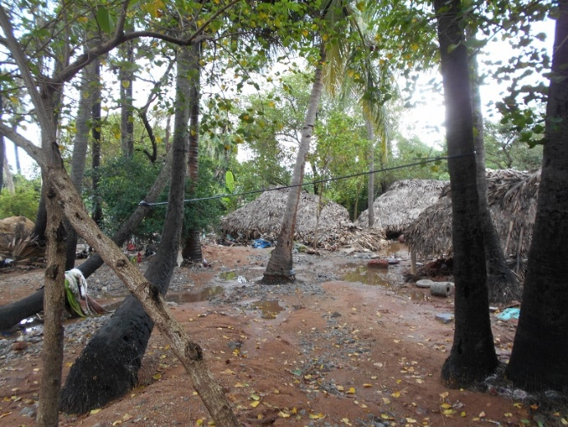
All these are only immediate needs that are getting addressed right now. All the displaced families need to be rehabilitated, and rehabilitation; houses need to be rebuilt, and all their household items and necessities need to be provided. Since many have lost their means of the livelihood in the form of livestock and poultry, they also need help in restoring livelihood or finding alternate means of livelihood.

Kalanjiyam is appealing to all of you to help us in accomplishing this difficult yet indispensable task of rehabilitation.

