*The support to the victims continued by the Foundation.*

*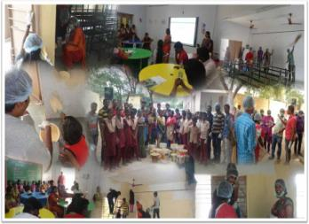School building were repaired, painted and electrified. City schools affected by the floods were done with minor repair works and painted by the team of volunteers.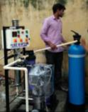 The student, teachers and the school authorities were glad to get back their classrooms even more vibrant than earlier. Some of the classrooms were also done with minor electrification works, fixing up lights etc.*

*Some schools were provided with R.O water plants so as to provide purified drinking water.*

*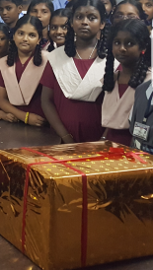*

*Most affected school libraries were covered up in the donations and surveyed on the requirements by the team from the Foundation. The books were procured based on the requirements from the schools and it includes book on Science & Fiction, moral stories & toons, dictionaries, fun with math, general knowledge, about Indian leaders, scientists etc.*

*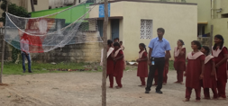The school’s sports department was also in the focus and the requirement list was analyzed and suggested materials were procured and handed over to the sports department authorities of the school. The sports kit contained in-door and out-door sports equipments like Carrom Board, Chessboard, rings, skipping ropes, throw balls, volley balls, Badminton rackets, nets, etc.*