Annual Report

Of

Hope For The Future Nepal (H4F)
Lalitpur

2014-15

Hope For The Future Nepal

P.O. Box # 8975 EPC 723

Kathmandu, Nepal
Tel/Fax: +977-1-5540967
Email: h4future2010@gmail.com

Message from the Coordinator

It is my great pleasure to see Hope for the Future (H4F) to be existed legally from 2014. Amazingly, the registration process in District Office, Lalitpur, District Administration Office, Lalitpur and Social Welfare Council were gone very easily. Then we were able to get the pan number and tax free letter from the respective offices.

This fiscal year 2014/15 was exciting for us as the project just started with new hope and a future. It started with rap up building with people, donors, community and other stakeholders. It was our great privilege to get to know some amazing people who supported us and showed an interest to do financial support. We also are grateful for our supportive committee members who encouraged us to form the organization to work for the poorest. After doing some survey and talking with local communities, we selected two backward communities Luvu and Lele VDCs of Lalitpur to begin with. We came to know the people there and their needs. We are very happy to conduct 8 training in its first year of establishment targeting poor women from those VDCs. Two training were about Health Awareness training on Women Health Problem and Prevention. The participants from Luvu and Lele were just amazing. More than 80 women got to learn their own problems, diseases and how to do a precaution and treatment. Other three training were about skill development training. We conducted 3 beads ornament making training to women from Lele and surrounding places of Lalitpur. Nearly 55 women took the training and were very happy to get the skill in free of cost. We were encouraged to see their level of satisfaction and after the training how they use the skill to earn a bit of money themselves. We will give continue in providing such skill development training in future too.

The organization also was able to sponsor 8 poor, orphan and disabled children for their education in this fiscal year. We are very much thankful to the individual sponsors for their commitment to help those children in need. The need is high so we are looking for new sponsors for other students who have requested for the education support. We also are looking for sources to support elderly people who are abandoned by their family members. We were excited to do the first AGM during this year. We made annual plan, policy and budget for the next year in that meeting.

We are still in a preliminary period but are excited to go on further in helping more and more people in need. I like to extend my thanks to our donors, prayer partners, supporters, executive board members, Government legal officials and local communities. Without their support H4F would not have started yet and would not have accomplished this year with success. I also would like to thank my co-workers for their endless support for the project success.

I look forward to continue working with you all in the years to come.
Regards,
Reshma Rai Shrestha
Hope For the Future Nepal

Introduction

Hope for the Future Nepal (H4F) is a social community development organization registered in Lalitpur District and affiliated with Social Welfare Council in 2014 July. It is established with the aim of sharing love and care to orphans, socially excluded, elderly people and all those marginalized people in the community. It plays a participatory role to equip people by providing educational, medical, social, financial, emotional and spiritual support. It provides education scholarship to orphans, needy and disabled children who are not able to go to school due to their poor financial condition. It gives skill development training to equip single and marginalized women to become self-employed and to gain confidence. It plans to give awareness training on various topics like sanitation, health, drug addiction, agriculture, environmental cleanliness and basic human rights. The organization will play a supportive role to bring an awareness of a better family where elderly people are given respect and honor. Better family leads toward better society and then a better country.

It has a mission to facilitate wholistic transformation of poor and marginalized communities through improving their level of education, health and livelihoods. This organization has been working in Lalitpur District with an aim to expand programs in other districts of Nepal when requires to improve quality of lives of vulnerable target groups.

H4F has a plan to focus mainly on 5 projects that are 1) Hope Children Education Project (HCEP) 2) Capacity Building Project (CBP) 3)Socio Economic Rehabilitation (SER) 4) Awareness Project 5) Advocacy Project to strengthen the quality of lives of the community people in Lalitpur and elsewhere. H4F provides education scholarship to orphan, very needy and disabled children for their school level education. It also supports for higher education and for technical training to highly marginalized students. The organization has a focus to help elderly people who are abandoned and single women for their social rehabilitation. The organization is in the process of making short term and long term planning.

Vision
“ A society where needy, orphanage, disabled, old and underprivileged people are given equal values in terms of economy, social, education and spiritual integration to regain a feeling of self-esteem and dignity.”

Mission
“Hope for the Future Nepal works with needy, orphanage, disabled and other marginalized people for their sustainable development by ministering to them and providing necessary physical and spiritual supports without any discrimination through the participatory approach.”

Objectives
Hope for the Future Nepal is a non-profit making, non-government social welfare organization. It will execute its programs following the law and the existing government policies and coordinating with concerned agencies to fulfill the following objectives, which are stated in the statute of the organization:

- To provide education scholarship and medical support to orphans and under privileged children of Nepal.
- To conduct different skill development trainings for helpless, single, low cast and poor women for their self-esteem and dignity. For this purpose, it will construct own training centre or hire a rental room as per need in future.
- To rehabilitate socially abandoned elderly people by providing them shelter, food, clothes and medicine. It can construct its own old age home or hire a rental house for this purpose in future.
- To develop human resources for transformation of the local community by creating job opportunities or advocating for job placement for needy and unemployed people.
- To work in partnership with like-minded organizations to reach the goals.
- To work with the community, using and recognizing their local resources to bring positive changes in education, empowerment and healthy lifestyle.
- To organize welfare projects providing social, educational and economic benefits to helpless women, children and needy people of the community. It conducts formal and non formal education to raise their knowledge level.
- To be a role model for making a better, united and helpful community by sharing in love and harmony with each other.
- To provide different modern agriculture technology training to the local farmers that will help to maximize production.
- To conduct various awareness workshops, seminars or training in environmental prevention, human trafficking, sanitation, HIV Aids, drug addiction and human rights.

The Activities

H4F has five main projects that ensure the better life of target groups. The fiscal year was the first program year for the organization so the year was busy in making initial plan, selecting program target groups and target areas, rapport building with the communities and to make a working strategy. However, we were able to start with supporting some children for their education, conducted trainings, supported few elderly citizens and also were able to do quick response for the humanitarian support to the earthquake victims.

Hope Children Education Project (HCEP)

The organization is aware of the need of education for the development of the community and the nation. Hope Children Education Project (HCEP) is one of the important project s of H4F. It provides education support to pay fee and stationary to orphan, needy and children from low income families. It always focuses on encouraging girl education since they are not very fortunate to go to school in many communities of Nepal.

It was our privilege to meet our first and encouraging donor Ms. Anne Gale from Germany in this fiscal year. We hosted an introductory program of our children who are getting support and the donor as well as the board members of the organization. There were 7 benefited children with their guardians presented and was very blessing time.
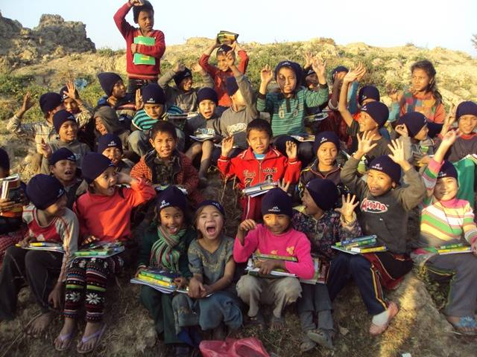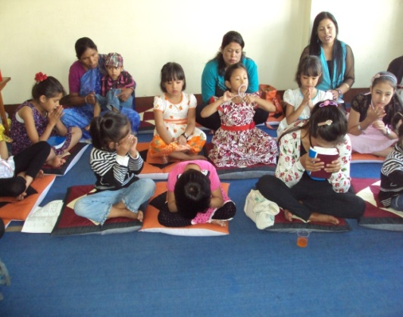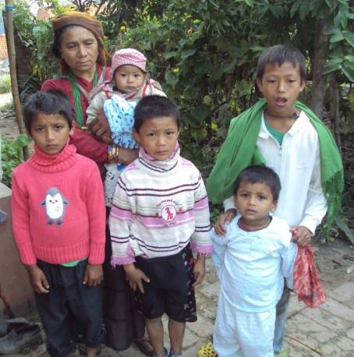

The organizations also succeed to support 9 children from class nursery to higher education already in the first year its legal status. We also distributed stationary and warm clothing to children who live or works in brick factory at Ochu. The following table shows the summary glimpse of education support:

S.No | Name of the Student | Address | Class | Remark
1 | Rupa Magar | Ramechap | Nursery | Her mother remarried with other man and her father left.
2 | Karuna Shrestha | Sanga, Kathmandu | I | Parents are jobless.
3 | Sahadev Shrestha | Dhading | IV | Orphan
3 | Isha Khati | Thankot, Ktm | V | A daughter of single mother.
4 | Sijal Shrestha | Imadol, Lalitpur | VII | Low income family
5 | Nima Lama | Dolpa, | X | She comes from very far village and needs support to study in Ktm
6 | Van B. Goutam | Sindhupalchok | IX | He is from very poor family background and he himself is a patient of muscular dystrophy. He is studying in Disabled Protection Center, Jorpati.
7 | Chhring Gurung | Dolpa | Dental Hygienist | She is a daughter of poor father in remote village of Dolpa. Her mother, sister and brother died of TB.
8 | Sangita Lama | Lalitpur | Nursing | One time support is given to her as she is from needy family.

We are getting many requests from people that show the need is very high. We are very thankful to our donors and sponsors who encourage us to run this project.

Capacity Building Project (CBP)
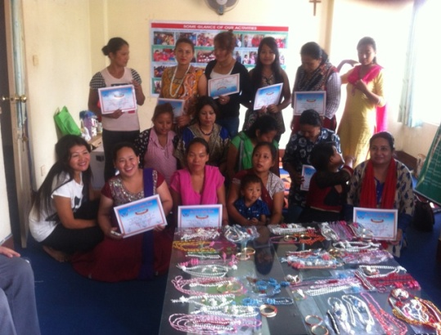
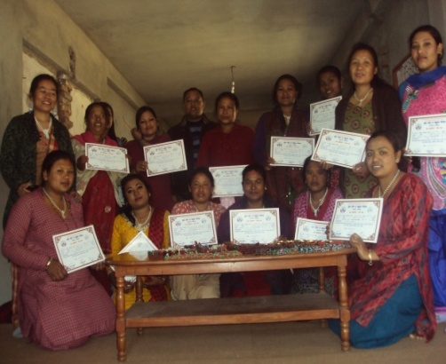
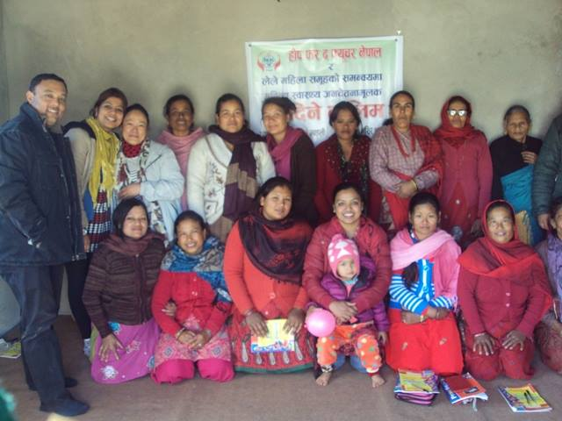
CBP is another mainstream of the organization. Transferring skill is sustainable than supporting money to the people so the focus of this project is to give various kinds of skill development training to low income people, needy and marginalized women. This fiscal year we could started conducting with 8 successful training to more than 130 women from Lalitpur district. We provided Women’s Health Awareness and Prevention training to rural women from Luvu and Lele VDCs. More than 80 women got benefited from the both training. That training was very useful for those participants from Luvu and Lele who got to know about the basic prevention knowledge of women diseases like breast cancer, cervical cancer, hygienic disease etc.

The organization gave 3 different beads jewelry making training to different women groups from Lalitpur in this fiscal year. The participants were very excited and eager to learn the skill that is very useful for earning money easily. It was very much encouraging to see their active participation and their excitement to earn bit of money from their own products. Many of them succeeded to sell different designs of jewelry to their friends, relatives and even in the shops. The trainer was very helpful and a skilled person. The demand of such training is very high and famous among women.

Table II
List of training provided by the organization in 2014/15

S.NO. | Training Subject | No. | Where | Remarks
1 | Women Health Awareness and Prevention | 40 | Luvu
2 | Women Health Awareness and Prevention | 35 | Lele
3 | Beads Jewellery Making | 25 | Lele
4 | Beads Jewellery Making | 20 | Office hall/women from Lalitpur
5 | Beads Jewellery Making | 25 | Kumaripati/Sahara group

I am Ashma Kapali. I got an opportunity to attend Beads Ornaments Making Training at Lele organized by Hope for the Future. Before attending that training, I didn’t know the beads jewelry making skill but I was amazed to make myself various designs of earring, necklaces, and bangles and to wear them where ever I go. People noticed my jewelries so they started to request me to make for them too and some even ordered me giving an advance payment. I was excited and I was able to make different designs of beads product according to their demand. That gave me confident and earning for my small expenses. I am encouraged when I got money from my labor. I started to get orders from local Beauty Parlor that is giving me regular income.
Although the income is less at present but it is helping for my personal expenses. I have given some orders to my co trainees when I am not able to make myself. My friends are also getting some money from it. I thank to the Hope for the Future for giving me an opportunity to learn such skill which gave me self-empowerment.

Socio Economic Rehabilitation (SER)

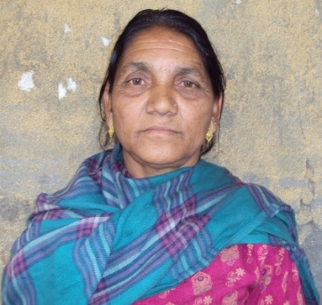
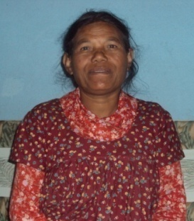
Nepal is a country of many rural villages and remote people here are struggling for two meals in a day. Millions of people have migrated from remote villages to Kathmandu and other cities looking for an opportunity, good food and better lifestyle. This migration hinders the scarcity of local resources in the cities and life became even harder for people due to the high prices of commodities. H4F addresses some rehabilitation program for urban poor and highly marginalized people for their integration into the society. The H4F has Elderly People Rehab program under SER. Situation of the elderly people is even more measurable in the city and in villages. As the society is developing in a rapid way, people are going abroad for further study and ended up in settling there. The development of technology has generated a huge gap between young and older member of the family. So elderly people are becoming a burden and thus they are left alone in the house or in the street. We provide monthly financial support to very needy and abandoned elderly people to buy medicine or to pay rent. Having our own Elderly Home or a rental house is a future plan of the program.
Harimaya

We are happy to see smile on the faces of some elderly women to whom we are able to support during this fiscal year. Mrs. Harimaya Sunar is a widow women staying with her brother in law. Mrs. Lila Nagarkoti is staying at Imadol with her son and daughter. She is physically week and needs regular medical treatment. She is very happy to get the support from H4F/Nepal.

Lila Nagarkoti

Action towards Natural Disaster Management

Relief Materials Distribution at Burunchuli VDC, Lalitpur

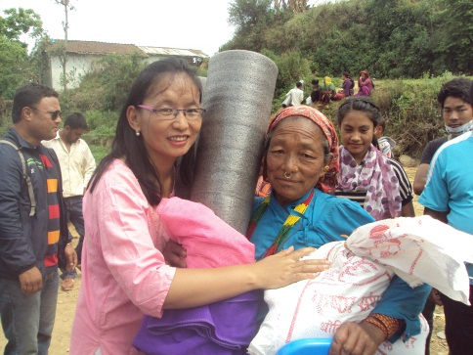
Nepal was hit by a mega earthquake on 25th of April and 12th of May. More than 9000 people lost their lives and millions of people were affected and became homeless. Burunchuli Village is one of the remote and affected villages that situate southern part of Lalitpur. This is a small village where mainly Tamang tribes live and their main source of income is daily labor, farming and animal husbandry. We found more than half of the population is illiterate. There are 65 households and almost all of them lost their houses because they were made of mud and thatch. They got tent and tin sheets from other organization so we were able to distribute other emergency daily consumption materials: rice, lentil, oil, salt, soap, towel, mosquito mat, sleeping mat, brush, tooth paste, toilet pot etc. We bought materials to distribute after doing a need based assessment and conversation with the victims. The quake affected people were so happy when they got the relief materials. We would like to give thanks to our supporters and friends.

Distribution of Tin Sheets.

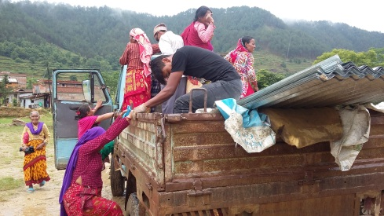
Lele VDC is another remote village of southern Lalitpur. The community is mix with different tribes like Newar, Tamang, Chettri and their main economic source is agriculture. Most of the residence houses are made of mud and tile. After doing a field, we found almost all mud made houses were collapsed and damaged after the quake of April 25. People were desperately asking for tin
roof so that they could make quick and temporary shelter to live in safely and put their belongings. We were able to distribute the bundles of sheet to 41 households at there in coordination with local village committee, local leaders and coordinator Ps. Baslal and brother Yusuf. We would like to thank and appreciate Lele VDC for its great help and coordination.

Individual Support

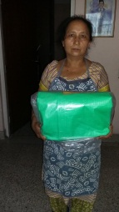
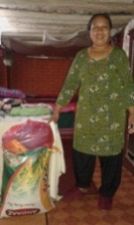
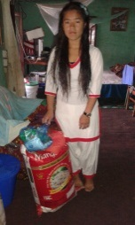
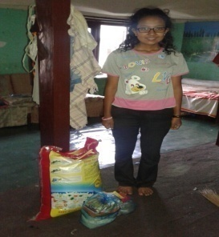
We found people who came to live in Kathmandu’s rental rooms in search of opportunities were suffering the most. Almost all are organizations were focused to deliver their support to the directly affected districts where the epicenter was but those people living in a small rents in Kathmandu were given less priority however there were many people who faced the direct affect of the disaster. We got many requests from those levels of people. The organization delivered the possible support to them after getting their requests and it was succeeded with the coordination of local leaders. We were able to give them food items and tarpaulin. They were daily laborers who have limited access of income for a better place to live in and to arrange their daily household expenses.

Story of Minakshi Rai

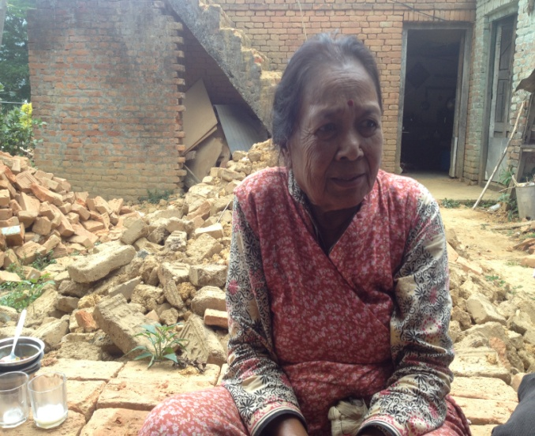
70 years old Minakshi Rai is a residence of Godawari. She is living with youngest son’s family and has one grandson. Her husband died 8 years before. Her elder son was died in an accident more than 15 years before and her only daughter is married. The only income of the family is her son Arbind’s teacher job but the income is very difficult to manage all expenses of the family. They have a mud two level house but gone collapsed by the massive earth quake. She did not get any support from any organization due to lack of knowledge. When we reached her house with some food items and two bundle of Zink sheet, she was overjoyed with tears. She offered us to eat something with her. It was so blessed moments to spend time with her and to restore smile and giving hope on her life. They were planning to rebuild a house later but for the immediate shelter they were making a temporary tin shelter to live in.

Advocacy/Project Support

H4F was please to play a supportive role for the ongoing work of a project called Mother’s Heart. Mother’s Heart is a registered NGO which aims to help resettlement of children with HIV Aids. That organization has 4 such children at present and H4F has been doing a monthly support for their monthly expenses and children education program.
Other Activities

- The organization could hold the first Annual General Meeting.
- It also did monthly prayer meetings, board meetings and meetings with other likeminded organization.
- The organization produces quarterly newsletter to distribute among friends, donors and other stakeholders.

Future Need
- We need more regular long term sponsors to support children in need for the education as we have some pending requests
- We need to look for more target working places around Lalitpur district and to hire staff.
- We need new donors and supporters for the skill development program
- We need more prayer partners, local stakeholders and good website designer.

Financial Figure of the Year 2071/72 (2014/15)

Income of the Year NRs.
Overseas Grant 1,541,302.00
Local Income 260,000.00
Membership fee 35,000.00
Total Fund Available 1,836,302.00

Expenditure of the Year
Hope Children Education Support 156,840.00
Capacity Building Program 108,143.00
Social Support Program (Elderly) 6,000.00
Project Support-Mothers Heart 200,000.00
General Support Expenses 204,960.00
Relief Distribution 348,187.00
Other Expenses/Bank Charges 3,026.00
Fixed Assets Purchased 110,700.00
Total Expenditure 1,137,856.00
Closing Balance of Fund 698,446.00
Cash in Hand 29,810.00
Cash at Bank 668,836.00

Acknowledgements

H4F would like to express its gratitude to many individual primary encouragers, donors, friends, family, partner organizations and local stakeholders who generously supported for this output of the many years dream comes true. Without their support, it could have been impossible for H4F to exist and to help so many people in its first year of establishment already.

Organizations providing technical or general support

Lalitpur District Office
Chief District Officer, Lalitpur
Social Welfare Council
Share and Care Nepal
Shanti Nepal
Village Development Committee, Luvu and Lele

We would like to give special thanks to our Main Donors, Individual Sponsors and Friends for their regular financial, moral and emotional support:

Miss Anne Gale, Donor and Sponsor (Germany)
Andrea Rachel, Sponsor (Germany)
Mary and Richard Croston, Sponsor (Germany)
Elke, Sponsor (Germany)
Anne’s friend (Germany) for disaster relief
Dick Harding Foundation (USA)
Mr. Steve Thomas, Donor for Disaster Relief, World Ministries (USA)
Niroj Manandhar, USA
Korean friends
All Executive Board members of the organization

Executive Board of the Hope for the Future Nepal

