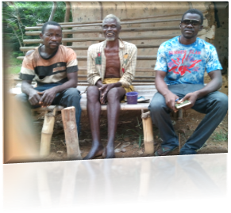  About the Author: Far right is Brocks.  Brocks Pokai, born in Bong Mines, Bong County, grew up in exile, graduated from SDA High School 2001 Ivory Coast. Certificate in Journalism, finance, NGO management, lobby and advocacy, PTSD counseling, peace building and computer software study, in Ghana at Pan African College. Brocks study community development approaches, online at the Colorado State University (CSU), organized by Village Earth. Brocks is a founding member of Initiative for the Development of Former Child Soldiers (IDEFOCS) since 2003. He establish the IDEFOCS Post Reintegration Investment (PRI) strategy, a sustainable youth driven policy that blends both charitable values with business. The policy has contributed in developing over 4000 youth, many of whom are former child soldiers and women associated with fighting forces. Brocks is the Head of finance at IDEFOCS and the Founder of GOLD. Brocks hope to see rural citizens develop the ability to set and achieve their own development objective through a democratic process, as a sustainable poverty reduction policy designed to develop rural citizens  .
  The Passion behind GOLD Establishment
  The concept behind GOLD was generated in 2010 during Brocks Pokai visit to his relatives in Gbarh’s Town, rural Grand Bassa County District one. According to the author,, the series of increasing prevalence of social inequality he observed was a life-threatening situation. According to Mr. Pokai, he saw a woman giving birth to a baby girl in a wheel barrow about 2 hours walk distance to the nearest health facilitate in Faynutolee. Brocks also observed the lack of childhood education and farm road to market were public concern. Children were drinking from shadow water. Based on this Background, the author decided to highlight an alternative which gave birth to Growing Liberia Democracy (GOLD), a rural development driven policy to improve the social, economic and political well be of rural citizens in Liberia
  Contact Us
  Phone: +231770108961
  Email: goldlib@outlook.com
  Web: www.facebook.com/goldlib
  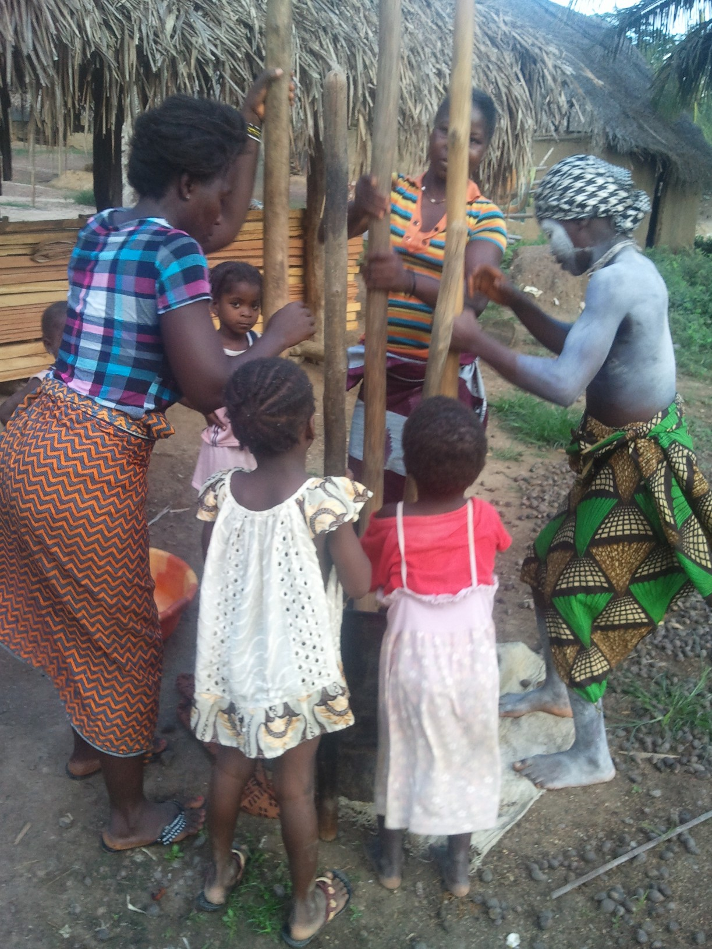 |  | gROWING lIBERIA dEMOCRACY (gold)  Opposite SD Cooper Road, Zone 12, Matadi Compound,  Paynesville City
  
  Subsistence Farming, remains the hope of decision making for rural women in family.
  gROWING lIBERIA dEMOCRACY (gold)
  Brightening the light of social equality, economic development, civic participation and women's right in rural Liberia.
  We are glad to collaborate in any of these propose projects.
  d
  d
  - LIVESTOCK FOR rual women rights and
  development
  - VILLAGE SCHOOL agriculture
  Brightening the Light on social equality through a democratic ral Liberia.
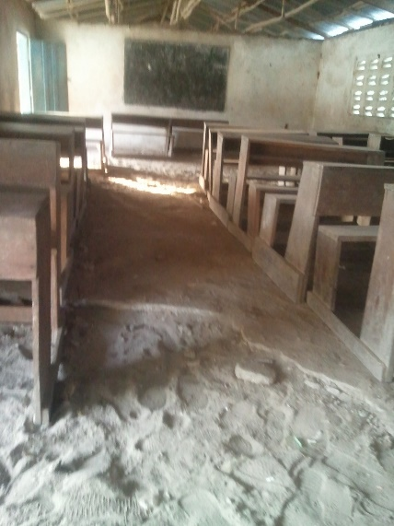  Little Bassa Public School, seeking for support in the Village School Agriculture PROGRAM.  Growing Liberia Democracy (GOLD), a civic grass root non-for profit organization that serves as watch dog between rural citizens and government with specific attention to rural women health development, family planning and livestock agriculture. We ensure the development of rural citizens is prioritized through the following training, lobby and advocacy, leadership, civic education and participation, electoral education, women and human rights education, agriculture and sexual reproduction education etc. to give them the ability engage government on their social, economic and political wellbeing. |  |  |  |  |  | 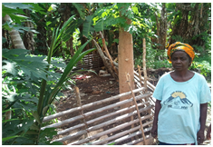  PROPOSED PROJECT  Title: The Livestock for rural women rights and development.  Rural Women in Liberia lack basic knowledge on their rights and development, many of whom live with low level of illiteracy. These women usually live as property to their husbands with very little role play in decision making. These norms and traditions in rural community continue to remain a basic contributing factor why women in rural community suffer domestic violence, rape, extreme poverty and low income level.  The Livestock for women rights and development has been designed to address problems rural women in Gbarh’s Town faced with their rights and development. The project has already identified 20 rural women who had suffered different forms of violence either from their homes, family or community.  We intend to provide these women basic leadership skill, women rights education and training in livestock agriculture. These skills are purposed to help these women develop the ability to address challenges rural women face with domestic violence, rape, extreme poverty and low income while improving their economic condition and preservation of wild life through animal farming to increase their income and protect species in their different rural community  “Don’t be shy! Show them how fabulous you are! This is a great spot for a glowing testimonial.”  Get the exact results you want  To easily customize the look of this brochure, on the Design tab of the ribbon, check out the Themes, Colors, and Fonts galleries.  Have company-branded colors or fonts?  No problem! The Themes, Colors, and Fonts galleries give you the option to add your own. |  |  |  |  |  | 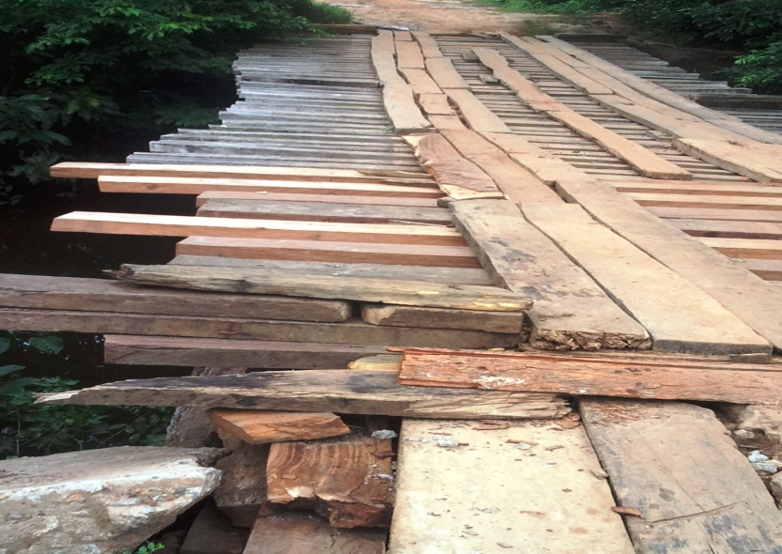  Advocating for the reconstruction of the bridge between Bong and Grand Bassa County, Faynutolee.  Current Activities  Providing leadership and advocacy education to enable local government in District 2 advocate for the reconstruction of the bridge between Bong County (Faynutolee) and Grand Bassa with the objective to promote food security in Grand Bass, Bong and Monsurrado Counties. It will also help improve farm road to Market.  We are also advocating for the recondition of the Little Bassa Public School. In helping the situation, we are working on a project called Village School Agriculture (VSA) with the focus to generate income revenue through cash crops. Fund generated from the project will be used to develop school condition every year. GOLD will continue partnering with local government, helping them with the relevant knowledge to seek the wellbeing of those they represent.

