Girl Child Sponsorship Program
“You educate a man; you educate a man. You educate a woman; you educate a generation.” – Brigham Young

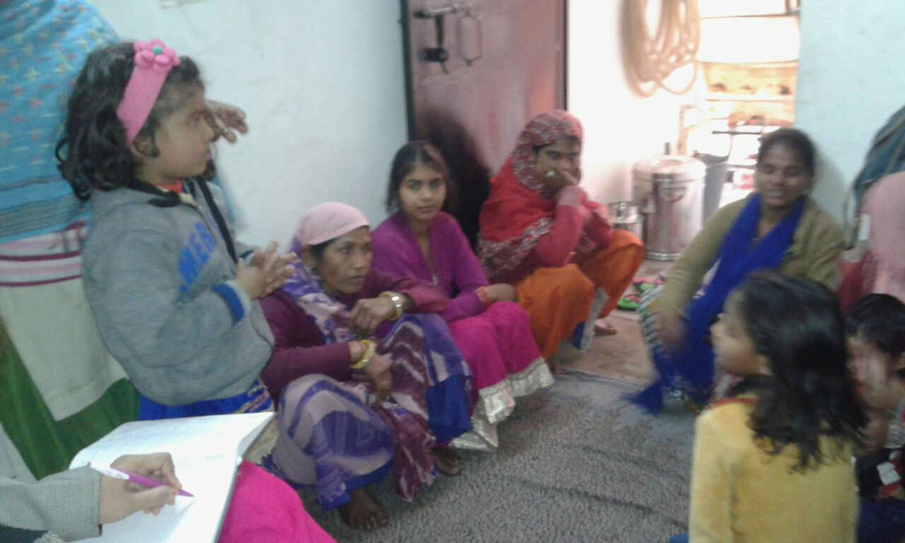

On the 10th December 2016, an event was held in the head office of Center for Social Research giving cheques of Rs. 14000 each to families who are economically handicapped to sponsor the education of their girl children. As a part of the follow up, Ms. Juthika Banerjee along with CMC staff of Vasant Kunj visited five such homes in the area of Koli Camp and a brief about each child has been written.
Aniya is the daughter of Ms. Vindhu Barini and Mr. Shivalok Maurya.
Address – CN – 183 – Koli Camp, Vasant Vihar.
She goes to Tammana Kindergarden Special School is Vasant Vihar, and lives in Koli Camp, Vasant Kunj. She wants to become a doctor in life. Her father is a house painter and her mother is a helper in Anganwadi. Orginally, the family is from Azamgarh, Uttar Pradesh. Since a long time, they are staying in this place and they are from an agrarian background, migrating from their native place. Aniya’s mother has studied up till 8th standard, and father has studied up till 9th standard. Her school fees is Rs 600, and the expenditure for her food, dress and others is Rs 450. Other than Aniya, they have another child.

Kalpana is the daughter of Mr. Ramkishor and Ms. Suman and are originally from Rajasthan.
Address – CN 183, Koli Camp, Vasant Vihar
Her father has studied up till the 5th standard and works as a driver, and her mother has studied up till the 7th standard and is involved in sewing and stitching. Kalpana goes to Savbodaya Senior Secondary Government School in Kusumpur Pahadi and is in the 2nd standard. She has a brother and a sister. Her expenditure on dress is Rs 700, shoes are Rs 400, warm clothes are Rs 200, and bag is Rs 300. So far, from the awarded money, Rs 3000 is withdrawn but entry updation is required.
Shital is the daughter of Mr. Mukesh Kumar and Ms. Rajani and are originally from Rajasthan.
Address – CN – 184, Koli Camp, Vasant Vihar.
Her father has studied up till the 5th standard and works as a labourer in building construction, and her mother has studied up till the 6th standard and works as a domestic help. Shital has a brother. Shital goes to Nagar Nigam Primary Government School and studies in the 3rd standard. Shital’s tuition fees is Rs. 1000 for two months and other than that, her other expenditures include uniform and shoes. So far, her parents have spent a total of Rs 4000.

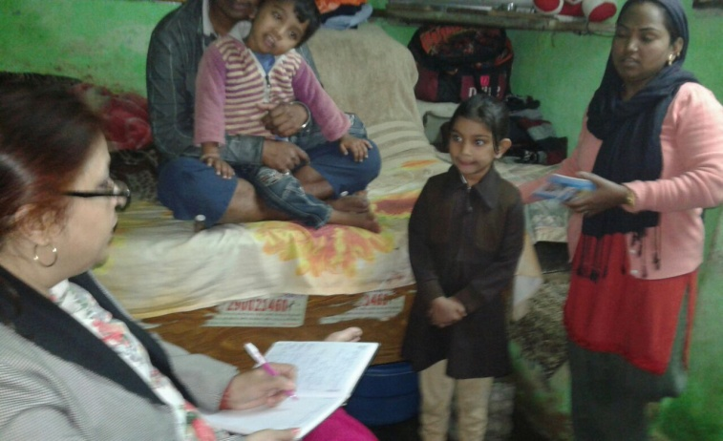
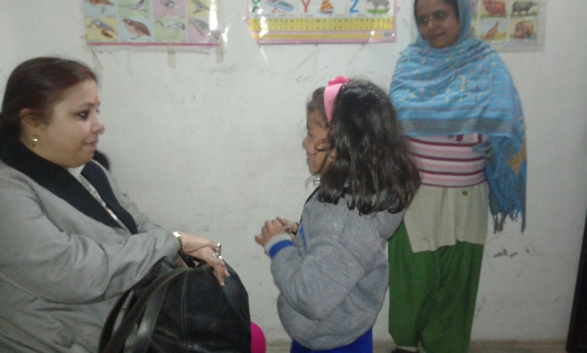
Aishya is the daughter of Mr. Kamaljeet Singh and Ms. Renu Singh.
Address – CN – 184, Koli Camp, Vasant Vihar.
Her father has studied up till the 9th standard and he is paralyzed for the last five years. Her mother works as a domestic help. They have another son. Aishya goes to Sarvodaya Vidyalaya in Munirka and is in standard 6th. So far, they have spent an amount of Rs 5000 on Aishya’s dress, books, geometry box and shoes.

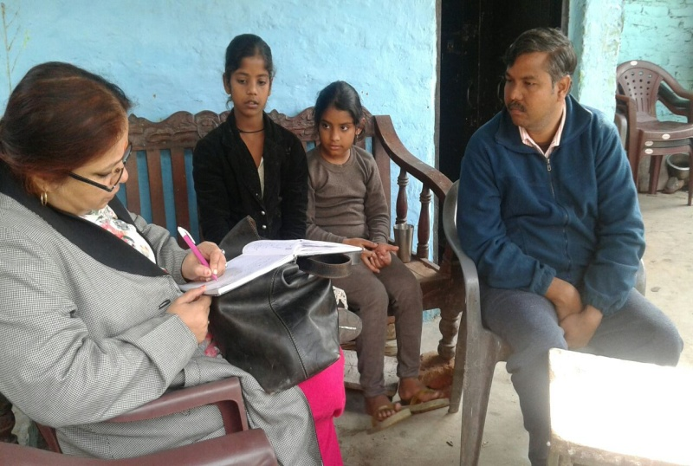

Saloni is the daughter of Mr. Amarjeet and Ms. Neetu and are originally from Haryana.
Address – CN – 184, Coolie Camp, Vasant Vihar
Her father has studied up till the 8th standard and works as a construction labourer, and her mother has studied up till the 6th standard and is a housewife. They have two more sons. Saloni goes to Sarvadaya Vidyalaya in Munirka in standard 3rd. So far, they have an amount of Rs 1000 on dress, socks, and shoes.
Through interaction that everybody has spent their money as per guidelines which has been checked expenditure on these children was verified through passbooks. Most of these families are migrants from neighbouring states and from agrarian backgrounds and have no such skills – most works as labourers and have small houses. Out of five, only one child studies in a private school and the rest are studying in a government schools. All children go for tuitions because their parents cannot assist them at home. Maximum money has been spent on books, school, and uniform. For some, whose bills could not be verified, they will be provided in time. Overall, parents of these children are very pleased and the children are also happy.
Action points –
- Regular monitoring
- House visits
- Interaction drive with School teachers and principals of 39 children

