NOVEMBER, 2015

RE: INSPIRING LESS PRIVILEDGED! PROJECT

Dear Sir/Madam,
Lifeline Dreams Organisation is pleased to present this proposal for your review. We look forward to seek assistance to provide aids and learning materials for pupils with poor performance especially in the core or fundamental subjects over the years in the district, called “Inspiring Less Privileged”. Lifeline Dreams Organisation has also targeted about five hundred and ten (510) pupils who lack certain basic materials hence having adverse effect on the academic performance. The objective of “Inspiring Less Privileged!” program is to help all pupils to reduce school drop out and to help children to improve academically especially in the Basic Education Certificate Examination (B.E.C.E.) and to motivate teachers in hither to remote areas.
During the previous year, we have been piloting the “Inspiring Less Privileged!” program with small number of pupils in the form of providing material assistance through textbooks, stationeries, Uniform, shoes and etc and to this end has seen immerse improvement academically.
- The “Inspiring Less Privileged!” program provides pupils with learning materials such as textbooks, pamphlets, pens, pencils, erasers, drawing board, mathematical sets and other things such as rechargeable lamps, school uniforms and shoes.
- It also organizes vacation classes for all final year Junior High School pupils.
- It has also made provisions to address the increasing number of school drop out due to teenage pregnancy through the frequent seminars or talk

on Sex Education and General Personal Hygiene.
- The program provides to remote schools some items including mattresses, chalk, teacher notebooks and computers.

We have seen measureable success and now seeking to expand our “Inspiring Less privileged!” program to address the needs of all targeted pupils who have difficulties due to these extensive reasons.
- Our proposal requests Three thousand two hundred dollars (US $3,200) in funding to help these children who we have identified.

We appreciate ... taking an interest in helping pupils in the district through the “Inspiring Less Privileged!” program.
Thank you in advance for your support and if you would like to be part of this humanitarian course.
Please get in touch with us via mobile +233506841629/ +233245166407/ +233240248312

website on www.lifelinedreams.org and email us on info@lifelinedreams.org
Thank you.

Robert Donald Dadson
Project Coordinator
Lifeline Dreams Organisation
Takoradi, Western Region
Ghana

Inspiring Less Privileged! Bridging the Education Gap for Rural Folks.

Date: NOVEMBER 2015

Robert Donald Dadson
Project Coordinator
Lifeline Dreams Organisation
Takoradi, Western Region
Ghana

Inspiring Less Privileged! Bridging the Education Gap for Rural Folks.

Project Abstract
Lifeline Dreams Organisation is seeking a grant to expand our financial assistance that she gives to brilliant but needy students with the objective of helping all pupils who are brilliant but lack reading and learning materials as well as students in the remote areas to help increase their academic performance and help curb school drop out in these remote areas.

The objective is that by the end of the year, the pupils would have at least improved in the performance of their academic work including Basic Education Certificate Examination results and to motivate teachers to accept posting into the remote areas. Also to bridge the gap between the less privileged and privileged children in the society. The “Inspiring less Privileged!” program is based on the personal findings of inadequate supply of learning materials of pupils in the remote areas. Funding in US $ 3,200 is requested for remunerating fifty professional teachers for vacation classes, purchase of computer for ICT and purchase of school supplies for the beneficiaries.

Statement of Need
According to the Shama District Education Public Relation officer (P.R.O). Mr. Emmanuel Mensah Tornigah, the district (Shama) in the Western Region of Ghana, presented a total of 1,540 candidates in 2014, from which 1,072 failed. He added that fourteen (14) could not write due to pregnancy and absenteeism. In effect, the students in the district perform poorly the Examinations. Some also find it very difficult to be punctual at school because of inadequate provision of school uniforms, shoes and etc. Out of an estimated number of 1,600 final year pupils currently, the program has targeted five hundred and ten (510) pupils within the district including Kumase-Shama, Supomu-Dunkwa, Annto- Aboso, Assorko- Essaman and Sofokrom.

Program Description
Inspiring less privileged! program will enable final year JHS pupils to receive

tuition from ten (10) professional teachers during the vacation in the core subjects. It will also provide school uniforms, shoes and other stationeries to ten selected pupils in the remote schools and also to motivate teachers in eight selected schools. To curb the problem of teenage pregnancy during B.E.C.E. , the project has planned to organize sex education seminars periodically for the pupils. The main motive behind their development is to improve the B.E.C.E. results, motivate brilliant but needy pupils, help curb teenage pregnancy and motivate teachers who would be posted to the remote areas

Goals & Objectives
The goal of Inspiring less Privileged! Project is to inspire young lives and to bridge the gap between the students from the urban areas who have access to private quality education and those in the rural areas.

The main objectives include

1. Providing a measurable increase in B.E.C.E. results

2. Reducing teenage pregnancy during B.E.C.E. and among the rural folks in the
district through seminars and talks

3. Motivating brilliant but needy children as well

4. Motivating professional teachers and national service personnel’s in the
remote areas

Timeline
Activities
Submit Grant Proposal | October, 2015
Expected Grant Notification | November, 2015
Acquire Desktop Computers | April, 2016
Vacation Classes | April – May 2016
Mock Examination | May 2016
Prepare Results Report | May 2016

Budget

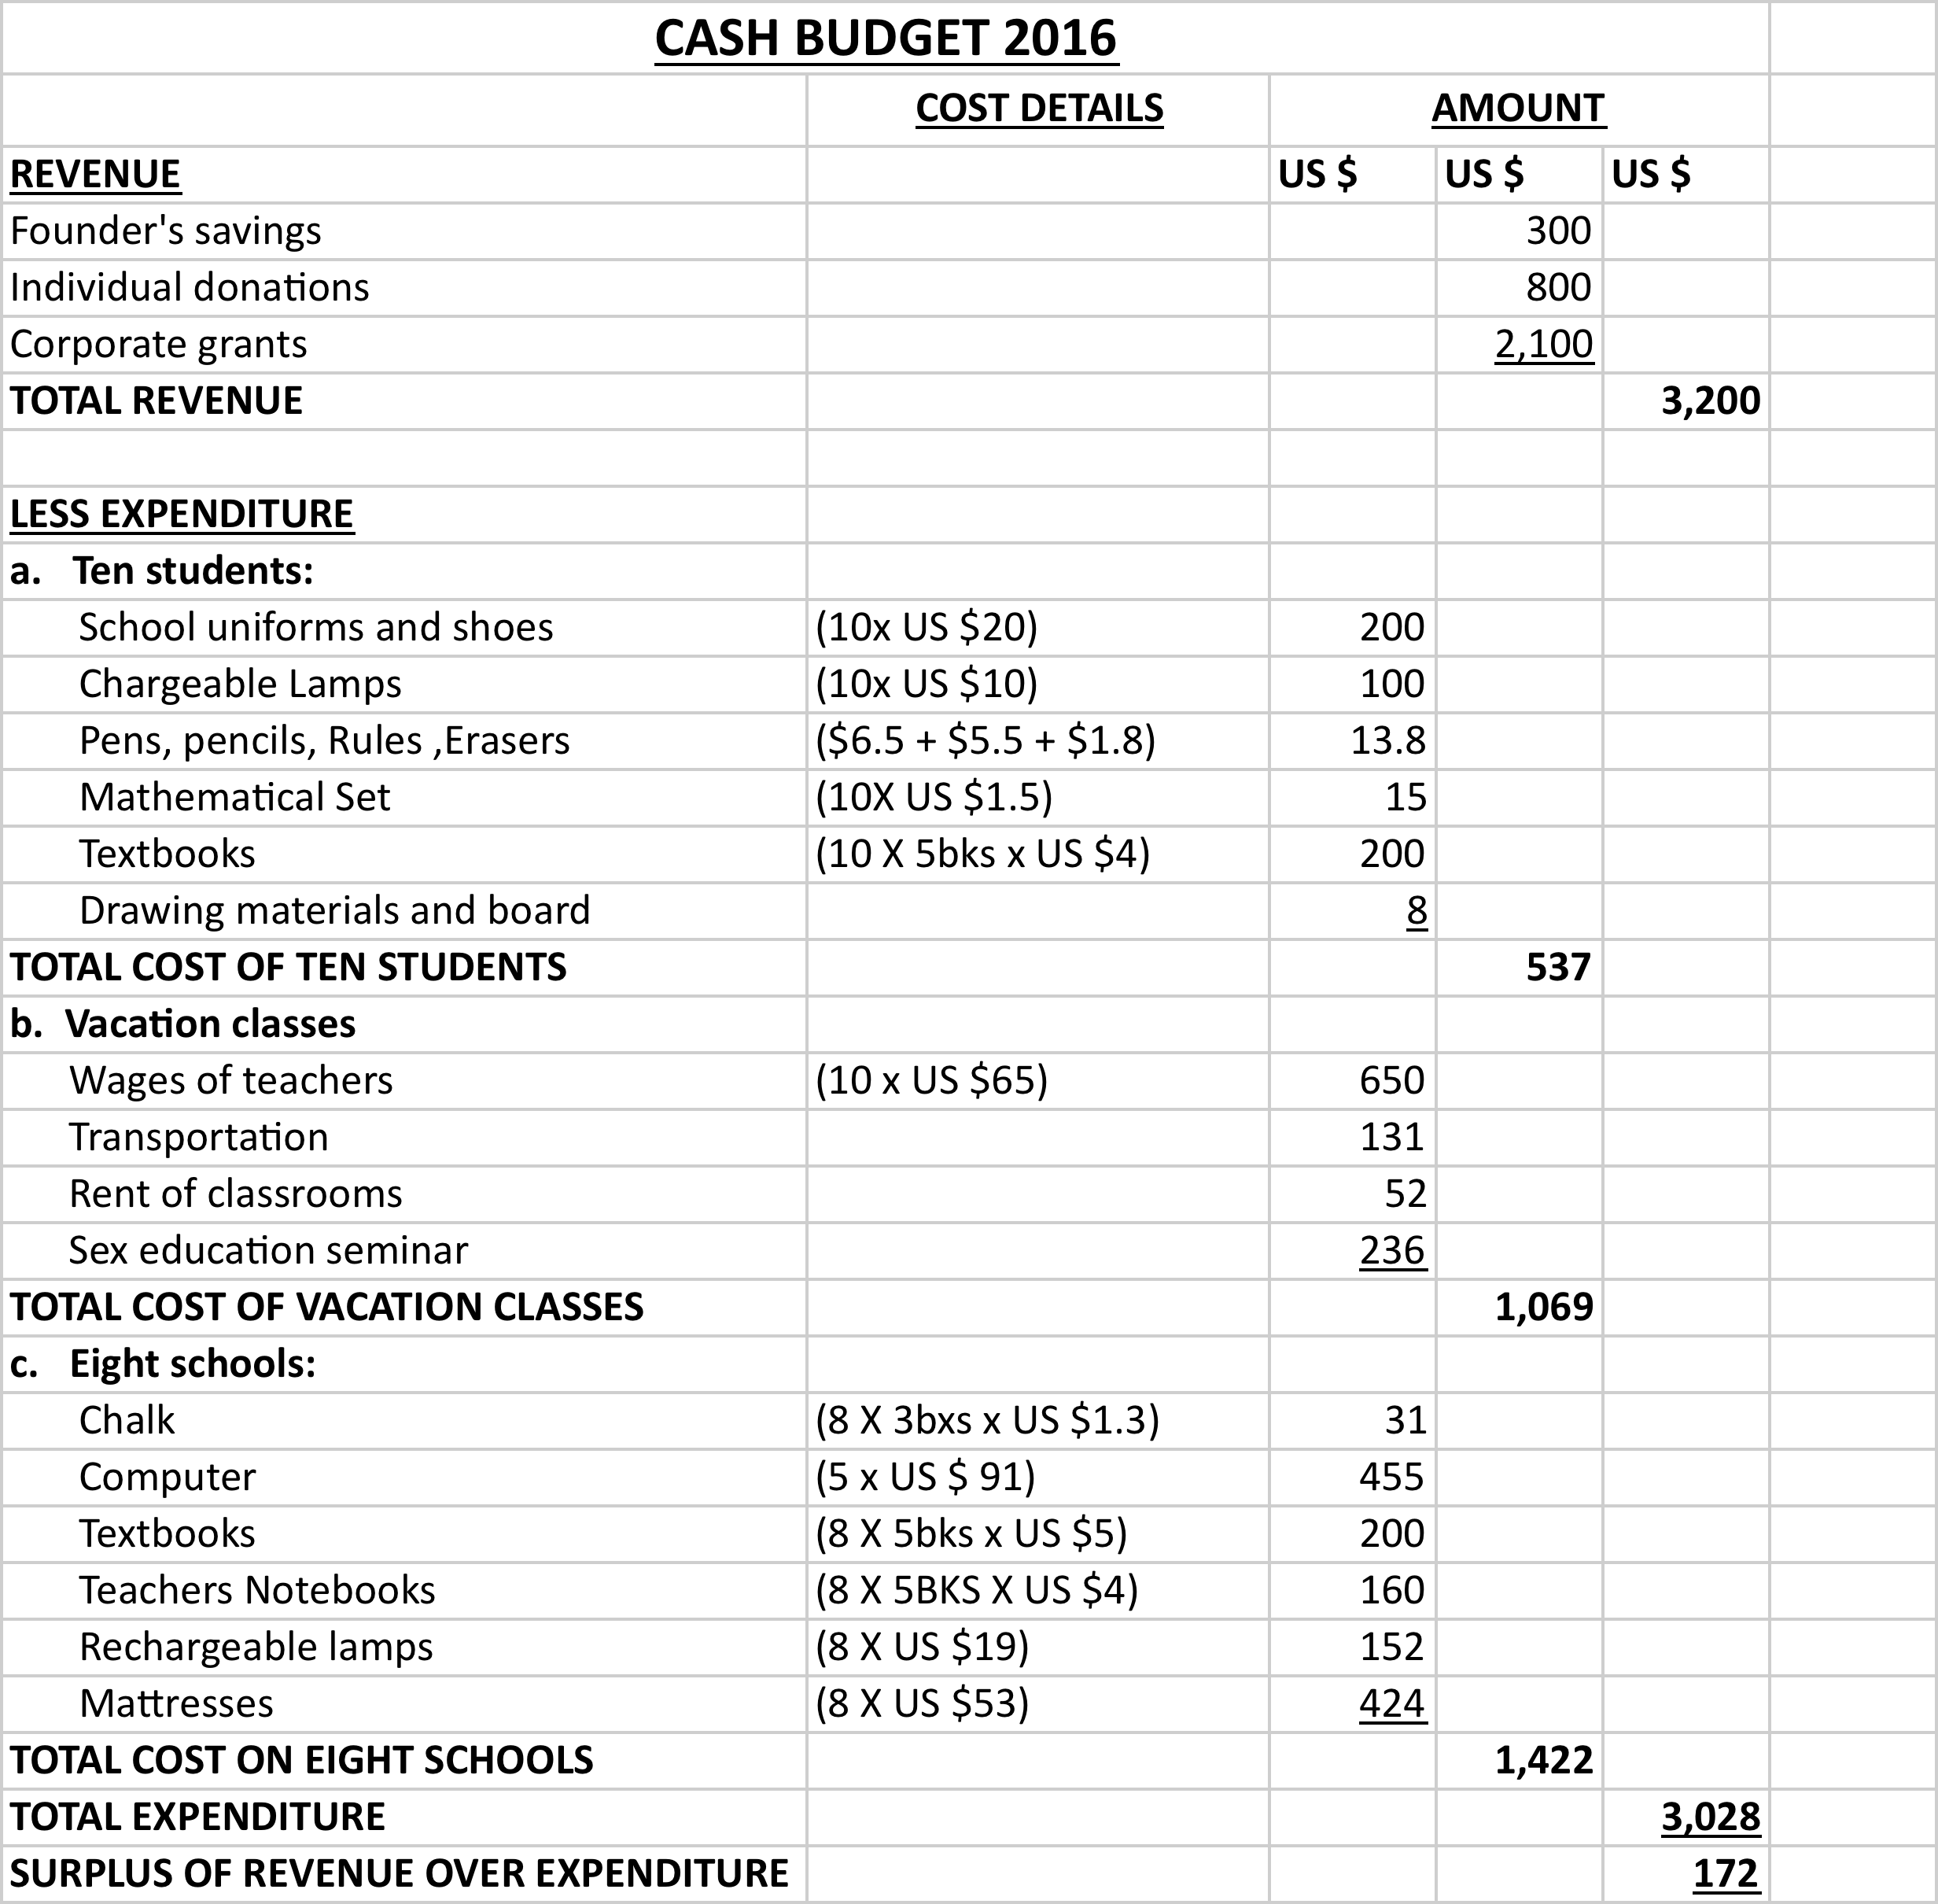

NOTES TO THE BUDGETS
a. The budget includes sponsorship for ten brilliant but need pupils by way of

providing them with financial assistance where necessary and material assistance including school uniforms, shoes, rechargeable lamps, stationeries, drawing board etc
b. It also includes the cost of organizing vacation classes for JHS final year students (510pupils) within the district especially for the core subjects namely English Language, Core Mathematics, General Science, Social Studies and Information Communication Technology. The cost includes wages of fifty professional teachers, transportation cost of both teachers and students during the period. The budget also made provision for organizing sex education seminar for students.
c. Included in the budget is a provision of learning and teaching materials or aids for eight selected remote schools in the district such as chalk, textbooks, teacher’s notebooks, rechargeable lamps, mattress and other stationeries. The organization has three computers and for the benefits of effective learning and teaching, five computers have been included in the budget

Financing
In financing the above expenditure, the budget target US $300 from founders fund, US $800 from individual donations and US $2,100 from corporate business.
Evaluation
Effective supervision shall be conducted at the start of the term and the end of the term in order to check the attendance of the teachers and performance of pupils. Additionally, mock examination shall be conducted for final year pupils to determine their performance in core subjects.

Staff and organizational information
1. Ebenezer Yankey, Head of Art Departments holds a Bachelor’s Degree in
Social Science Education from University of Education, Winneba. Ebenezer
Yankey is working with students with severe reading difficulties. He will be
responsible for supervising and checking teachers attendance and students
performance respectively

2. Peter Mensah, Head of Business Department holds a Higher National Diploma
in Accountancy from Takoradi Polytechnic and a Diploma in education from
University of Education, Winneba. Peter Mensah has taught for ten years, four
years in basic schools and six years in secondary school respectively. He is also
the Head of Timetable committee. He will be responsible for organizing buses
for students and teachers and also drafting timetable for the classes.

3. Dela Aho, holds Bachelor’s Degree in Education (Management) from
University of Cape-Coast. Dela Aho has taught at both the basic and
secondary schools. He has volunteered for implementing the pilot program
in August 2014.He will be responsible for dispatching the teaching and
learning materials and stationeries to students as well as teachers.

4. Vincent Atobrah, holds Bachelor’s of Science Degree in Agriculture from
Kwame Nkrumah University of Science and Technology (KNUST), Kumasi-
Ghana. He was a head teacher for a year and has taught in secondary school.
He was a literacy facilitator in the Non Formal Education Division (N.F.E.D.) for
a year. He has also taught Mathematics and Integrated both at the basic and
secondary level. He will be responsible for training integrated Science and
Mathematics tutors.

5. Marian Acquah works with Kwesiminstsim Poly clinic and our resource person
She is will be educating the pupils through the seminar on Sex Education,
Teenage Pregnancy and its implications and Personal Hygiene. She is a
registered nurse with five year experience after a General Nursing Diploma
and now pursing BSc. Emergency Nursing at Kwame Nkrumah University of
Science and Technology.

6. Robert Dadson, Projects Coordinator with extensive knowledge across three
fields has banked experience over the years. With an Engineering background,
he has also worked in formal education, currently working as the Assistant
Head teacher of Golden Gate Senior High School and Out door Education
(Activity Head and Age Group Leader) in Ghana and the United Kingdom
respectively. He was responsible for implementing the successful pilot test
program in 2014. He is proficient with Learning technology, including software
and hardware.

Lifeline Dreams Organisation
P.O.Box Ax 714
Axim Road, Takoradi
Ghana
November, 2015

RE: INSPIRING LESS PRIVILEDGED! PROJECT

The lifeline Dreams Organization in Ghana is seeking a grant to provide help less privileged in the rural areas. These pupils currently are out of school or lack required learning materials and performs poorly academically, with some not having any basic reading skills. The objective of “Inspiring Less Privileged!” program is to help all pupils in these remote areas to reduce school drop out, to help children to improve academically especially in the Basic Education Certificate Examination.

The funding in the amount of Three thousand, two hundred dollars (US $ 3,200) is requested to implement this program and for purchase of teaching and learning materials for teachers and selected remote schools, purchase of computers for ICT training for the pupils, textbooks, school uniforms and others.

Lifeline Dreams Organisation has about five hundred and ten (510) pupils who have been identified to be at risk for a reality of reasons such as inadequate teaching and learning materials and motivation of teachers.

Additionally, Lifeline Dreams Organization is eligible for funds and if these pupils are not given the opportunity to improve their performance. They are at risk of falling behind their counterpart in urban schools making truancy and school drop out more likely as it is prominent in the district.

The budget includes sponsorship for ten (10) brilliant but needed student, cost of organizing vacation classes for about five hundred and ten (510) pupils JHS final year and provision of learning for eight (8) selected remote areas.

We appreciate ... taking an interest in helping pupils in the district through the “Inspiring Less Privileged!” program.

Respectfully submitted,

Robert Donald Dadson
Project Coordinator

