JUHUDI CHILDREN IN
CRISIS (JCIC)
PROGRESS/IMPACT REPORT 2024-2025
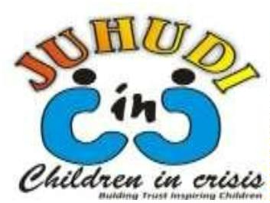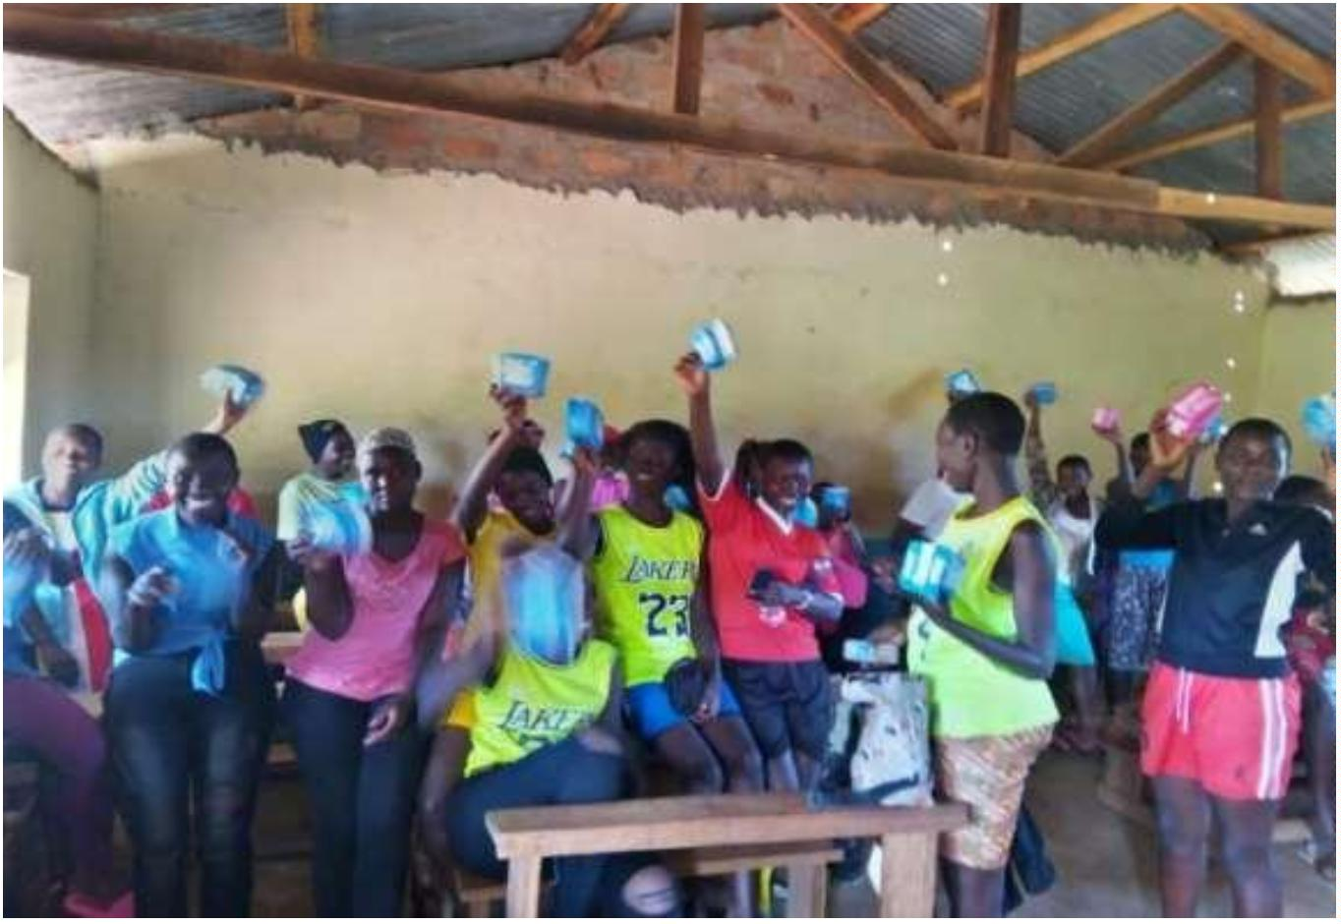

1. Girls we can
Girls we can is a slogan that came up after we managed to rescue many girls from early
marriages. Most communities had believes that a girls should not be educated but get married.
Since the inception of our project, early marriages have reduced drastically. We are now
registering few cases of early marriages. Girls have been empowered to know their rights of
education. Also parents have realized that girls are also important like boys and they can do
better than boys.
In schools you find that we have more girls than boys. The girl’s enrollment has surpassed those
of boys. Even the performance, girls are doing very well in their exams, registering more
number going to university.
Gift is very happy in school and working hard to catch up with others in her studies. Gift was at
the risk of dropping out of school you came in handy and saved her. Her smile speaks
everything on her step to the future. She has promised us to work extra hard so that she can
change life of someone else in future.
We always remain humbled for the support that you give our girls. we continue counting on
you to see more vulnerable girls remain in school.
We are always determined to see that our School going girls, students pupils and all
beneficiaries received much-needed school supplies—including pencils, notebooks, books, and
more. These supplies are not just tools for learning—they're symbols of hope, encouragement,
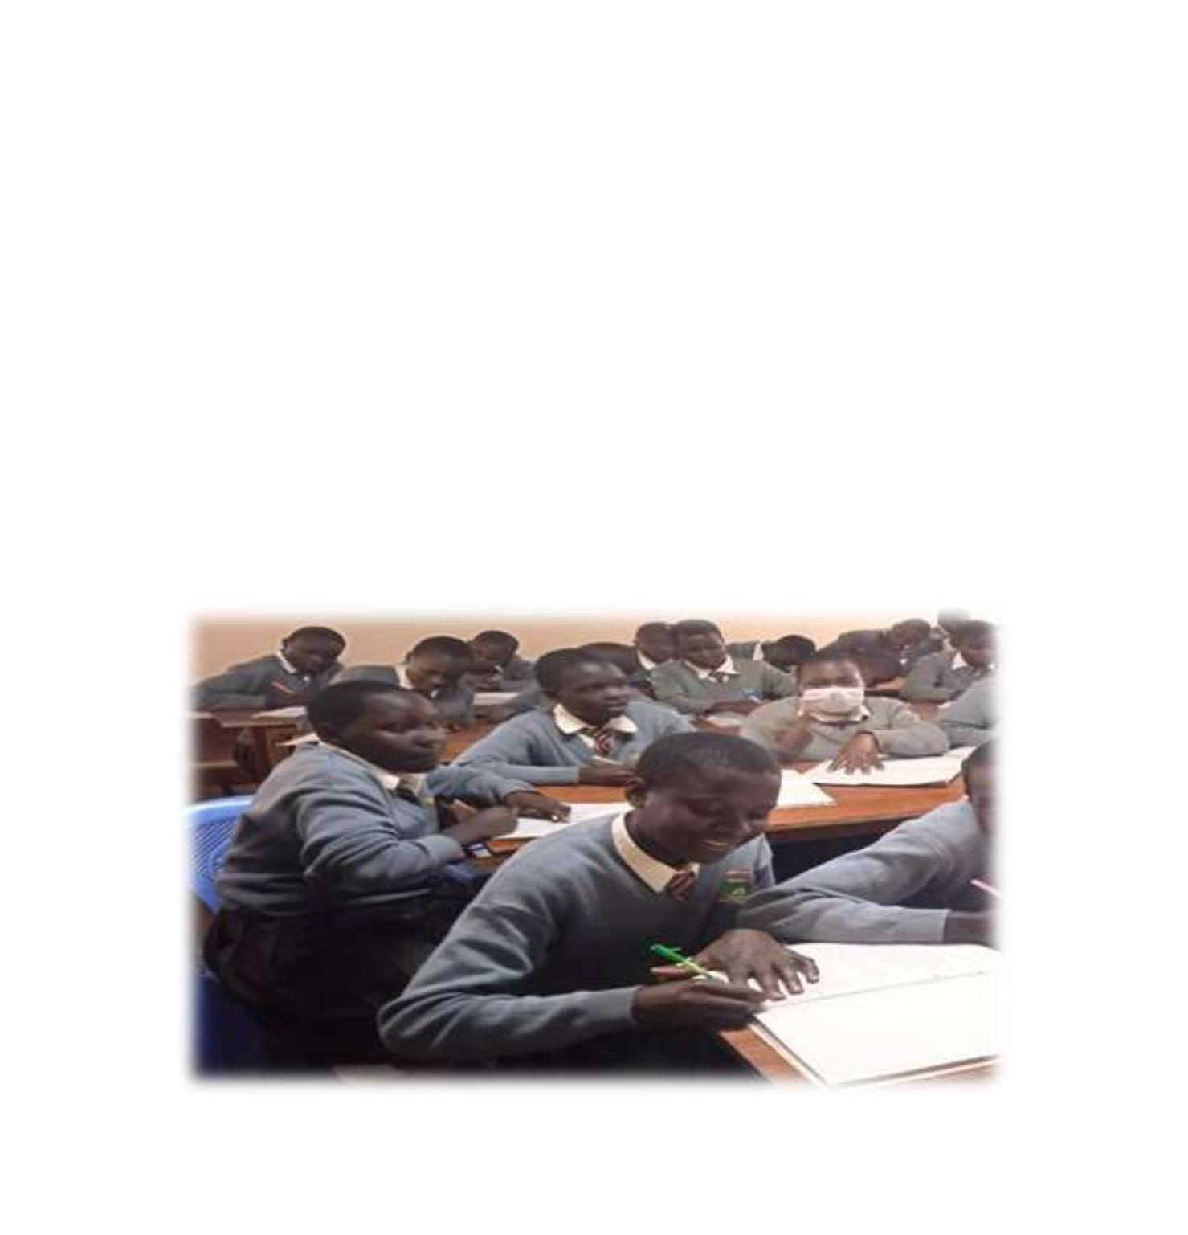

and opportunity. Apart from making sure that they access basic needs for their education as
uniform we remain steadfast in making sure that our beneficiaries remain in school.
2. Mildred proceeds to university
Do you remember the story of Milly? We have been supporting her since she was in primary
school. She went to secondary school determined to make it to the university and later come
back to support her community. As we speak today, after her final secondary school exam,
Milly has made it to the university and she has secured a chance to peruse a degree in
counseling Psychology.
We are very proud of her that we have walked the journey together since she was young. This
has been possible through you sharing of what we do with friends and network and making
sure that you are always contributing towards many girls education with financial support. We
say big thank you for the donations.
As Milly and many girls are joining university this coming month of September, we welcome any
support from you, friends and network to assure our girls that they will be part of the team the
will be on frontline that will start the semester.
3. A happy community
Am happy today to report back to you about Educating an Orphan child. This project started
long time ago and it has changed the life of many orphan children in the community. Over 1500
children have benefited through this project. It is one of our milestones we have achieved in
our organization. This could not been happened without you. You have been so committed to
this project by supporting it up to this level. The whole community is happy about our work.
We have recently admitted 70 new beneficiaries from the marginalized community into our
program. These children come from underprivileged backgrounds, and their families cannot
afford to provide them with quality education. However, with your help, we can change that. By
sponsoring the education of these children, you can help provide them with the opportunity to
learn and grow. Through your unwavering support, this will make the girls and children remain
in school and break the cycle of dropping out of school and early marriages for underage. This
will break the cycle of poverty and improve their chances of a brighter future. Your contribution
will not only benefit these children but will also have a positive impact on their families and
their entire community. We urge you to consider becoming a sponsor and helping us make a
difference in the lives of these deserving children.


4. Continued Unwavering Support for orphan children
We always foresee their education, meals both at home and in the institution that they go.
We do regular awareness sessions on personal hygiene, sanitation, and health safety. Our
commitment to nurturing and educating these children began more than ten years ago with
just two orphaned children. Today, we proudly sponsor more than 200 orphan and
vulnerable
children
from
different
communities
in
where
we
work.
5. Gift is happy in school
Girls like Gift are receiving the education they need to build a brighter future, thanks to support
from generous donors like you. Gift has just started her education after the challenges that she
was facing made her stay at home. Gift is a very bright girl who has stayed home to make sure
that her old grandma is safe. She only remains with the option of going to work in the farm
around to make sure that at least she gets a meal a day.
Recently, she was provided with a full support to get food to her and her grandma to make sure
that she has enough time to access education. In addition, your contributions have also helped
cover her tuition fees, easing the financial burden.
