THE ONE LOVE STORY
One Love was founded in 2010 after Yeardley Love, a senior at the University of Virginia, was killed by her ex-boyfriend, also a UVA scholar athlete. After her death, Yeardley’s friends and family were stunned to learn that 1 in 3 women and 1 in 4 men will be in an abusive relationship in their lifetime. Young women ages 16-24 are at 3X greater risk and have limited awareness of that fact. One Love exists because Yeardley was killed and her death was avoidable. Today, we work to ensure that everyone has information about unhealthy and abusive relationships that Yeardley, her friends and her family did not. We want everyone to understand the danger in these types of relationships and empower them to leave an unhealthy situation—or help a friend leave—before it escalates to abuse.
OUR APPROACH
One Love’s educational approach starts with the creation of emotionally compelling, film-based content that opens people’s eyes to the presence of unhealthy and abusive behaviors in their lives. This content sparks conversations unlike others that have taken place before and gives people guideposts on how to talk about unhealthy and healthy relationships. In opening people’s eyes and sparking conversations, we are establishing stigma around abuse that we believe is the first ingredient in changing the horrible statistics.
Newly awoken and motivated to help others, individuals on campuses and in communities around the country are raising their hand and giving their time, energy and resources toward the movement by joining Team One Love. This decision to participate and desire to help in whatever way —no matter how big or small—is the key to moving from educating to movement-building to social change.

Escalation Workshop
The Escalation Workshop is a 90-minute, film-based experience that educates about the warning signs of an abusive relationship, creating a safe zone for discussing an all-too-common problem. Over 135,000 students have seen Escalation at over 2,900 unique workshops. The workshop is consistently cited as “relatable” and “eye-opening” by students. Here’s what to expect:
- The film, Escalation, introduces us to Page and Chase, a college-aged couple whose relationship starts exciting and fun, but ends in tragedy. The film enables students to understand the more nuanced signs of relationship abuse as well as how important it is for friends to step in if they see these behaviors.
- Following the film, the audience breaks into small discussion groups led by One Love trained facilitators to discuss key scenes from the film. Groups talk about the warning signs, actions that could have been taken, and how the film relates to their own lives.
- In the last 10 minutes, students can join Team One Love where they will be provided with additional messaging around healthy and unhealthy relationships as well as receive activation ideas they can bring back to their friends and campus community.

Team One Love
After the workshop, students are prompted to join Team One Love—a community of over 15,000 people nationwide excited to carry the torch around this issue in their communities. Whether a student joins Team One Love individually and/or starts an official club or group on campus, One Love provides them with access to One Love staff mentors, continuous messaging about healthy and unhealthy relationships, and ideas on how they can continue to educate and empower others in the community around relationship abuse.
We are increasingly co-creating specific campaigns with students who can then bring them to their campuses to build momentum and awareness about healthy relationships and One Love Foundation. Examples of campaigns include: #ThatsNotLove flyer campaigns, Stick it to Love, the Scarlett Bookmark, #ThatsNotLove playlist. One Love’s virtual intern program has engaged 85 college students deeply in the last year, supporting them in their efforts to mobilize their campuses and enabling them to network with each other.

#ThatsNotLove Campaign
The discussion about healthy and unhealthy relationships has also been brought online through the #ThatsNotLove campaign. The five chapters of One Love’s #ThatsNotLove campaign have been viewed a combined 60 million times.
#ThatsNotLove is a series of short, shareable digital content in six unique chapters [Chapter 1: Because I Love You, Chapter 2: Couplets, Chapter 3: Asterisk, Chapter 4: Love Labyrinth, Chapter 5: Pets vs. Partners and Chapter 6: Behind the Post launching soon) that seeks to define the gray area between love and control. The campaign was intentionally designed and named to allow people to use the phrase, “That’s Not Love!” when they see friends in an unhealthy or abusive relationship.

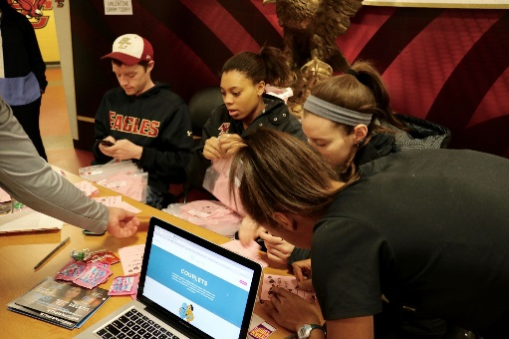

OUR IMPACT

“I saw [the Upworthy video of Love Labyrinth], And Im the guy, I am so the guy, I know i am wrong, I want change but idk how. I dont like hurting the person i like and it always ends up hurting me too but i know i hurt the other person more now”
"One of my friends who was at the workshop last night texted me last night about her friend she didn’t realize is in an abusive relationship - She called her friend and talked about it last night. She said this was the first time her friend was honest with her about how her boyfriend has been treating her. Thanks for doing what you do, you already made a difference in someone’s life here at LUC!"
“Your Love Labyrinth video helped me realize that the relationship I was in was unhealthy and my boyfriend at the time was emotionally abusive and controlling. It was like watching a short film of what I was facing daily. Thank you so much. Leaving him was very messy and scary and emotionally taxing but I'm so thankful that I was able to. My friends and family had been warning me about him, but I made excuses. Your foundation helped me wake up and realize that it was not normal. Keep it up, you changed my life. God bless.”

- Over 135,000 young people in communities across the country have participated in the Escalation Workshop, a number that has doubled since March 2016.
- To date, our #ThatsNotLove videos have been viewed over 60 million times.
- Over 9,000 people have been trained as facilitators of the Workshop, a number that goes up every day.
- In recent testing, 99% of participants would recommend Escalation to a friend and 97% believe it should be required at their school.
- Nearly 15,000 young people have signed up to join Team One Love, signifying their desire to stay active and engaged in our work going forward.

TOGETHER, WE CAN CHANGE THE STATISTICS AROUND RELATIONSHIP VIOLENCE
