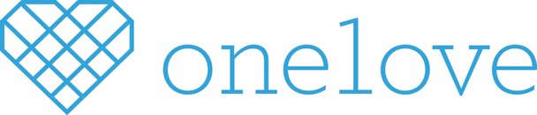
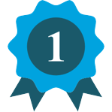
OUR IMPACT
Our compelling content has taken campuses and communities by storm, below is a snapshot of
our impact since January 2015:
Workshops
Participants
250K
Trained Facilitators
15K
#ThatsNotLove Campaign
Views
85M
483K
Social shares
“You gave me the
power to leave and never go back and I just wanted to thank you for that.”

ONE LOVE EXISTS FOR ONE REASON
Yeardley Love was killed and her death was avoidable. Then a senior at the University of Virginia and three weeks shy of her graduation, Yeardley was beaten to death by her ex-boyfriend.

Devastated by her loss, Yeardley’s family created One Love, a foundation that educates young people about the difference between healthy and unhealthy relationships so that they may seek help before an abusive relationship escalates to violence.

OUR APPROACH: ENGAGE COMMUNITIES
IN A MEANINGFUL WAY
Through a dynamic, multi-layered education and social engagement campaign, One Love educates and equips young people with knowledge to help them develop healthy relationships and the tools to avoid abusive ones.

By intervening early with content and conversations that highlight the difference between healthy and unhealthy relationships, we are improving young people’s relationship IQ and helping them navigate their relationships in a positive way.

Learn: Discussions through innovative content
People are never too young (or old) to learn about healthy relationships. In fact, we need everyone to participate in this conversation to create real change. Our preventative approach gets young people talking earlier and more often, as we pair educational videos with research-based discussion guides to foster deep conversations amongst peers. You can access all discussion guides by going to www.joinonelove.org/act/start-convo/. Here is a snapshot of our content offerings, followed by suggested distribution options categorized by age group:

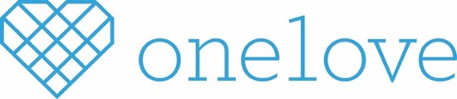
CONTENT

ESCALATION WORKSHOP

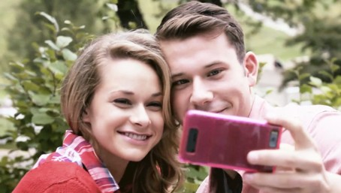
BEHIND THE POST

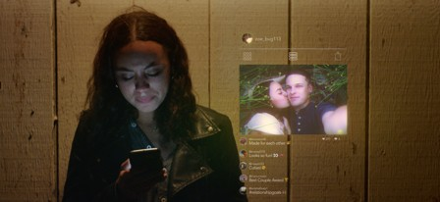
BECAUSE I LOVE YOU

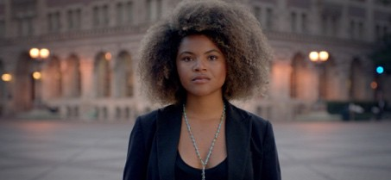
LOVE LABYRINTH

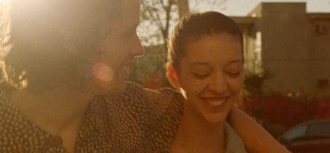
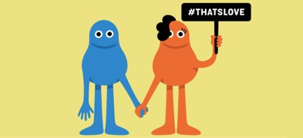
COUPLETS

90-min or Three 40-min Sessions | Recommended for ages 14 – 22
The Escalation Workshop is a film-based experience that educates about the warning signs of an abusive relationship. Utilizing peer-facilitators trained by One Love staff, Escalation provides young people with the framework they need to identify the warning signs and the tools to help a friend who may be in an abusive situation.

40 – 60 min | #ThatsNotLove Series | Recommended for ages 14 – 22
Social media can skew our view of the relationships around us and, in some cases, influence our decisions to stay in unhealthy ones. Use our guide to explore all 10 signs of an Unhealthy Relationship and start the conversation with your friends. Discussion guide includes a classroom lesson plan!

20 – 60 min | #ThatsNotLove Series | Recommended for ages 14 – 18
This series is focused on how the phrase “Because I Love You,” can be very manipulating in an abusive relationship. To help you with this conversation, we’ve created a guide complete with questions and answers to help you talk about controlling statements and other unhealthy relationship behaviors.

20 – 60 min | #ThatsNotLove Series | Recommended for ages 14 - 18
This powerful video focuses on how feeling trapped in the Love Labyrinth is a very real and very frightening symptom of relationship abuse. Even the tiniest of behaviors from your partner can impact your self-esteem, independence and ability to recognize the relationship you deserve.

15 min per Video/ Discussion | Recommended for ages 11 – 13
This series consists of eight short clips that show both the healthy and unhealthy version of a situation. The discussion guide also includes a lesson plan with discussion questions and classroom activity ideas!

START THE CONVERSATION: How adults can talk to young people
See guide for suggested discussion lengths | Recommended for ages 25+ Our goal is to equip parents, caregivers, and other adults working with young people with tools to engage their children and the young people they work with in conversation about the difference between healthy and unhealthy relationship behaviors. The guide provides action steps one can take if they suspect the young persons in their life are in an unhealthy relationship.

Take Action: Building a community-led movement
In order to create real community change we must combine education with action. Below are some additional ways communities across the country engage with One Love to build a movement to end relationships abuse:

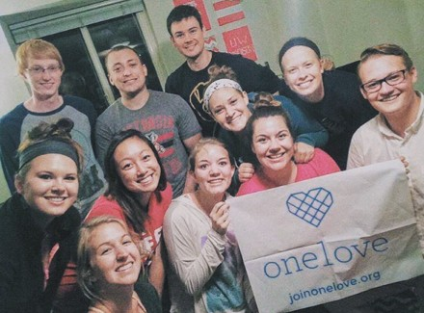
Team One Love Club* | All Ages
Creating a Team One Love Club is a great way to root students in One Love’s mission and programs. The club setting provides a structure for students and community members to raise awareness and activate their community.
*Each school and community is different. Contact One Love to learn more about how you can get your club started!

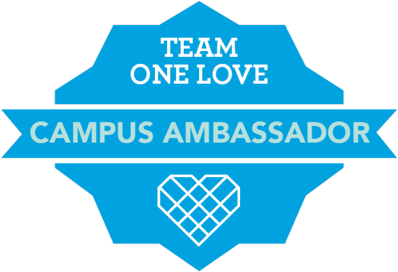
Campus Ambassador Program | High School & College
One Love’s national Campus Ambassador program creates a virtual and collaborative space for college and high school students to engage with others in their pursuit to build grassroots movements to end relationship abuse in their communities. The tri-annual (summer, fall, and spring) internship provides an opportunity for students to more deeply engage with One Love staff through programmatic implementation, goal setting and Team One Love club creation.

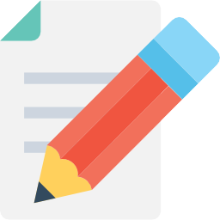
Writer’s Corps | High School & Above
Do you have a [healthy] obsession with making sure your friends, family or loved ones know the difference between a healthy and unhealthy relationships? Do you feel comfortable writing anything from tips to advice to pop culture to thought pieces? If you answered yes to these questions, you should consider joining One Love’s Writer’s Corps! You can help One Love grow our digital content on joinonelove.org.

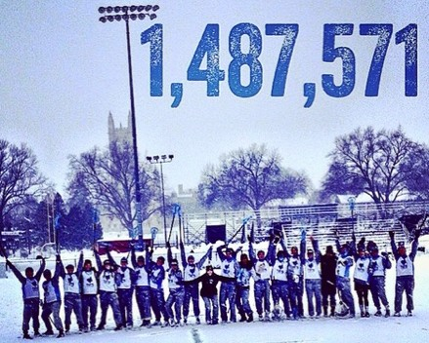
Yards for Yeardley Challenge | All Ages
Whether you’re training for an upcoming race, walking around campus, or want to host an official event, you can join others from across the country to log yards and raise awareness about One Love. Yards for Yeardley can take many forms– biking, walking, swimming or even roller blading - and you can participate as an individual or as a community!

