Local Newspaper Aaj (5th October 2009)
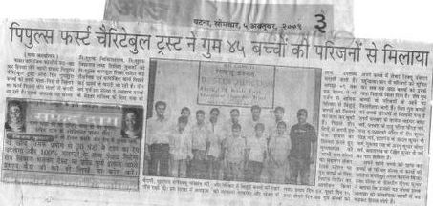
People First re-united 45 missing children to their family.
People First has a great reputation locally regarding landmark social work projects and reuniting lost missing and trafficked children with their families for the last three years. Even the Trust is working with free clinical services, free schools and providing computer training for youth for many years.
Three years before the Trust has started Rescue Junction at Bairagi for upliftment of Railway and orphanage children. In this centre children are getting free education, food and shelter and also providing shelter for missing children. Before August 2009 the Trust has re united many children through this centre.
But in the last three days Trust has expanded its work organized a special camp with Mugalsarai based Organization called Sathi at Gaya Railway Station and on the first day Trust reunited 24 children with their family and second day 15 and last day six. Children were contacted at the Platform and referred to Rescue Junction and then their parents were contacted and reunited the child with their family.
Some children who were reunited were as follows, Tarwez Ahmad (12 Years), Raju pandit (14 years) from Dhanbad in Jharkhand, Rit Kumar from Gaya, Badal Kumar from Hunterganj, Anup Kumar from Gurua , Ranjit Kumar from Kahalgaon.The parents who found their child were very much thankful to the Rescue Junction and all are wishing Rescue Junction for their good work.
People First re-united 45 missing children to their family. ( Sanmarg News Paper on 5th October)
