Writer: Fasiha Khan, Program Coordinator-RESIP
How a mother of Army Public School’s attack martyr feels at saddening moment!

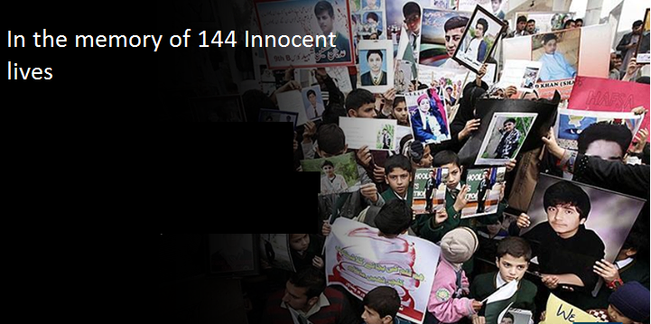
It was a normal morning like aneveryday. I started waking my sons, who were my everything since 06:00 am that morning lying that hurry up beta it’s been 07:00 o clock there are only 10 minutes for your van to come. It was the scene of every morning where I started waking them 1 hour before and they hide their heads in warm beds saying mama 2 more minutes, 5 more minutes…
After cuddling and giving up alarms, both of my kids dressed up in routine for school. Like every day I prepared their lunch boxes, packed their bags, gave them breakfast and leave them in their van with recitingAyat-ulKursi (prayer for their safety).
After they left my routine was to do me and my husband breakfast and seeing him off after which I start my daily home tasks, cleaning and preparing for lunch. In all that was a very routine day till I finish up my tasks and sat to watch some. My watching goes same, a while with some morning T.V shows of my favorite channels and then some overview of news that what’s happening around. This was what that have turned my life away! The breaking news over all the news channels was same. For a moment I calm my heart with the trust that how could terrorists reach to school inside, they might be outside of school to spread terror. I rushed towards the telephone to call my husband – who was at his duty- to enquire further. Talking to him relieved me that this situation was going for past 30 minutes and now an army operation was going. I was reciting almost everything that was on my fingertips since childhood. Further 10 minutes passed. Suddenly my heart began to fidget, perhaps that was the moment when my youngest son SHAHMEER studying at grade 7 was shot bullets. I moved outside the house to my neighbor’s. They too gave me satisfaction that Kids will be saved but that bulletin about continuous firing had perturbed my behavior. I was stopped by my neighbors and colony fellows for not to go school side as said by the news channel that was sealed for army operation.
By around 12 o clock that heavy day, we got the news my elder son who was studying grade 10 in the same school is safe. But my young soul my Shahmeer, we couldn’t hear about him until 04:00 that evening. Every minute I felt my heart will burst. All my relatives living in Peshawar along with my husband were searching for him in hospital wards, enquiring volunteer teams by every possible way with the hope to find him alive. A group of my relatives visited death ward where those heavy coffins were uncounted in number, there my Shahmeer was in one of coffin. My heart knows how I bring all this to story! I do not know who had brought my shahmeer coffin to home, I do not know how many people I have hugged that day, and all I know was my Shahmeer was no more with us. My small loving family has ruined. That cold winter night I could not feel anything, I could not away my eyes from my son whose face was visible. I do not remember have I cried shouted or what. The stop less tears for my son’s pain haspassed my year.
I don’t feel better with anyone. Our lives are totally changed. Now we (victimized parents) are closer than our relatives because we understand eachother’s pain. We meet regularly; previously we do not know each other. We sit and talk for hours for our children who were world to us. I had 15 years dream with my son and likewise others for their children.
I still send my elder son to the same school. Every morning is hard for me. I look to his bed and regret what if I would not send him to school that day. Sigh! The feeling that our kids have served their innocent lives for the country regains my lost strength. Sending my son to the same school is a defeat to terrorists’ approach.
Voice from ShahmeerShaheed mother

The Tragedy that struck Pakistan on 16th December 2014 - Peshawar – APS attack – impacted the nation with an irreplaceable loss and a vide that can never be filled. We remember and pray for the 144 innocent lives that wear lost a year ago. Let’s pay our respect to the lives that wear lost for Pakistan while gaining education and console others who had gone through this nightmare. May God bless them All.

