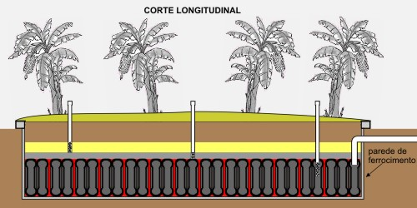
Lateral view of an Evapotranspiration bed sewage system.

