Welcome
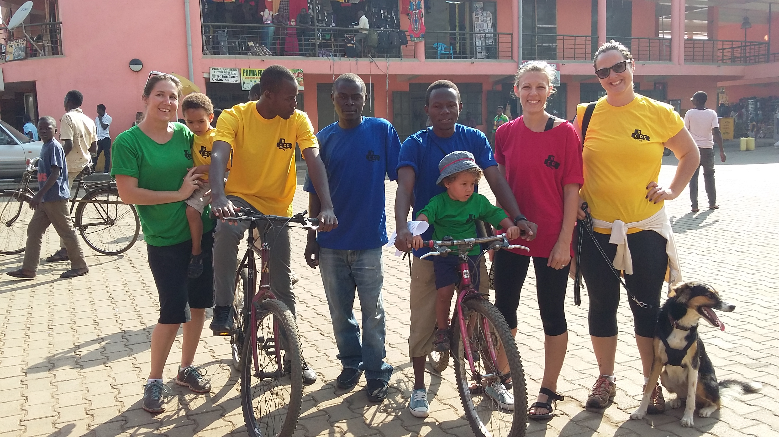
Welcome to the second newsletter from Kyaninga Child Development Centre (KCDC). Thank you for your continuing support, whatever form it takes. We are getting extremely busy here in Fort Portal, with over 150 children registered and approximately 15 new referrals each month. We have successfully recruited a Ugandan occupational therapist, Ariho Patrick, which is certainly helping to reach more children in need.
I hope that you enjoy reading about some of the activities of KCDC over the past few months.
Best wishes, Fiona x
Volunteers

Over the past few months we have welcomed a number of volunteers to work with us. Julia Radder, a special education teacher from Germany was travelling across East Africa during her summer break and asked if she could join us for a month. She worked with many of our children who are not yet in school due to their disability or living situation. They loved learning colours, numbers and letters with her, and she gave us many ideas to continue with once she left.
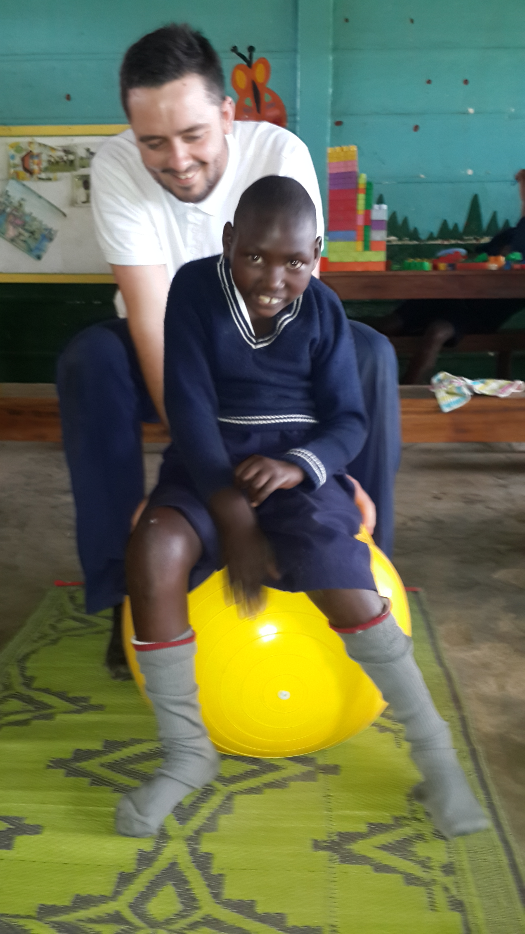
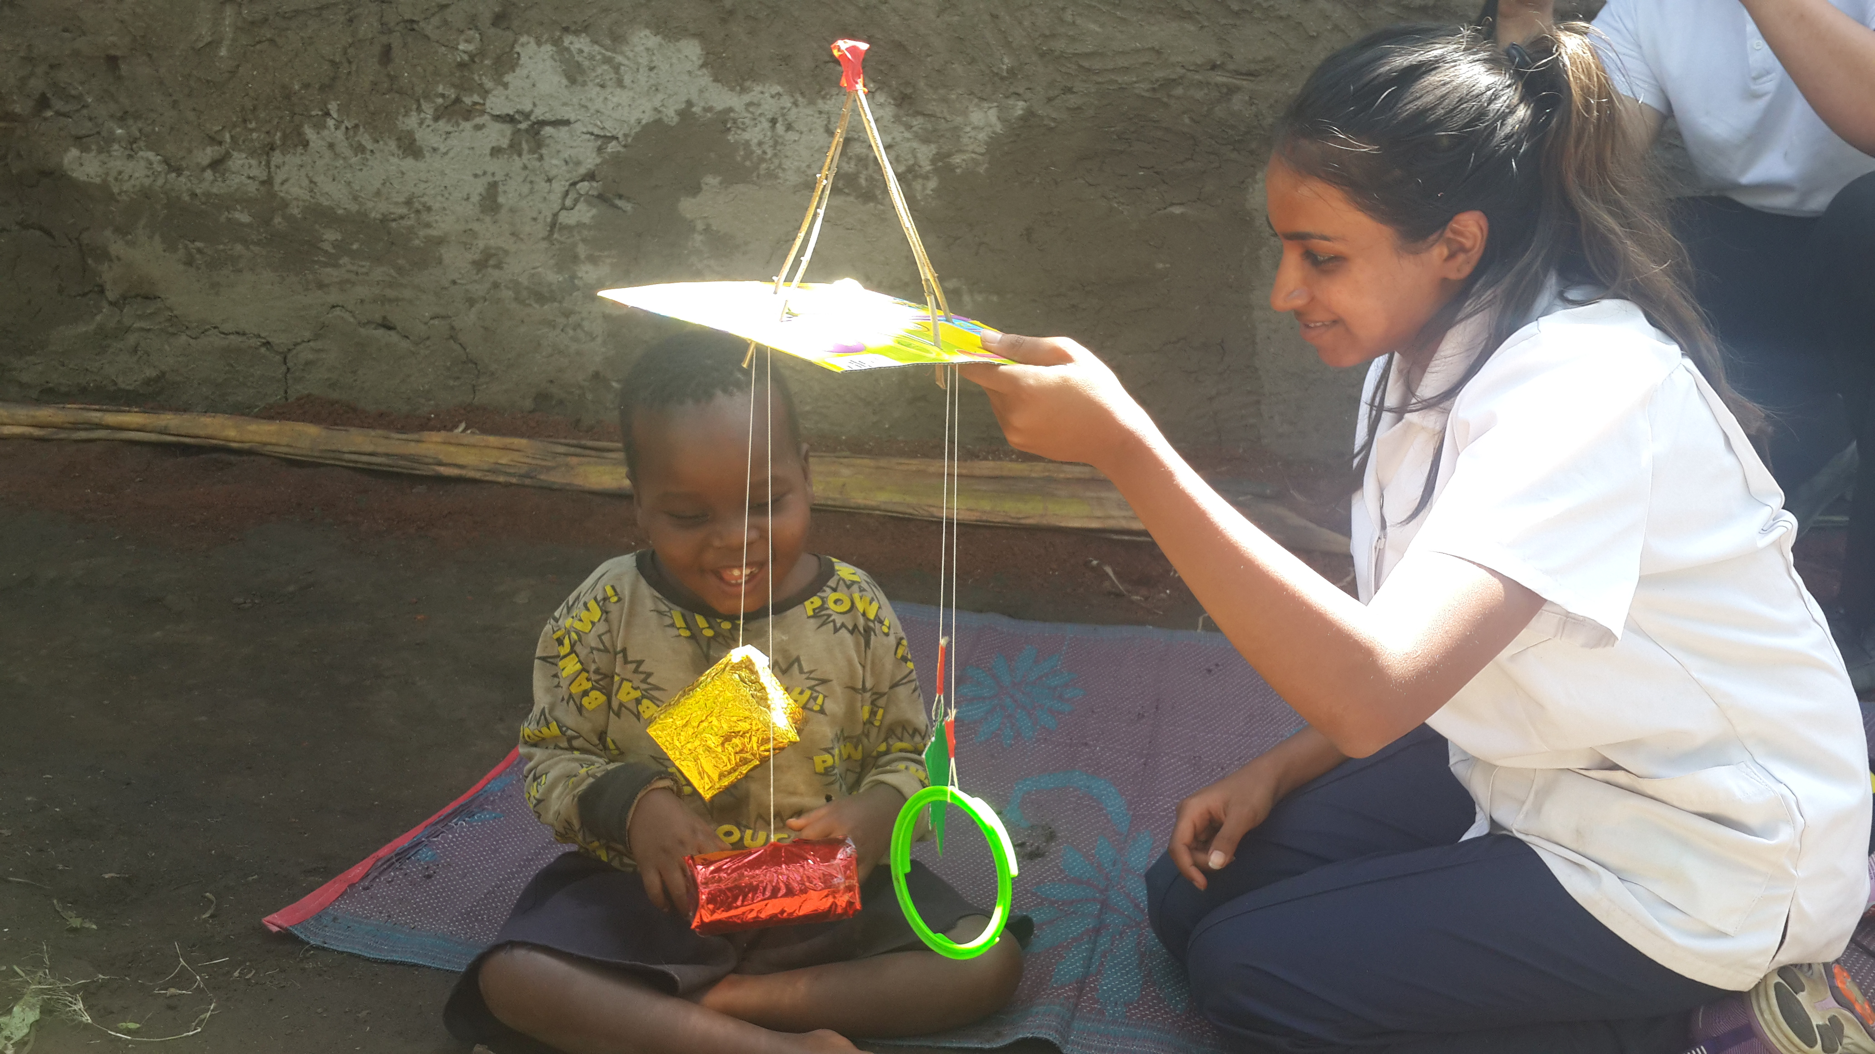

We have also partnered with Health Education England who had a pilot project sending health professional students on placement to developing countries to share and gain knowledge and experience. In total we hosted 8 students from Salford University over 3 3-week placements, including physiotherapy, occupational therapy, midwifery and integrated nursing and social care students. They were all very enthusiastic and hardworking and enjoyed the experience with us. Health Education England is looking to expand this project and so we are likely to be welcoming more students over the coming months.

Success Stories
I want to share with you a couple of stories that have really stood out for us over the past couple of months. Hopefully this will give you an insight into some of the work that we are doing and the families we meet regularly. Many of you heard the story of Kiiza, the 6 year old orphan and even donated money to help her. This is her story:
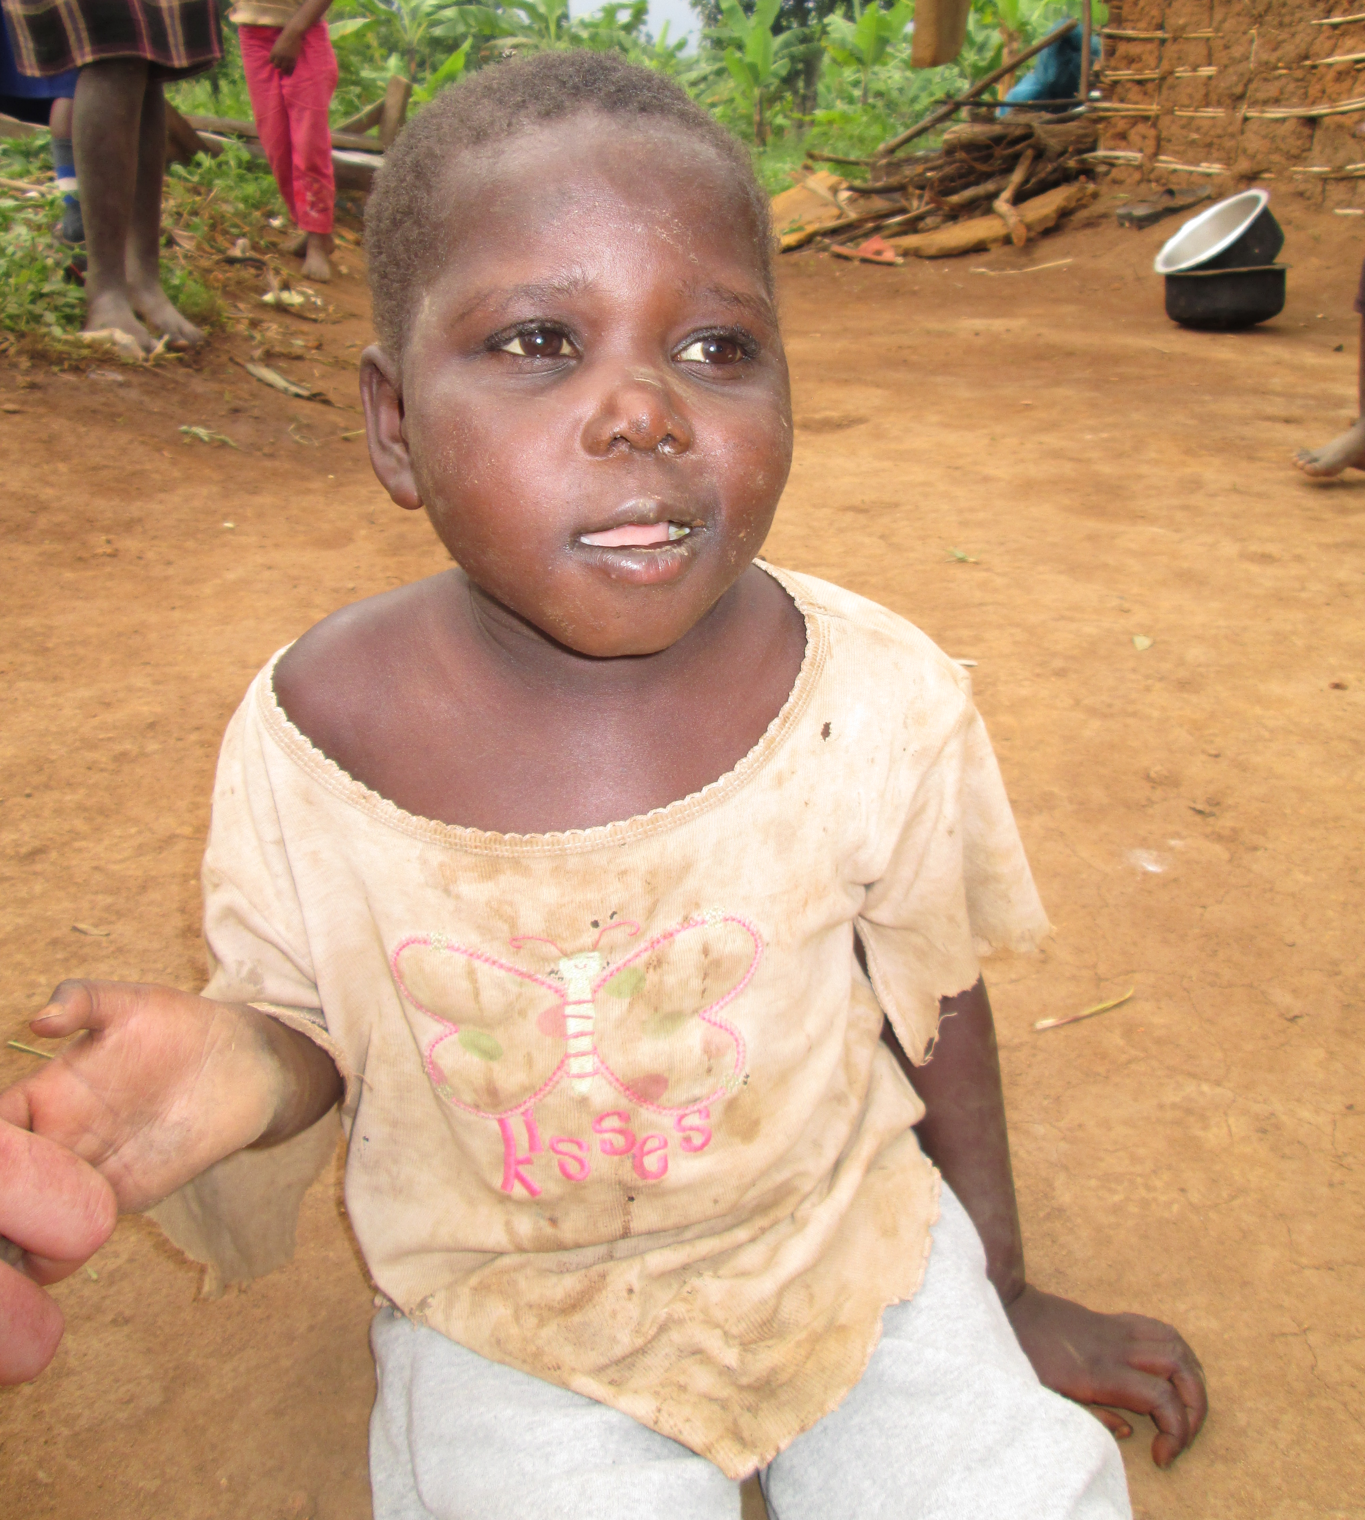
KIIZA
I was asked to review a child who was unable to walk or talk by one of the district councilors in July 2015. He couldn’t give me much more background detail so off we went. The village LC1 met us and took us to her house and unlocked the padlock. I was shocked to see a dark, sparse room with a small mattress on the floor, and a small girl, covered in dirt and faeces looking up at us. She was an orphan, abandoned by the community, and living alone at 6 years of age and unable to care for herself. She was able to sit and crawl but not stand, walk or talk.

We bathed her, dressed her and gave her some food, before taking her to the medical centre for assessment. She was severely malnourished, about 10kgs underweight, with a chest infection and dehydration. After treating her we looked for a place for her to live but none of the local orphanages would take her – she was too old, didn’t have HIV, from the wrong parish or had a disability. We managed to find a short-term caregiver from her village who agreed to take her for 2 weeks while we found an alternative option. The foster family was given plenty of food to try and resolve her malnutrition and help her gain weight, and medicine to treat the infections.

A visit a week later found her happier, and already gaining weight, and she was trying to stand alone and play with other children. We managed to find a mother in the community willing to care for Kiiza alongside her own children, with our help financially and so they were set up in a room, the first time she had a proper bed.

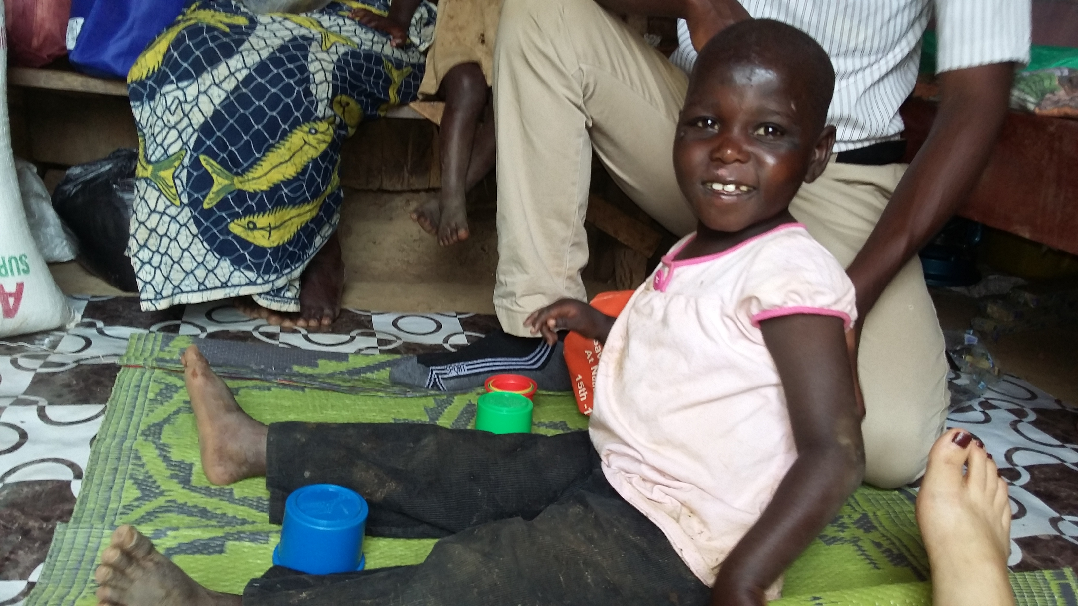
We have worked closely with the new caregiver, providing regular physiotherapy and occupational therapy to improve her strength, mobility and use of her hands and she is now able to walk around on her own. We also discovered that she was having seizures, which the caregiver was worried to tell us about as she thought if we knew Kiiza was demonic we would withdraw our support. Instead we took her to the mental health unit for assessment and treatment, and she is now on medication to control the seizures. We are continuing to work with Kiiza and her new family to help her learn new skills and tasks for the future with the aim to enroll her into school next year.

PETER
Another one of our joyful stories involves Peter, an 8 year old boy who was growing up happy and well until the age of 5, when he contracted Malaria and became severely unwell. Since this illness he has been unable to talk, sit independently, feed himself or perform most basic activities at home. He is now unable to go to school and having seizures daily.

He was brought to us for assessment in June 2015, after visiting a nearby children’s clinic that also started him on anti-epilepsy medication to control his seizures. When he arrived he was able to stand with support, but couldn’t walk, I had to use my feet to step with his, and support him while he was sitting. He had little interest and interaction with anything or anyone around him. After his assessment our goal setting was to work on independent sitting and encouraging interest in objects with a long-term view to feeding himself again.

The following week he returned with his parents, and was able to walk on his own, with just support for balance and guidance. We worked on sitting balance on the floor and on a therapy ball, and in a standing frame that was donated by PhysioNet where we were also encouraged exploration of different objects with his hands.

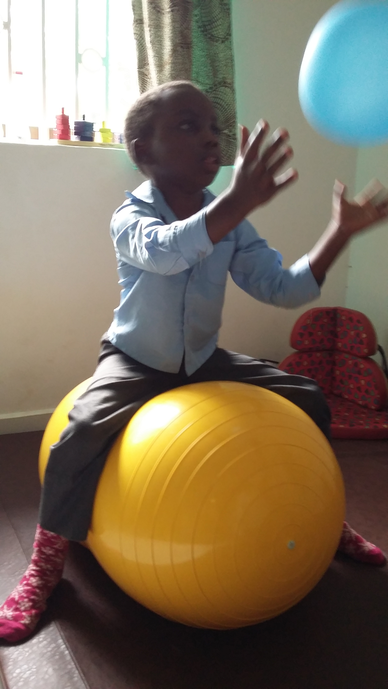
Peter continued coming to KCDC twice a week for the next 6 weeks for intensive therapy and each week he demonstrated improvements. His interest in toys has grown, he likes banging the drum, bouncing on the ball and putting objects into a cup, or stacking toys. We have introduced the picture exchange communication system to encourage communication and making choices. He has started feeding himself and enjoys chasing a football in the garden.

One of most significant changes has been with his parents however. They first came to us with little hope or expectation, resigned to the fact that they would always have to feed and care for their son, now they interact with him, laugh with him and play ball with him. Peter continues to attend KCDC weekly to further develop his skills but there is hope for him now that he can be part of his family and community again.

Introducing Patrick
I am Ariho Patrick, positive, reliant and always willing to learn. Born in 1992 to Mr. Mubangizi Patrick and the late Mrs. Tumwesigye Grace in Kabale District, south-western Uganda. I completed my Diploma of Occupational Therapy at the Uganda Institute of Allied Health and Management Sciences – Mulago in July 2015 and joined KCDC in August 2015. I particularly enjoy the community work that we do at KCDC.

I enjoy reading books, listening to interviews, watching football and working with people. My goal is ‘to acquire more knowledge so that I can help individuals overcome the barriers they face in their lives’.

School Outreach
We are currently working in 3 local schools that have children with disabilities enrolled. 2 are government aided and one is private. We work closely with the teachers and students to enhance their learning environment and ability to participate in the lessons, as well as providing individualized therapy sessions and equipment when needed. We would like to expand this project, with the help of a trained teacher, to work with more schools where children with disabilities attend, or would like to attend, and work at home with children who can’t reach their nearest school because of their disability.
There is such poor understanding of disability here that a large part of our daily role is education to community members, teachers, church leaders etc. We were horrified to read more than one school report that said ”could do better if she was normal” – despite the fact that the test scores had increased. If you know of anyone who may be interested in working with us in the school outreach project please pass on this newsletter and ask them to contact us.
Coming Up next
We are really excited that we have a volunteer speech therapist coming to work with us for a few weeks. She already has a long list of children to work with and will be training all the KCDC staff as well so that we can continue the programmes that she implements. We also have a volunteer grant writer coming for a couple of months to help us prepare proposals and grant applications.

Accomplish Children’s Trust
Accomplish Children’s Trust is a UK charity that was set up to support 2 organisations working with children with disabilities in Kasese District, Western Uganda. We are very grateful that they have decided to expand their support in Uganda and include KCDC, which involves sponsoring our 2 Ugandan therapists, David and Patrick.
If you would like to know more about the work of Accomplish you can see their website www.accomplishtrust.org.uk

Getting Involved
You can get involved by sharing this newsletter with your family, friends and colleagues to let them know about the great work we are doing. If you are planning a fundraising event then please consider KCDC as a beneficiary.

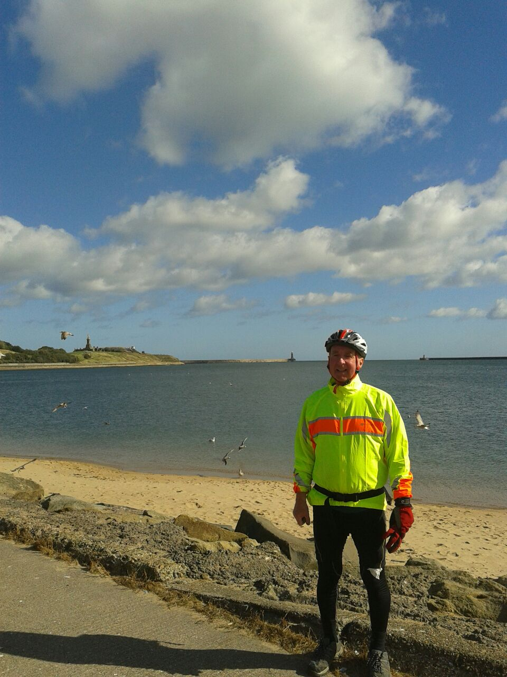
I am so proud of my father, Jonathan Beckerlegge. During the last week of September he took on the challenge of the coast-to-coast cycle ride to raise money for KCDC. This is a 175-mile cycle across northern England. He managed the whole distance in 5 days, and without falling off, and says next time he will do it in 4 days – not bad for a man of 70 years.

As the demand for our services increases, we need additional funding for a long term speech therapist and a community health worker to join our team We are also looking for funding and sponsorship for continuing therapy treatment and equipment for our children and expanding our programmes to reach more in need.

You can make a donation via PayPal on our website www.kyaningacdc.org or contact us directly to discuss these partnership opportunities at info@kyaningacdc.org

There is so much more that I could tell you about so keep up with the latest KCDC news by following us at www.facebook.com/kyaningacdc

