Working closely with families to support CWDs in the ‘New Normal’

The COVID-19 pandemic is not a short term disruption but it is going to take months before our lives go back to normal and due to the exponential nature of the spread of coronavirus, the Government of Uganda is not leaving anything to chance. In response to the COVID-19 global pandemic, the Ugandan Government introduced a set of strict measures in mid-March 2020, to prevent the transmission of the virus in the country. These restrictions were put in place as the healthcare system would be unable to cope with the high numbers of cases seen in other countries, with only 135 intensive care beds and 104 working ventilators in Uganda.
On September 20, President Museveni announced changes to the existing restrictions including opening of Entebbe International Airport and all land borders, allowing schools to re-open on October 15 for Finalists, permitting places of worship to gather with groups of 70 persons or less, lifted restrictions on movement to and from border districts, and allowing open air activities to resume without spectators.
Containment of Covid-19 has ruptured everyday social and economic exchange in Uganda, with lockdown measures posing challenges to people who need to work to survive. Both fear of Covid-19, and adjusting to the lockdown imposed on 31 March 2020, have radically changed every day social lives across Uganda, as in many other countries. Global literature from the Lancet, UNICEF and the World Bank has shared data on the long term impact of COVID 19 on children globally. It is predicted that children will be the prime causalities of the global economic crisis caused by COVID 19. Children are experiencing increased risk of abuse and significant risks associated with increased poverty including increased risk of malnutrition.
The World Food Programme warns of a hunger pandemic post pandemic with 6.7 million children at risk, the majority of these children will be in Sub Sahara Africa. With increased risks of malnutrition in pregnancy and early childhood there is also increased risk of developmental delay and children needing additional support to reach their full potential. In addition to this while most things have reopened it is unlikely schools will reopen until 2021, meaning a whole academic year has been lost. This is likely to mean that many children, particularly those with disabilities may never return to school

KCDC continues to provide quality services to children with disabilities and their families in the current new normal by working more individually with families, providing food supplements (Milk powder) to children suffering from malnutrition, supporting their health and wellbeing through home rehabilitation and community outreach programmes whilst working safely and responsibly within national and global guidelines that include using face masks and shields, sanitizing, washing hands and physical distancing. Since the beginning of 2020 we have received a total number of 400 new referrals and the numbers keep increasing by day due to the growing desperate need for our services. Our multi-disciplinary team has to date provided more than 5367 therapy sessions.
KCDC’s Street Business School Programme has registered 200 businesses started by the graduates of the 4 cohorts of the SBS training, including the one associated with HFHU. Feedback received from graduates through focus group discussions revealed that all members have maintained and restarted their business following the Covid-19 lockdown. One member was quoted saying “We are now able to provide for our families, make repairs on our homes, pay for medical costs and we no longer feel isolated and ridiculed by our communities.”

During this quarter, we also partnered with The Everret and Austin Project to give out four wheelchairs to children living with Muscular Dystrophy in Kasese District. Muscular Dystrophy is a genetic condition that worsens overtime causing progressive muscle weakness starting around age 8-9 with the lower limbs resulting in an inability to walk, followed by upper limb weakness and loss of hand function and finally it causes difficulty breathing due decreased muscle strength and power in the chest. It is a difficult condition for families to fully understand and often they spend a lot of time and money searching for a cure, we run a small family support group to increase understanding and offer peer support for this devastating condition. Wheelchairs are essential to allow the child to continue attending school and engaging with life in the family and community.
In addition, the Everret and Austin Project provided packages to thirty families that were struggling with economic hardships related to ongoing COVID 19 restrictions. The packages consisted of basic food stuffs, sugar and soap to meet immediate needs for a few weeks. The packages also included few kilograms of beans that were specifically meant to be planted to help sustain the families in the middle to longer term. The Kasese team is happy to report that most families have used the current rainy season to plant these seeds and we hope that soon, they will be ready to harvest!
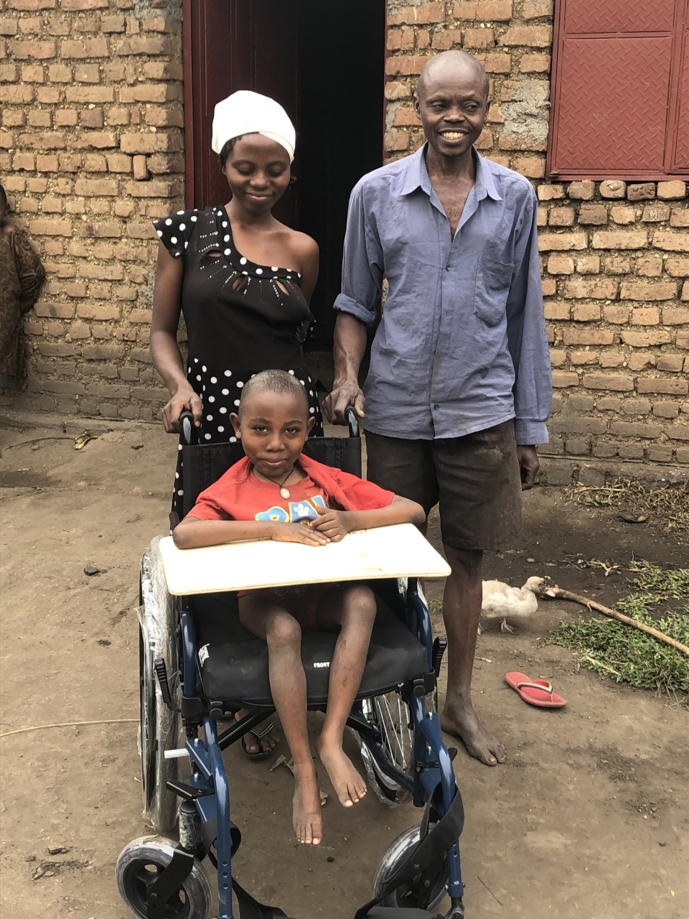

The impact of the pandemic has be been devastating however, some children with language difficulities have benefited from the lockdown in the area of language development since they spent more time with their parents and other family members at home. A significant number of children seen for speech therapy have a history of insufficient Language stimulation and as a treatment strategy in this scenario, modification of a child’s enviromnent and encouragement of quality time with children has been used. During home visits our therapists, special needs teachers and social workers met with the family members of the CWD and together they supported the child. With continous follow up, the outcome has been remarkable ie most children with delayed language and history of under stimualtion have greatly improved.
Natasha a 5 yr old girl with delayed language is an example of several children with language delay who have shown notable improvement strongly linked to the stimulation made possible by the lockdown. She had 2 word attempts /aa..aa/ for “tata” (yes/Dad) and /aai/ for bye in 2018 during initial assessment. With speech therapy sessions and some carry- efforts by the often busy family members, Natasha’s Language gradually improved to consistent single word utterance and 2-word phrase attempts as of Jan 2020. Following over 3 Months of lockdown when most Family members stayed at home with Natasha this resulted to more stimulation, her language improved exponentially to consistent 3-word utterance, 4-word sentence attempts and following complex instructions.
