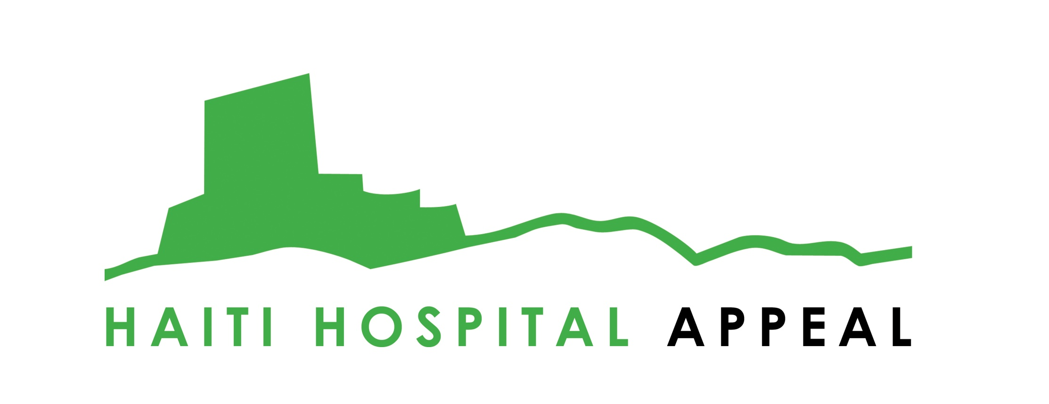

Project Title: Help Build and Run a New Maternity Service in Haiti

The Haiti Hospital Appeal is working alongside the Haitian Government and a number of other NGOs to help support the governments’ efforts in reconstructing Haiti. Our heart is not to create a separate health system, but empower Haitian medics to create a sustainable, inclusive and accessible health service. We’re committed to ensuring Haitians are offered health care without any form of regional, religious, or economical discrimination.
Our 2010 vision is focusing on some of Haiti’s most pressing health needs, through the establishment of a maternity and paediatric program and surgical department. In Haiti 75% of births take place at home without any form of medical support resulting in many mothers and babies losing their lives unnecessarily. Haiti has the highest rate of infant, under five and maternal mortality in the western hemisphere. Birth complications often bring about permanent disability and future health difficulties. A mother in Haiti is 50 times more likely to die in child birth than America. Our vision is to establish a coherent and accessible maternity service in North Haiti.
The project will begin to establish a new era of safer childbirth in a region of over a million people. Every minute of every day around the world a woman dies of pregnancy related complications, totaling more than half a million women each year. We are part of changing that in Haiti, where every year over 3000 women die in childbirth.

Maternity Program
In partnership with The White Ribbon Alliance, and thanks to the Naomi Campbell 2010 Fashion for Relief show, we are about to launch a major maternity initiative. We have established a team in Haiti in partnership with Konbit Sante (Cap-Haitien Health Partnership) and medical professionals within the MSPP (The Haitian Ministry of Health) to plan and deliver this project in three parts:
1. Establish our maternity unit.
This unit will consist of pre and post natal wards, delivery rooms, a surgical department for C-sections and emergency surgical needs, and a neo-natal unit. The unit will provide pre and post natal care, offering vaccinations, family planning, education, vitamin distribution and much more.
We have completed the construction of these three units, and we are installing a robust electrical system that can provide constant electricity which is essential for maternal and neo-natal care.
The next stage will be equipping these units with incubators, surgical equipment and a blood bank, as well as training the Hatian staff for the use of the equipment and new services we are providing.
2. Improve maternity care across the North.
We have established links with existing government sites providing maternity care, and will be helping to improve their services. This will include providing emergency support through our ambulance, developing training, and supporting improvements in both the infrastructure and running of these departments.
3. Supporting Community Health Agents.
Reaching into the heart of the community will be a major priority for this program. We will provide support for community midwives, providing them with birth kits designed to reduce risk and save lives. Together with Konbit Sante we are also launching a mobile health clinic which will provide screening, inoculation services to the local communities.

Paediatric Program
Haiti has the highest rate of infant, under five mortality in the Western Hemisphere. Around 1 in 12 children die before the age of 5 in Haiti. Our paediatric unit will work directly with our maternity program to ensure that children are given the brightest hope and future possible.
This work will include vaccination programs, monitoring child development, nutritional support, nourishment programs for malnourished children, health education for families, and an inpatient and outpatient service.
In partnership with our maternity program, this work will include both on site support at our hospital through a fully equipped neo-natal and paediatric unit, as well as community based care within rural areas and some of the poorest slums across the North.

Find out more about us at www.haitihospitalappeal.org
Email us at info@haitihospitalappeal.org
Become a fan on Facebook at www.facebook.com/haitihospitalappeal
Follow us on Twitter at @haitihospitalap

