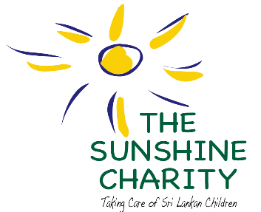Creating Equality,

Thank You from The Sunshine Charity
by Sharadha de Saram – Project Leader
As one year ends and the new year starts we would like to wish all our donors, volunteers and friends of The Sunshine Charity all the best for the year ahead and say thank you for your support and funding. Thanks to all of you we could carry out our tasks and implement projects in the last twelve months of Global Giving’s Open Challenge. Thanks to all of you we have survived the last twelve years, keeping to our mission statement that we will take care of Sri Lanka’s vulnerable children irrespective of their ethnic and cultural backgrounds.
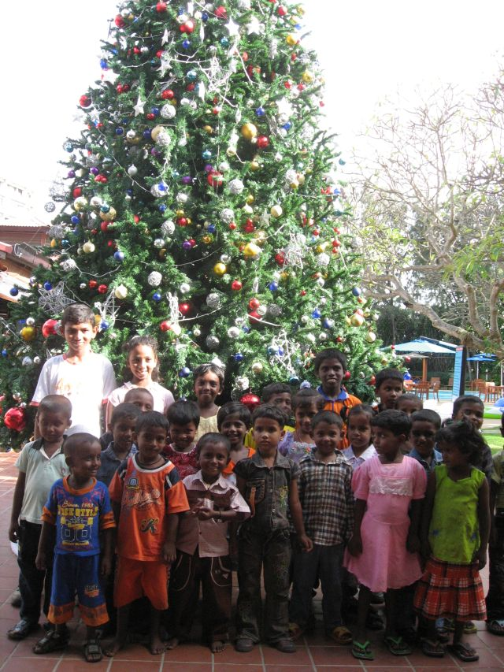
While many day care centres established in the Trincomalee District, Eastern Province by international and local organizations soon after the tsunami to take care of children impacted by the devastation stopped functioning chiefly due to lack of funding, The Sunshine Charity is proud to be able to celebrate its twelfth year because of the support given by our donors, volunteers and friends. Through your support, we were able to provide 45 vulnerable and orphaned children in eastern Sri Lanka with health care, pharmaceutical drugs, worming treatment, one wholesome and nutritious meal, educational tools, uniforms, creative opportunities, outings and a committed and trained staff.

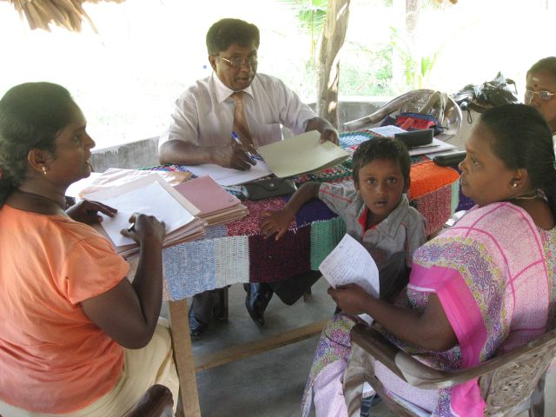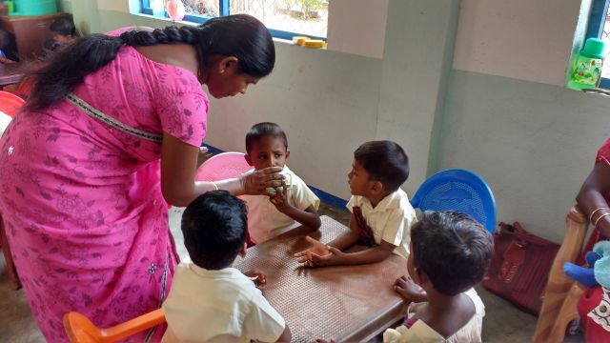
The day care centre compound is equipped with playground equipment and provides an open space for the children to play. The trustees also organize health and nutrition workshops for mothers to allow them to understand the health needs of their children. Check our website www.sunshinecharity.org and you will see the impact of our work due to the donation you made.
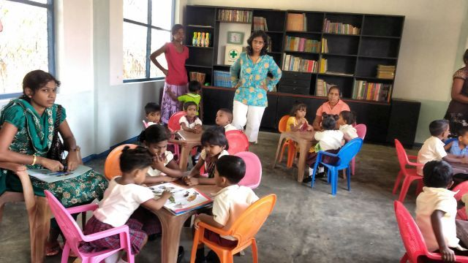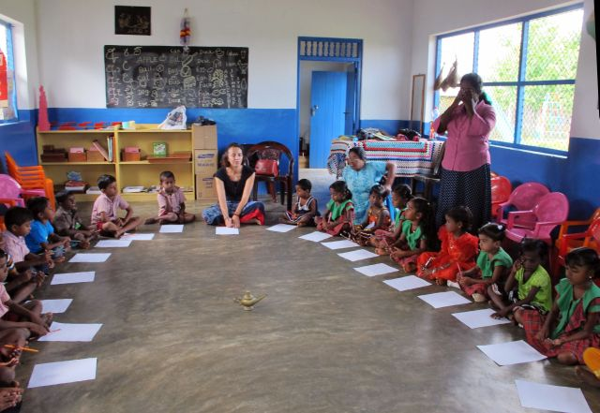
Visiting families at their homes and talking to them helped us, the Trustees of The Sunshine Charity, learn and understand the needs of vulnerable communities and in particular the families living in the District. In doing so we were also able to select children to attend the day care centre based on need. At times, we wished we could expand our work to admit more children but wisdom prevailed over emotion to not go beyond the mandate of the Charity or else we would like many of the other organizations have failed.
It was a challenge to participate in the Open Challenge Campaign: Health Care to 45 Vulnerable Sri Lankan Children at Global Giving’s prestigious online fundraising platform for nonprofits. This platform is the world’s first, largest, and most respected curated nonprofit crowd-funding community. It was our first ever try and we were nervous at the start but one year later we are proud to announce that we raised a total of $9,653.52 from eighty donors.
We could not accomplish our goals without the support, involvement and enthusiasm of our donors, volunteers and friends of The Sunshine Charity. So, thank you again for your help.
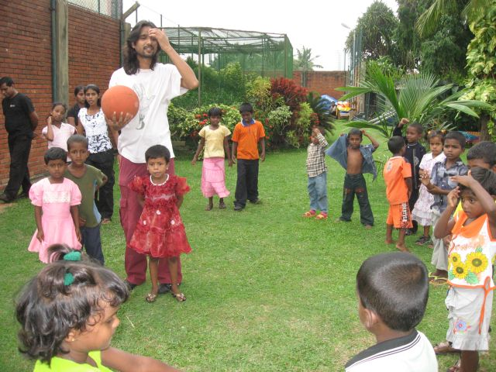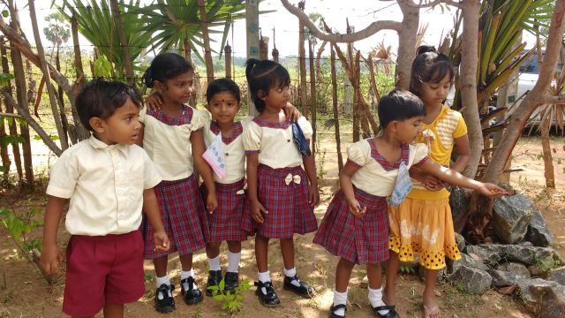
In the new year, our plans are to continue our work to include more children from the community. The day care centre we manage has space for no more than fifty children. In addition to holding health and nutrition workshops for mothers and children at the cetnre, we plan on running a similar workshop at a community centre to allow for more inclusiveness in the community. Our plan is also to get the local doctors involved in these workshops so that the mothers of the children can have a direct and personal relationship with the doctor when they visit the local clinic where they are working. We will also include children from the community when arranging outings and creative opportunity workshops.
Your giving has given hope and will give hope to the children of the Eastern Province of Sri Lanka. We could not be more grateful to having you as our partner. Thank you!

