Inspirational Success Stories from Sri Lanka
by Sharadha de Saram – Project Leader
In-spite of its beautiful beaches, verdant forests, abundant foliage and fauna, fertile soil and a high literacy rate, there are pockets of areas on this resplendent island where communities live below the poverty line, where parents struggle daily to care for their children and where tragedies have affected them. The lives of some of these children would have looked very different if not for the facilities afforded to them at The Sunshine Day Care Centre, the only day care between a two-hundred mile stretch that provides the children space to enjoy enrichment programmes in art, music, song and educational skills among many other services.
During our most recent visit to conduct a medical, health and nutrition programme for the children, we wanted to learn for ourselves, how our programmes have impacted and how they have benefited our children since the organization established the day care over ten years ago. Some of the homes we visited opened our eyes to the issues and challenges these families face and encouraged us to strive harder to make a difference in the lives of vulnerable children.
Kithushalini has been at the day care centre for just over a year. Prior to this, she attended the Government managed centre just across the street from her home. It was her two best friends, sisters Kavisha and Kavishalini who first told her about the Sunshine day care which they attend. “We enjoy playing games, singing and writing and have lots of fun,” they told her. Begging her parents to transfer her, Kithushalini soon found her way on the Sunshine bus – one of the biggest attractions to families. The Sunshine bus picks and drops the children from their homes thereby giving the much needed time to mothers to attend to their own work. Children love the ride.
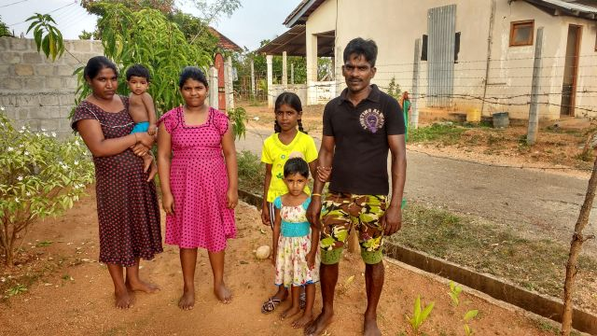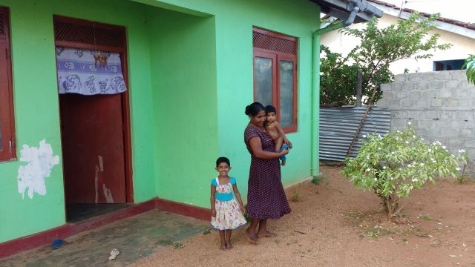
Kithushalini with her parents and siblings at her home in Sambalthivu, Trincomalee
Kithushalini’s father is an unskilled worker earning his living doing odd jobs in town. Along with his wife and four children they live at his mothers’ house built for tsunami survivors. The family saves on child care facilities and above all the glass of milk and lunch time meal which Kithushalini is provided.
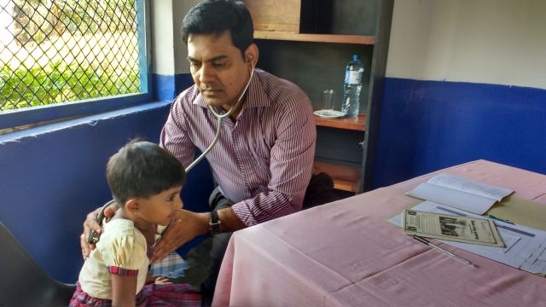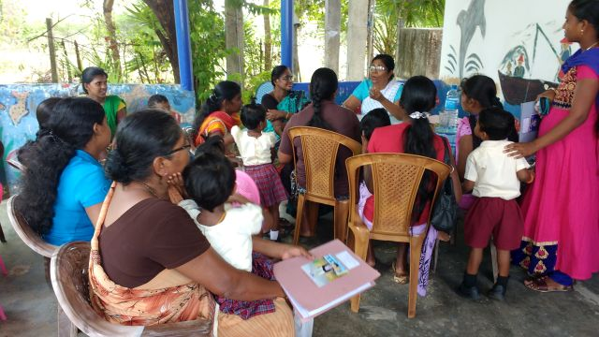
With access to annual medical check-ups the provision of vitamin, iron and worming treatment, Kithushalini’s family is able to save a substantial amount. The health discussion for mothers inspires them to be more aware on nutritional needs of their children.
Lakshan was four years old when he joined the day care centre. Previously, Lakshan spent his time at home playing with the few broken toys he owned or helping his mother. He is the youngest of a family of five children, three of whom attend the local school and one, the eldest, a school drop-out. At the time of our visit we were able to meet only Ranjani, Lakshan’s mother and eldest sister, Lavinia. The temporary make-shift shelter where the family live was constructed illegally. The father, an alcoholic earns a paltry amount as a labourer with most of his earnings spent on alcohol. Thanks to Sunshine Charity’s local partner, the Grace Education Centre, Ranjani will be gifted a house very soon while Lavinia will work as a volunteer at the day care centre.
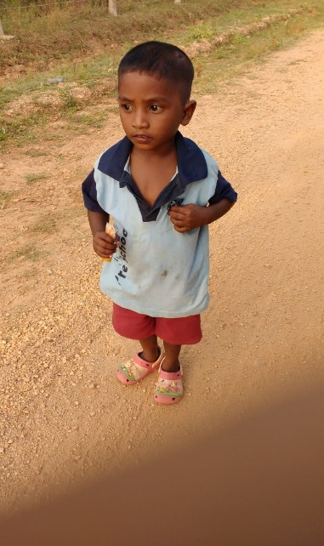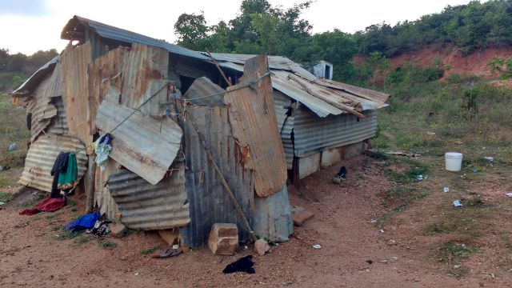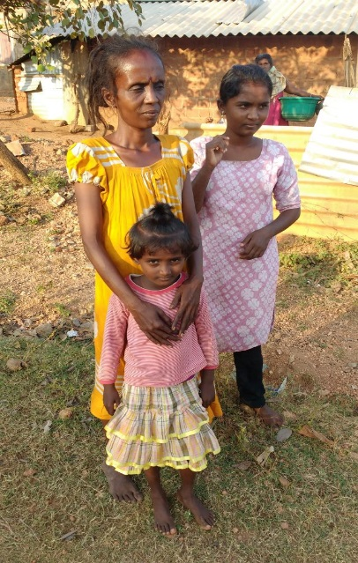
We met three and a half year old Lakshan on his way home to meet his mother Ranjani elder sister Lavinia and younger sibling
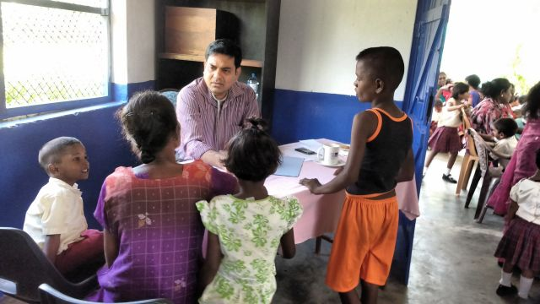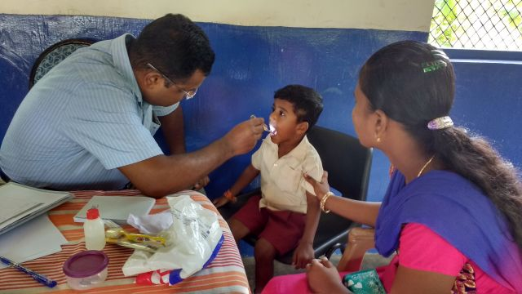
It is at medical clinics such as these that children like Lakshan and Kithushalini are able to know the status of their health. It is only here that mothers of the children receive guidance on the nutritional needs of their children, dental check-ups and advice on oral hygiene. More importantly, the participating doctors are from the district allowing the community to connect with them easily. Having made contact already, the doctors encouraged the mothers to visit them at their clinics for any follow-up treatment. It is only here that most children enjoy a glass of milk and a nutritious lunch time meal.
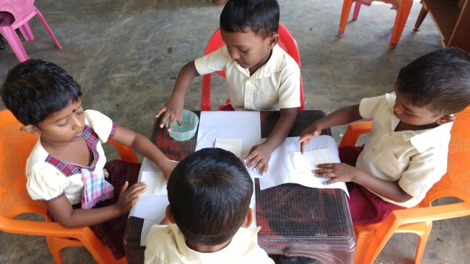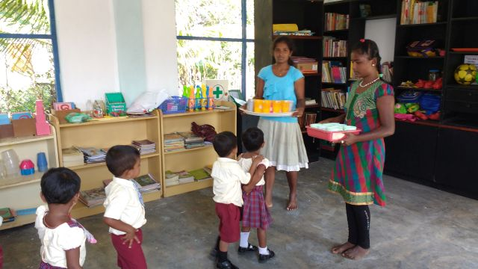
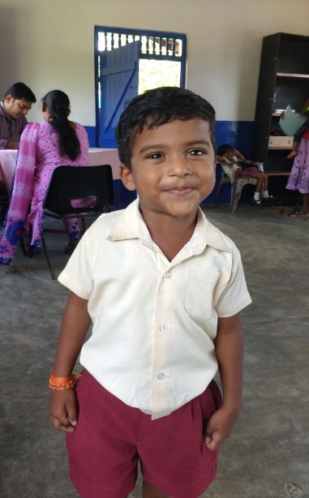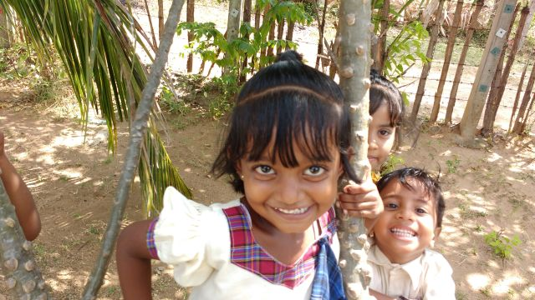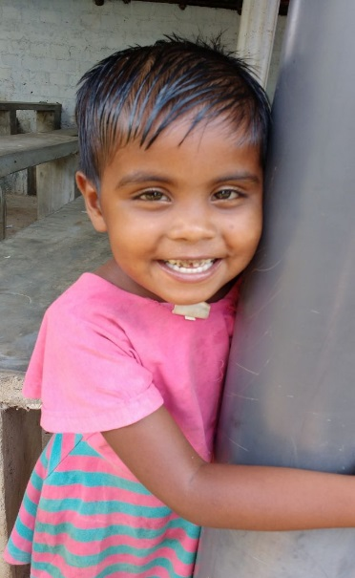
These are only some inspirational success stories which have effected change in the lives of children attending the Sunshine Day Care Centre.

