One example of a change story; a story about a child we have worked with in the past 22 months who has experienced positive change due to his or her participation in our programs
The Sunshine Day Care Centre - Sambalthivu, Trincomalee, Sri Lanka
Kalaivani
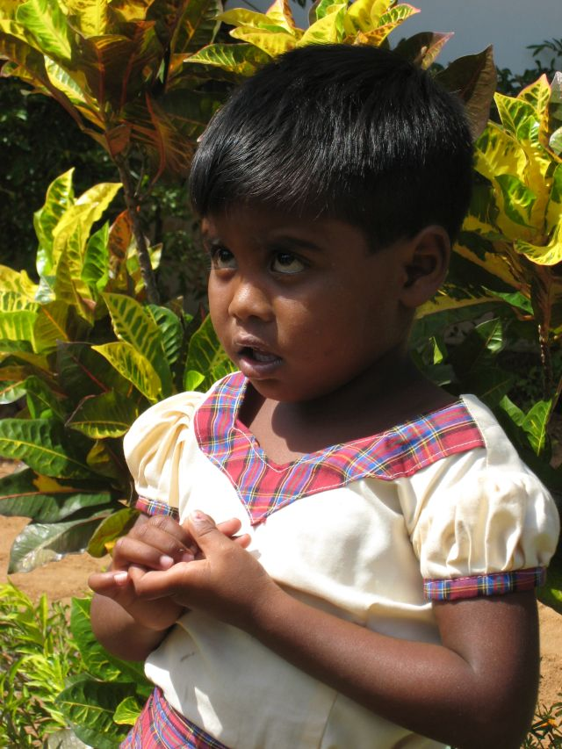
It was in March 2014 that we first met Kalaivani, a couple of months after she was admitted to the Sunshine Day Care Centre in January 2014. Along with her four siblings, Kalaivani was sent to the Grace Education Care Centre, the Sunshine Charity’s local partner by the local Department of Probation and Child Care Services. Grace runs a home for boys and girls next-door to the day care centre. The Sunshine Charity could not ask for a more convenient partnership. While the majority of our children live with either one or two of their parents in their own homes there are some children between the ages of 1-6 who live at the Grace Home and attend the day care centre till 3pm after which they are taken back to the home. Kalaivani is one of the children in the care of both the Grace Home and the Sunshine Day Care Centre.
The March visit was to conduct a health and wellbeing workshop with the organization’s Consultant Pediatrician, the regular doctor monitoring the health of our children. This is how we recorded Kalaivani’s health and wellbeing at the time.
- Date of Birth unknown.
- No immunization or birth certificate available.
- Weight 40 lbs. Height 34”.
- Orphaned child. Lives at Grace Home. Father killed by elephant. Mother died from cancer in 2014
- Follow-up required on immunization and certificate of birth.
- Follow-up required on oral hygiene
The health and medical check-ups afforded to children like Kalaivani have benefitted the children hugely. It is during such a check-up that Kalaivani was found to be over-weight. Kalaivani is fond of eating. The staff at both Grace Home and The Sunshine Day Care Centre have tried hard to monitor Kalaivani’s diet but it is a challenge to have her eat less. She often asks for more. We learnt from the staff that Kalaivani becomes very stubborn when she is not given a second serve. The trustees have arranged for a psychologist to observe Kalaivani and advise the staff what positive steps could be taken with regards to Kalaivani’s eating disorder.
Meeting Kalaivani for the first time, she looked depressed, sad and frightened. Refusing to interact with anyone, when spoken to she would cry. Her security were her toys which she kept close to her. During a subsequent visit, we found Kalaivani to still appear sad though we learnt that she had improved significantly in many ways. She would play with other children in ‘fits and starts’ but for the teachers this was a huge step moving forward.
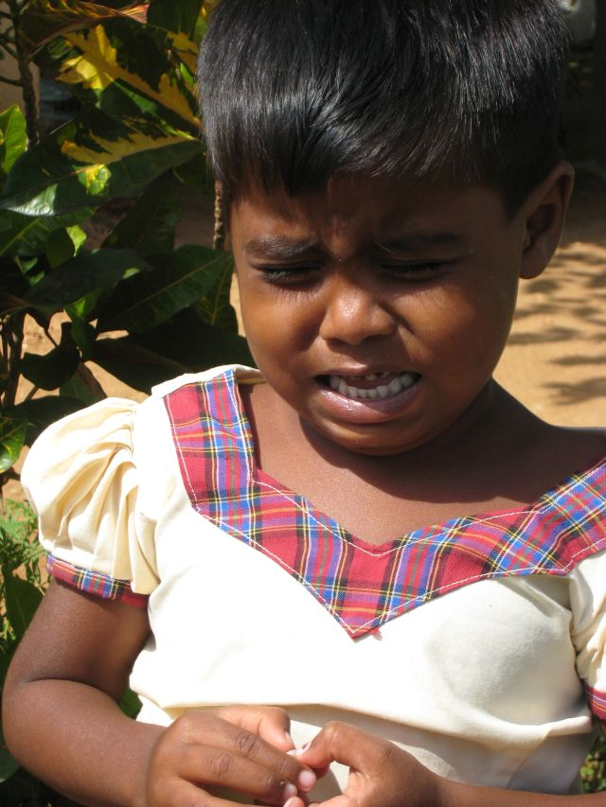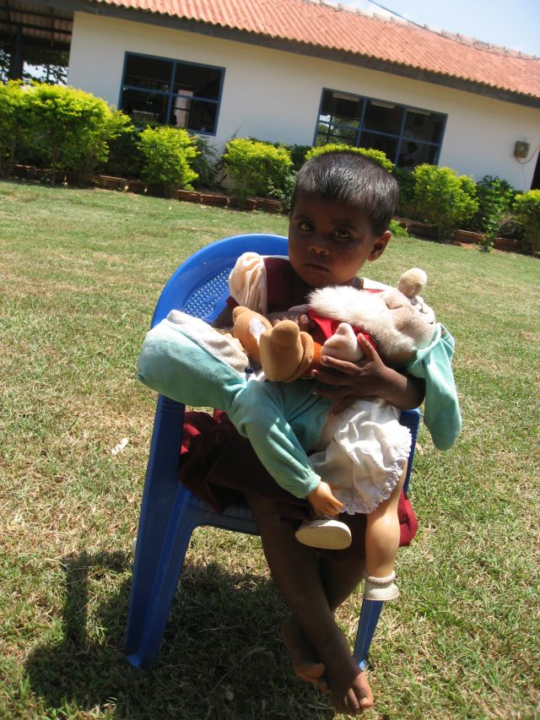
Kalaivani - March 2014
Kalaivani’s father had been killed by an elephant sometime back and her mother had died of cancer in 2014. It was a challenge for the staff at both Sunshine and Grace Home to address Kalaivani’s psychological needs. Thanks to the numerous teacher training workshops conducted for the members of the staff which included counselling and understanding the psycho-social needs of children, they were better equipped with skills that helped them to understand Kalaivani.

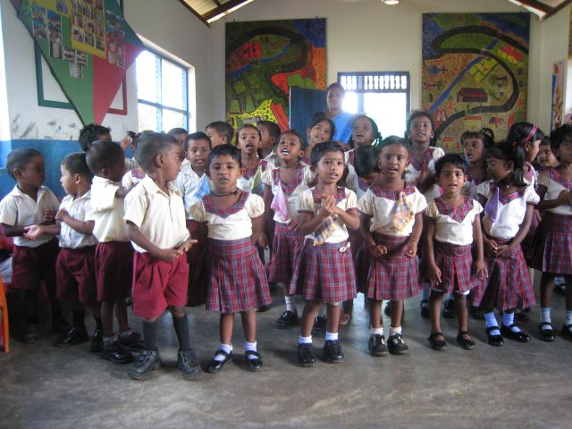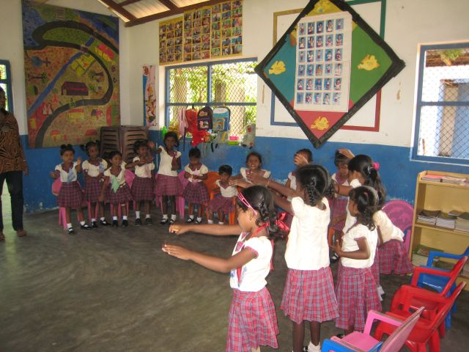
The Sunshine Children
Over the last months we have kept in touch with Kalaivani and in particular with Celine who coordinates the Grace Home and Sunshine day care partnership. This loving and committed lady who takes charge of the children living at the home has contributed remarkably to Kalaivani’s progress. In addition, S. Padmini, First-line Teacher: Children’s Needs continues to encourage Kalaivani to participate in all the activities conducted at the centre.

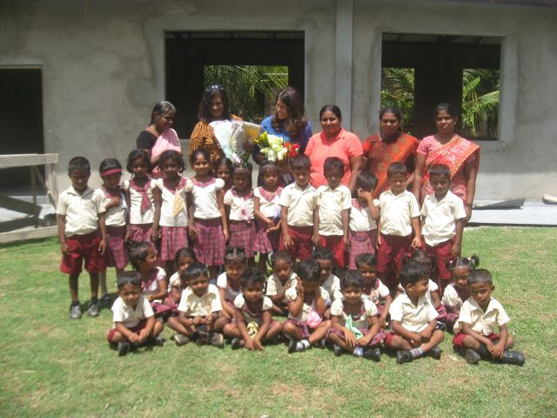
October 2015 – with members of the staff and trustees

It was however during our most recent visit to the centre, in October 2015 that we noticed the significant changes in Kalaivani’s behavior. Kalaivani was no longer a sad looking girl, instead we met a smiling and happy child, ready to talk expressively. She told us that she would like to be a singer one day as she loves singing. She plays with the other children with ease and enjoys relating stories to them.
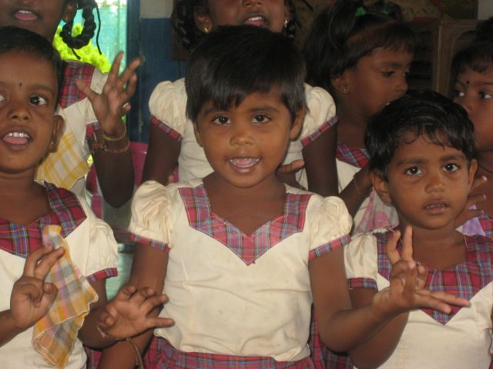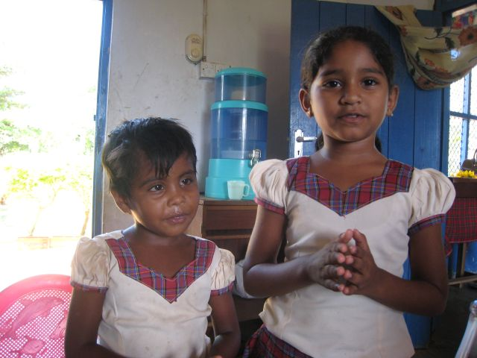

(L) Kalaivani with her friends and with her friend Abhiya (R)

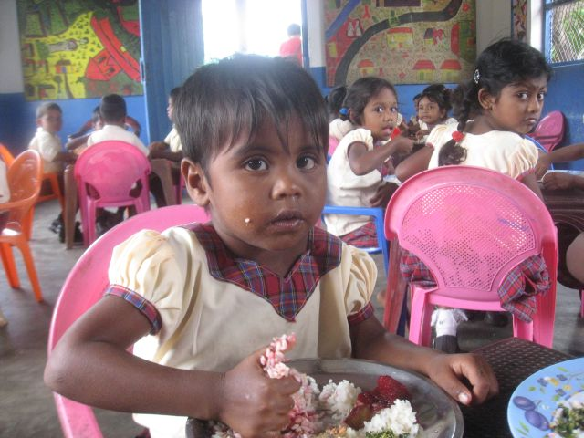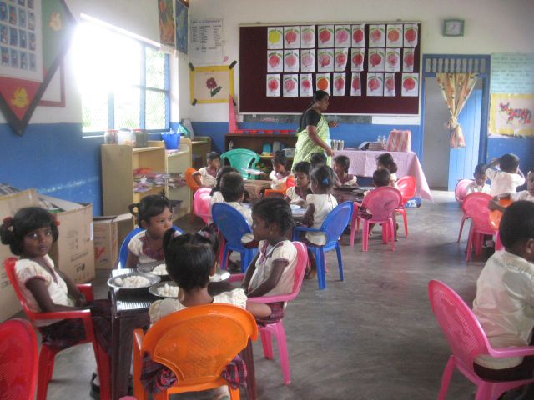
Kalaivani at lunch

Thanks to our international and local donors, children like Kalaivani can enjoy a nutritious meal at the centre. It usually consists of rice with a vegetable, dhal and fish curry which, to many is the only wholesome meal they have for the day. Meeting with some of the families at their homes on this visit, we learnt that quite a few children have just bread and a gravy for dinner. The parents expressed their gratitude for the lunch their children receive. The children are also provided with fruit and a glass of milk for breakfast. The mothers in particular were thankful that their children are picked and brought back safely to and from their homes five days of the week in the Grace bus. This makes their own life so much easier and allows them time to attend to their household work or an income generating activity. Besides, having a bus to ride to school and back prevents the child from excusing him or herself from class.

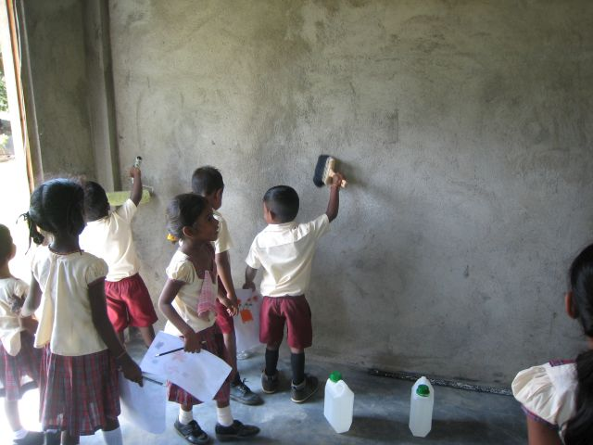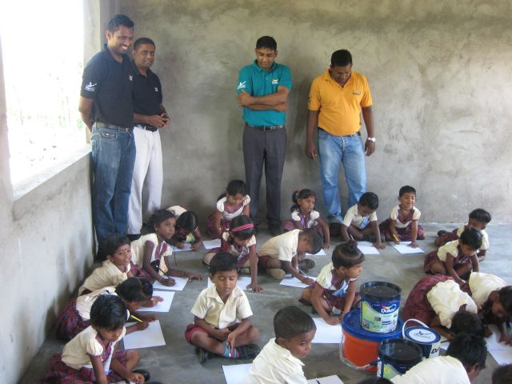
Step by Step Kids Paint Workshop with Akzo Nobel Paints Lanka (Private) Limited

At a kids paint workshop the children had a great time painting the walls of the new building. In July 2015, The Sunshine Day Care Centre took a bold step to construct a second building which will allow the 35-40 kids attending the Sunshine Day Care Centre in Sambalthivu, Trincomalee more space for their day to day activities. The existing building constructed in 2005 seemed no longer spacious to manage the increased children’s activities.
The building almost complete was now ready for painting. Stepping in to extend their support with liters of paint was Akzo Nobel Paints Lanka (Private) Limited, which conducted a step by step kids workshop. The children enjoyed working with the Akzo Nobel team having fun painting the wall surfaces. Later, they used their imagination to transfer their ideas to paper which they proudly showed off to the Akzo Nobel team.

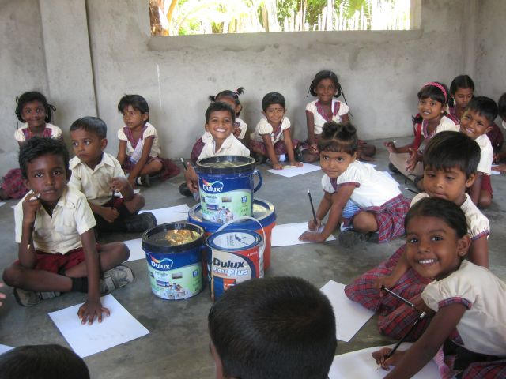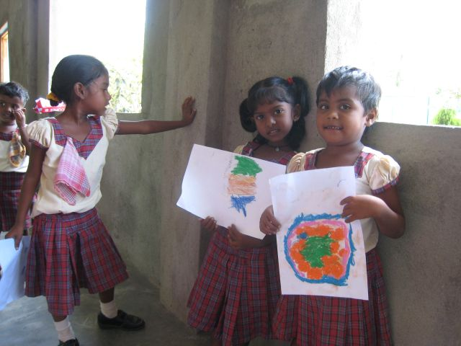
Kalaivani on extreme right proudly showing her painting

We are happy to note that Kalaivani has been given the necessary immunizations. Her birth certificate was found in her grandmother’s home and is now with our records. Kalaivani has also participated in the vitamin, iron tablet and worming treatment programme during the past year and a half. The programme, funded by local donors have helped the children attending the day care to be provided with these pharmaceutical drugs. Like others, Kalaivani has also participated in the 2014 eye camp conducted by Vision Care Capital (Pvt) Ltd, Sri Lanka.

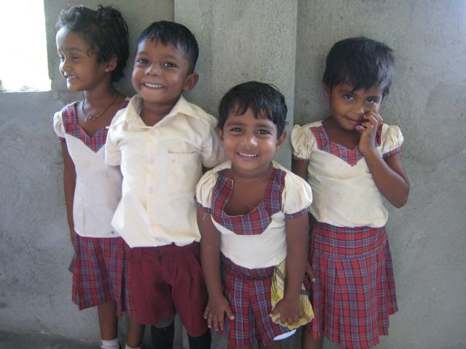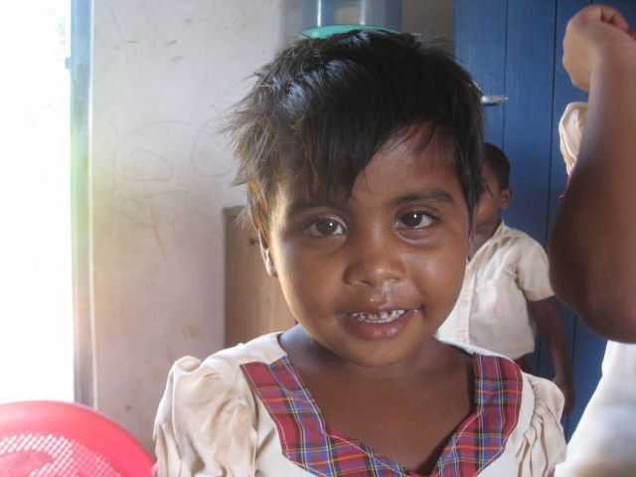
October 2015 - Kalaivani with her friends

These are some of the positive changes experienced by Kalaivani on account of her time spent at the Sunshine Day Care Centre. Many donors ask us, “what would happened to children like Kalaivani if she did not have these opportunities?” is a question many donors ask. Reading Kalaivani’s story you will realize how a small donation can impact on a vulnerable child’s life. The funds donated would provide for one wholesome meal, educational material and toys, activities such as reading, story-telling and dancing, counselling, a team of skilled staff members, participate in health and nutrition workshops are a few opportunities.
Kalaivani’s story is one of the many stories we have experienced. Founded in the aftermath of the 2004 tsunami, the organization celebrates ten years of caring for children. For a small organization with no administrative costs, where the donor’s funds are utilized entirely to benefit vulnerable children, where all the trustees work on a voluntary basis and participating in the programmes implemented, the Sunshine Day Care Centre located in the small village of Sambalthivu, Trincomalee, Eastern Province of Sri Lanka is inspired to continue its work because small donations have contributed and helped change the life of children like Kalaivani.

