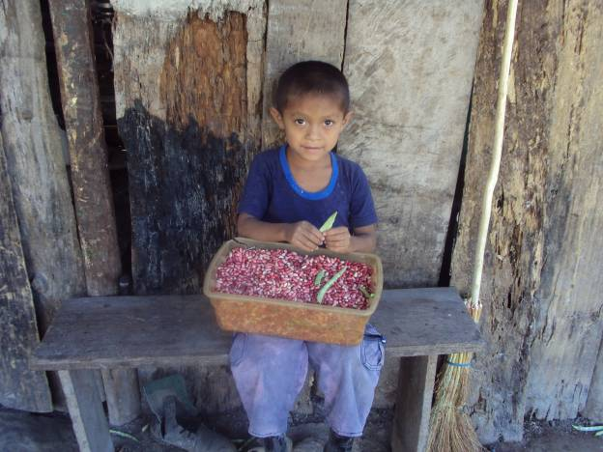
A young boy removes beans from their shell, the first step in preparing them for consumption

