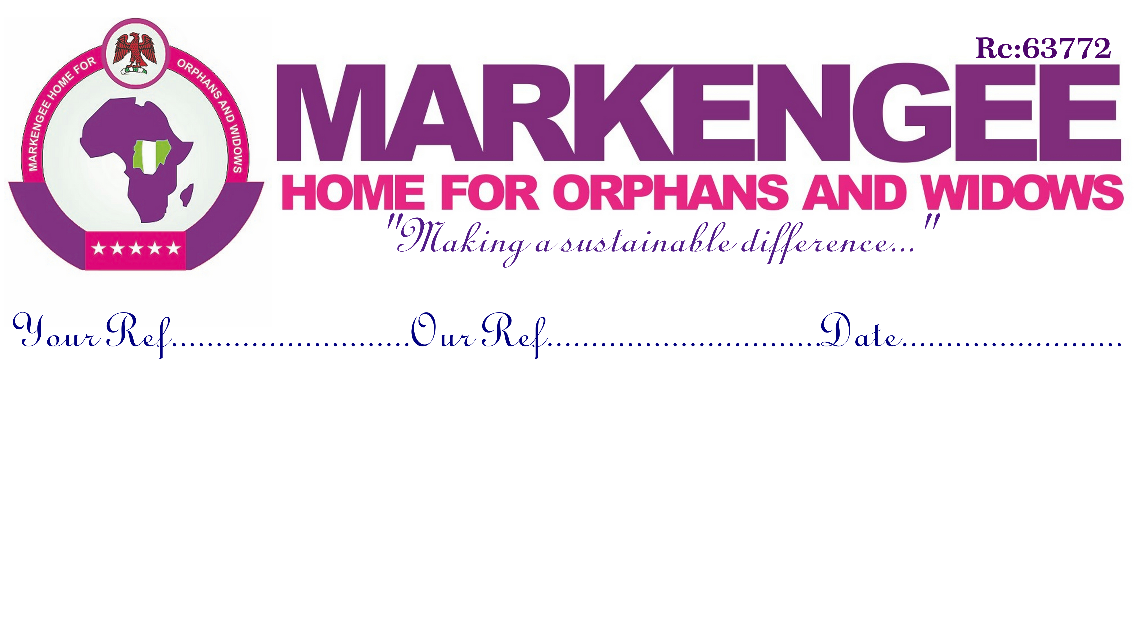

A MEAL A DAY PROJECT FOR THE ORPHANS AND WIDOWS AMONG THE IDPs

WORK PLAN
NAME OF PROJECT | A MEAL A DAY
NAME OF ORGANISATION | MARKENGEE HOME FOR ORPHANS AND WIDOWS (MAHOW)
EXPECTED OUTCOME | PROVIDING THIRTY DAYS OF HEALTHY MEALS FOR THE LESS PRIVILEGED
TOTAL FUNDS | Five Thousand Dollars ($5,000)
DURATION | Thirty Days (One Month)

 | Main Planned Activities | Implementation Period | Lead Party/Person
1. | Organisation of Meal | Entire Duration | Mr. Damilare
2. | Distribution of Meal | Entire Duration | Mr. Godfrey
3. | Safety Talk | Entire Duration | Dr. O. Daniel
4. | Security | Entire Duration | Mr. O. Frances

ESTIMATED BUDGET
ORGANISATION | MARKENGEE HOME FOR ORPHANS AND WIDOWS
PROJECT | A MEAL A DAY FOR THE ORPHANS AND WIDOWS AMONG THE IDPs
BUDGET | FIVE THOUSAND DOLLARS
DURATION | ONE MONTH (30 DAYS)
LINE | ITEMS | UNIT COST | NO. OF UNITS | AMOUNT
 | PROJECTS ACTIVITIES |  |  | NGN | USD
A1 | A PACK OF MEAL | 150 | 200 | 30,000 | 150
 | DURATION |  | *By 30 Days
 | SUBTOTAL |  |  | 900,000 | 4,500
 | LOGISTICS
B1 | PROCUREMENT | 25,000 |  | 25,000 | 125
B2 | TRANSPORTATION OF SUPPLIES AND PERSONNELS | 25,000 |  | 25,000 | 125
 | SUBTOTAL |  |  | 50,000 | 250
 | OVERHEAD
C1 | PERSONNEL | 50,000 |  | 50,000 | 250
 | SUBTOTAL |  |  | 50,000 | 250
TOTAL COSTS |  |  |  | 1,000,000 | 5,000

