Progress Report No. 5: January 16, 2017

Medicine and Care for 2500 Ugandan Orphans

Leslie D. Montgomery, Project Leader
David Ssagala, Project Field Manager

Global Giving Report.
Our project goal was best expressed in the summary statement of our original posting of the project on Global Giving - "Bambi Uganda Orphans hopes to expand its Mobile Health Clinic (MHC) program and provide medicine, health care items and training in hygiene and sanitation to 2500 orphans and their care givers in 15 remote villages in central Uganda."
The project brought health care to the the 15 individual villages. It provided additional drugs to treat simple needs such as pain and cough elixirs and prescription medications that battle more complicated conditions. The Mobile Health Clinic treated communicable childhood diseases as well as infections, malaria, and other tropical maladies. It also allowed Bambi Uganda Orphans to expand its sanitation and hygiene wellness programs during the MHC visits to each village.
Bambi Uganda Orphans treated patients in mobile clinic sessions in the 15 villages of Kakiri Subcounty, Wakiso District of Uganda listed below:
- Kyegogo
- Simbamanyo
- Kitotoro
- St. Michael Kakiri
- Nadangira
- Nampunge
- Kakooge
- Katiiti
- Zimudi
- Kirundi
- Ssebi
- Bugumya
- Kikajjo
- Kiwumu

During our Global Giving project a grand total of 3,781 patients were treated at Bambi Uganda Orphans' Mobile Health Clinic;
of these 2,748 were children; (1,643 were children between age 0 – 5 years)
(1,105 were children between 6 – 17 years) and 1,033 patients were adults
A more complete breakdown as to the number of patients served in each category is given in the table below. The relative number of each patient group served by our MHC is presented in the chart below showing patient attendence.

MOBILE HEALTH CLINIC ATTENDANCE GLOBAL GIVING PROJECT

Category | 0-5  Years | 6-17  Years | Female Adults | Male Adults | Adults | Children | Total
Number of people treated | 1,643 | 1,105 | 681 | 352 | 1,033 | 2,748 | 3,781

A GRAPH SHOWING PATIENT ATTENDANCE

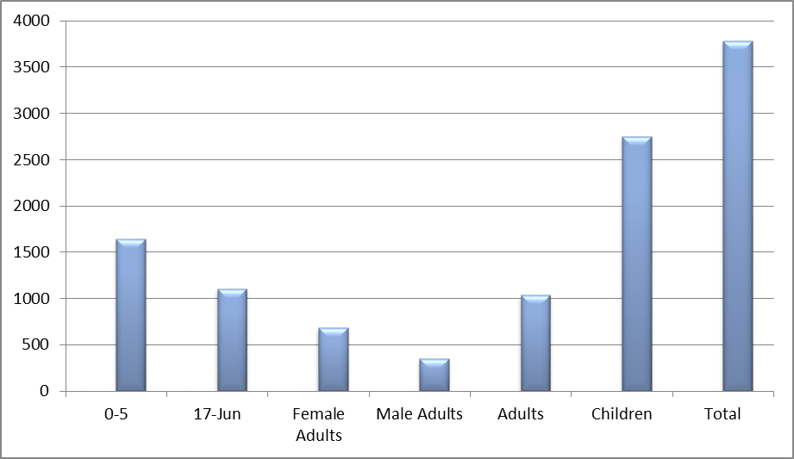

The number of patients treated for each type of disease is given in the table below. The relative number of patients with each disease is shown in the graph labeled "GRAPHIC REPRESENTATION OF PATIENTS AGAINST DISEASES.".

NUMBER OF PATIENTS AGAINST DISEASES

Diseases | Numbers
Malaria | 379
Cough | 562
Worms | 2,427
UTI | 62
Diarrhea | 31
HIV | 11
Toothache | 23
Wounds | 61
Eye prob. | 39
Pregnancy | 24
Backache | 155
Referrals | 18
Arthritis | 13
Anemia | 08
Ulcers | 121

GRAPHIC REPRESENTATION OF PATIENTS AGAINST DISEASES
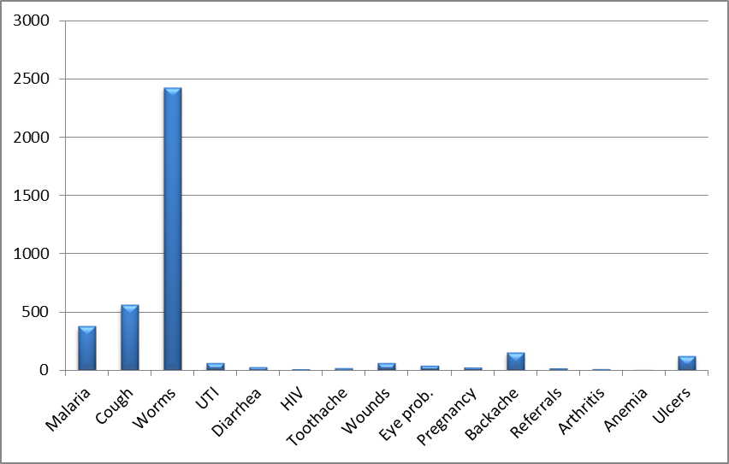

From the above table and graph it can be seen that the water borne diseases; malaria, cough and worms; are very prevalent among the patients served in the 15 villages.
Stagnant water at one home breeds mosquitoes that spread malaria to other households in the villages.
The drugs obtained using funds from Global Giving that were used in the Mobile Health Clinic visits to the 15 villages were:
- Antibiotics (Ampiciline, tetracycline, septrine, cipro)
- Panadol
- Mabendazol
- Anti malaria
- Multi vitamin
- Vitamin C
- Vitamin B complex
- Rapid malaria testing kits
- Flagyle
- Indocide
- Anti diarrhea
- Magnesium
- Valium
- Brufen

Bambi Uganda Orphans' Mobile Health Clinic provided not only patient treatment but also wellness education and taught skills to prevent illnesses especially among children. This health education is not given at the government and or for-profit hospitals.
Additionally the Mobile Health Clinic staff gave classes on hygiene, sanitation and communication. They encouraged women to work together to stay healthy - that everybody is affected.
The following items describe the observations, achievements, challenges and recommendations that resulted from the Mobile Health Clinic treatment and educational activities during the past year. We believe that many of these results are very important in helping to prevent disease and to enhance the overall wellness and relationships within any rural village.

Achievements.
- Behavioral change communication has been key in the fight against myth and traditional beliefs. Communities have appreciated the fact that diseases are not caused by being bewitched and that the best source of healing is through prevention and early treatment. A total of 1,533 beneficiaries participated in wellness workshops which are held before and during each Mobile Health Clinic.

- Patients have been taught how to make homemade mosquito repellant (from lemon grass and other natural insect repellants), deworming using natural methods like eating pawpaw seeds. These traditional medicines are free and are readily available.

- Women and children were encouraged and taught to talk to their husbands and fathers about the importance of health. A campaign was launched to see that the number of male participants in the clinic increases. This campaign has been designed in a manner that it’s the family members that encourage their men to attend… participatory encouragement.

- Beneficiaries learnt how to correctly administer drugs as prescribed and complete taking the prescriptions.

- Knowledge on how to prevent the spread of HIV/AIDS and its treatment was disseminated.

- Better Hand washing skills were demonstrated and adopted.

- Mothers were taught how to prepare nutritious, balanced meals for their children.

- The question and answer sessions greatly empowered the participants and gave then a new aspect to life – many had never spoken in public and confidence and self-worth were improved.

- There has been a significant change in the life styles of the participants for example many now have planted fruit trees and vegetable gardens due to the acquisition of knowledge regarding the value of fruits and vegetables to our health.

Challenges
- Malaria has continued to persist despite government efforts of distributing insecticide treated mosquito nets throughout the country. What emerged is that the beneficiaries were not taught and sensitized on how to use these nets. The nets have instead turned out to be misused by many families. Although the nets have instructions printed on each packs, the instructions are written in English and French. Most villagers speak local languages and many are illiterate. This means that very few are able to read and understand how to use the nets properly.

- Large numbers of patients remained untreated at the end of the several clinic sessions due to limited supply of medicines and resources.

- Bambi Uganda Orphans has only one clinic day a week and yet the demand is great.

- The heavy rains made work harder as it became difficult for patients to move to and from the clinic. The long dry season that followed resulted in widespread famine throughout Uganda. Food prices are very high and many families are hungry or starving.

- The general election and political campaigns interrupted many clinic sessions as most village leaders who usually mobilize communities for the clinic were busy campaigning for re-election.

Recommendations
- The success of the Mobile health Clinic greatly depends on the ability and willingness of the participants to actively engage in all decision making processes. Participation of all stake holders is key in the sustainability of health interventions.

- The project has been such a huge success that it should be scaled to other villages that were not covered and are begging for medical services.

- The need for health interventions remains great and yet the resources are very limited. This therefore necessitates to continue with the project and also to increase the number of clinic sessions per week.

- Continue Behavioral Change Communication and Community Health Education as part of the clinic.

- Increase the drugs and MHC budget so that we can improve our health services and also have enough medicines for all our patients.

- Project evaluation enables us to identify and repeat what works best for the people we serve. Funds should be allocated in the budget for monitoring and evaluation.
Even though this report presents just the results of our Global Giving project during 2016 it is typical of our overall program and in particular of our health care projects. The photos below will show you various activities that took place during the visits of our mobile health clinic to the 15 rural villages in Uganda.
Please visit the websites below to obtain general information and a complete description of our programs and activities:
http://bambiugandaorphans.org/

We hope to have enough medicine in the future to help all who need medical attention. Your donations to this project, through Global Giving, will help make this possible. Please consider making another donation to this project – they are very appreciated.

