Progress Report No. 3, July 3, 2016
Medicine and Care for 2500 Ugandan Orphans

Leslie D. Montgomery, Project Leader
David Ssagala, Project Field Manager
The Bega Kwa Bega Mobile Health Clinic (MHC) has treated a total of 2617 patients. Of these 1745 were children and 872 adults. The ailments recorded were malaria, worm infections, cough, urinary tract infections, HIV, toothache, wounds, eye infections, anemia, ulcers, diarrhea, pregnancy related problems, backache, arthritis and sexually transmitted diseases (STDs). There were serious and complicated (that need hospital admission), cases that were referred to health centers for further treatment and these.
The Mobile Health Clinic has provided basic medical health care to needy communities in kakiri sub county. The activities that have been involved are sensitizing and educating, sustainable use of local available alternatives for curative purpose, guidance and counseling, general treatment, deworming on site, blood testing for malaria treatment. Empowering and practically engaging patients in areas of hygiene, family planning, dietary issue and environmental conservation and management.
The mobile clinic outreach team has three nurses and a dispenser. The administrative team has two support office staff. The challenges are many but a setback has occurred to the health sector. Usually BKB MHC works in tandem with Village Health Teams (VHT), these are usually given drugs to health distribute to needy communities. They have been disbanded awaiting a new programme to be rolled out and as such it has created a very big health challenge. On many occasions we are now unable to satisfy all the patients that turn up for treatment- an average of 30 patients miss out due to the limited number of drugs assigned to each clinic session. To try to counter this serious problem, the MHC has devised sustainable strategies of encouraging and teaching about the usage of local medicine using available and know herbs. For every clinic session that was later carried out information regarding this issue was first passed on.
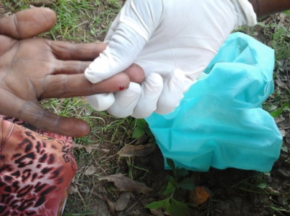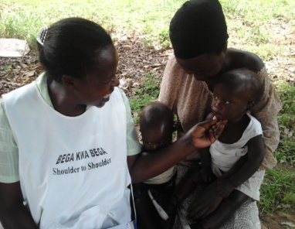
Taking a blood sample Nurse examining a patient
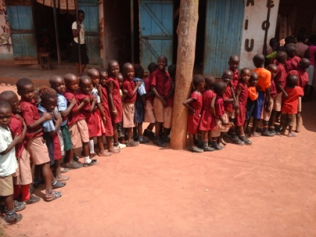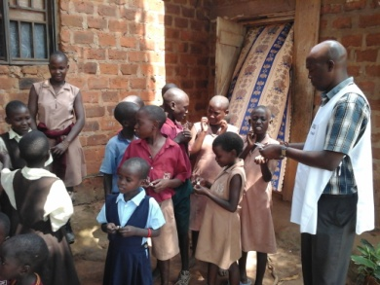
Children lining up for deworming Distributing dewormers

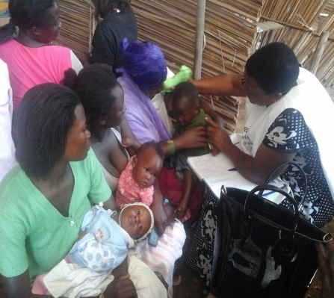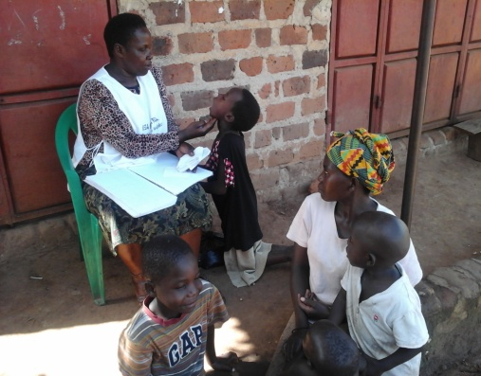
Examining a patient Checking for the cause

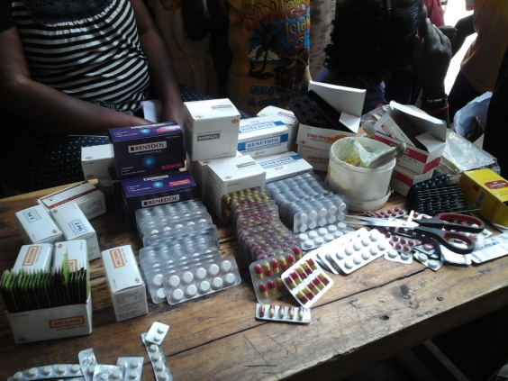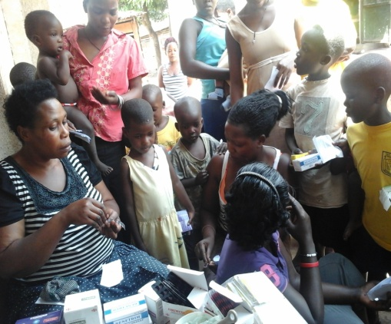
The various drugs used at the dispenser table Patients being given drugs

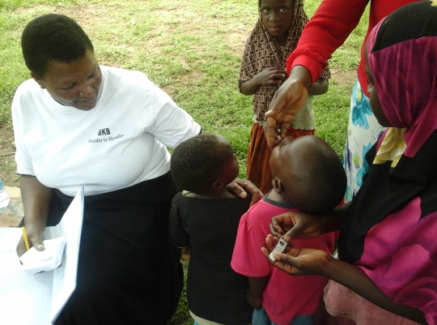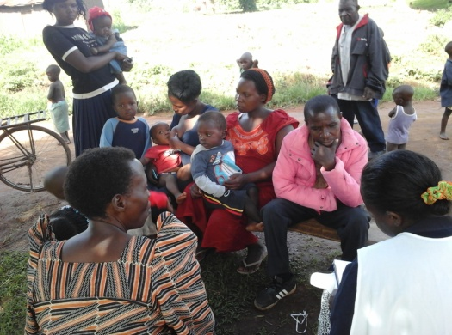
Administering dewormers to a child Waiting their turn to be diagnoised
Patient story
Katongole Ronald is a 14 year old boy who hails from Wagaba village in Kakiri subcounty- Wakiso district. He lost both his parents when he was a very young boy. He dropped out of school in primary five mainly because the grandmother could not afford to meet his school dues. The grandmother, Nansubuga Rose a 60 year old says that her grandson has many complications, but right now he has issue of moving about as his legs hurt a lot. It was visible that he had wounds on both legs. The boy is currently an HIV positive patient and taking septrine tablets. The grand mother says that he sells local chicken to raise money to go to hospital.
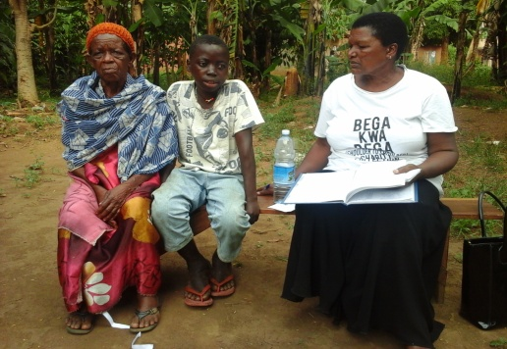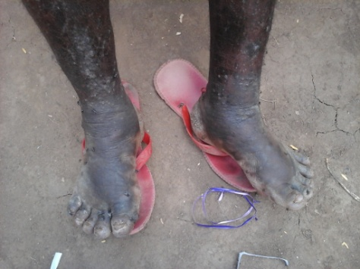
Ronald and his grandmother Ronald’s septic wounds all over his legs
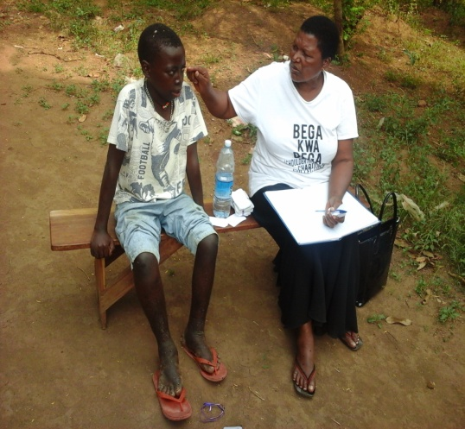
The nurse examining Ronald

