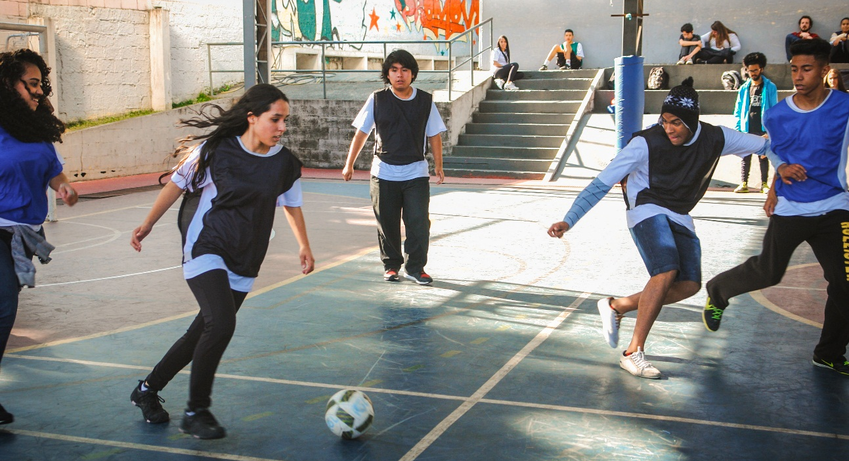

During the months of December, January and February, the "Goal for Equality" project did:

- evaluate the qualitative results of the project in 2016. To do it, we organize two focal groups: one with educators and another one with the young leaders. You can see some personal testimonials (results) below:
- Girls empowered for social life: family, school and community
"We can see the changes mainly in our community, with our friends. We can see that the girls are increasingly wanting their space, wanting to play. It is so. Thus, after this project we can see beyond, we can see that we can multiply this information that we have, and I think we can do it." Young monitor 7
- Boys in favor of the empowerment of girls
“I feel like a multiplier at home. Because, as incredible as it may seem, I have a very macho mother in my house and we always debate and fight about it - about the relationship between man and woman. For her, in a relationship who will always be wrong is the woman. This kind of thing that happens in my house I have to debate and try to change my mother's opinion on these matters... there is still chauvinism” Young monitor 13
- Participants recognize girls' right to practice sports
“After Goal for Equality, the day-to-day life with our children and young people improved a lot, because there was a lot of not wanting a girl on the team. As one woman's goal was worth two goals, the boys only included the girls because of that. Now they themselves notice when there are no girls on the team .... they say, "why do not girls want to play?", and they go after them. This is really cool, and it was changing after our project. Because it served to open the eyes not only ours (of the monitors), but also of all group (students)” Young monitor 10
- Attitudes of greater respect to the right of participation and protagonism of the girls
“In the old days, there was only one monitor girl in the middle of 15 boys, within the training. Some time ago, the girls began to show up in the sport. Now there are a lot of girls looking to be monitors and we were not like that, in the past there were very few girls wanting to be sports monitors. We, monitors, are good multipliers because we bring the women here.” Young monitor 11
- Identification of girls' empowerment attitudes during practice
“I think the main change was the girls putting themselves on. The boys' jokes are no longer fun. The girls started to talk more, we showed them for example that Marta won more gold balls than Messi. They had no idea what the female players' lives were like, their stories. So I think the main change was for them to empower themselves more. Often they do not practice for lack of stimulation, they realized that they can contribute as well, because the question of chauvinism still has to be worked hard with them.” Educator 4
- Girls and sport
“I and my friends were playing in a court here in the neighborhood. One boy said that we were not going to play because we were girls - "What are you doing here on the court? Girls do not play football." And I said, "Who told you that? I do not think the same way you do." Got it? I tried to show him that it's not the way he thinks... I will not stop playing because the boy told me that I cannot play because I'm a girl.” Young monitor 3
- Girls and social participation
“The cool thing about the Goal for Equality Project was that we also included the children... we not only had soccer, but we also had dance, capoeira and various activities. He even had a girl with a baby, with a cloth wrapped around her body, like a kangaroo, and the baby was there with her while she was doing graphite. So she did not have to leave her son to go. It was like this, the community was participating, there were many people who took the family so it was not only the women, but the whole community and the whole families.” Young monitor 10
- Start of the second year project activities: dissemination of activities, opening of enrollment and training / preparation of the team of educators and young leaders to meet the challenges of the new year.

