The Project Location
Hamro Samaj Nepal, the partner organisation has formed a team of four outreach workers. The team will investigate an ideal location to develop the centre that is convenience and easily accessible to people from Bhagawatpur, Mahadewa and Bathanaha village panchayats.
The team has been talking to individuals in the villages who will play an active role in the project. The team will also organise a public consultation by the end of March 2016 to collect villager’s opinion on location of the project. Outcomes of the consultation will be covered in the next report.
Fundraising:
Even the first phase of funding has not been secured yet so please forward this project to those who are willing to support. Your help in this matter is highly appreciated.
Bhagawatpur, Village Panchayat on google map
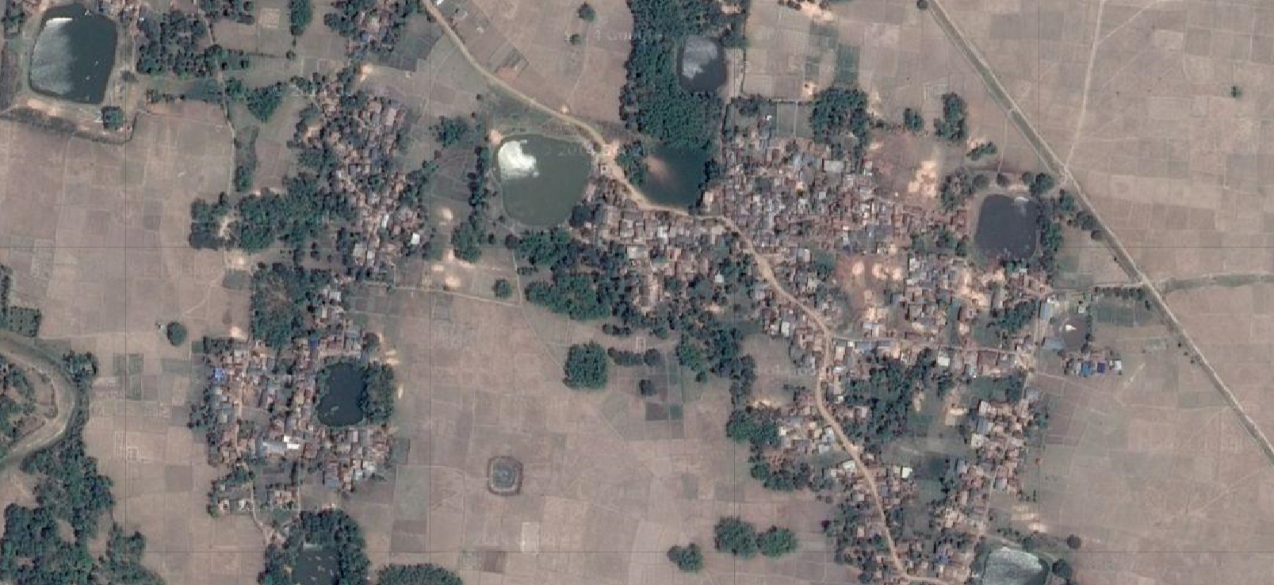
Project location on a larger map
