Contact: Alan Williams
Email: camaid4cameroon@gmail.com
Website: www.camaid.org

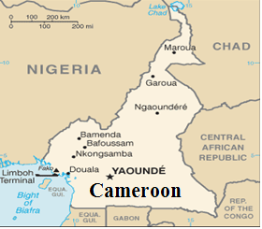
Feeding Children and Women
Project

Non-Profit Organization (NPO): CamAid
Partner with: The Red Cross of Cameroon
Founder/President:
Alan Williams
Subject: Feeding Children and Women
Financial Source: Global Giving
Program Duration: Two years
Year start & finish: 2015-2016
Location for Projects: In the city of Douala in Cameroon-Africa
Fundraising request:
1st year Total: = $12,500
2nd Year Total: = $12,500
Donation Total: = $25,000
Total Program Cost to Total Expenses Ratio (TPC/TE) 1st yr. = 82 %, 2nd yr. =83 %

____________________________________________

Objective
CamAid is a Non-profit organization created in Cameroon-Africa and the United States registered in the state of Minnesota. CamAid’s main mission is to be a pass-through conduit, to raise funds such as donations and grants, to help the underprivileged children, by providing shelter, education, school tuition for those who cannot afford it, provide medical assistance and innovative economic empowerment initiative projects for women. Provide shelter for the refugees, victims of sex trafficking, and homeless girls and women.

Problem
Cameroon ranks 150 out of 186 on the 2012 UNDP Human Development Index. With a gross domestic product (GDP) of US$2,002 per capita, more than 40 percent of the country’s 20 million people live below the poverty line, and 70 percent depend on agro-pastoral activities, (World Food Program, n.d.). We want to help eradicate in the biggest city of Cameroon. There is 33% starving children in Douala alone of the population 2,449 million, (Embassy of U.S. of Yaoundé Cameroon, n.d.).

Solution
CamAid is proposing to provide meals for children and women who are living in the streets. The homeless will eat at our shelter facility when they are hungry. If there is room, they can stay in our shelter facility until we find a more suitable living and safe environment.

Financial Statement
Below, the spread sheet demonstrates girls and women shelter project. We are proposing to implement the ‘Global Giving’ crowd giving budget to feed the girls and women at our shelter facility project proposal.
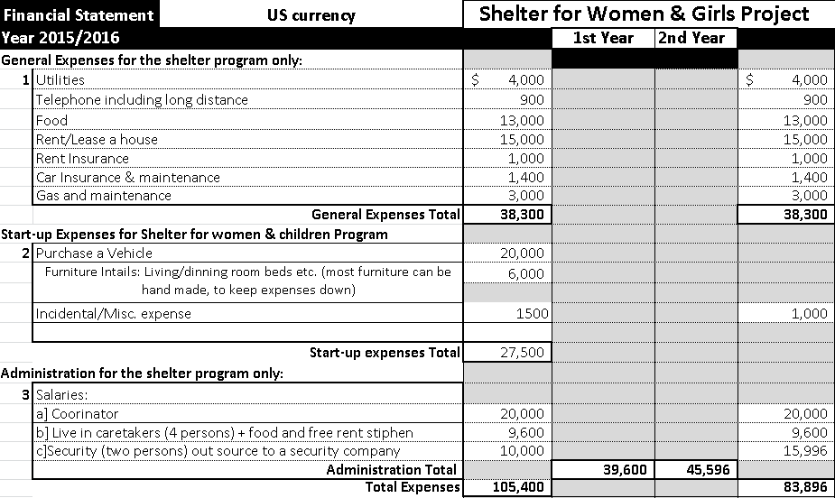
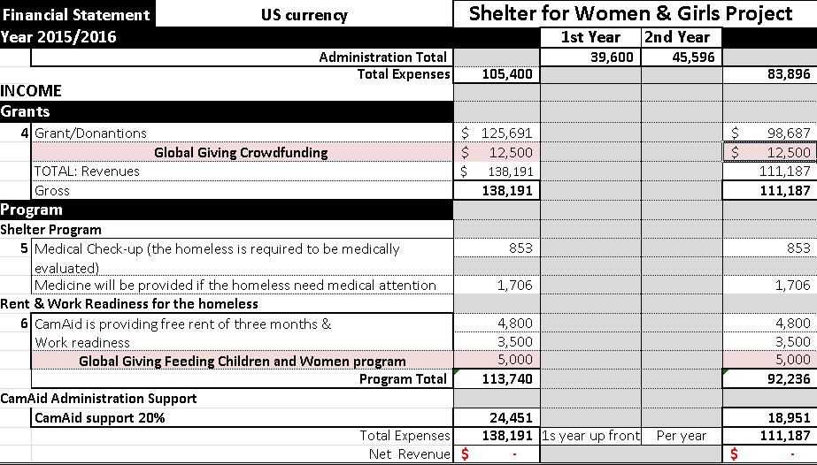

Reference:
https://www.wfp.org/countries/cameroon

