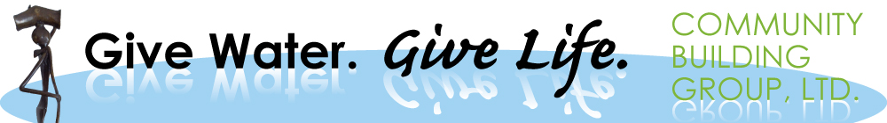
Report

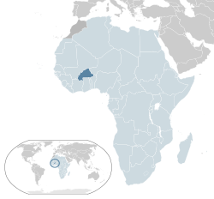
Catch Rainwater for 6,000 Villagers in Drylands

By Community Building Group, Ltd. Inc.

Groundbreaking Launching Ceremony in Kamsi for Building Rainwater Catchment Basin

Community Building Group -West Africa (CBG- WA), through its GIVE LIFE GIVE WATER (GWGL) program has held last week, a groundbreaking ceremony for launching the construction of the rainwater catchment basin in the village of Kamsi in the Center West region of Burkina Faso.

The groundbreaking ceremony was held on January 27th, 2016 at 10:30 am under the patronage of His Excellency the Ambassador of USA in Burkina Faso. About 20 delegates from USA embassy in Ouagadougou in Burkina Faso attended the ceremony, in addition to several 100 people such as local authorities, the regional governor, the officials from the Ministry of Agriculture and Ministry of Research and Innovation, volunteer and others etc….
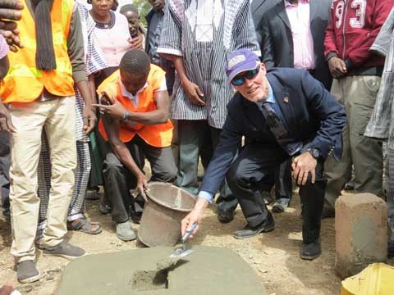
Photo 1 (USA: Embassy Jan 27, 2016): USA embassy diplomate, Mr. David Young
who is the “Chargé des affaires” is launching the construction of the rainwater
catchment basin in Kamsi. SEE THE NEWSPAPER IN ATTACHMENT.

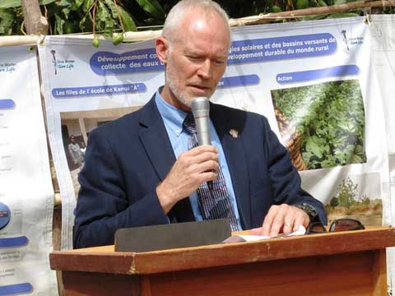
Photo 2 (USA: Embassy Jan 27, 2016): USA embassy diplomate, Mr. David Young
who is the “Chargé des affaires”, giving the opening speech of the ceremony.
http://lefaso.net/spip.php?article69384&id_document=55462#documents_portfolio

The main goal for building the rainwater catchment in Kamsi is to secure access to water year round for food security and for improving health in providing drinkable water, and to help women and girls for overcoming their burden of fetching for water all day.

Immediate Impacts of the rainwater catchment basin in Kamsi
The construction of the rainwater catchment basins will make water available during the dry season for varied uses; increases water aquifer and groundwater table, raising water level in wells; alleviates burdens on women for fetching water; and frees girls to attend school. Because, with water year round, girls will have now finally time to go to school, as there is no need to walk with their mother for dozen miles to search for water. Water filtration will reduce unclean water related health problems. With this project, more than 6000 residents in Kamsi will now have water all year round for their domestic uses, small gardens irrigation activities. It will also create socioeconomic development in the rural area of Burkina Faso.

In the opening speech, the USA embassy “Chargé des affaires” Mr. David Young, said “ I know that with the rehabilitation of water retention basins, rainwater will be collected and, due to the exact placement of the basin, the water aquifer will be restored, which will raise the water table. Raising the water table then raises the level of the water in the various wells around the basin that can then be used for successful rural economic development. When designed and used properly, the rainwater catchment basin will hold water each and every day of the year. Kamsi residents will have water for domestic use and also for the small market garden irrigation of crops in the dry season. I remain convinced that with the rehabilitation of the basin, residents will be able to produce more crops and contribute to the fight against food insecurity and achieve true sustainable development.”
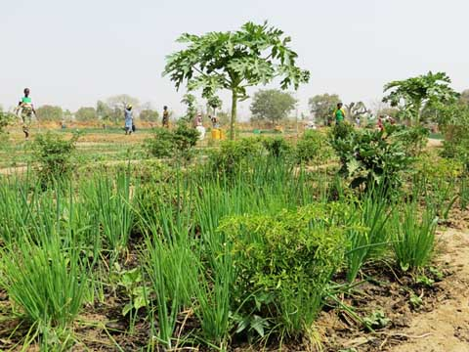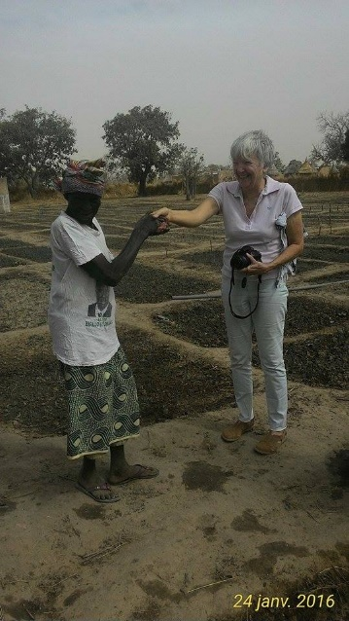
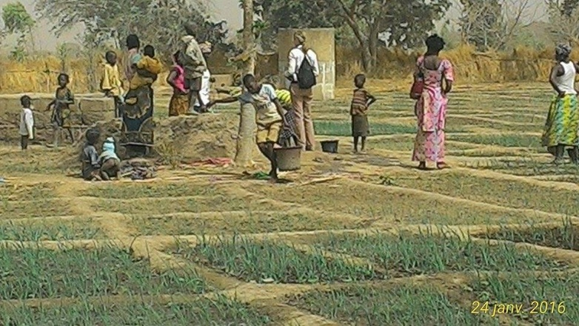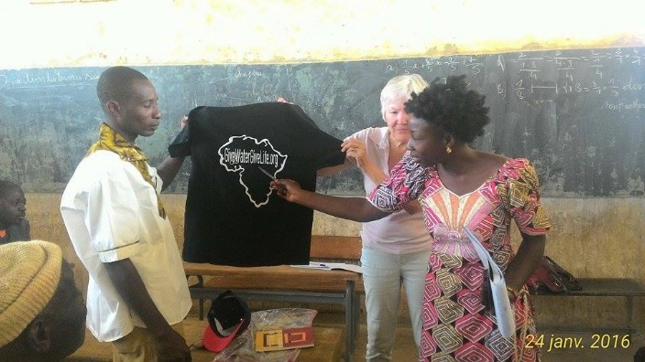
Photo 3 (Jan 27, 2016): Small irrigated garden cultivate d by the women cooperative group of Kamsi.
These agriculture plots are next to the basin and belong to the women cooperative group (more than 200 members). The plots are fully irrigated with the water collected in the basin. Burkina Faso has two main season: Rainy season (5months) and dry season (7months). Which Mean, after the construction of the basin, and after the rainy season, the women can still be able to growth crops using the water from the basin in the dry season.

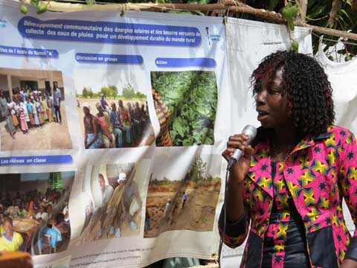
Photo 4 (Jan 27, 2016): Community Building Group regional coordinator presenting the
upcoming rainwater catchment construction works to take place in Kamsi in the coming weeks.

With the support from all, Kamsi will secure water and food and sustain its socioeconomic development. Your donation are the key ingredients of our success for solving water climatic related disaster in the dryland in Sahel. We thanks USA embassy, all volunteers, local authorities from Burkina Faso, friends in USA, FBF, and the rural communities for their commitment in this water harvesting and storage initiative for helping women, girls and most vulnerable people who are at the frontline of water scarcity fight in Sahel. Thanks to Global Giving for helping us with their donation platform for raising money.

As soon as we raise more money, the basin will be entirely completed soon…..
Please your donation is needed!!!!!!!!!!!!!!!!!!!!!!!!!!!!!!!!!!!!!!!!!!!!!!!!!!!!!!!!!!

Additional Information

www.GiveWaterGiveLife.org

Laeticia KABORE EP SAWADOGO  Coordonnatrice Régionale :  Community Building Group_West Africa (CBG-WA) Give Water Give Life Program  Secteur 22, Zone du Bois  11 BP 1282 CMS 11, Ouagadougou  BURKINA FASO  Mobile +226.70.42.42.68  BURKINA FASO  cbg.wa.regionaloffice.ouaga@gmail.com  www.GiveWaterGiveLife.org | Traore Seydou, Ph.D.  Directeur Exécutif  CBG-WA ; Give Water Give Life  Community Building Group, Ltd.  13785 Walsingham Road, #119  Tel :, (+1)979 422 6312 ;  Largo, Florida 33774  United States of America  cbg.wa.regionaloffice@gmail.com  www.GiveWaterGiveLife.org | Kathleen McDonald  Président  CBG-WA ; Give Water Give Life  Community Building Group, Ltd.  13785 Walsingham Road, #119  Tel :, (+1)727.515.0371  Largo, Florida 33774  United States of America  kmcdon3107@aol.com  www.GiveWaterGiveLife.org

