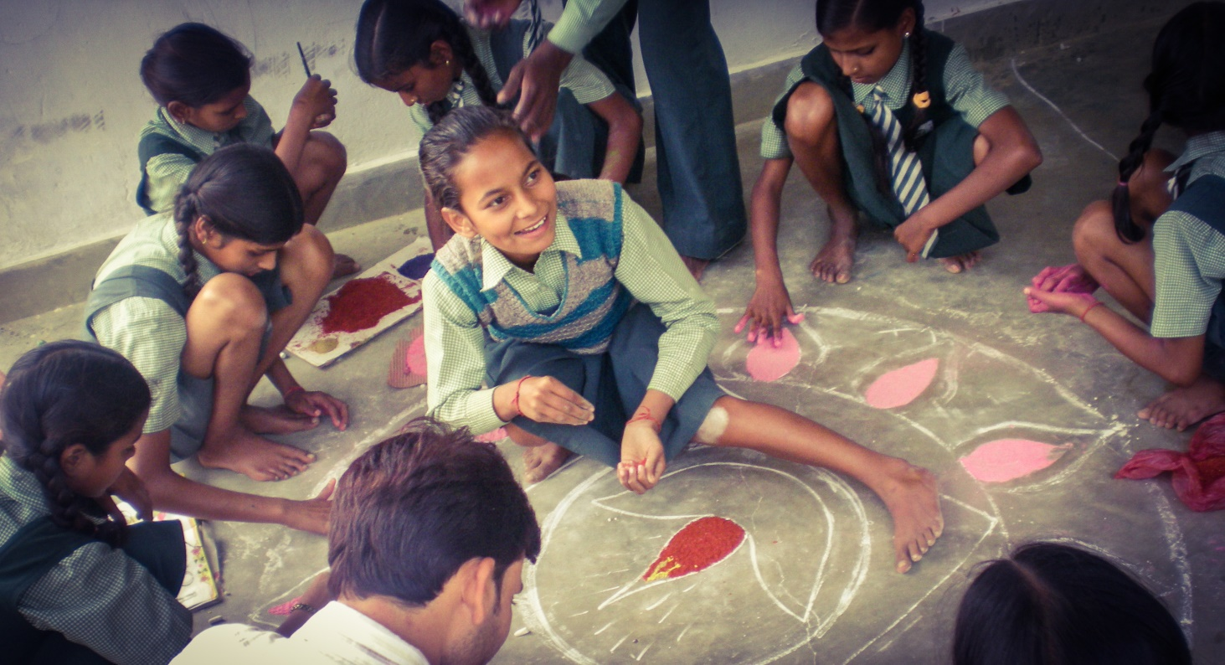

Milaan Be The Change

Milaan Overview:
Started in 2008 in Uttar Pradesh, India, with only 10 students and 1 teacher, Milaan School (Swarachna Learning and Resource Center) grew out of the dream to build a model school which would house the innovations and aspirations of tomorrow for rural children.

Working in coordination with the government, Milaan works in government schools to enhance the experience of girls as part of the Milaan Outreach Program. This program is further supplemented by The Girl Icon Fellowship Program which assists girls in realizing their aspirations and amplifies their voices within their community while creating sustainable impact in their schools and towards furthering the roles of girls in decision-making processes.

Milaan’s mission is to create a world of opportunities for children to fulfill a million dreams.

Milaan School and Milaan Lab for Innovation and Education (MiLIE)
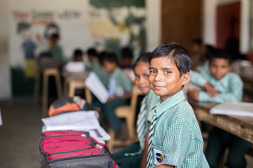
Milaan School began as the Swarachna Learning and Resource Center and has since transformed to serve as the center of a vibrant wheel that works towards nurturing the dreams of adolescent girls from rural and marginalized communities.
Located in Sitapur District, Uttar Pradesh, Milaan School is the hub of education for students within a 20 km radius from kindergarten to Class 12. The school focuses on creating an education model that is impactful, powerful, and full of imagination for rural children.

Together, Milaan School and MiLIE’s combined programs work to increase the demand for innovative school environments and increase the supply of excited families who want their students to be empowered role-models.

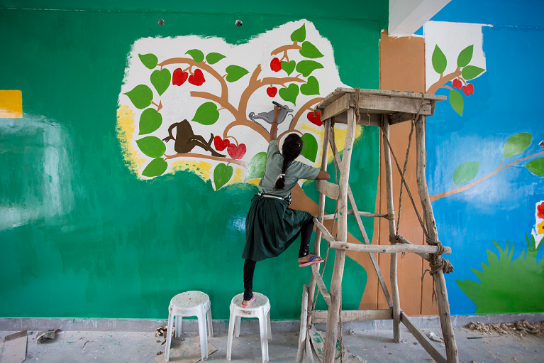
Research
Initialized as a hub of innovation in rural Uttar Pradesh, MiLIE serves as a center for discovery and research. Students, staff, and teachers work together to realize the impact and effect of programs that might benefit a larger group of students.

The center places special emphasis on macro and micro level understanding of the barriers to education of adolescent girls as well as keeping adolescent girls in school, furthering their aspirations, and engaging rural communities in girls’ education.

Outreach Program
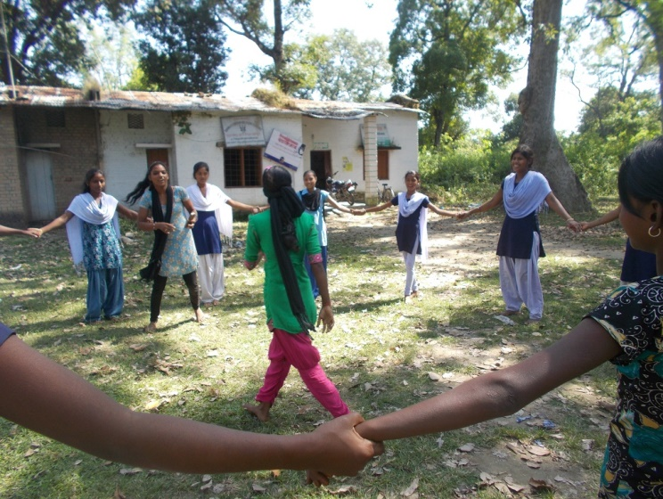
The Milaan Outreach Program transfers innovative working, education pilots on enhancing the experience of girls in schools to government schools within a 50 – 60 km radius of Milaan School. This program specifically aims to work with government schools in understanding the barriers and gaps in education of adolescent girls in government schools.

Tested by the Leadership Team at MiLIE, and improved upon by the students themselves, programs target girls from class 6th - 12th and especially seek to amplify the voices of rural girls studying at KGBV schools.

The program consists of 10 – 12 sessions per year with the girls and be in coordination with government bodies, teachers, and stakeholders. Curriculum and work will be documented and converted into digital curriculum to serve as learning tools for future classes and teachers.

20 schools in the surrounding districts will work in coordination with the hub school, Milaan School, and the leadership team to impact the education system with a pure adolescent girls lens.

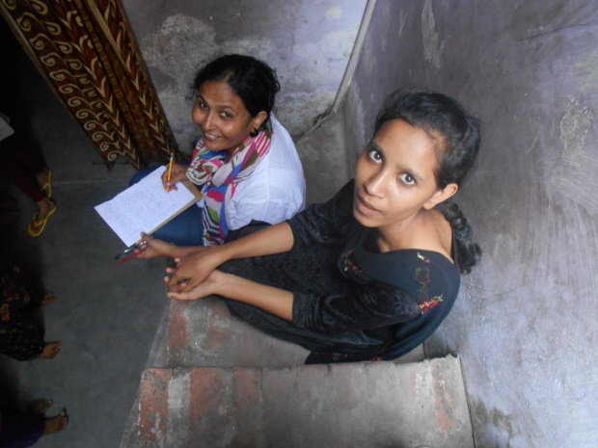
Milaan Girl Icon Fellowship Program
The Girl Icon Fellowship has been created to inspire the larger community to support adolescent girls in their aspirations The Girl Icon Fellowship Program will target 100 girls from 20 government schools within the next two years. We aim to create 1,000 change makers by 2020. It will be for a period of two years, and aim at providing financial, leadership, and capacity building support to girls selected on the basis of need, merit and ability to become a change-maker.

The Fellowship will provide girls with a stipend to attend a school of their choice. They will be encouraged to work on outreach within their communities, design and implement a social change project, and will be connected with Milaan mentors.

Fellows will meet on a quarterly basis for a two – three day workshop on leadership within their community and schools. At the end of the fellowship, students will be required to choose one project that would enrich their community and empower others. An alumni network will be established and tracked by Milaan in order to ensure that fellows are fulfilling their aspirations.

Impact
Milaan aims to change the environment within schools to enhance learning with a special focus on adolescent girls. By creating tested innovative programs that emphasis the aspirations of girls at our hub school, we can bring working models to completely restructure how government schools approach education for girls. In empowering these students we seek to impact the larger communities that they come from, and inspire a legion of girls to come.

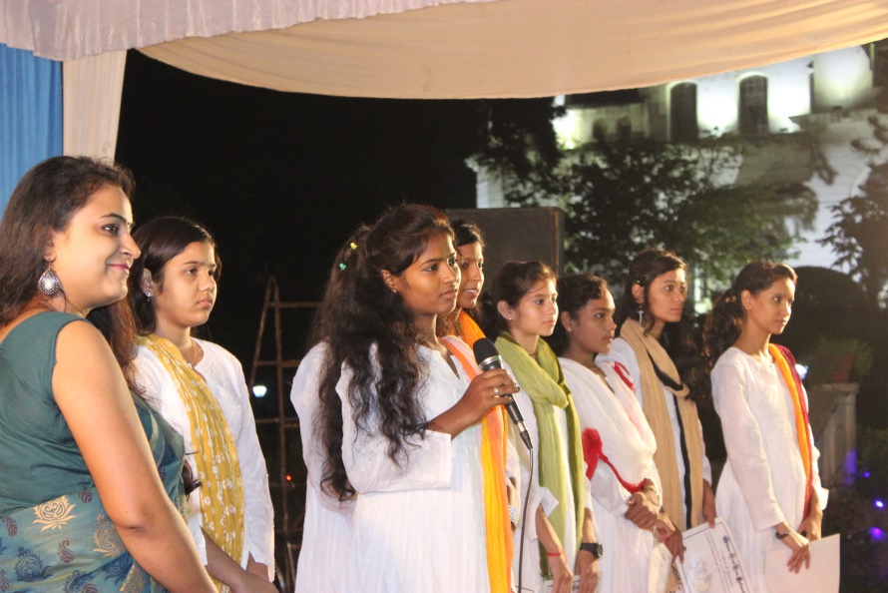

Milaan.in
3/129, Vidhayakpuram, Vinay Khand, Gomti Nagar
Lucknow, India 226010

