

**ENABLE 500 YOUTH FEEDING THEIR FAMILIES IN ZEZE VILLAGE**

**THE FEEDBACK FROM ZEZE VILLAGE FOR AUGUST 2016**

Poverty and farming illiteracy continue to be big problems for many household peasants in areas of rural Africa like the Zeze community. However, Mboni ya Vijana Group (MVG) is transforming the Zeze community to adapt best practices for sustainable farming, and micro-businesses. All these practices are seeking to enable youth in the community to feed their families with food (nutrition), services (health, education, clothing, etc), and access to clean water and energy. Since the beginning of 2016, Mboni ya Vijana Group (MVG) has made decisive progress to enable youth and other households in the community (Zeze village); who are benefiting from agricultural produce, small enterprises, and access to clean water.

**PROGRESS INDICATORS AND EVIDENCES**

**Observable Evidence from the Field**

**Community access to clean and reliable water** is the evidence indicating progress in enabling the Zeze community to feed their families. Water has been the major challenge in Zeze village, but the fund from GlobalGiving has made it easier for the community to access it. A water borehole attached to a rope hand pump, is feeding 240 households with water for 12 hours every day.

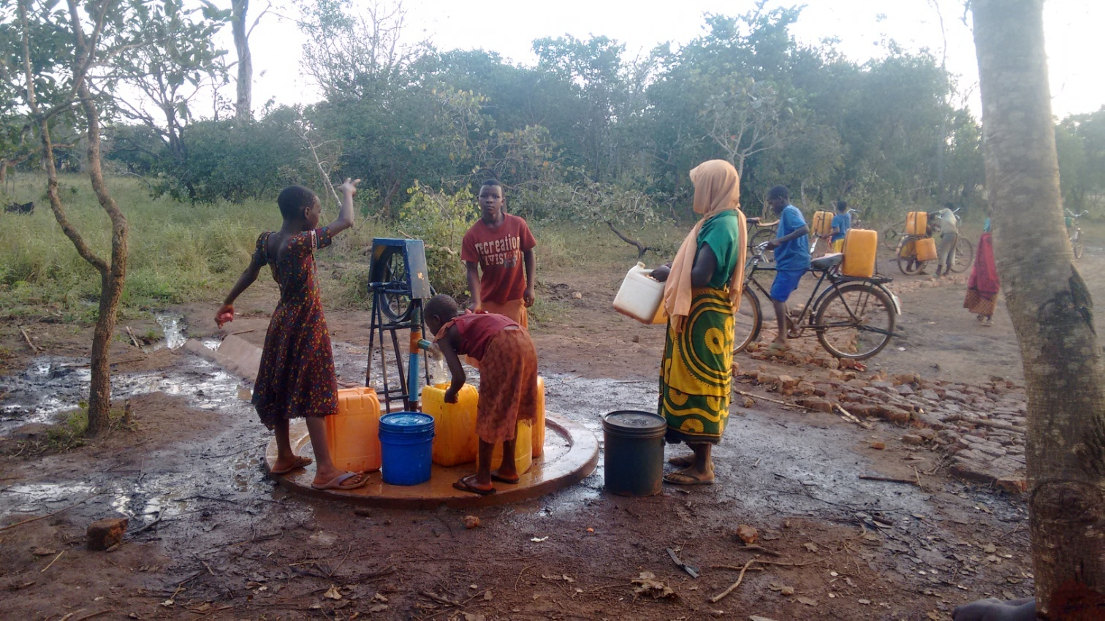

*Plate 1: People in Zeze collecting water for domestic use. Field picture June 2016*

**Youth growing vegetables and other crops on** land to enable their family’s access to nutritious foods and income, is now taking place at Zeze village. MVG is supporting the youth with farming facilities including seeds, watering canes, and farming skills. Since May 2016, MVG has 24 youth operated farming activities at Zeze village to enable their families with food sufficiency.

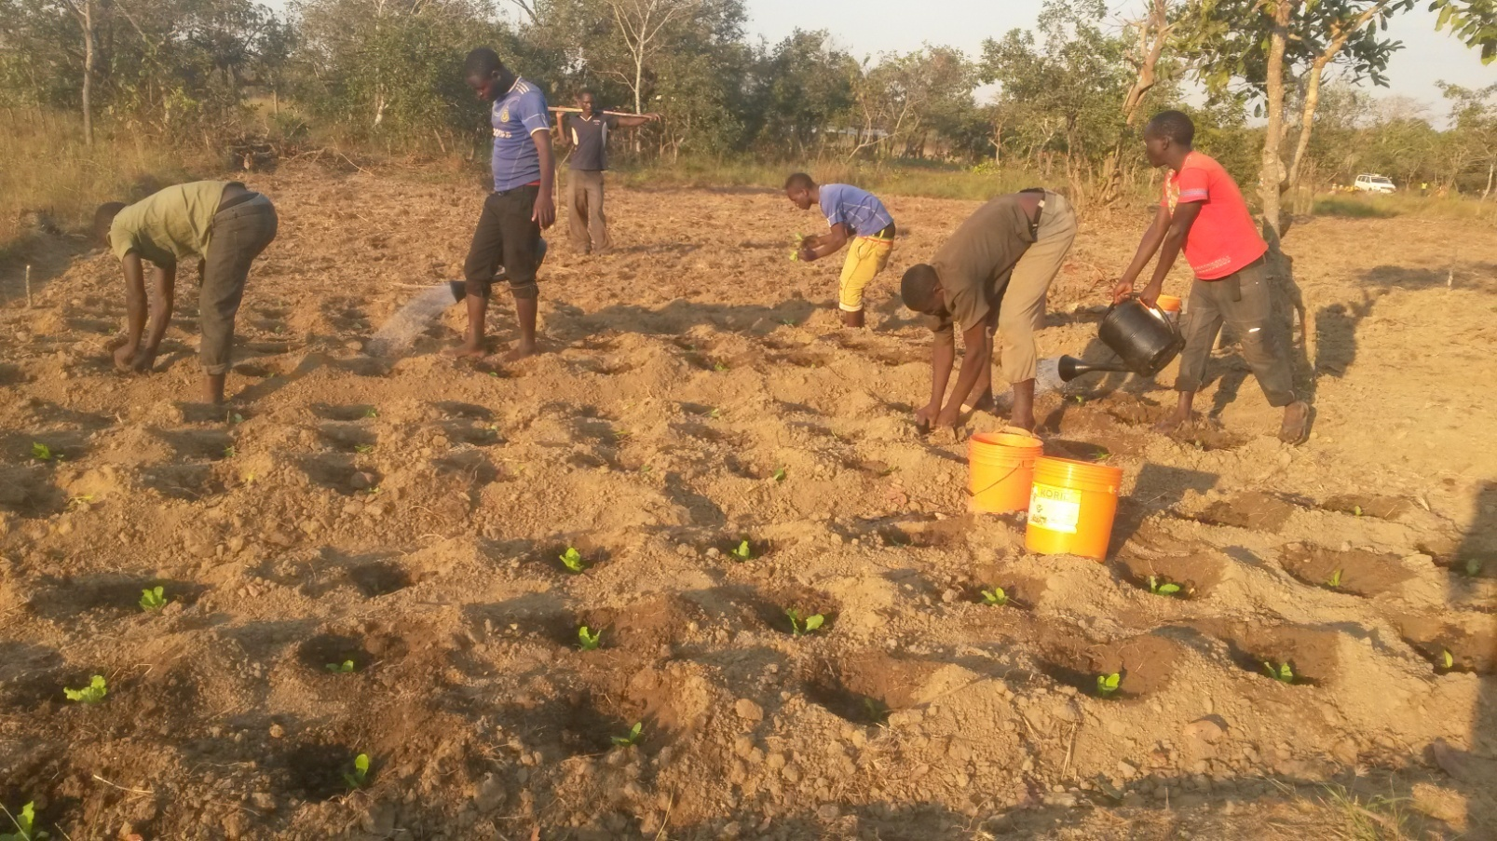

*Plate 2: Youth working on communal farm to grow vegetables, field picture July 2016*

**Feedback from the beneficiaries**

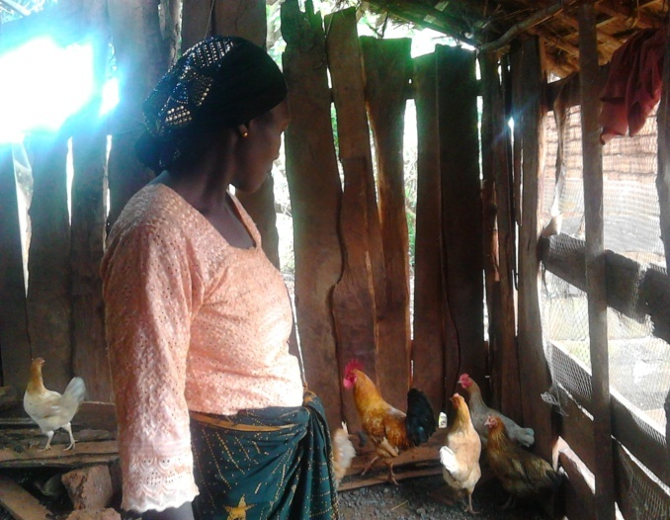**Modesta** is a woman in a household of seven members in village. She cares her four kids, her old mother and her young sister. She is happy with the difference she is making in her life and for her family. Modesta says “I am the family mother. I am happy with chicken and vegetable farming because they are giving solutions to my family.” She is running small scale farming that involves chicken raising and vegetables farming. “You see, the assistance I have been getting from Mboni ya Vijana Group, is doing this (Chickens and vegetables). They are really changing our lives in my household,” Modesta says.

*Plate 3: Modesta in her chicken hut telling how she achieved it, Field picture in June 2016*

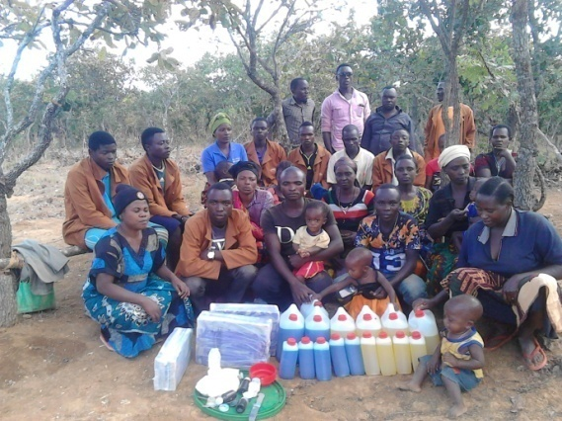Young women and men have things to share for improving their families by improving their income capacity. Instead of depending on farming as the solution for their lives, they have been making soap to generate income which will then diversify into farming and other families use. However, the mothers need soap and water for hygienic purposes as most of them are nursing. “My health cannot improve by eating good food only, but can be if I improve the hygiene of my family,” Levitha says. “We are in a group making soaps for income but also for unity and hygiene,” January added. The picture shows young men and women together making soap.

*Plate 4: young men and women on the picture showing soaps they produce to improving their families and the community. Field picture May 2016*

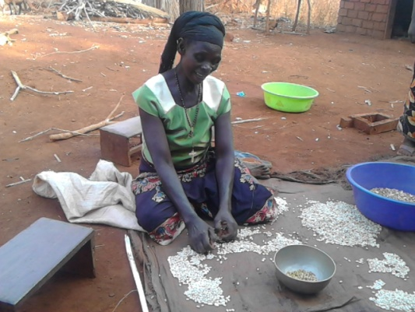Epiphania had never thought she could feed her family of 6 household members including three school students because agricultural produce has been declining. She did not know how to improve small scale farming to increase yields until she got MVG support. Since February 2016 she started adapting to modern farming which has enabled her to increase white beans production. “I would have not managed to produce enough food if I did not have your (MVG) support. Since I adapted soil improving farming methods from you in February, I have tripled production with the same size of land I used before. I am proud to be feeding my family this year and will increase more production next season,” Epiphania says. Mboni ya Vijana Group supported her with the best farming methods education and agriculture implements in March 2016.

*Plate 5: Epiphania sorting agricultural produce before storing in Zeze. Field picture July 2016*

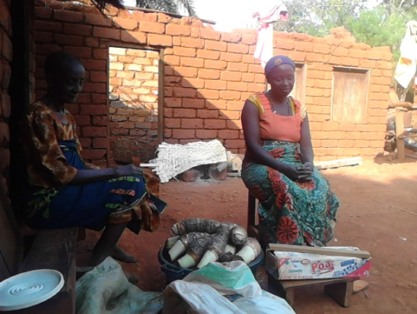**Godiliva** is a married woman living with her mother and other six children out of her 9 children. She benefits with Mboni ya Vijana Groups’ projects including micro-credit scheme. In March 2016, she started growing yams and other crops with the assistance of Mboni ya Vijana Group and now she is harvesting both crops. “*I am not only happy with my work but we are all happy in the family. We eat, we enjoy and we support each other in the family and community as well. Mboni ya Vijana Group’s support is the liberal to our lives. I think we will be the next generation in which family self sufficiency will be great,” Godiliva says.*

*Plate 6: Godiliva in the right hand side with her mom in the left side showing the yams harvested from her farm. Field picture July 2016*

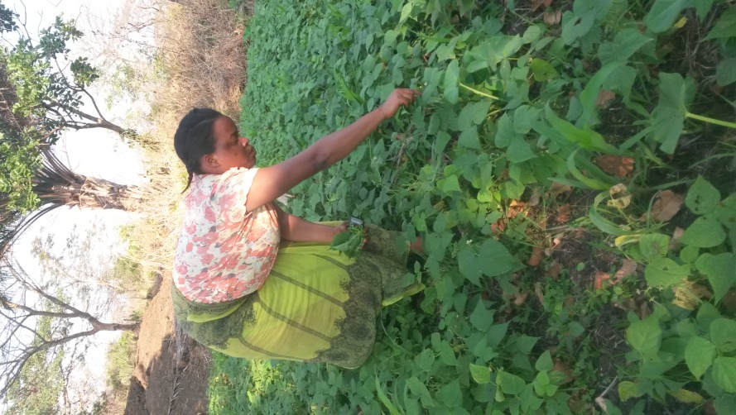**Adrophina** is a graduate and MVG member who is transforming Zeze society to adapt best means of farming to improve productivities per area and resources. She has established a pilot plot on which she grows varieties of crops including vegetables. *“I would really like the community to learn from my work. I am not doing this (improved farming) just to enable my family, however, I am doing this to teach others,” Adrophina says*. Adrophina is maintaining her plot using water drilled by MVG but also with varieties of seeds and irrigation materials supplied by it.

*“I think people need to see than speaking only, now I receive many people who ask me how I have managed my small area of land with good crops, Adrophina added”.*

*Plate 7: Adrophina on her vegetable farm harvesting some vegetable for use. Field picture July 2016*

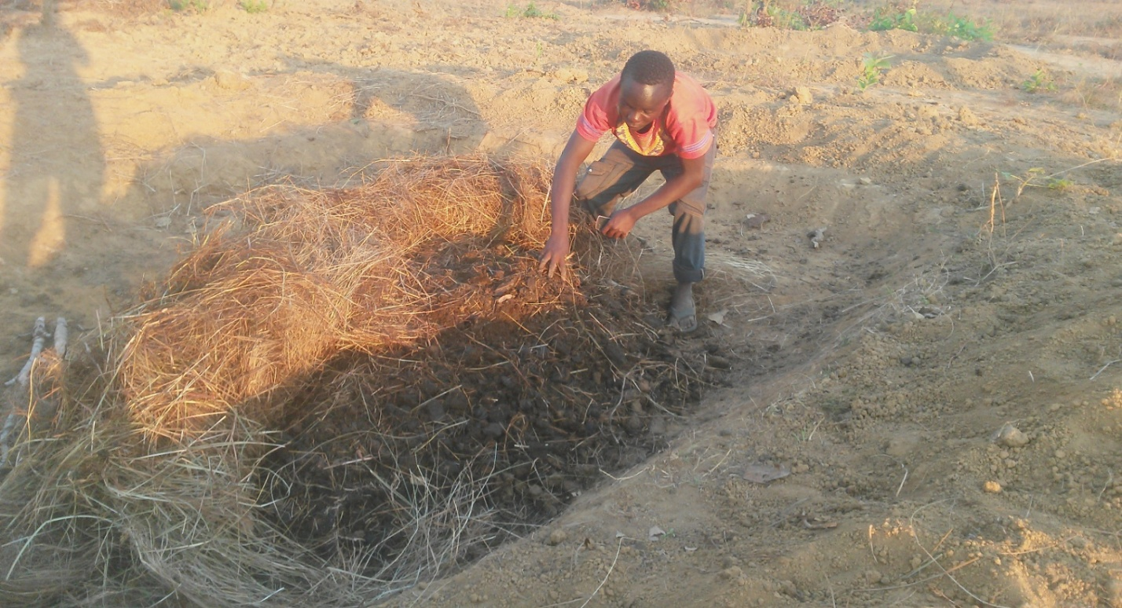**Vedasto** is one of the Mboni ya Vijana Group (MVG’s) beneficiaries lives in Zeze. He is living with his older parents and his nephew in a household of four members. He was often migrating around Tanzania searching for a good life without success and finally decided to stay at Zeze and to adapt modern methods of farming using organic matters. “Mboni ya Vijana has enlightened my future. I was illiterate to improve agriculture but now I know how to change obstacles into opportunities. I will be changing waste into organic fertiliser to yield high,” Vedasto says. “I did not believe that dry materials could change into fertilizer hence I was burning everything that was dry with fire. But with Mboni education, I will be using waste for wealth production,” he added.

*Plate 8: Vedasto preparing organic matters for his farm in Zeze village. Field Picture June 2016*

**Conclusion**

Mboni ya Vijana strongly delivers agriculture, business and environmental knowledge to the Zeze community so as to improve their lives. When you go to Zeze village to see the change that Mboni ya Vijana Group is making in the community, the stories presented in this report will be observed. Athough Mboni ya Vijana Group does better in the processes of improving the lives of the community, the resources are still less than the demands which we need for more cooperation from other stakeholders.