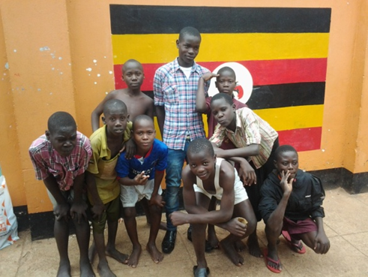

**Retrak supports boys like Oscar at the Lighthouse in Kampala**