**UDHAVUM ULLANGAL’S**

**ANANDHA DEEPAVALI 2015**

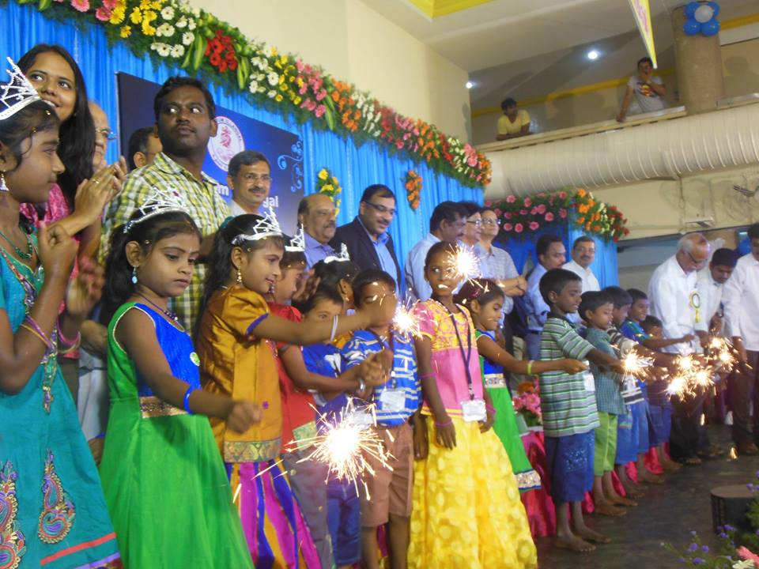

“Deepavali celebration for those who cannot afford to celebrate” has been the theme behind celebrating ***Anandha Deepavali***. Over the years, your continuous participation in this celebration has helped transform lives of thousands of children, for whom education was not affordable. We bring together cheerful children from 15 orphan homes under one roof and along with spending the day with them, you get to feel the limitless happiness that you have brought to them. We utilize the fund generated to provide educational support to students.

We are celebrating ***18th Anandha Deepavali*** with 1251 children. They will be given a custom-fit dress, sumptuous meal, sweets and a whole day of non-stop entertainment. The one-day festivity, feasting and fun will be on Saturday **24th October 2015 at Krishnaswamy Kalyana Mandapam, South Boag Road, T. Nagar, Chennai – 600017**. Event of such magnitude has been possible for 17 continuous years only because of generous support of the service-minded people like you. In addition to your valuable contribution, we request you to take your precious time out and talk to your colleagues, friends and relatives about us and Anandha Deepavali for getting their support.

For online transfer: (Please email remittance details to uu1sankar@gmail.com)

**Indian Bank, Nandanam**

Udhavum Ullangal

A/C No. 418713350

IFC Code: IDIB000N078

**ICICI Bank, Nungambakkam**

**Udhavum Ullangal Public Charitable Trust**

A/C No. 000901120890

IFC Code: ICIC0000009

**For Foreign Contribution only.**

AXIS BANK

NUNGAMBAKKAM

**Udhavum Ullangal Public Charitable Trust**

SB ACCOUNT NO. 912010054963859

SWIFT CODE: AXISINBB006

ACCOUNT TYPE - SBFCR

Registered under Foreign Contribution Regulation Act

Your contributions are exempt from tax under Section 80-G of the Income Tax Act, 1961

For further details, please contact:

**Udhavum Ullangal Public Charitable Trust**

No. 77, 1st Main road CIT Nagar

(Opp. Fiat showroom)

Nandanam, Chennai – 600035

Phone: +91 44 2434 4743

Mobile: +91 94441 94743

Email- [uu1sankar@yahoo.com](mailto:uu1sankar@yahoo.com)

Website: udhavumullangal.org.in

**About Udhavum Ullangal**

The journey of **Udhavum Ullangal** as a Registered Public charitable trust began in 2000 with a vision to create awareness and build a socially conscious selfless society helping people in distress, poverty and during crisis. Our activities are primarily volunteer driven and our administrative expenses account for less than 4% of the total funds spent.

Our key accomplishments include:

* Education support to students, with 547 students being offered scholarships in the current year amounting Rs. 40 Lakhs, including 177 students from Sivakasi studying in National Child Labour Project Schools
* Mentorship programme every month in Chennai and bimonthly in Sivakasi
* Monthly provision to families of 130 leprosy affected and visually challenged.
* 1560 women have been trained through skill development centres at Hasthinapuram, Lakshmipuram and T Nagar in association with Accenture and CAF
* Cancer Prevention Center @ Tirunelveli creating cancer awareness to 30,000 people, screening 10126 people and treated 41 patients for cancer in the district of Tirunelveli. Day care hospital and oncopathalogy lab started functioning from August 2014 to give affordable treatment to the poor
* Financial support for constructing 7 class rooms to Swami Vivekanandha Rural Community College at Pondicherry to the tune of Rs. 48 lakhs

You can also be part of these activities.

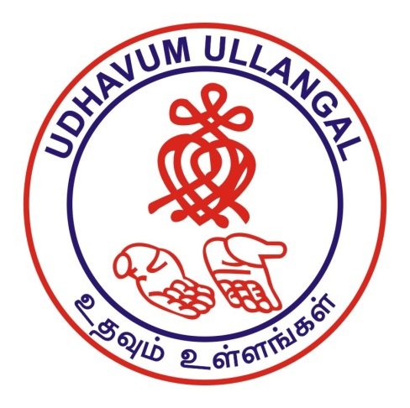

Anandha Deepavali is a Festival of light where you can light up a lamp in the life of a child labour by supporting their education:

How can you help?

Make a child happy with Deepavali sweets : Rs.250/-

Make a child happy with Deepavali sweets& Feast : Rs.500/-

Make a child happy with Deepavali sweets,feast& dress : Rs.1000/-

Give life to one child with education & Deepavali :Rs.5000/-

Please also refer your friends, relatives & colleagues with their email ids to us so that they can also support this noble cause.